
Workflow & Event Triggers Training Manual
Contents
1. INTRODUCTION 3
2. GETTING STARTED 3
2.1 Sales 4
2.2 Tasks 4
2.3 Additional Tasks Tool 5
2.4 Changing Your Reported View 6
3. CONFIGURING A WORKFLOW SCHEDULE 8
4. EVENT TRIGGERS 11
5. MANUALLY ADDING A CASE INTO 360 12
5.1 Adding more than one client 13
6. ADDING A SALE EVENT 14
6.1 Sale Details and History 15
7. ADDING A MORTGAGE 17
8. ADDING A BUILDINGS AND CONTENTS POLICY 19
9. ADDING A LIFE POLICY 20
10. ADDING AN INCOME PROTECTION POLICY 22
11. ADDING A PENSION 23
12. ADDING AN INVESTMENT POLICY 25
13. DELETING 26
13.1 Deleting Sale Events/Products 26
13.2 Deleting a Case Record 27
14. CASE MERGE 28
14.1 How to use the Case Merge Tool 28

- INTRODUCTION
The Workflow/Office module allows you to be automatically and instantly informed that a sales process has been imported from Workbench and track your cases right up until completion. You can filter by administrator, advisor, lender etc. to see reviews and tasks which need completing across a number of cases. This tool allows you to centrally manage pipeline, across a number of advisors, through the tasks set against each of your cases and policy records at a pipeline status. All of the above is achieved through using the ‘Admin Pipeline’ and/or ‘Tasks’ section of the system.
- GETTING STARTED
Begin by double clicking on the Office Icon which should be located on your Desktop.
Your login page should now open, allowing you to enter your credentials. Once you enter your Username and Password, the Office landing page will now open as per below:
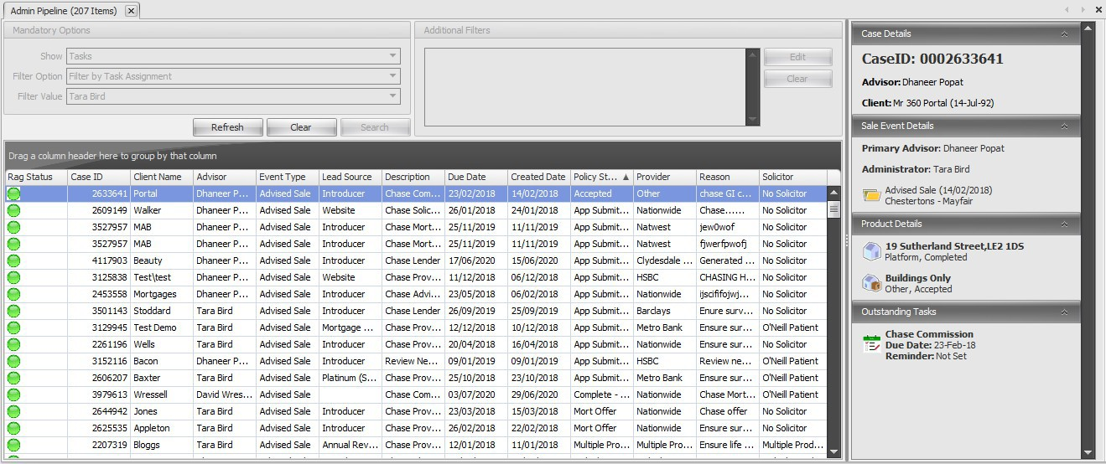
The Workflow function can now be opened under the ‘Tools’ tab in Office and selecting ‘Admin Pipeline’. The new view for this is a mandatory view but will allow for much more extensive visibility of the outstanding work that needs to be done, including client details, sale details, product details and an outstanding tasks
overview screen. The majority of the entries in this overview section can be selected which will direct you to that area of the relevant case record. This will look like the below.
The first dropdown you will see is ‘Show’. This is split into two parts, ‘Sales’ and
‘Tasks’. Further filters can be created by using the ‘Filter Option’ under ‘Show’, and you will get the options to select ‘Show Outstanding Tasks (No Filter)’, ‘Filter b Administrator/Advisor/Servicing Advisor/Task Type/Task Assignment’. If one starting with ‘Filter’ is selected, the Values box underneath will open allowing you to further filter the Tasks or Sales in scope. You can also add Additional Filters by selecting ‘Edit’ in the screenshot below, and filtering on Product Type, Provider, Solicitor, Introducer, Task Date and Lead Source.
  - Sales
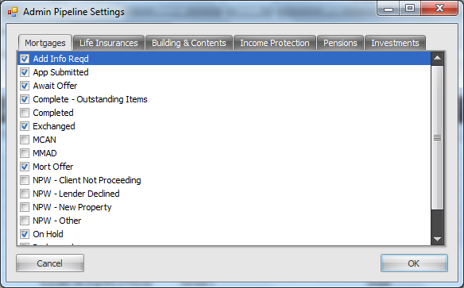
This will show you all records which holds a policy record at a Pipeline Policy Status
e.g. ‘In Progress’, ‘App Submitted’ or ‘On Hold’. The Sales which appear within this area are driven by the policy status and the Filters selected. Please note that you can decide which policy statuses should be reported within Admin Pipeline Cases by entering Office, Maintenance, General
and Admin Pipeline Settings. Those statuses ticked will then result in policy records with a matching policy status appearing against the Administrator/Case Owner in Admin Pipeline Cases.
  - Tasks
This will show you all the records where a Tasks has been added, but not yet completed.
    - Creating A Task
To add a task to your Admin pipeline:
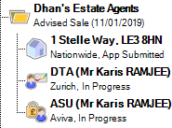
Open the relevant case record and click onto the ‘Vanilla’ sale event folder.
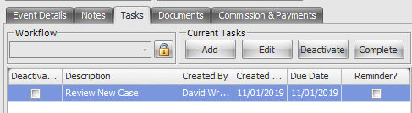
Select the Tasks tab and click ‘Add’

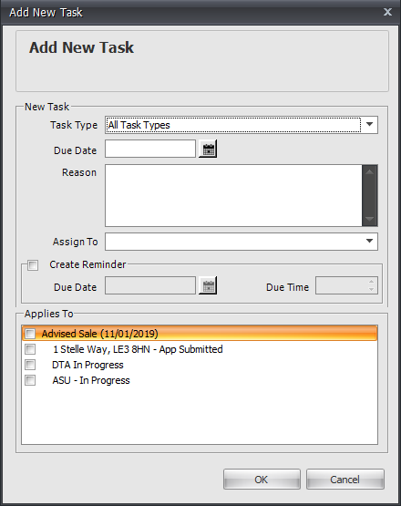
You will be presented with the window to the right.

- Complete the details of the Review by selecting the relevant ‘Task Type’ from the drop-down menu and enter the ‘Due Date’. Please note that you can add your own Task Types by entering Office, Maintenance, General and Task Types.

- You can enter some further notes if applicable within the Reason section.

- Select the user you want the task to go to in the ‘Assign To’ dropdown.
- If you check the box to ‘Create Reminder’ this will set a pop-up reminder against who the task is assigned to at the relevant date/time. This is a useful ‘alarm’ function for when you need to make contact at a specific time (e.g. Doctor Surgery which can only be contacted at certain hours). The reminder will pop up in 'Office' at the time and date specified where you have the option to snooze, dismiss or open.
- Tick the box next to the policy which the review corresponds to, (or whole sale event) and set by clicking ‘OK’.

- You can come back into this screen to ‘Edit’, ‘Complete’ or ‘Deactivate’ the review by clicking on either of the respective buttons. Completing closes the task, removes this from Admin Pipeline and updates the Notes section showing that the task has been completed, this retaining a full audit history. Deactivating the task removes the task from the Admin Pipeline but stays in the task screen.
  - Additional Tasks Tool
There is also a Task option within Tools that allows you to filter and show all outstanding Tasks filtered by Task Type & Due Date, irrespective of who the Case Owner/Administrator is. This can be used in instances where it is the role of one individual within the business to focus on one particular task/review type e.g. chasing medicals, irrespective of who the default Administrator or Case Owner is.

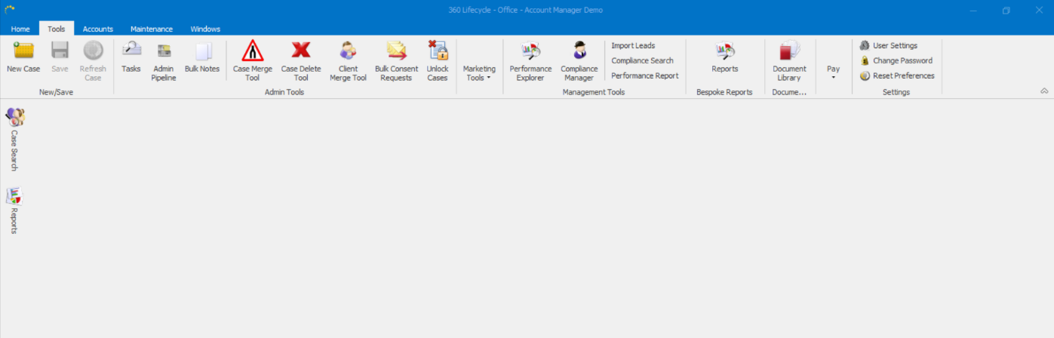

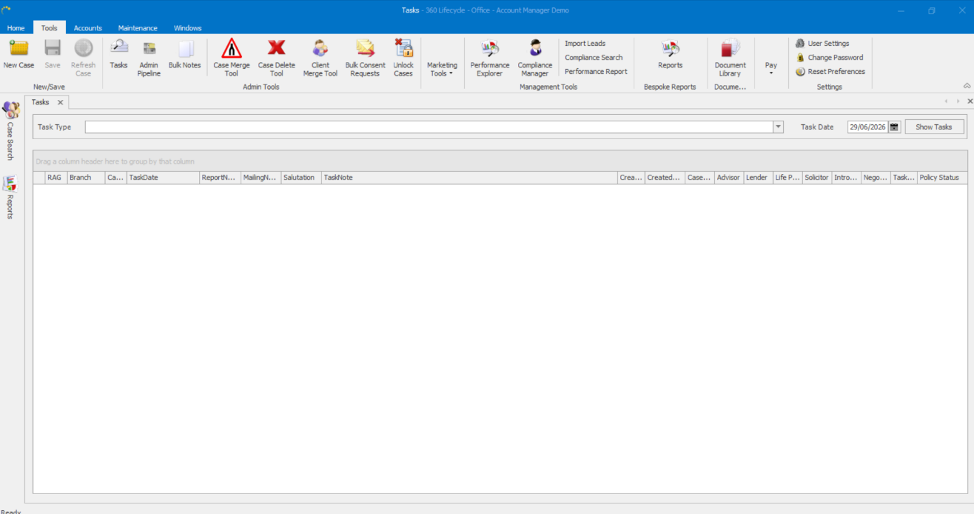
  - Changing Your Reported View
Please note that as per elsewhere within the system you can bespoke and amend your view of either Admin Pipeline Cases/Reviews or Tasks display by ‘right clicking’ on the columns and being presented with various options. This will allow
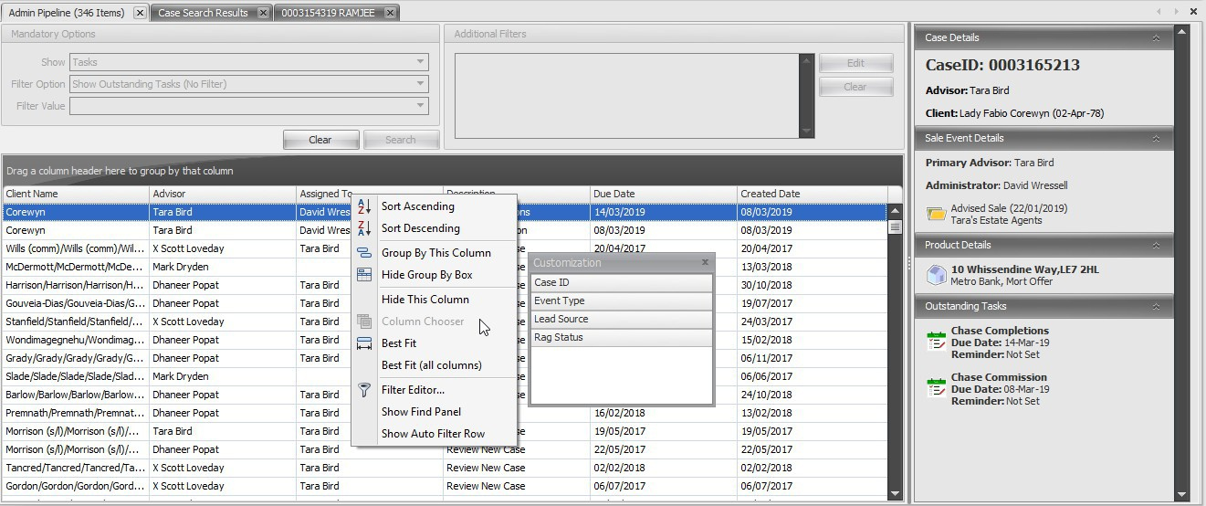

you to ‘Sort’, ‘Filter’ and add or remove the columns and information you are presented with, please see the below screenshot.

- CONFIGURING A WORKFLOW SCHEDULE
In 360 Lifecycle, you can configure ‘Workflow’ schedules, which will allow for tasks to ‘pop up’ based on your existing Post-Sale administration process.
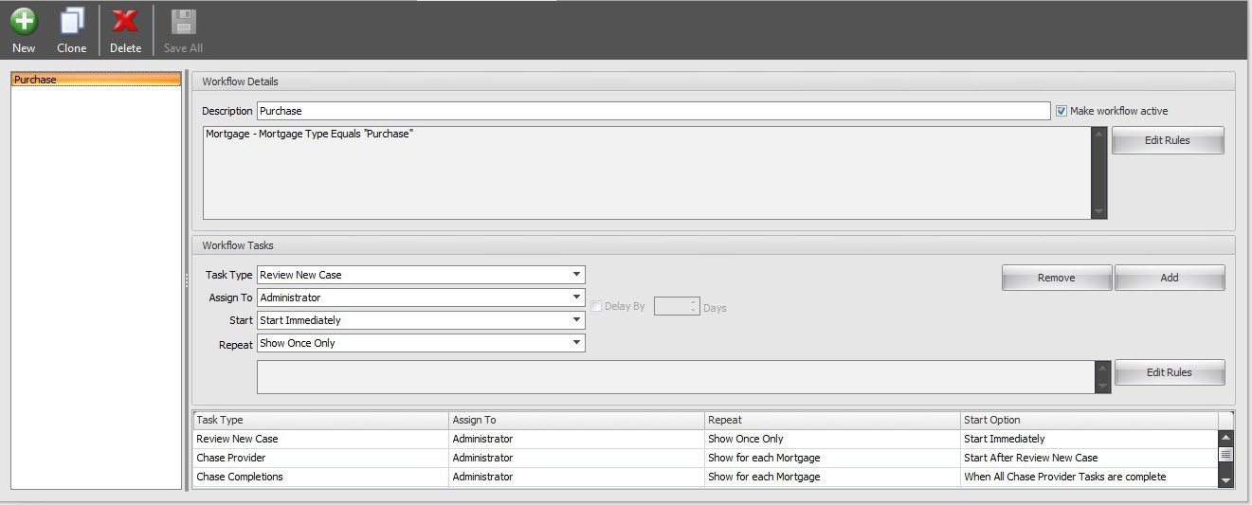
To access this configuration screen, go into 360 Office > Maintenance > General > Workflow > Workflow Configuration. You will be greeted with the below screen.

To add a new schedule, click ‘New’. This will open a blank screen allow for you to now configure your schedule.
The first thing you will need to do is name your schedule. This could be as generic as ‘Mortgage Workflow’, or you could delve deeper into this and call it ‘Residential Purchase with Halifax’.
To the right of this, you have an option to ‘Make Workflow Active’. This allows you to make changes to your scheduling without this affecting people using this in Case Records. Unticking this will prevent users selecting this Workflow.
You will then get the option to create ‘Rules’ for your Workflow schedule. These will assist in assigning your schedule to a Sale Event upon Submission of a FactFind and will look at the Submitted FactFind to confirm whether this Workflow is useable for this sale.
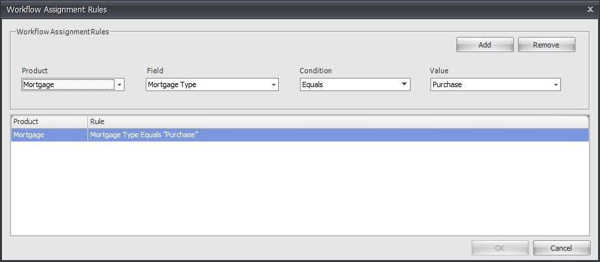

The ‘Product’ dropdown allows you to select different policy types, along with Case, Client and Sale details. The ‘Field’, ‘Condition’ and ‘Value’ dropdowns then will differ depending on the Product selected, until you have all fields filled in. Once completed, click ‘Add’, and then ‘Ok’ at the bottom of the window to save your rules.
Please note, if you have a FactFind submitted that fits multiple Workflows, you will have to select the relevant Workflow from the dropdown on the task screen.
From here, you can then build your schedule by adding tasks in to appear at certain points.
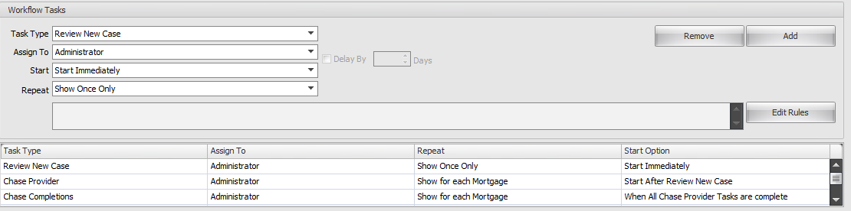
When you select ‘Add’, you will be able to fill in the following dropdowns:
- Task Type – this is the type of task being generated.
- Assign To – from here, you can select which user on a said Sale Event receives allocation of this task.
- Start – you can use this to schedule effectively. You will have the option to ‘Start Immediately’, i.e. allocation of the Workflow to the Sale, or after other tasks have been completed. If you prompt this to start after another task, you can tick a box on the right to ‘Delay’ this generating and input a number of days.

- Repeat – this will dictate how many times this task will show. For example, to Review the Sale, this would show once only. If you had multiple mortgages on a Sale, you can prompt a task to appear for each of these to manage the policies effectively.
You can also add rules to individual tasks if you need to, in the same way as you can with the Workflow schedule itself.
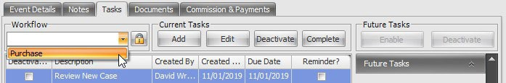
Once you have completed your schedule editing, click ‘Save All’ and this will save your changes. If you need to delete a Workflow at any point, click ‘Delete’, and if you want to replicate a Workflow but make some subtle changes, you can ‘Clone’ these which will create a duplicate for you to amend accordingly.

After a Workflow has been made ‘Active’, you can then select this within the ‘Tasks’ section of a Sale Event folder.
If you select this, your Workflow will then be implemented to that Sale. Please note, if you already have one selected, this will overwrite your existing tasks and replace these with those in the new schedule.
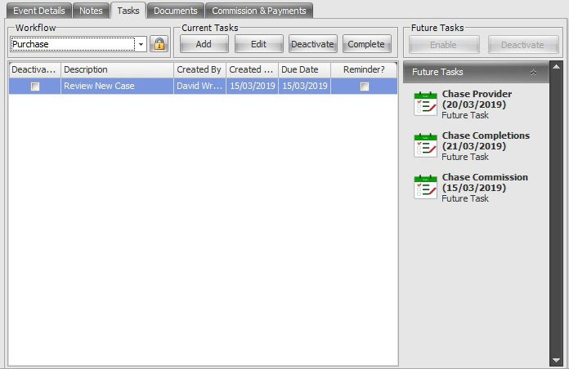
You should then see a screen like the below:

The tasks in the middle of the screen are your ‘Active Tasks’, and those in the right-hand tab are the ‘Future Tasks’ which are due to become Active after the completion of previous entries. If you want to bring these forwards, simply click on a future task and click ‘Enable’ above the list. If the task scheduled is no longer relevant, simply click ‘Deactivate’ and this will prevent it from appearing in the future. Otherwise, upon Completion of active tasks, these will then transfer into your Active Tasks list automatically.

- EVENT TRIGGERS
Event Triggers in 360 are a platform to prompt automation within your Sales Process. This may be an Email or SMS upon the booking of an Appointment, or a Task being created upon Submission of a FactFind.
To add these in, go to 360 Office > Maintenance > General > Common Settings > Event Triggers. You will see a screen like the below:
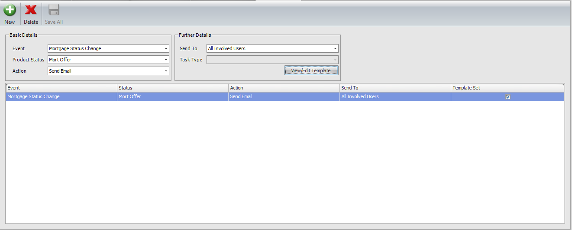
To add a new Event Trigger, click ‘New’ and this will open a new line in the trigger section.
You will need to select an ‘Event’, a ‘Product Status’ (if applicable) and an ‘Action’ that will be generated upon completion of the Event. These dropdowns will differ depending on the Event selected.
Depending on the Action selected, the ‘Further Details’ section will allow you to send templated Emails/SMS Messages to users on a Case Record or create a certain Task. If you are sending out automated content, you will have the ability to ‘View/Edit Template’ and add in several Merge Fields to pre-populated this. This can be directed to Clients on Status Changes if required and will pick up on the relevant owner(s) of the policy as to who to send this to.

Once you are happy with your Event Trigger, click ‘Save All’ and this will commit your changes. If you need to remove a Trigger, highlight the line you want to remove, and select ‘Delete’.

- MANUALLY ADDING A CASE INTO 360
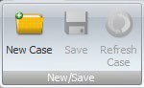
The below will show you how to manually add a client/case record for any new business which you have carried out for a client.
To add a case manually you need to be logged into 360 Office. Once logged in you will need to navigate to the Home tab, clicking on the ‘Add New Case’ icon.
This will bring up a screen where you will add routine client information:
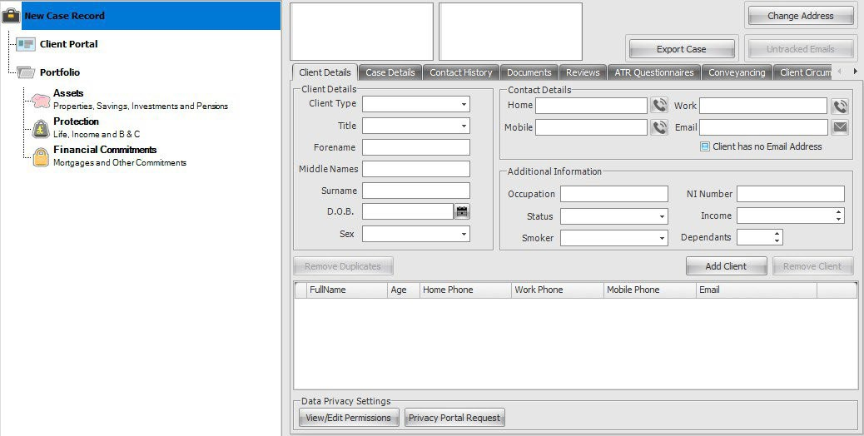
Populate the ‘Mailing Name’ and ‘Salutation’ fields by clicking on the ‘…’ buttons.
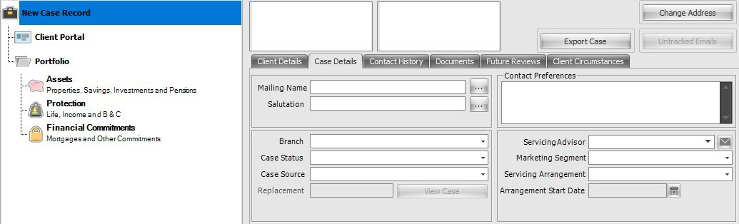

Enter in as much information that is asked as you can. To enter the address, click on the ‘Change Address’ button at the top right-hand section of the case screen.
The following box will appear:
Here all you need to add is the house or flat number in ‘Address Line 1’ along with the postcode. Click on ‘Find Address’ and the system will search and populate the rest of the address fields. Click ‘Ok’ and the address will populate the case record.
Once you are happy that you have entered in all information, click on the save icon underneath the home tab.

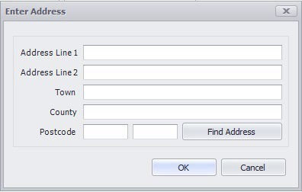

  - Adding more than one client
To add another client to the same case simply click on the ‘Add’ button underneath the email field. This will bring up a new blank record where you repeat the same steps you went through with the first client.
NB: Remember to update the ‘Salutation’ and ‘Mailing Name’ by clicking on the ‘…’ buttons. This will ensure that the case record is kept up to date but will also update the Portfolio Report (discussed further here) to reflect the additional client.
To remove a client, click on the ‘Remove’ button to the right of the ‘Add’ button remembering to click save. NB: You cannot remove a client if there is only one left on the case record.

Remember to click the ‘Save’ icon next to the ‘Add New Case’ icon to save your information and changes.

- ADDING A SALE EVENT
Once you have completed the above you will be able to add the sale event folder. It is here that you will save details of the advisor and administrator of the case along with details of the event type.
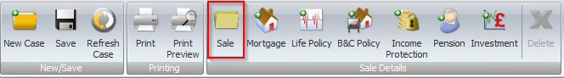
To add the sale folder, click on the ‘Sale’ icon. This will take you to the event screen.
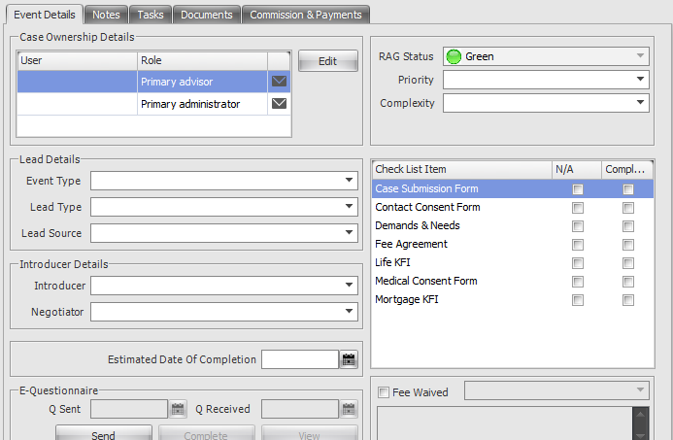

- Case Ownership Details refer to the Advisor responsible for the case.
- Primary Administrator is the administrator who handles the case. This may be the same person as the Advisor in some cases. You can have multiple Advisers and/or Administrators on these folders.
- Lead Details contains Event Type (e.g, Purchase, re-mortgage), Lead Type (e.g, Purchaser, Vendor, Applicant) and Lead Source (e.g, Website, Yellow pages).
- Introducer Details can be selected if the sale has been introduced to the advisor.
- RAG Status (Red Amber Green) indicates the urgency of the case.
- Priority is High, Medium or Low.
- Complexity is Simple or Complex.

- Check List is a tick list of what has been gathered for the sale so far.
- Fee Waived – tick this box if you have an agreement for this sale to be exempt from fees. Using the drop-down menu select the Manager who has authorized the exemption and then complete the text box with a reason for the exception.
- Estimated Date of Completion. Whilst this is simple to know for a re-mortgage, if at the time of creating the case you do not know an estimated date of completion it will need to be updated or filled in when known.
NB: Many fields trigger reports or reviews. E.G, when a date of completion is entered this will appear on the Completed Business Report.
  - Sale Details and History
When you click on the sale folder there are a number of tabs you can use: Event Details (which has been detailed on the previous pages), Notes, Reviews, Documents and Commission & Payments.
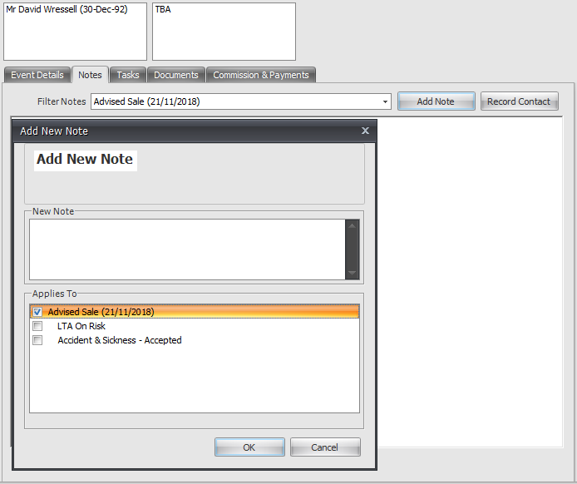
Notes are used as an audit trail/sequence of events for the sale within the case. They can be added at any time during the sale progression.

- Select the ‘Notes’ tab and click ‘Add Note’.
- Type the details of the note and check the relevant box(es) to which the note applies to, clicking the ‘OK’ button when you have done so.
- You can filter notes using the drop-down menu. Notes are also colour coded:Red=Mortgage, Green=Life, Purple=GI, Black=Pension, Investment and IP.

Documents are uploaded and saved to 360 Lifecycle System from your document folder. You can use the facility to scan documents to your computer and eliminate paper copies.
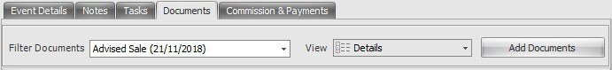

- Select the ‘Documents’ tab and select ‘Add Document’.
- Locate the document from your system.
- Click ‘OK’. Your document has now been uploaded.
- You can also upload documents in bulk. Simply select the documents you wish to upload and select ok as before.
For more information on adding documents please refer to the Adding Documents Section.
Commission and Payments can be added manually as shown below. They are updated automatically by the loading process used by accounts when payments are received and checked off against statements.
- Select the ‘Commission and Payments’ tab and click the ‘Add’ button.
- Select the ‘Commission Type’ from the drop-down menu and the ‘Amount Due’.
- Tick the appropriate event the commission belongs to (if you attach a commission to the sale event, e.g client review, this commission will not be shown in product specific commission reports, e.g a mortgage commission report. To achieve this,
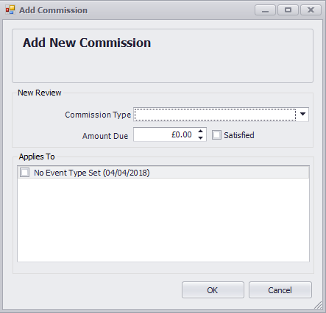
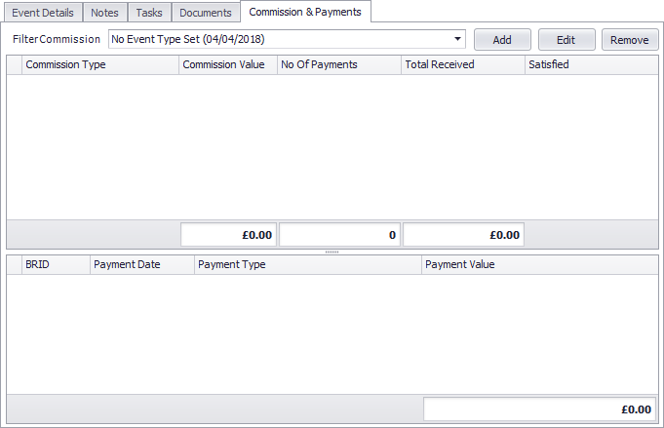
- you need to tick the box next to the mortgage product to pull over into the mortgage commission report.

- ADDING A MORTGAGE
Click on the ‘Mortgage’ icon. A product will fall in the case tree under the sale event folder and a mortgage detail screen will open for you to add the details. You need to have added a sale event to be able to add a mortgage. Please refer to adding a sale for a guide on how to do this.
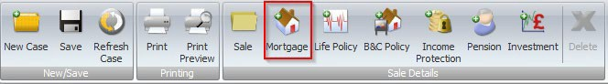
The ‘Advisor’ and ‘Referrer’ fields are automatically populated from the names selected in the sale event screen. You cannot edit these names from a mortgage screen, you will need to refer to the sale event screen and edit them from here.
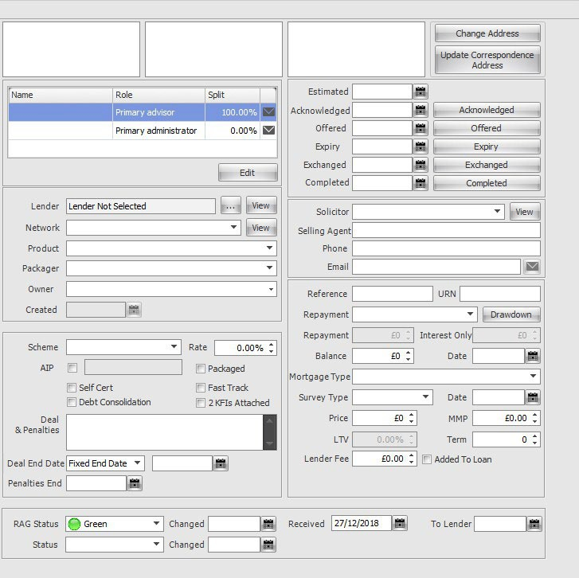
If there is a referrer for the sale you can edit the commission expectations by changing the percentages next to their name in the mortgage screen.

- Select ‘Lender’ by clicking on the ‘…’ button and selecting the appropriate option from the drop-down menus.
- Ensure ‘Network’ is correctly selected. This will assist accounts without any delay should there be any need to chase up payments.
- Select the ‘Product’ from the drop-down menu.
- Select the ‘Packager’ of the mortgage from the drop-down menu.
- Select the ‘Owner’ of the mortgage. This drop-down menu is populated from the clients entered and saved in the top-level part of the case record. The owner itself refers to the name(s) on the mortgage agreement.
- Select the ‘Scheme’ from the drop-down menu.
- Enter the interest ‘Rate’ as a percentage.
- Tick ‘AIP’ if the mortgage is agreed in principle and check the correct box for the type of mortgage it is.
- ‘Deal & Penalties’ can contain information regarding redemption penalties, how much and when.
- ‘Deal End Date’ is a dropdown field that can either be ‘Fixed End Date’, ‘Initial Period’ or ‘No End Date’. This will amend the next option accordingly between a date field, an option to input years and months, or remove it completely.
- ‘End Date’ and ‘Penalties End’ dates need to be entered when known, as these trigger the re-mortgage campaign report and activate Hotbox entries.
- Select the ‘RAG Status’ from the drop menu. This indicates the urgency of the case.
- Choose the ‘Status’ of the application, e.g ‘In Progress’ from the drop-down menu. It is important that you keep this status updated as the case progresses, so it appears on the relevant reports.
- Acknowledged/Offered/Exchanged/Completed. Enter the correct dates for the corresponding options. Once a Mortgage Sale has a completed date it will no longer appear in the Admin Pipeline. NB: The completed date on a mortgage will trigger the annual review of the case.
- You can enter the details of the solicitor (if there is one) using the drop-down menu to select the appropriate Solicitor company and filling in the ‘Selling Agent’ and their ‘Phone’ and ‘Email’.
- Complete the mortgage ‘Reference Number’ and the ‘URN’ (Unique Reference Number) if relevant.
- Select the method of ‘Repayment’ along with the ‘Repayment Amount’ (The whole amount the client has to pay back) as well as the ‘Mortgage and Survey Type’ e.g, ‘Full Structural, Basic, Home buyers.
- The ‘Balance’ is the amount left outstanding on the mortgage with the
- ‘Date’ field being the date that this figure was taken.
- Input the property ‘Price’ and the ‘LTV’ (Loan to Value ratio).
- Add in the ‘Terms, Lender Fee and MMP (Monthly Mortgage Payment). If the fee is to be added to the loan tick the ‘Added to Loan’ box.

To add the property the clients are purchasing (same procedure for re-mortgage) click on the ‘Change Address’ button at the top right of the screen and enter the address in the same way as their correspondence address. Once the case has been completed, click on ‘Update Correspondence Address’ button and this will automatically correct the system. On completion of the move, simply click on ‘Update Correspondence Address’ and this will notify the system where the client can be contacted. If it is a buy to let case, then you will not need to update the correspondence address.
- ADDING A BUILDINGS AND CONTENTS POLICY
To add a buildings and contents policy click on the ‘B&C’ icon under the home bar. To be able to add a buildings and contents policy you first will have needed to add the case record and the sale event folder. Please see above for a guide on how to do this.
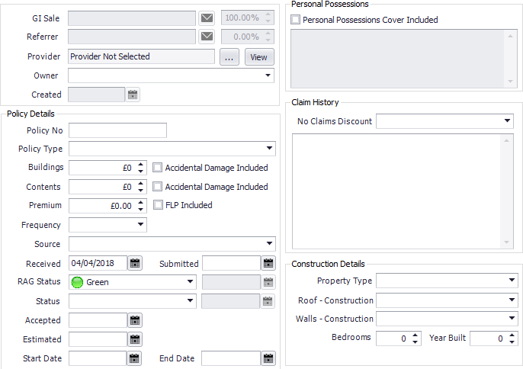
- The ‘GI Sale’ is the advisor selling the policy. This field is pre-populated by the advisor selected in the sale event folder. It is here that you can edit the advisor selected.
- Select the ‘Provider’ by clicking on the ‘…’ button.
- Select the ‘Owner’ of the policy (the client whose name is written on the terms of the buildings and contents policy) from the drop-down menu.
- Enter the ‘Policy No’ (if known)
- Select the ‘Policy Type’ from the drop-down menu.
- ‘Buildings’ and ‘Contents’ refers to the amount of cover given for each. In some cases, only one of these needs be filled in.
- Tick the boxes next to these fields if ‘Accidental Cover is Included’.
- Enter the ‘Premium’ the client is to pay each time, ticking the box if ‘FLP is Included’ in this.
- Select the ‘Source’ of the policy from the drop-down menu. E.g, is the property a main residence, or a buy to let, etc.
- The ‘Received Date’ is the date that … and the ‘Submitted Date’ is the date that the policy was submitted to the provider.
- ‘RAG Status’ indicates the urgency of the case with green being not urgent and red being extremely urgent.
- Select the ‘Status’ of the policy application from the drop-down menu. It is important that you keep this as up to date as possible so that the policy appears on the correct reports and in the correct categories in Performance Explorer.
- The ‘Accepted’ date is the date the provider accepted the policy. The ‘Start’ date is the date the policy goes live with the ‘End Date’ being the date the policy is due to expire.
- If the policy is a buy to let you may need to add a new address to reflect this. You can do so by clicking on the ‘Add Address’ button
- If ‘Personal Possessions Cover’ is included tick the check box and in the details box list any items the client has asked for in particular to be covered.
- Detail any information regarding claims in the ‘Claims History’ box
- Select the construction of the house using the drop-down menus.
- Remember to save the policy as you go to avoid any loss of details.

- ADDING A LIFE POLICY
To add a life policy, click on the Life Policy icon under the home tab. To be able to add a buildings and contents policy you first will have needed to add the case record and the sale event folder. Please see above for a guide on how to do this.
Once you have clicked on the icon a screen will appear for you to add the relevant details.
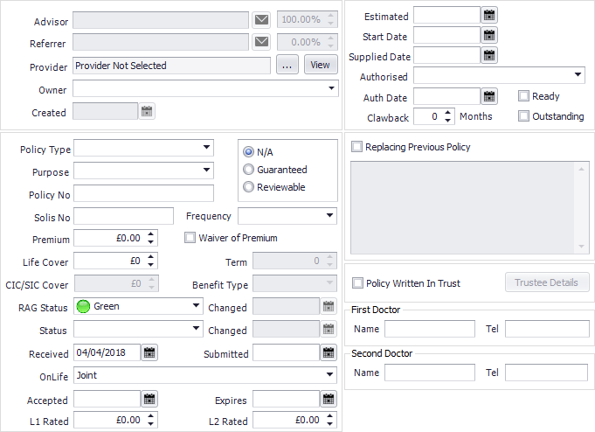
- The ‘Advisor’ and ‘Referrer’ fields are prepopulated from the details entered and selected in the sale event part of the case record. It is here that you will need to change or amend any details.
- Select the ‘Provider’ of the policy by clicking on the ‘…’ button.
- Select the ‘Owner’ of the policy (the name of the client taking out the policy
- Select the ‘Policy Type’ from the drop-down menu.
- Select the ‘Purpose’ of the life policy from the drop-down menu.
- If applicable enter the ‘Solis Number’.
- Select the ‘Premium’ the client is to pay choosing the ‘Frequency’ from the drop-down menu.
- Enter the ‘Sum Assured’. This is the whole amount the client is covered by.
- Depending on the type of the policy you may need to enter a term. You can do this by selecting the ‘Term’ from the drop-down menu.
- Select the ‘RAG Status’. By default, the system puts this as green, but you
- may need to change it.
- Select the ‘Status’ of the application. It is important that you keep this as up to date as possible, so it appears on the correct reports and in the correct columns in performance explorer.
- The ‘Received Date’ is the date that the client first came to you.
- The ‘Submitted’ date is the date you have submitted the policy application to the provider.
- Select the ‘OnLife’ from the drop-down menu. This refers to the clients who are covered by this policy.
- If the policy has been rated, you will need to enter the extra premium that the policy has been rated by within ‘L1/L2 Rated’. This can be done for either client. Please ensure that the premium and relevant commissions are updated.
- The ‘Accepted’ date is the date the policy is accepted by the provider and the ‘Expires’ date is when the acceptance terms for the policy may expire.
- The ‘Start Date’ is the date the policy is due to go live.
- Select from the ‘Authorised’ drop-down menu.
- Enter the ‘Auth Date’ along with the ‘Clawback Period’.
- Tick the box for replacing previous policy if it is relevant with a brief explanation along with the policy number of the plan which needs to be cancelled.
- Tick the box if the policy is written ‘In Trust’, filling in the ‘Trustee Details’.
- If this is a first policy, then the doctor’s details need to be entered.

- ADDING AN INCOME PROTECTION POLICY
To add an income protection policy, click on the ‘Income Protection’ icon under the home tab. This will bring up a screen for you to enter the details of the policy.
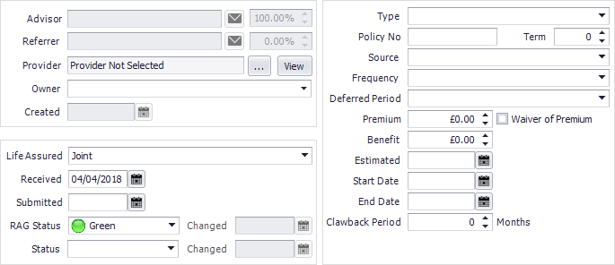

- The ‘Advisor’ and ‘Referrer’ fields are prepopulated from the details selected and saved in the sale event part of the case record.
- Select the ‘Provider’ from the drop-down menu.
- Select the ‘Owner’ of the policy from the drop-down menu. This is prepopulated from the clients you have entered and saved at the top-level part of the case record. The owner here is referring to the name written on the policy terms.
- Select the ‘Life Assured’. This refers to the clients who are to be protected by this policy.
- Enter the ‘Received Date’ (the date the clients came to you to take out the policy)
- The ‘Submitted Date’ is the date you sent the application to the provider.
- ‘RAG Status’ indicates the urgency of the case, green being that the case is progressing in good time, red being that the case needs to be pushed through quickly.
- Select the ‘Status’ of the application. It is important that you keep updating this as the policy progresses so that it appears in the correct reports and in the correct fields in performance explorer, etc.
- Select the policy ‘Type’ from the drop-down menu.
- Enter the ‘Policy Number’ along with the ‘Term’ of the policy in years.
- Select the ‘Source’ of the policy from the drop-down menu.
- Select the ‘Frequency’ of the premium from the drop-down menu.
- If there is a deferred period, you can specify this using the options in the drop-down menu.
- Enter the ‘Premium’ the client is to pay to keep this policy.
- If ‘Waiver of Premium’ is included, please tick this box.
- For any ‘Benefits’ you can add this as an amount in the benefit field
- The ‘Start Date’ is the date the policy goes live and the ‘End Date’ is the date that the policy will expire. It is important that these dates are entered as they trigger the reviews for the case.

- ADDING A PENSION
To add a pension policy, click on the Pension icon under the home tab. This will bring up a screen for you to enter the policy details.
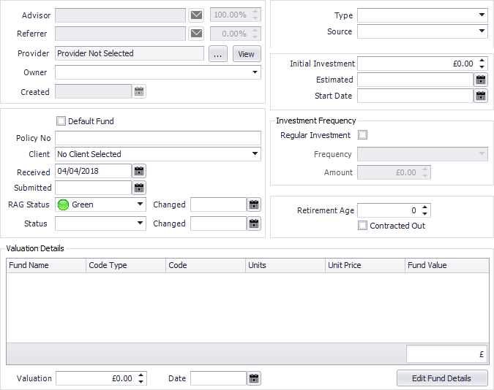

- The ‘Advisor’ and ‘Referrer’ fields are prepopulated from the names you have selected in the sale event folder of the case record. It is here that you can make any amendments to the names entered.
- Select the ‘Provider’ of the policy by clicking on the ‘…’ button.
- Select the ‘Owner’ (the client whose name the policy is in) from the drop-down menu. This field is populated by the clients you have entered in the top-level part of the case record.
- Enter the ‘Policy Number’ in the field provided.
- Select the ‘Client(s)’ who the pension is to cover.
- The ‘Received Date’ is the date that the clients came to you to start their pension application.
- The ‘Submitted’ date is the date you submitted the policy to the provider.
- ‘RAG Status’ indicates the urgency of the case, green being that the case is progressing in good time, red being that the case needs to be pushed through quickly.
- Select the ‘Status’ of the policy. It is important that you keep this status updated as the case progresses so that it appears on the relevant reports and in the correct columns in performance explorer.
- Select the ‘Type’ of the pension from the drop-down menu.
- Select the ‘Source’ of the pension (why has the client(s) come to you wishing for a pension? Is it a new pension, a pension transfer, etc.)
- Input the ‘Initial Investment’ of the pension
- The ‘Start Date’ is the date the pension goes live. It is important that this date is entered as it triggers reviews of the policy in the future to fall into your Hotbox.
- If the pension is to be ‘Regularly Invested’ into tick the box, selecting the ‘Frequency’ from the drop-down menu along with the ‘Amount’ that is paid per time.
- If you need to enter any valuation details you can do so by entering the ‘Valuation’ (how much is held in the pension) along with the ‘Valuation Date’ (the date that this figure was taken)
- Enter the ‘Retirement Age’ (the age that the client wishes to retire)
- The ‘Fund Details’ area allows you to add in any funds the client currently possesses.
- Remember to save your progress.
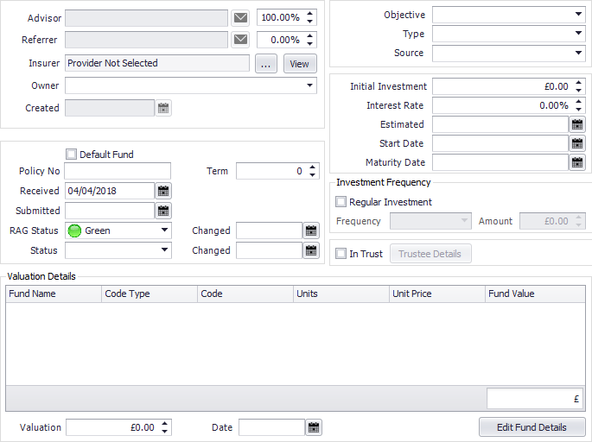
- ADDING AN INVESTMENT POLICY

- To add an investment policy, click on the investment icon under the home tab. This will bring up a screen for you to enter the policy details.
- The ‘Advisor’ and ‘Referrer’ fields are prepopulated from the names you have selected in the sale event folder of the case record. It is here that you can make any amendments to the names entered.
- Select the ‘Insurer’ by clicking on the ‘…’ button.
- Select the ‘Owner’ of the policy from the drop-down menu. This is the client(s) whose name is written on the policy terms.
- Tick the box if the policy is the ‘Default Fund’.
- Enter the ‘Policy Number’ along with the ‘Term’ of the policy.
- The ‘Received’ date is the date the clients have come to you wishing to take out this policy.
- The ‘Submitted’ date is the date you have sent the policy application to the provider/insurer.
- ‘RAG Status’ indicates the urgency of the case, green being that the case is progressing in good time, red being that the case needs to be pushed through quickly.
- Select the ‘Status’ of the application from the drop-down menu. It is
- important that you keep this field updated as the case progresses so that it appears in the correct reports and the correct performance explorer fields.
- Select the ‘Objective’ of the investment from the drop-down menu.
- Select the ‘Type’ of investment.
- Select the ‘Source’ of the investment. Why has the client come to you wishing for an investment? Is it a new investment? Is it a change of agency?
- Enter the amount of the ‘Initial Investment’ along with the ‘Interest Rate’.
- Enter the ‘Start Date’ (the date the policy goes live)
- Enter the ‘Maturity Date’
- If the investment is regularly added to tick the ‘Regular Investment’ box, along with the ‘Frequency’ of the payments and the payment ‘Amount’ that is added each time.
- The ‘Fund Details’ area allows you to add in any funds the client currently possesses.
- If the investment has been valued, you can enter the details in the ‘Valuation Details’ section of the policy record.

- DELETING
There are two delete buttons in 360 Office. One is for deleting specific case policies and one is for deleting entire case records. We strongly recommend that you are careful using the following tools. Accidental deletion is both time consuming and costly which is why being able to delete is permission based.
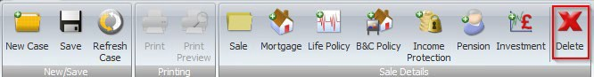
  - Deleting Sale Events/Products

To delete a sale event, you need to have open the case record. Make sure that you have selected the correct policy to delete. Click on the ‘Delete’ button located under the home tab.
When you have selected the policy, a dotted square will appear around it. Click the
‘Delete’ button indicated above.

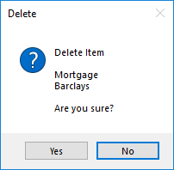
A prompt will appear asking you to confirm your deletion.

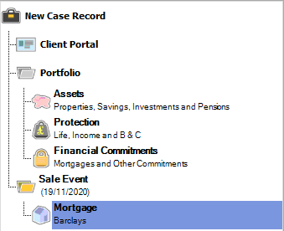
Once you have clicked yes remember to save the deletion. If you are wishing to delete a sale event folder you do so using the same steps as above but be aware that deleting a sale folder will delete all the policies attached to that sale event.

  - Deleting a Case Record
To delete a whole case record you need to log into 360 Office and select ‘Case Delete Tool’ under the Tools menu. Please note you may not have the ‘Case Delete Tool’ option as this is permission based. If not please speak to your system administrator.

Selecting ‘Case Delete Tool’ will bring up the Case Delete Toolbox.
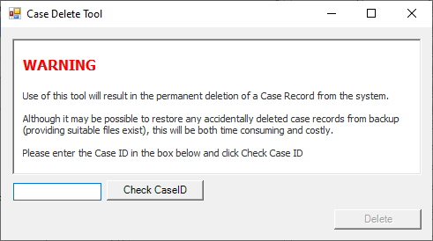

Simply enter the CaseID of the record you wish to delete into the field and select ‘check CaseID’. Once you are happy that the correct case is selected for deletion select ‘Delete’.
- CASE MERGE
The ‘Case Merge Tool’ can be found within ‘Tools’ in 360 Office. This allows you to merge multiple cases together where the client(s) exist on more than one case. If duplicate clients have been created for any reason, through Case Merge you can create one record with all your client information within and resulting in no loss of data.

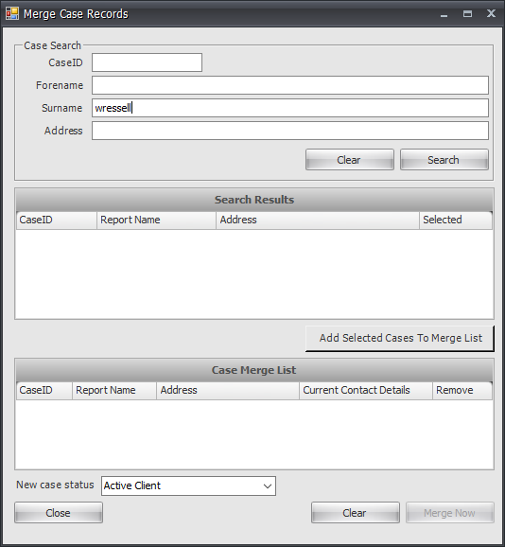
  - How to use the Case Merge Tool
- Open both cases which you would like to merge by simply searching for the cases and select the case.

- Go to ‘Tools’ within the tabs at the top, then click on ‘Case Merge Tool’ and the screen below will appear.

- Enter the ‘Case ID, Forename, Surname or Address’ within the ‘Case Search’ Section and click on ‘Search’ button, then the case will be displayed in the ‘Search Results’ section as displayed on the next page.

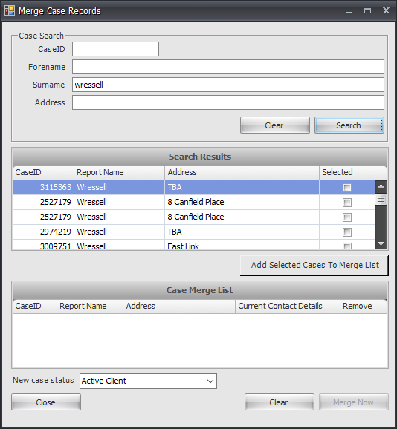
- Tick the ‘Selected’ tick box and click on ‘Add Selected Cases to Merge List’, then click on ‘Clear’ button and enter the other ‘Case ID, Forename, Surname or Address’ within the ‘Case Search’ Section again.

- Click on ‘Search’ button, then the case will be displayed in the ‘Search Results’ section as displayed above and tick the ‘Selected’ tick box and click on ‘Add Selected Cases to Merge List’ and both cases will be displayed in the ‘Case Merge List’ section as shown below.

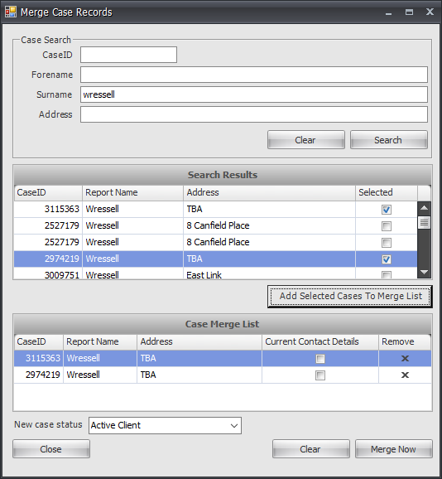
- Tick the case you would like to keep the contact details for by ticking on ‘Current Contact Details’ tick box as shown on the next page.

- Once happy with the cases you wish to merge select ‘Merge Now’. Cases will be automatically deleted when the new case record is created.

Information Classification Procedure
Document Classification | Public
Document Ref | ISMS-SD27-A05-12-01
Version | 1
Dated | 29 June 2026

