
Staff Member Maintenance Training Manual

Contents
1. Introduction 3
2. Getting Started 3
2.1 User Details 5
2.2 Allocating Roles 7
2.3 Allocating Client Access Permissions 9
2.4 User Access Groups 10
2.5 Diary Views 11
2.6 Allocating Final Permissions 12
2.7 Diary Permissions 13
2.8 Refer & Transfer 15

- Introduction
The object of this manual is to provide you with the necessary navigational support in order for you to efficiently set up a new staff member on 360 Lifecycle.
This manual will show you how to set up a new staff member tailoring this to ensure they have the correct access to specific areas within 360 Lifecycle depending on their role within the business. This will also allow you to set up diary and Hotbox access, access to specific advisers clients, refer and transfer permissions along with setting a default administrator to ensure that all sales added to 360 Lifecycle are dropped straight into an administrators Admin Pipeline to start work on immediately.
The guide will also clarify what each particular role within 360 Lifecycle does ensuring that you are giving the correct roles to staff members.
Please note that adding a new staff member or making changes to existing staff records may impact your 360 licensing agreement and future invoicing. Please check with 360 Support or your Account Manager if you are unsure.
- Getting Started
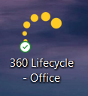
Please note that anyone accessing ‘Maintenance’ will themselves need the role of ‘System Administrator’. The following process assumes you have an internet connection and are working in connected mode.
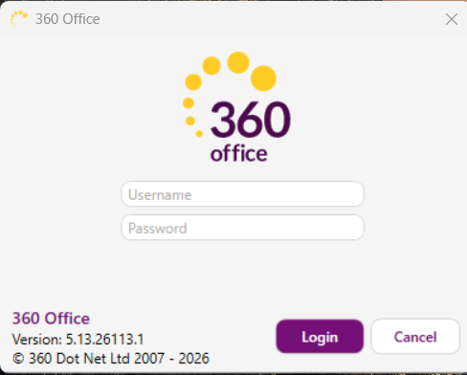
Enter your Username and Password and click Login.

Once 360 Lifecycle has opened, click onto the ‘Maintenance’ tab to access.
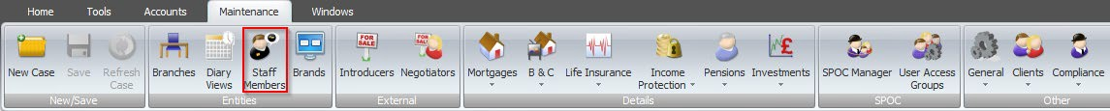
Then click onto the ‘Staff Member’ tab to open the relevant screen.
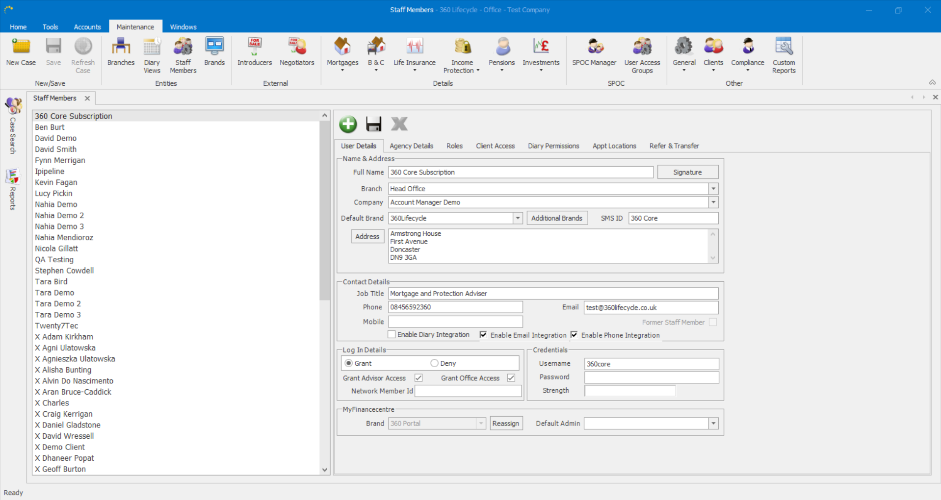
You will then see a list of the existing staff members appear on the left-hand side of the screen along with their details on the right-hand side.
You can begin adding your staff member by clicking on the ‘Add’ button as shown below:
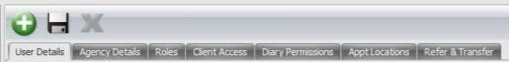

  - User Details
Complete ALL fields on this page choosing from drop down options where these are available.
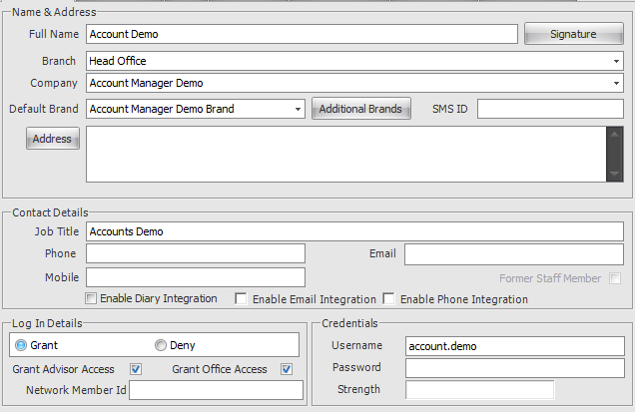
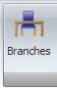
    - Full Name: This is a mandatory field
    - Branch: If the branch that you require is not showing in the drop-down box, you can add additional branches by clicking on the ‘Brach’ option within Maintenance. Then click onto the ‘Add New’ button to add the relevant branch and click ‘Save’.
    - Company: If the company that you require is not showing in the drop-down box, please contact us and we can arrange for this to be added for you.
    - Branding: Your business’ logos will have been added to your database by 360 Lifecycle. From the ‘Branding’ drop down, you can now choose the branding relevant to the staff member (if applicable).
    - SMS ID: Maximum of 11 characters and would usually be your company name (or abbreviated company name) depending on the number of characters. This will show on a client’s mobile when an SMS is sent directly from their client record within 360.
    - Job Title: This is a mandatory field.
    - Contact Numbers & Email Addresses: These are recommended fields.
    - Enable Diary Integration: If you are enabling diary integration for any staff member, you will need to ensure that their email address which corresponds with their chosen external diary in which they wish to integrate with is entered in the ‘Email’ field.
    - Enable Email Integration: This links your email address in order that any emails sent directly from a client record within 360 are audited and email replies from a client are received and tracked back to the client record
You will be required to create a Username and Password i.e.
USERNAME: James
PASSWORD: 5@nt@nder123
If you have added a ‘poor’ password, you will not be able to save and proceed. The password needs to be ‘Medium’ or ‘Secure’ strength password to enable you to be able to save the staff member record accordingly. Therefore, we would recommend adding in symbols and numbers to ensure the password is as strong as possible.
You will then be required to grant Office and Advisor access by ticking both boxes which will then make available more tabs to complete the staff member set up.
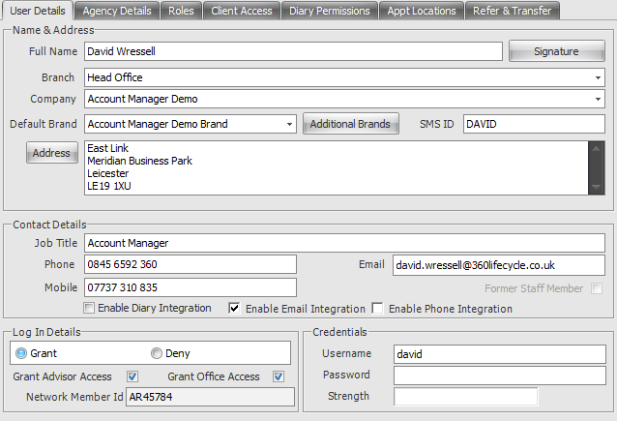
Below is an example of a completed ‘User Details’ screen:

Please note: The Intrinsic RI ID is only for Intrinsic members and will facilitate the integration with Point of Sale.
  - Allocating Roles
This area as shown below allows you to set roles to enable a staff member access to specific areas of 360 Lifecycle. You can choose and tick multiple roles.
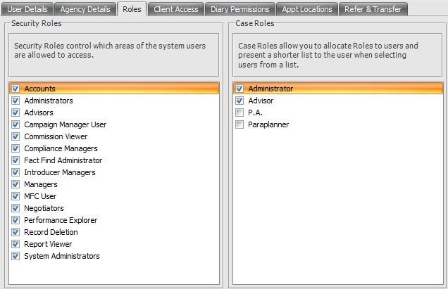
Please find below a list of how each role works within 360 Lifecycle:
- Accounts: Access to the Accounts module, ability to set & view account related information across the whole database.
- Administrators: Access to Admin Pipeline, Reviews, Case Merge Tool, Case Delete Tool. Does not give access to Hotbox or ability to add appointments and opportunities. Also able to access Compliance Manager.
- Advisors: Access to all diary functionalities, all Hotbox functionalities (apart from Refer & Transfer permissions which are permission based), Case Build Functions. Also able to access Compliance Manager.
- Campaign Manager: Provides access to the Campaign Manager query builder tool and allows the user to create campaigns to send out to clients.
- Commission Viewer: Ability to view and set commission expectations within a case record.
- Compliance Manager: Gives user access to SPOC Manager and all items under the Compliance icon in the Maintenance tab.
- Introducers/Negotiators: Gives access to the Introducer/Negotiator maintenance tools.
- Managers: Managers can access Performance Explorer based on Client Access permissions and set/amend Performance Explorer targets. Managers also provide access to certain Maintenance functions, e.g. adding branches, organising diary views, adding/editing staff members as well as setting up user access groups and adding/editing introducers and negotiators. Does not give permissions to access – Letter/Email templates, servicing arrangement setup, and other options in the ‘General’ drop down under the maintenance tab. (As a personal note, I have found that this role is best along System Admin).
- MFC: Only applicable to ‘MFC’ Client Portal users
- Performance Explorer: Provides access to the Office Performance Explorer module only and is based on Client Access permissions.
- Record Deletion: This provides access for users to delete entire Case Records.
- Report Viewers: Provides the ability to access reporting with ‘Filter’ options based on client access permissions set against the Staff Member record.
- System Administrators: Allows access to the whole of the system both in advisor and office allowing the user to set up new accounts, grant permissions, set up user roles, etc. Provides access to amend System Maintenance areas such as Staff Members and adding providers etc. Can access all items in Maintenance tab.
Below is a typical example of an Adviser’s roles given on 360 Lifecycle:
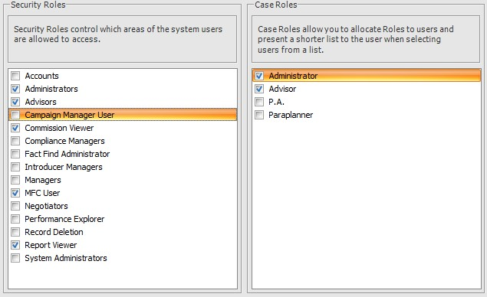
Please note, the ‘Case Roles’ are used to shorten the relevant lists in the system, primarily found in ‘Case Ownership Details’.
  - Allocating Client Access Permissions
Once you have chosen the relevant roles, you will now be required to add in the new users ‘Client Access’ by ticking the relevant staff members name as shown below.
This determines which adviser’s clients the staff member is able to view within 360.
** Please note that for the purposes of referrals in 360 a staff member does NOT need access to another advisers clients as this gives them access to ALL of said adviser’s clients within 360. Once a sales opportunity if referred from one Hotbox to another, this automatically gives the receiving adviser access to that particular client **
*** Usually, an adviser would only have access to their own clients within 360 Lifecycle ***
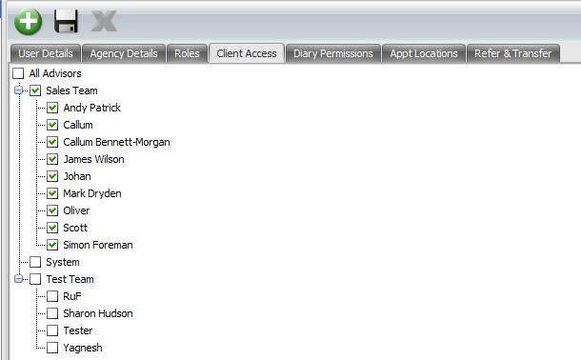
**** Please note that at this stage you may not see your new staff members name appear in the hierarchy as shown above. This is due to the new staff member (Advisers Only) needing to be added to the hierarchy in ‘User Access Groups’ ****
At this point you can give temporary access to another staff members clients until you have added the new staff member to the hierarchy. This can then be removed later on in the process ensuring that the new staff member has the correct client access.
If the new staff members role is anything other than an adviser then that staff member will NOT need to be added to the hierarchy and you can give them the relevant client access as normal.
You can save your changes as you go along by clicking on the ‘Save’ option as shown above.
** You will now add your staff member to ‘User Access Groups’ and the ‘Diary Views’ before proceeding any further **
  - User Access Groups
Continuing within ‘Maintenance’ please click on ‘User Access Groups’

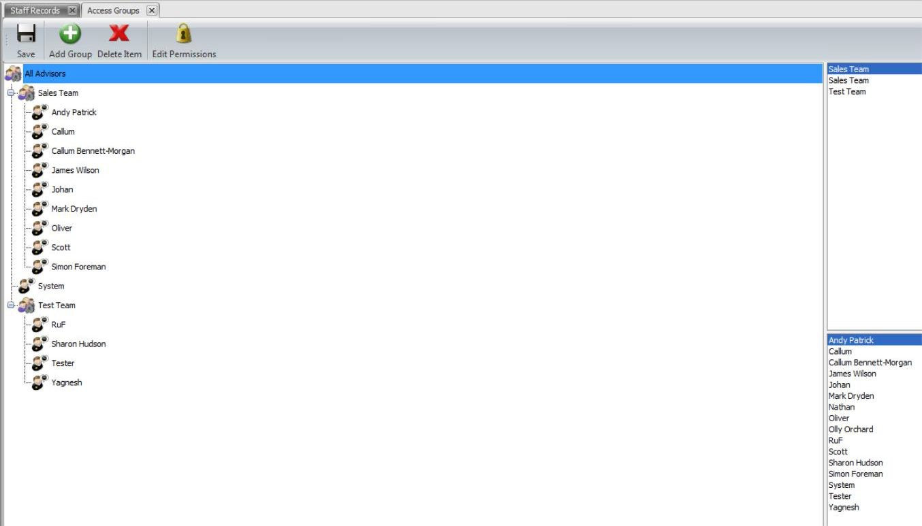
You can now see the hierarchy of the business on the left-hand side of the screen. These will have been grouped by certain teams within the business i.e. Sales Team, Management Team or Entire Group etc.

At the top right-hand side, you will see any groups currently set up and at the bottom right-hand side will be your staff member list.
From the list of staff members, you will find your newly added staff member which you can now highlight and ‘drag & drop’ across to the relevant group within the hierarchy on the left-hand side.

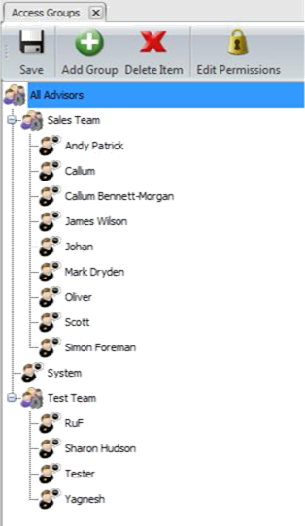
Now click the ‘Save’ button to ensure your changes are saved and click back into ‘Staff Members’ and locate your staff member to continue the process.
** If you are setting your hierarchy up from scratch then please follow the steps below **
Within ‘User Access Groups’ click ‘Add Group’ and name your group accordingly i.e. Sales Team, Management, Entire Group etc and click ‘Ok’.
Your newly added group will appear in the list at the top right corner of the screen. This will then need to be highlighted, dragged & dropped across to the left-hand side of the screen to start building your hierarchy.
From the staff member list at the bottom right of the screen, highlight, drag & drop your staff member across to the group you have just added and click ‘Save’.

  - Diary Views
Continuing within ‘Maintenance’ please click into ‘Diary Views’
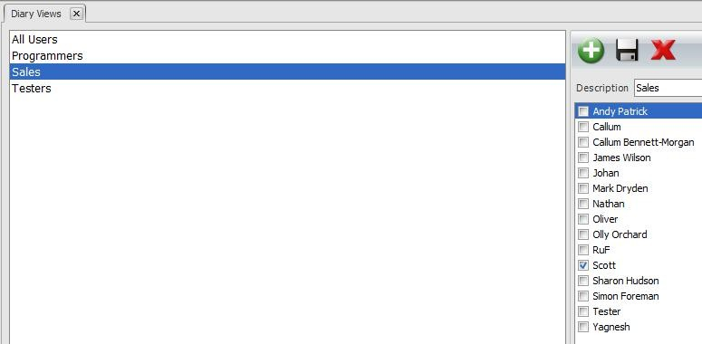
You will see a list of existing diary groups on the left-hand side of your screen. You will need to click on the relevant diary group to which you are adding your new staff member and on the right-hand side of the screen, the staff member list will

appear where you can now tick against your new staff member to add them to the diary group and click ‘Save’.
** If you are setting your diary group up from scratch then please follow the steps below **
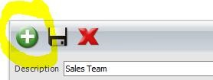
Within ‘Diary Views’ click on the ‘Add’ button and name your diary group i.e. ‘Sales Team’ as shown.

Your newly added diary group will appear on the left-hand side of the screen which you can then click on and tick the newly added staff member and then click ‘Save’.
Once your staff member has been added to the correct diary group you will then need to go back into ‘Staff Members’ to complete set up of your staff member.
  - Allocating Final Permissions
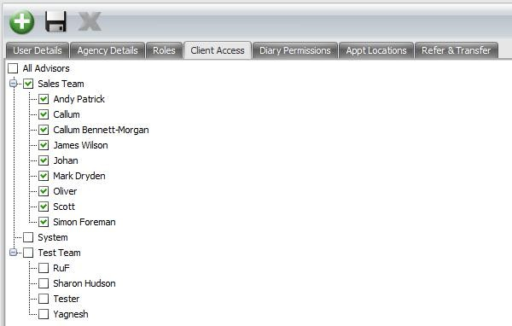
Please now click onto the ‘Client Access’ tab and tick on the relevant staff member’s name to add the correct client access.

Please note that should you wish to create a diary view for a single person rather than a user being created within a diary group, you would be required to add the diary view as that particular users name which will appear on the left hand side of the screen. You would then need to tick the relevant users name in the list on the right-hand side of the screen. Please see below as an example:
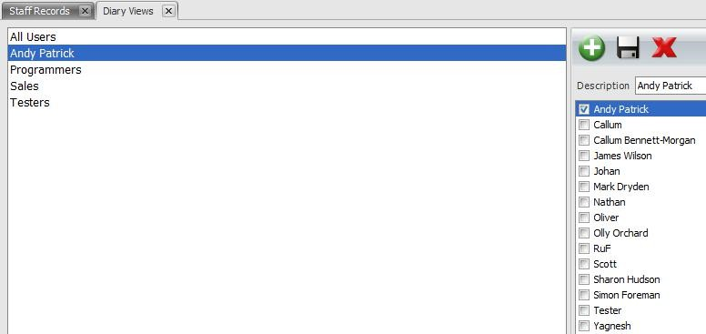
  - Diary Permissions
Next, click onto the ‘Diary Permissions’ tab as shown below:
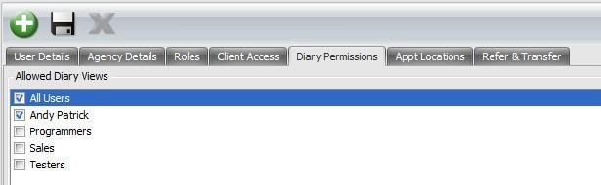

Select which diary groups you would like your new staff member to be able to view within 360 Lifecycle Advisor. For example, if you were setting up an Adviser they would usually be set up within the ‘Sales Team’ diary group and only have access to the ‘Sales Team’ diary. This will enable them to view the whole of the Sales Teams diaries mainly for referral purposes.
Please note that a user can have access to multiple diary views if required.
Once you have chosen the required diary group, at the bottom of the screen you can now set the default view which will list the diary group as ticked above and you can then choose the default diary view which will be the diary your new staff member sees when logging into 360 Lifecycle Advisor.
The ‘Default Administrator’ option would be selected if an Adviser has an Administrator or PA who progresses their cases post sale on their behalf. By choosing the default administrator this ensures that when a sale is added to 360, the case will drop straight into the administrators Admin Pipeline for them to start progressing the case.
Click ‘Save’ to save your progress so far.
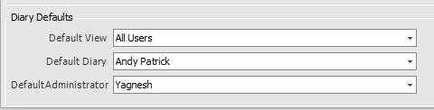

  - Refer & Transfer
Finally, click onto the ‘Refer & Transfer’ tab.
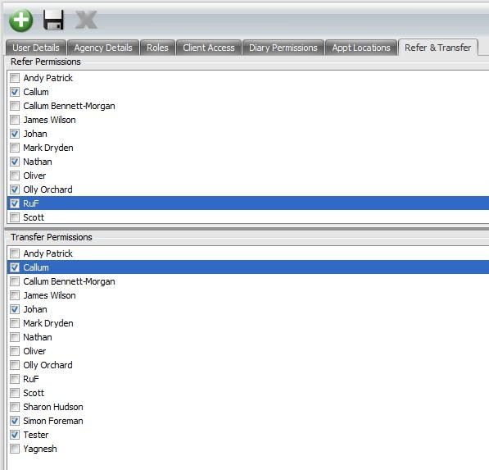
Within this area there are 2 sections – Refer Permissions and Transfer Permissions. This does not have to be completed if not required.
You can choose (If applicable) who your new staff member has permission to refer or transfer any sales opportunities to from within their Hotbox.
Refer: This enables the ability for advisers to refer sales opportunities from one Hotbox to another advisers Hotbox ensuring that the client receives the best possible service and advice in all areas of financial services. By referring any sales opportunities this ensure that the servicing adviser still retains their client and

remains their servicing adviser and can track any referrals via the Hotbox.
Transfer: Once a sales opportunity is transferred, this action will physically transfer away the client record to another adviser, changing the servicing adviser on the case record to ensure that all future sales opportunities now go into the newly stated advisers Hotbox.
** Please only give transfer permissions if absolutely necessary ** Click ‘Save’.
This now completes the set-up process and your new staff member should be able to log into 360 Lifecycle with their new credentials.

Information Classification Procedure
Document Classification | Public
Document Ref | ISMS-SD27-A05-12-01
Version | 1
Dated | 29 June 2026

