
Recommendation Report Editor Guide

Contents
1. ACCESSING THE TEMPLATE EDITOR 3
2. Template Editing Screen 4
3. Editing your layout 4
4. Adding and/or editing a paragraph 5
5. Adding Merge Fields 7
6. Adding/Editing/Removing Conditions 8
7. Sharing your template 9

As a result of completing the 360 Lifecycle Online FactFind, you also get the functionality allowing you to create a ‘Recommendation Report’. You will be able to use a stock template of this report for you to use, which is pre-built for you upon onboarding, however this guide is entailed to assist you with setting up, or amending and maintaining your own template.
- Accessing The Template Editor
To access the Report Template Editor, you will need to be logged into 360 Lifecycle Office. From here, select the Maintenance Tab, locate the Compliance button, and select ‘Setup Recommendation Report’ from the list that appears. When you hover over this, it will show you a selection of options, the defaults of which are found below:
- Online FactFind*
- Mortgage Advice
- Mortgage Only
- Protection Only
- Building & Contents Only
*this template is referring to the old Template Editor, the guide to which can be found in the Online FactFind Manual.
The list above is driven by the number of unique FactFind configurations you have created, which can be managed within the Compliance tab also. For more guidance on amending these, please refer to the Online FactFind Manual.
To open the Editor, simply click on the required FactFind, and this will open a new screen, as per the below.
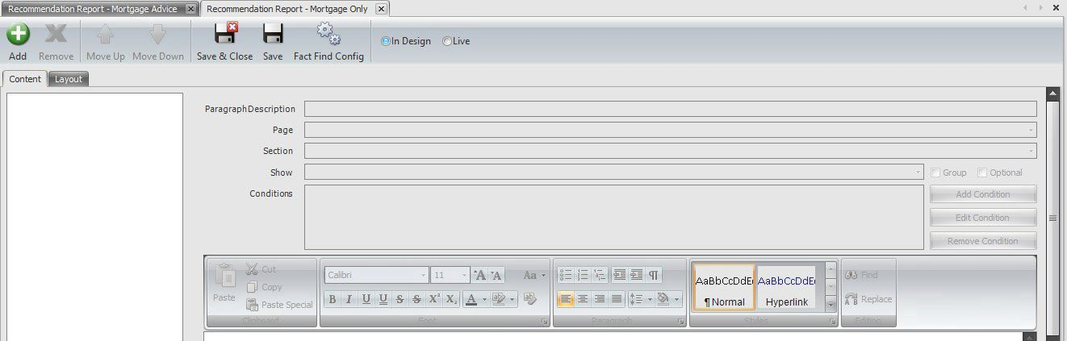

- Template Editing Screen
From this screen, there are a selection of buttons you can click, all of which have different functions which are outlined below.
Add – noted by the Green Plus button, this will allow you to add in a new paragraph into the template.
Remove – noted by the ‘X’ button, this will allow you to remove the highlighted paragraph.
Move Up/Move Down – noted by the upward and downward facing arrows, these options will move a paragraph up or down in the template itself, if this needs to appear earlier or later on in the report.
Save & Close – noted by the floppy disc icon with the ‘X’ overlaid, this will save any progress you have made on the template and cross the screen.
Save – noted by the floppy disc icon, this will save any progress on the template but leave the window open.
FactFind Config – noted by the two cogs, this will open up the FactFind Configuration page, allowing you to make required changes to your FactFind setup.
In Design/Live – noted by the two radio buttons above, this will allow the visibility of the report template after completing a FactFind. If this is set to ‘In Design’, no one will be able to use this template upon FactFind completion. If set to ‘Live’, then this can be used by anyone submitting a FactFind of the same configuration, i.e. Mortgage Only.
Underneath this ribbon, you have the option of two further tabs, ‘Content’ and ‘Layout’. The ‘Content’ tab will include all text from the template and will be the main area where editing will take place. The ‘Layout’ tab is where you will find the option to amend any margins on the template, along with the ability to add Header and Footer images and/or texts for any number of trading styles you have within your business.

- Editing your layout
When you click on the ‘Layout’ button, you will see the screen below.
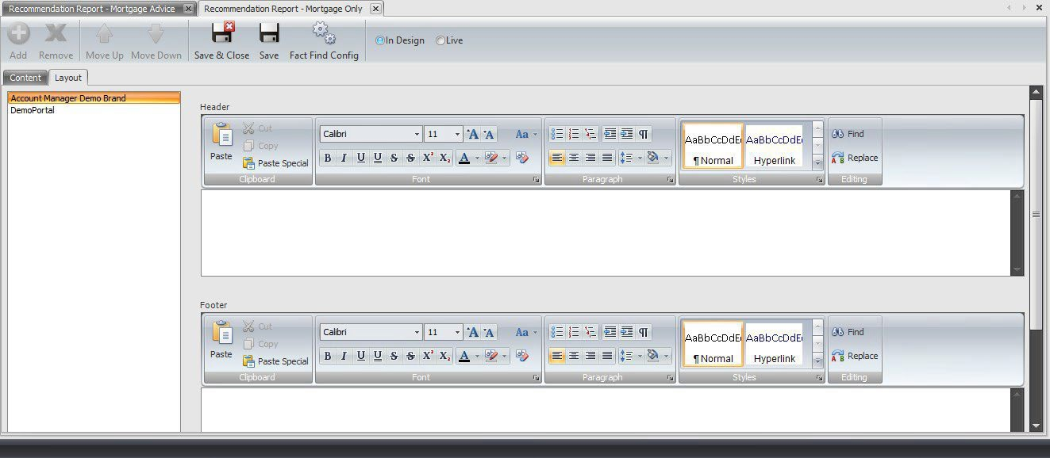
The buttons in the ribbon will remain available, but the options on the left-hand side are the relevant trading styles appropriate to your business. Selecting one of these will then allow you to edit the Header and or Footer paragraphs, found on the right-hand side of the screen. Within these sections, you can make the necessary amendments to font colours, sizes, orientations and styles, as is typically found in Microsoft Word.
When in the paragraph editor itself, right clicking will also open some additional editing functionality, as seen below.
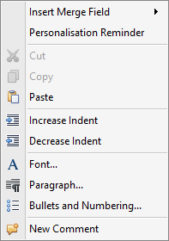
The main items to focus on here are ‘Insert Merge Field’ and ‘Personalisation Reminder’, as these are pertinent to the Recommendation Report. The former will allow the insertion of several fields that will generate based upon the information submitted in the FactFind, such as Branding Image. The latter will insert reminder text, which will come through in the Report in bold, red font, prompting those producing these Reports that intervention is required.

- Adding and/or editing a paragraph
To add a new paragraph, select the ‘Content’ tab and click ‘Add’. This will open up some drop- down options on the right-hand side of the screen where the main editing will take place.
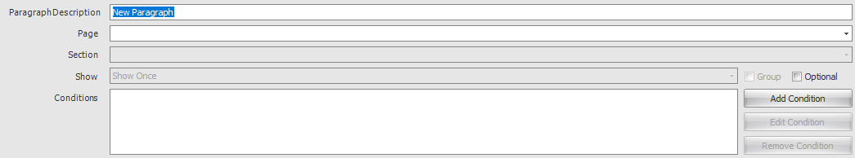
Paragraph Description – this is the description that will display when editing the report post- completion of a FactFind. This is typically the name of the paragraph in the document itself.
Page – this is the Page of the FactFind that this paragraph is relating to. This can be left blank, however it is recommended this is populated to the most relevant section, i.e. if referring to a Mortgage Recommendation, Submission Sheet would be selected in this. This list will retain the order and options related to the FactFind Configuration screen.
Section – this will open up, assuming the Page selected has multiple facets to it. For example, ‘Mortgage Requirements’ will not have a corresponding section, whereas ‘Income’ will contain the sections ‘Employment Details’, ‘Self Employment Details’, ‘Other Income Details’, ‘Periods of Unemployment’, ‘Employer Contact Details’, ‘Business Contact Details’, as per the sections of the Income Page of the FactFind.
Show – this will dictate how many times this paragraph will show when producing the report. This can be selected as ‘Show Once’, ‘Show for Each Item’, or ‘Show if None’. For example, if two Mortgages have been submitted, this will show the wording from this paragraph twice if ‘Show for Each Item’ is selected.
- It is important to select ‘Show for Each Item’ if you’re looking to input any merge fields to ensure these populate correctly. See the ‘Adding Merge Fields’ section for more information.
Conditions – these give you the ability to dictate the paragraphs shown upon completing the FactFind based on the information submitted.
Group – this will alter the order of the template, if the same page and section of the FactFind is selected. For example, if multiple paragraphs are associated with the ‘Mortgage Requirements’ page in the FactFind, and the group option is ticked, this will move these up or down the template to bring these together.
Optional – this will allow the user completing the Report to choose whether these are included or excluded from the Report itself. If not ticked, these will be assumed to be ‘Mandatory’ and will be included on all reports produced assuming no Conditions have been applied.
When the above is setup, you can input the text relevant to that paragraph. You can either type in this detail, or copy and paste from another source, which will retain any previous formatting. From this point, if required, you can add further ‘Merge Fields’ to pre-populate the produced report, based on information from the Online FactFind.

- Adding Merge Fields
To add in a Merge Field, simply right click where in the template you would like this to show, and a list of options will appear, as per the screenshot in the ‘Editing Your Layout’ section. If you select the ‘Insert Merge Field’ button, you will be greeted with at least 3 further options:
- General Counts
- General Lists
- General Other
- This Paragraph*
*this will show if the paragraph added has the ‘Page’ and – if required – the ‘Section’ populated, and show is set to ‘Show Each Item’.
General Counts – this will simply populate a number, based on the amount of the selected field in the FactFind. For example, if the ‘Properties Count’ field is included, this will pull a sum total of the Properties entered in the FactFind. If nothing is populated, this will appear as Not Identified, so is easily picked up on.
General Lists – these are pre-configured lists of key information about several things. For example, ‘Life Policies Sold List’ will generate a brief table outlining the Provider, Policy Type, Premium and Cover Amount for all policies sold.
General Other – these are fields that generally available across the editor, such as Date, CaseID, Client and Adviser Name to name a few. These do no require association to a FactFind page.
This Paragraph – if this is available, this will list every field from the area of the FactFind itself for you to add in. For example, if relating to the ‘Submission Sheet’ page and ‘Mortgage’ section, you will have options such as Purchase Address, Loan Amount, Lender, End Date, etc. These will differ depending on the ‘Page’ and ‘Section’ selected.
Upon adding these in, they will appear in a format similar to the below:
@IGenerallyAvailable.BusinessAddress @IGenerallyAvailable.AdvisorName
The format is outlined by @, then where this has been pulled from, following with the information being populated. They will pull through in the font colour and format you select in the editor, so if you want this to still come through in bold and red if required for intervention, then you can update this in the editor.

- Adding/Editing/Removing Conditions
Part of the intuition available in the Recommendation Report editor is driven by the ability to use ‘Conditions’. These are pieces of logic applied to the editor, allowing the inclusion or exclusion of certain paragraphs based on the information submitted in the FactFind.
To add a Condition, select the ‘Add Condition’ button. This can be found underneath the ‘Optional’ tick box found in the screenshot in the ‘Adding and/or Editing a Paragraph’ section.
Once you click ‘Add Condition’ and window will appear.
The ‘Page’ and ‘Section’ options will pre-populated based on the selections made when adding the paragraph. The options below are then configurable and based upon the selections made earlier.
Property – this will generate a list of generic conditions, followed by paragraph specific conditions, provided a ‘Page’ and – if required – ‘Section’ is selected, and the ‘Show’ option is selected to ‘Show for Each Item’.
Condition – this will change depending on the ‘Property’ selected above, and will have options such as ‘Equals’, ‘Not Equals’, ‘Contains’, etc. These will change depending on the type of field in the FactFind.
Value – this is the operating detail in completing the condition. This can be free typed, e.g. a numeric value, selected from a defined list, or simply a ‘True’ or ‘False’ option.
Once these are populated, click ‘Ok’ and this will add the condition.
To make any changes to the highlighted condition, select ‘Edit Condition’, or to remove it entirely, select ‘Remove Condition’. Please note, if you add multiple Conditions, the paragraph will need all of these to be satisfied from the FactFind for the paragraph to show. If this is not the case, or any conditions are not met, this paragraph will not appear.
- Sharing your template
Once you are happy with your template and satisfied it has been completed, you can then allow users upon FactFind completion the ability to use this. To do so, simply tick ‘Live’ in the ribbon, and Save your changes. This will immediately allow users access to this template, so only look to do this once you’re happy with the template.
If you need to restrict access to this, change the option from ‘Live’ to ‘In Design’ and this will revert users back to the previous template tool.
Finally, if you have multiple FactFind Configurations and you want this copying across a number of these, or across a number of different firms, please contact our Support team who can assist with this process.
Information Classification Procedure
Document Classification | Public
Document Ref | ISMS-SD27-A05-12-01
Version | 1
Dated | 29 June 2026

