
Performance Explorer Training Manual
Contents
1. INTRODUCTION 3
2. TO BEGIN 3
2.1 Show Data 5
3. WRITTEN BUSINESS 6
4. COMPLETED BUSINESS 7
5. COMPLIANCE KPI’S 7
6. PERSISTENCY KPIS 9
7. BUY TO LET KPI’S 10
8. TARGET SETTING 10
9. SHOW OPPORTUNITY MANAGER 10
10. SHOW FUTURE OPPORTUNITIES 11

- INTRODUCTION
Performance Explorer enables you to review company performance in real time allowing you to see results and improve productivity pro-actively at the root of an issue.
You will be able to analyse historical sales and KPI data, spot trends, identify training gaps and needs as well as gather data for RMAR. Performance Explorer is the only part of the system in which you can report on such things as leads, opportunities and future reviews.
This can be selected by adviser, employed or self-employed, combined as team, as an office, region or the whole group. Temporary teams can be set up which may be useful for creating a group of advisers who may need further training and attention.
This tool is essential for business planning and not just for the management team. Giving them permission to see their own performance track, allows them the transparency to see their own activity around KPI’s and income.
They can see what has been written, completed and banked. Advisers will be able to see what has been paid and what has not, giving them more ownership and responsibility.
- TO BEGIN
‘Performance Explorer’ can be found in ‘Office’ under the ‘Tools’ tab as per below

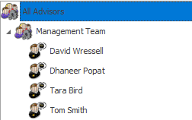
By clicking on ‘Performance Explorer’ you will be presented with a list of advisers. Performance Explorer is permission based and allows only people which have permission within ‘Client Access’ to use Performance Explorer. You can either select ‘all advisers’, individuals by name, or any groups that show which individuals sit in. The group example below is ‘Management Team’.
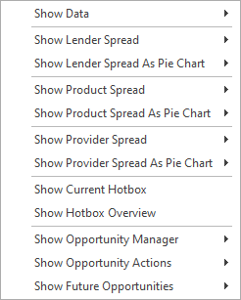
To do this, you should right click on the adviser in question, where you will see a list of options as per below. Please find explanations of these options further below:
- Show Data – Allows you to view data on selected groups or individuals over a chosen period of time. Information such as Written business, Completed Business, Written Policies, Written Business Commission, Completed Business Commission, Banked Income, Compliance KPI’s, TCF Questionnaire Results, Persistency KPI’s, Buy to Let KPI’s.

- Show Lender Spread – Allows you to view data on selected groups or individuals over a chosen period of time. The data will show in bar chart form of the selected mortgage lenders over the time period chosen.

- Show Lender Spread as Pie Chart – Allows you to view data on selected groups or individuals over a chosen period of time. The data will show in Pie chart form of the selected mortgage lenders over the time period chosen.

- Show Product Spread – Allows you to view data on selected groups or individuals over a chosen period of time. The data will show in bar chart form of the selected products over the time period chosen.

- Show Product Spread as Pie Chart – Allows you to view data on selected groups or individuals over a chosen period of time. The data will show in pie chart form of the selected products over the time period chosen.

- Show Provider Spread – Allows you to view data on selected groups or individuals over a chosen period of time. The data will show in bar chart form of the selected providers for insurance over the time period chosen.

- Show Provider Spread as Pie Chart – Allows you to view data on selected groups or individuals over a chosen period of time. The data will show in pie chart form of the selected products over the time period chosen.

- Show Hotbox Overview – provides an overview of your opportunities, including what status they are set to, and certain other key indicators.

- Show Current Hotbox – Allows the user to access all groups or individuals current Hotbox and report on current Leads and Opportunities.

- Show Opportunity Manager – Allows the user to view all opportunities no matter the status of the groups or individuals selected.
- Show Opportunity Actions – Shows the Actions recorded for each lead or opportunity for the selected group or individuals selected.
- Show Future Opportunities – The user can view all future reviews and future opportunities for the chosen time period & chosen individual or group.
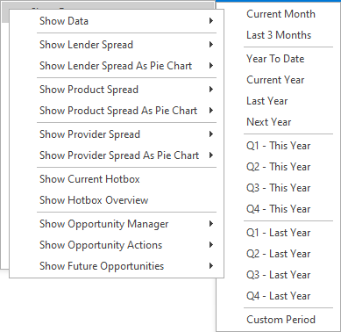
By hovering your curser over the options, you will see that each option will bring out a second menu offering time periods.

  - Show Data
When you select a specified timeframe, you will be greeted with a summary screen as per the below.
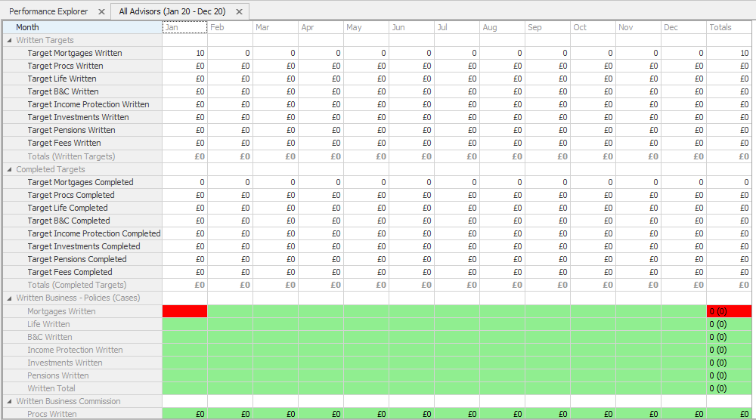
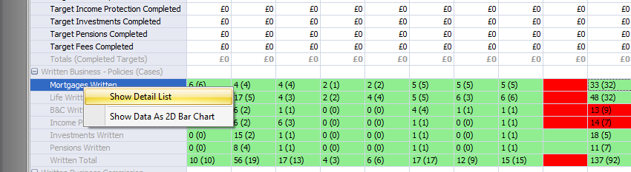
You can then ‘Right Click’ this will allow you to view the highlighted section in more detail.

This will then bring up the list of data as a report & you will be able to filter the data.
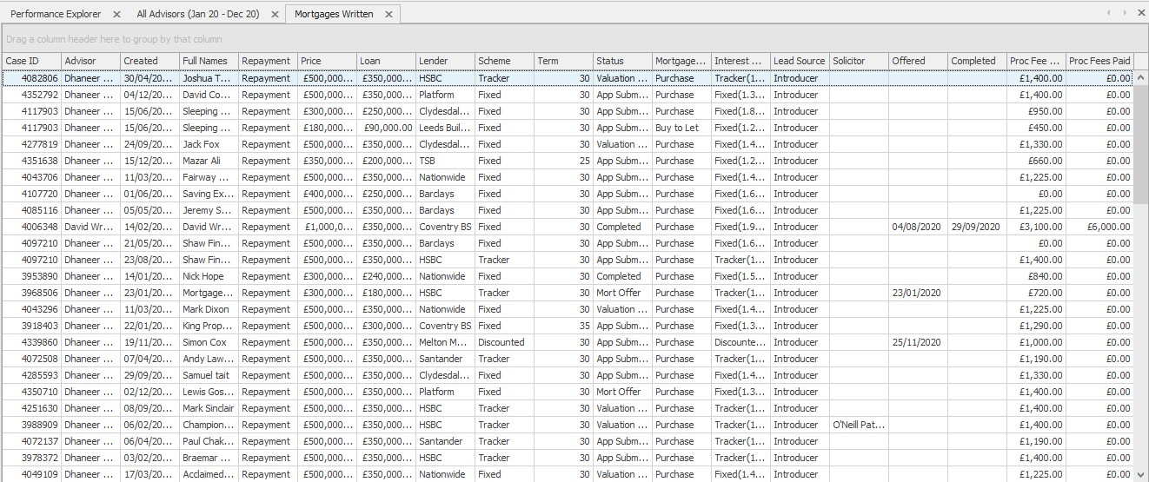

- WRITTEN BUSINESS
- Mortgages Written – Shows all mortgages that have been added to the system in the period you are querying against in Performance Explorer. These results are not status driven.
- Life Written – Shows all life policies that have been added to the system in the period you are querying against in Performance Explorer. These results are not status driven.
- B&C Written – Shows all B&C policies that have been added to the system in the period you are querying against in Performance Explorer. These results are not status driven.
- Income Protection Written – Shows all income protection policies that have been added to the system in the period you are querying against in Performance Explorer. These results are not status driven.
- Pensions Written – Shows all pension policies that have been added to the system in the period you are querying against in Performance Explorer. These results are not status driven.

- COMPLETED BUSINESS
- Mortgages Completed – Shows all mortgages where the ‘Completed’ date on the policy is in the period you are querying against in Performance Explorer. These results are not status driven.

- Life Completed – Shows all life policies where the ‘Authorised Date’ is in the period you are querying against in Performance Explorer. These results are not status driven.

- B&C Completed – Shows all B&C policies where the ‘Start Date’ is in the period you are querying against in Performance Explorer. These results are not status driven.

- Income Protection Completed – Shows all income protection policies where the ‘Start Date’ is in the period you are querying against in Performance Explorer. These results are not status driven.

- Investments Completed – Shows all investment policies where the ‘Start Date’ is in the period you are querying against in Performance Explorer. These results are not status driven.

- Pensions Completed – Shows all pension policies where the ‘Start Date’ is in the period you are querying against in Performance Explorer. These results are not status driven.
- COMPLIANCE KPI’S
- Mortgage to Life – Calculates the percentage of how many cases have a life policy written compared to how many cases have had a mortgage policy written in the period you are querying against in Performance Explorer.

- Mortgage to Life (Normalised) – Calculates the percentage of how many life policies have been written compared to how many mortgage policies have written in the period you are querying against in Performance Explorer.

- Mortgage to B&C – Calculates the percentage of how many cases have a B&C policy written compared to how many cases have had a mortgage policy written in the period you are querying against in Performance Explorer.

- NPW Mortgages – Shows all mortgage policies where the status has been changed in the period you are querying against in Performance Explorer to one selected in your databases NPW Settings (found in Office > Maintenance > General > NPW Settings).

- NPW Mortgages Before Offer – Shows all mortgage policies where the status has been changed in the period you are querying against in Performance Explorer to one selected in your databases NPW Settings (found in Office > Maintenance > General > NPW Settings) and the date that the policy is set to NPW is before the ‘Offered’ date on the policy or there is no offered date entered.

- NPW Mortgages After Offer – Shows all mortgage policies where the status has been changed in the period you are querying against in Performance Explorer to one selected in your databases NPW Settings (found in Office > Maintenance > General > NPW Settings) and the date that the policy is set to NPW is after the ‘Offered’ date on the policy.

- Debt Consolidation – Shows all mortgages that have been added to the system in the period you are querying against in Performance Explorer where ‘Debt Consolidation’ has been selected on the policy record.

- Fast Track – Shows all mortgages that have been added to the system in the period you are querying against in Performance Explorer where ‘Fast Track’ has been selected on the policy record.

- Self Cert – Shows all mortgages that have been added to the system in the period you are querying against in Performance Explorer where ‘Self Cert’ has been selected on the policy record.

- Employed Self Cert – Shows all mortgages that have been added to the system in the period you are querying against in Performance Explorer where ‘Self Cert’ has been selected on the policy record and the employment status set against the policy owner is ‘Employed’.

- Term > 25 Years – Shows all mortgages that have been added to the system in the period you are querying against in Performance Explorer where the term added to the policy record is greater than 25 years.

- > 5 Times Income – Shows all mortgages that have been added to the system in the period you are querying against in Performance Explorer where the mortgage loan value is 5x greater than the policy owners income saved in their client record.

- LTV > 100% - Shows all mortgages that have been added to the system in the period you are querying against in Performance Explorer where the LTV added to the policy is greater than 100%.

- Interest Only – Shows all mortgages that have been added to the system in the period you are querying against in Performance Explorer where the mortgage type is ‘Interest Only’.

- Part & Part – Shows all mortgages that have been added to the system in the period you are querying against in Performance Explorer where the mortgage type is ‘Part & Part’.

- Into Retirement – Shows all mortgages that have been added to the system in the period you are querying against in Performance Explorer where the client’s age will be 65 or greater when the mortgage completes its term.

- Interest Only into Retirement – Shows all mortgages that have been added to the system in the period you are querying against in Performance Explorer where the repayment method is ‘Interest Only’, and the client’s age will be 65 or greater when the mortgage completes its term.
- PERSISTENCY KPIS
- One Year Persistency – Shows a percentage of all life policies you have received commission for in the last year where the policy is still on risk.

- Two Year Persistency – Shows a percentage of all life policies you have received commission for in the last two years where the policy is still on risk.

- Three Year Persistency – Shows a percentage of all life policies you have received commission for in the last three years where the policy is still on risk.

- BUY TO LET KPI’S
- Buy to Let – Shows all mortgages that have been added to the system in the period you are querying against in Performance Explorer where the mortgage type is ‘Buy to Let’.

- BTL Interest Only – Shows all mortgages that have been added to the system in the period you are querying against in Performance Explorer where the mortgage type is ‘Buy to Let’ and the ‘Repayment Method’ selected on the policy is ‘Interest Only’.

- BTL Into Retirement – Shows all mortgages that have been added to the system in the period you are querying against in Performance Explorer where the mortgage type is ‘Buy to Let’, and the client’s age will be 65 or greater when the mortgage completes its term.

- BTL Interest Only into Retirement – Shows all mortgages that have been added to the system in the period you are querying against in Performance Explorer where the mortgage type is ‘Buy to Let’ and the repayment method is ‘Interest Only’, and the client’s age will be 65 or greater when the mortgage completes its term.
- TARGET SETTING
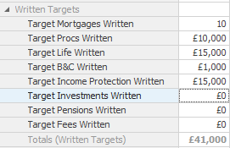
You can also set targets for individual advisers. This can be done in the ‘Show Data’ section once you have specified a timeframe. The targets section will appear at the top of the screen. Simply type in the numeric or monetary target you want to set (this can be done for either Written or Completed business) and click ‘Save’ in the top left corner.

- SHOW OPPORTUNITY MANAGER
This next option shows a summary of the opportunities for the Adviser in question, below is an example of the breakdown.
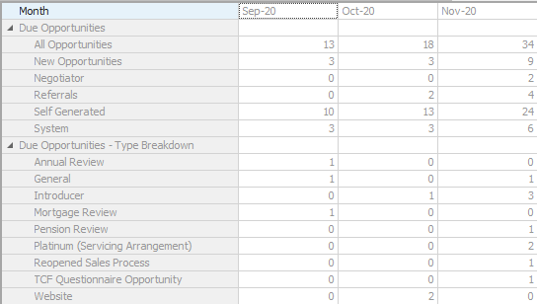

You then can ‘Right Click’ to view Opportunities in more detail by clicking on the individual rows which will create a report showing all the relevant details.
- SHOW FUTURE OPPORTUNITIES
This option will show you any future opportunities which are due into this advisers’
Hotbox for the next 12 months. You can pick a time period that you would like to look over. The report will show a breakdown of the future opportunities into categories of business.
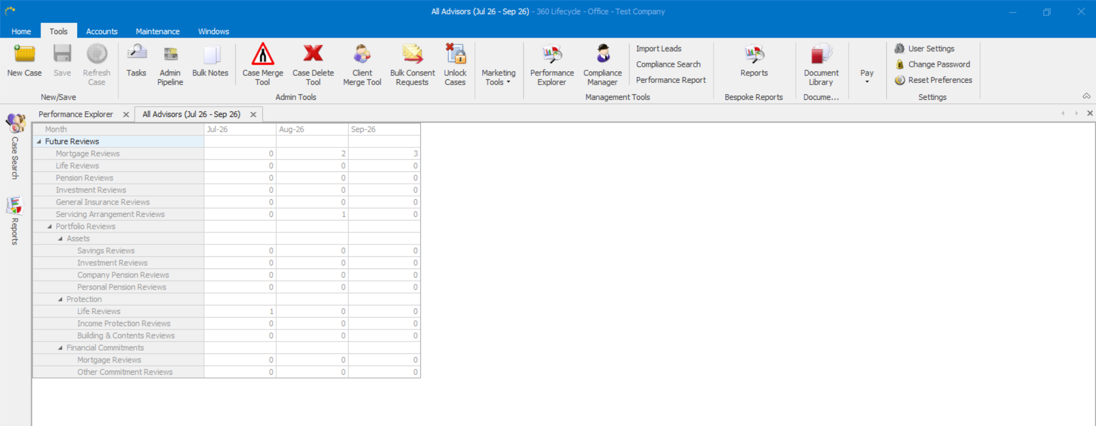

A simple ‘Right Click’ will allow you to view the details of each opportunity heading in more detail.
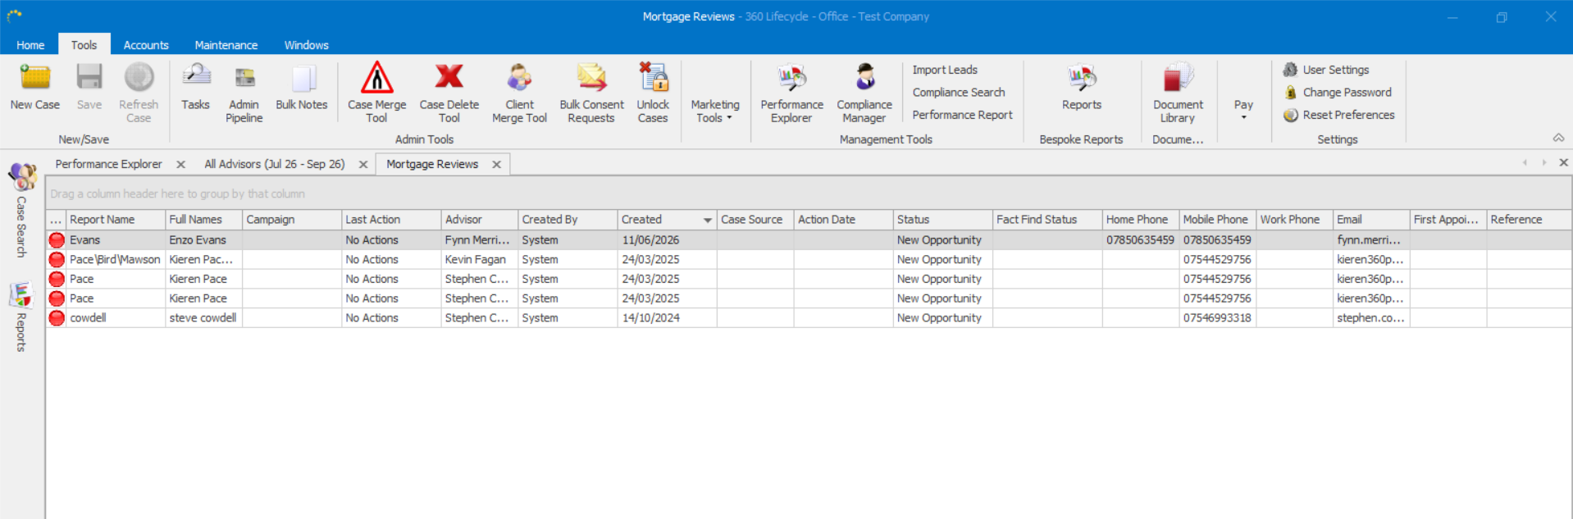

Information Classification Procedure
Document Classification | Public
Document Ref | ISMS-SD27-A05-12-01
Version | 1
Dated | 29 June 2026

