
Lead Import Tool

Contents
1. Introduction 3
2. Lead Import Tool Overview 3
3. Lead Import Process 3
3.1 360 Lifecycle Office 3
3.2 Import Leads 3
3.3 Template Generation 4
3.4 Updating the template 5
3.5 Importing 6
4. 4 Reviewing Imported Leads 8
4.1 360 Case Record – Advisor and Office 8
4.2 Hotbox – 360 Advisor 9
5. 5 Support and Assistance 9

- Introduction
The object of this manual is to provide support in using the lead import tool for the creation of client records and opportunities directly into the hotbox.
The following guide will show how to do this without rekeying information sent by the lead provider. This improves efficiency, saves time, and creates a simple process for the adviser to drag their leads into their 360 diary, which can be integrated with smartphones and Outlook calendars to save double entry.
- Lead Import Tool Overview
The lead import tool is used to create case records in bulk and import leads directly into an adviser’s hotbox. These leads may have been generated by an introducer, referred via another adviser/ firm or they may simply have been held within an external database.

- Lead Import Process
  - 360 Lifecycle Office
The lead import tool is accessed from 360 Office; select ‘Import Leads’ from the ‘Tools’ ribbon, the option is within the ‘Management Tools’ section of the ribbon.

  - Import Leads
Having selected ‘Import Leads’ from the ribbon the ‘Import Leads’ window will open; an example is shown below:

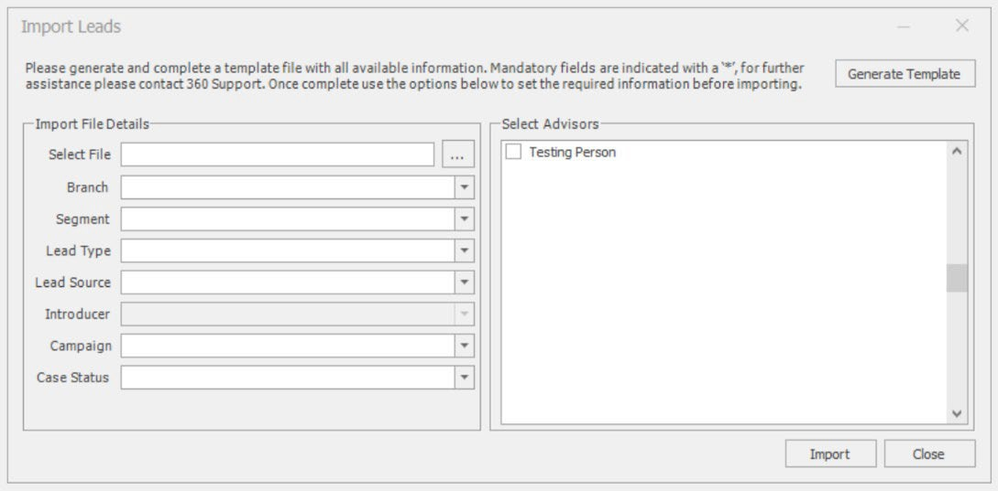
  - Template Generation
Importing leads requires the data to be provided in a defined format, to assist with this process a template can be generated, saved, and populated with the required data.
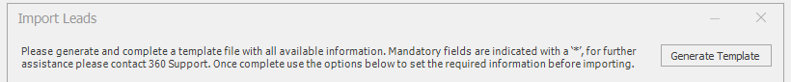

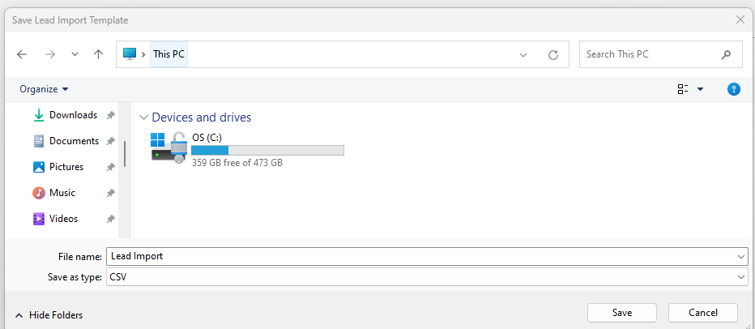
Selecting ‘Generate Template’ will save a template file, in the required format, complete with column headers in a specified location. A window similar to the one below will be opened, by default the file name provided is ‘Lead Import’ but this can be updated. Save the file in the desired location for editing.
The import file must be saved in the .CSV type as set by default.

  - Updating the template
The template can be opened by most applications that recognise the .CSV file type. The template contains a header line detailing the information required in each column of the spreadsheet. The following columns are mandatory:
- Title
- Forename
- Surname
The requirement for these columns to be populated is indicated by a ‘*’ following the column name in the header row.
All date fields should be provided in the DD/MM/YYYY format and gender must either be ‘M’ for male or ‘F’ female. These requirements are also indicated in the header row following the column name.
When completing the template, it is important to note that each row will be converted to a case record, the import template can only accommodate a maximum of two clients per case. When importing two clients for the same case, such as a husband and wife please ensure the details are added to a single row and the ‘Partner’ fields are used to record the second client.
The ‘Review Date (DD/MM/YYYY)’ is not mandatory but is a useful addition when importing leads. This field, where populated should specify when the next review for the clients/ case should take place. Where this field is not populated or populated with a date that is prior to the import date then an opportunity will immediately be added to the specified hotbox. If a future date is provided, the case and client records will be created but an opportunity will not be added to the hotbox until the specified date has been reached. This allows for the importing of existing or new clients while providing the ability to specify when that client requires their next review, which may not be immediately.
To make the most from the import process it is recommended that all fields are populated where possible. Please do not remove columns or the header row from the import spreadsheet, the import process relies on data being provided in the specified format and changes to this will cause the import to fail or for data to be imported incorrectly
  - Importing
When ready to import open the lead import tool as outlined in section 3.1. Then utilise the ‘Import File Details’ section (shown below) to locate the file and set the required attributes.
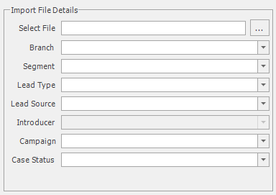
Use the ellipsis (…) option to the right of the ‘Select File’ field to select the file for importing. Choosing this option will load a window, from here you will be able to select the file for importing.
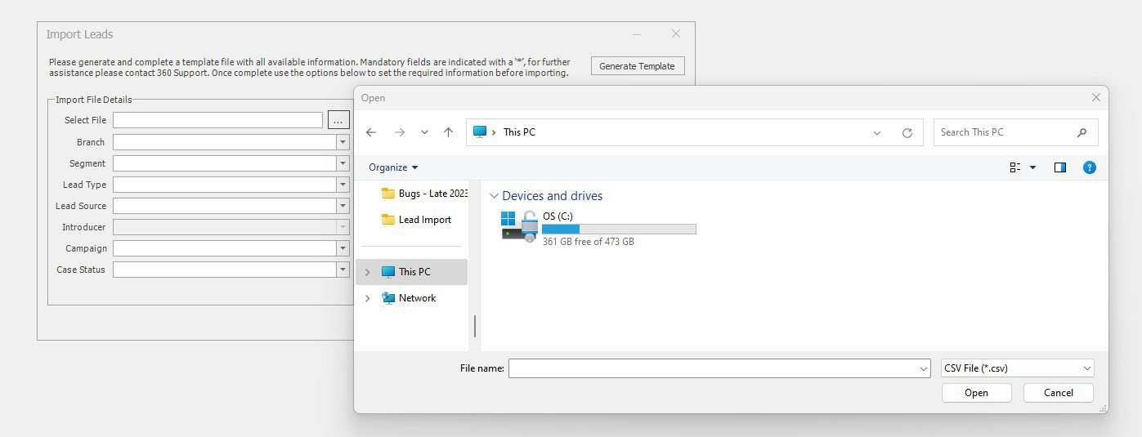

Once the file has been located select ‘Open’ and the ‘Select File’ field will populate with the file location.
The ‘Branch’, ‘Lead Type’, ‘Lead Source’, ‘Campaign’ and ‘Case Status’ must be provided for the data to be imported. If segmentation and or introducers are being utilised, this information can be provided but it is not mandatory for the import to process.
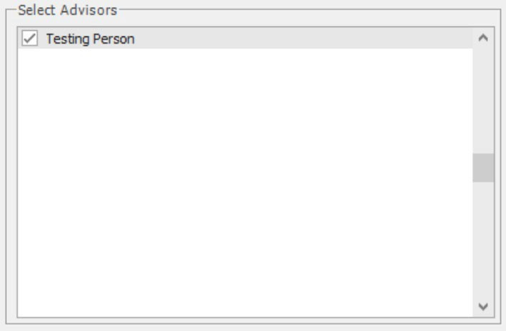
When the mandatory ‘Import File Details’ have been provided move to the ‘Select Advisors’ area. This section facilitates the choice of advisers to associate with the leads. Selecting more than one adviser will split the leads equally between the selected advisers.

When the required advisers have been selected, click the ‘Import’ button and the file will be processed. If mandatory ‘Import File Details’ have not been specified or one or more advisers have not been selected, then a warning will be shown advising the required action.
During the import process the title of the ‘Import Leads’ window will update to show the progress of the import, an example is shown below.

Following a successful import, an ‘Import Complete’ dialogue will detail how many leads have been imported from the total number of rows read from the import file.
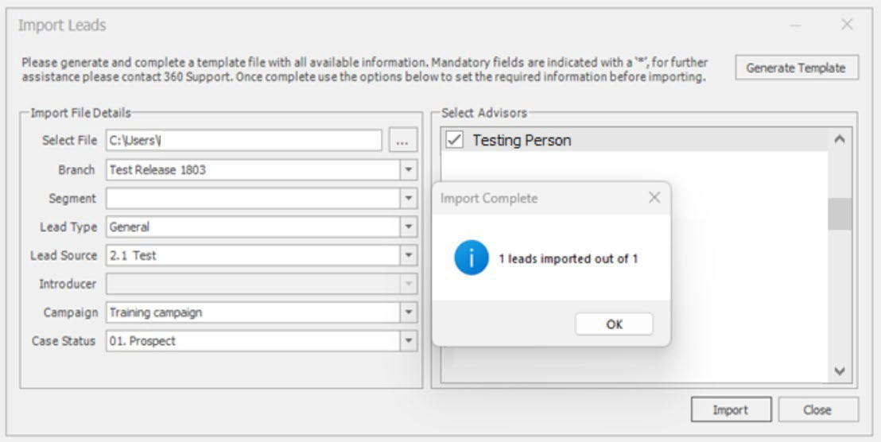

The import process will create a case record for each row included within the import file and either a current or future opportunity, these will appear in the advisers hotbox.

- 4 Reviewing Imported Leads

  - 360 Case Record – Advisor and Office
Once the import has completed the Case record(s) can be reviewed to check the imported data.
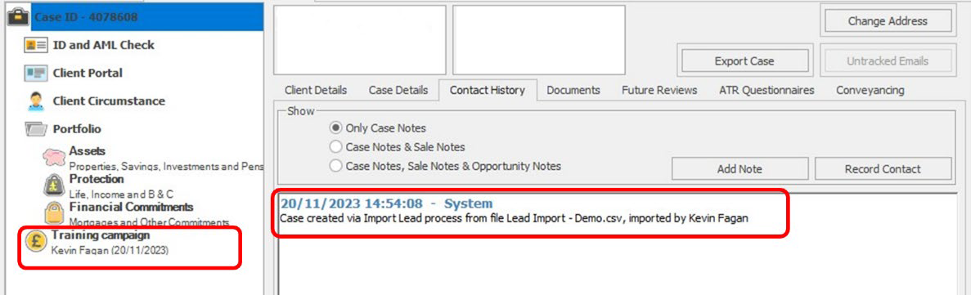

The above example details a lead that has been imported with no review date, an immediate opportunity has been created, this is shown with the pound icon and the associated campaign name ‘Training Campaign’ (outlined in red in the ‘Case’ menu). A system note is also added indicating that the case was created from the import process, the file name of the import file is recorded along with the logged in user who performed the import.
The below example is a lead that has been imported but with a future review date provided within the import file. There is no opportunity currently in the case menu, as above a Case Note exists confirming the record was created from the import process. In addition, the ‘Future Reviews’ section details when the next review is required. This review date is the date that was provided in the lead import file and the ‘Review Type’ is set to ‘Lead Import Review’.
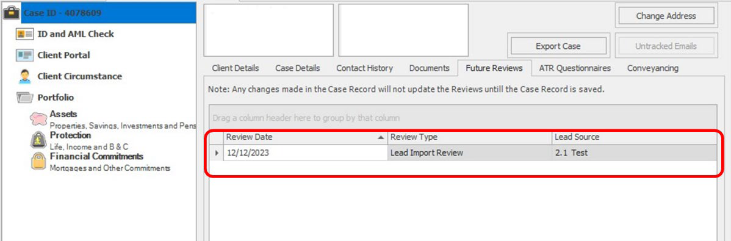

  - Hotbox – 360 Advisor
The hotbox within 360 Advisor displays the opportunities created and assigned to the adviser via the import process. Please note that if multiple advisers where selected as part of the import process, the import procedure will have distributed the leads between the specified advisers. Any leads with a future review date populated will not show in the adviser’s hotbox until the review date has been reached.

- 5 Support and Assistance
The 360 Lifecycle Support Team are available to assist with the lead import process, if you do have questions or require any assistance, please contact us using the details below:
Email: support@360lifecycle.co.uk Phone: 0116 2408621
Live chat is available via our website: www.360lifecycle.co.uk

Information Classification Procedure
Document Classification | Public
Document Ref | ISMS-SD27-A05-12-01
Version | 1
Dated | 09 September 2025

