
KPI Reports Training Manual

Contents
1. INTRODUCTION 3
2. KPI REPORT 3
2.1 Life Policies 3
2.2 Income Protection 5

- INTRODUCTION
This guide has been produced to explain how the KPI Report works in 360 Lifecycle.
The 360 Lifecycle KPI Report gives you the control to effectively manage your business and its needs. Below is a breakdown of information on where the data in the KPI Report comes from.
- KPI REPORT
  - Life Policies
For the Life policy benefits to return in the report correctly, the policy types (configured in 360 Office) must be set up accordingly.
These settings can be accessed via: 360 Office > Maintenance > Life Insurance > Policy Types. Below depicts the configuration for each column:
Replacement - Must have the ‘Replacing Previous Policy’ option ticked against the Life Policy sale record within the Case:
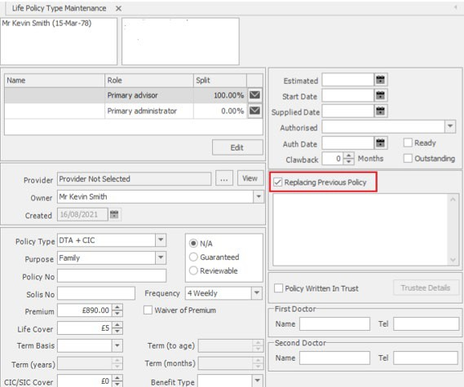

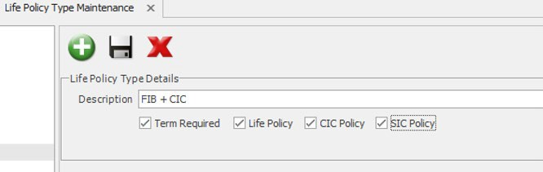
Term - Must have the ‘Term Required’ option set against the Life Policy Type Details under Maintenance\Life Insurance\Policy Types.
Life - Must have the ‘Life Policy’ option set against the Life Policy Type Details under Maintenance\Life Insurance\Policy Types.
CIC - Must have the ‘CIC Policy’ option set against the Life Policy Type Details under Maintenance\Life Insurance\Policy Types.
SIC - Must have the ‘SIC Policy’ option set against the Life Policy Type Details under Maintenance\Life Insurance\Policy Types.
Life Providers (Written) – This will display a count of written business for the period for each provider, including a total of all providers. If there are no applicable policies, no figure or percentage will be displayed.
Life Benefits (Written) – This will display a count of written business for the period for Replacement policies, Term policies, Life policies, CIC policies and SIC policies. If there are no applicable policies for each type, the results will return blank.
Life Policies (Written) – This will display a count of Written Business for the period for each policy type of LTA and LTA+CIC, including a total of all policies. This will display a percentage of each policy type based on the total:
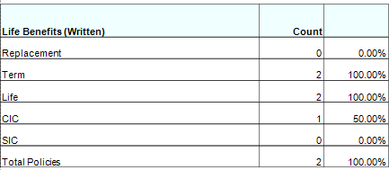

  - Income Protection
For the IP benefits to return in the report correctly, the policy types (configured in 360 Office) must be set up accordingly. For the columns:
PHI - Must state ‘PHI’ in the policy type description under Maintenance.
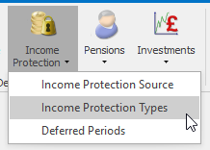
Unemployment - Must state ‘Unemployment’ in the policy type description under Maintenance.

IP Providers (Written) - This will display a count of written business for the period for each provider, including a total of all providers. If there are no applicable policies, no figure or percentage will be displayed.
IP Benefits (Written) - This will display a count of written business for the period for PHI policies and Unemployment policies, including a total of all policy types. If there are no applicable policies for each type, the results will return blank.
IP Policies (Written) - This section of the report returns written business for the period for each policy type for ASU, PHI etc. including a total of all policies. If there are no applicable policies, no figure or percentage will be displayed.
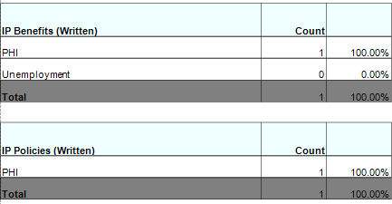

GI Providers (Written) - This section of the report returns the written business over the period for each provider, including a total of all providers. If there are no applicable policies for each type, the results will return blank.
GI Benefits (Written) - This section of the report returns the written business over the period for each provider, including a total of all providers. If there are no applicable policies, no figure or percentage will be displayed.
Lender Spread (Written) - This section of the report returns the written business over the period for each lender, including a total of all lenders. If there are no applicable lenders, the results will return blank.
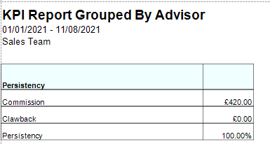
Persistency is calculated as banked income including clawbacks, not only written (please note, clawbacks cannot have been deducted from the total). This returns the total commission. Cancelled business will be any business where the status has an NPW setting configured from it.
High Risk Mortgages - High Risk Mortgages returns ‘Interest Only’, ‘Term Into Retirement’ and ‘Total Mortgages’ information for mortgages written for the period selected. If there are no applicable policy types, no figure or percentage will be displayed.
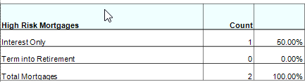

Information Classification Procedure
Document Classification | Public
Document Ref | ISMS-SD27-A05-12-01
Version | 1
Dated | 29 June 2026

