

FactFind Training Manual

Contents
Introduction 3
- Getting Started 3
- To Begin 5
FactFind Navigation 5
FactFind Menu Options 5
- Editing the FactFind 8
Convert FactFind 9
Sales Process Screen 9
FactFind Completion 12
FactFind Requirements & Sourcing 14
Capturing Requirements 14
Sourcing & Results 15
- Submission Sheet 17
Show Details, Request Illustration, Chosen and Remove 17
Retrieving SolutionBuilder Quotes 19
Manually Adding a Recommendation 20
- Documents 21
Upload Documents 21
- Notes 22
Add Note 22
All Notes 22
- Submit Business 23
Updates To The 360 Lifecycle Case Record 24
- Recommendation Report 26
- Creating or Amending Recommendation Report Templates 29
Getting Started 29
Amending Recommendation Report Content 30
Header and Footer 32
Page Layout 33
Amending Recommendation Report Content with the ‘Report per FactFind Template’ Editor 33
Layout 35
- FactFind Configuration 36
Adding, Amending and Removing FactFinds 36

Introduction
360 Lifecycle’s FactFind provides you with the ability to carry out a full sales process through capturing key FactFind data, fully integrated sourcing, quote/apply, recommendation report building and overall document creation and management.
360 Lifecycle FactFind offers you the option to ‘Invite Client’ so your clients can complete, or part complete FactFind at any stage and potentially in advance of any appointment. 360’s FactFind can be accessed from any web enabled device, thus allowing you to be in control and have access to the case information anytime and anywhere. The guide focuses specifically on the key navigation points of the sales process and allowing you to ‘Submit Business’ back into 360 Lifecycle.

Getting Started
The FactFind can be launched or accessed in one of three ways:
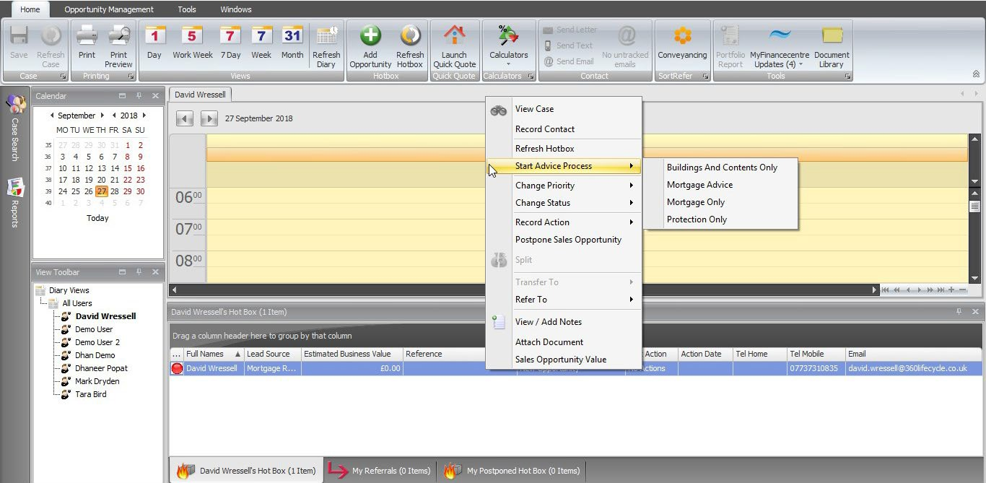

  - From selecting ‘Start Advice Process’ against the sales opportunity within your Hotbox.

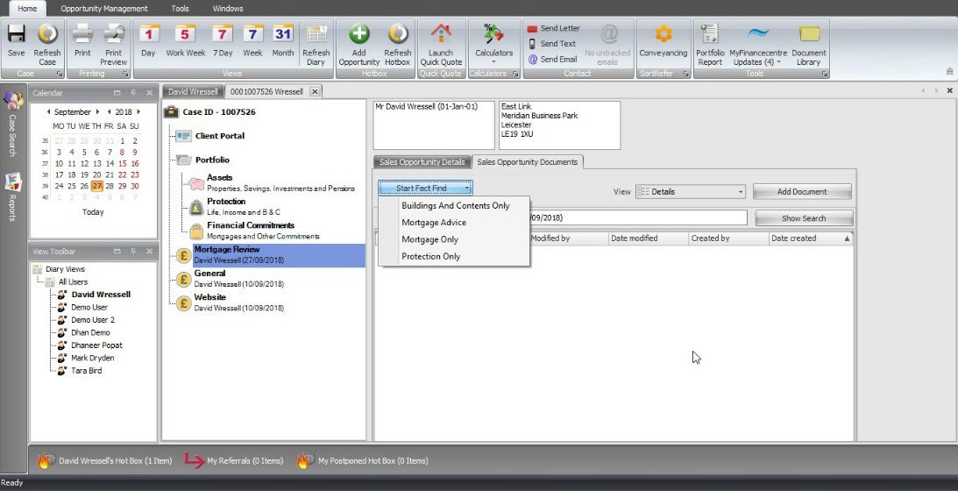
  - From accessing the sales opportunity within 360’s case record.
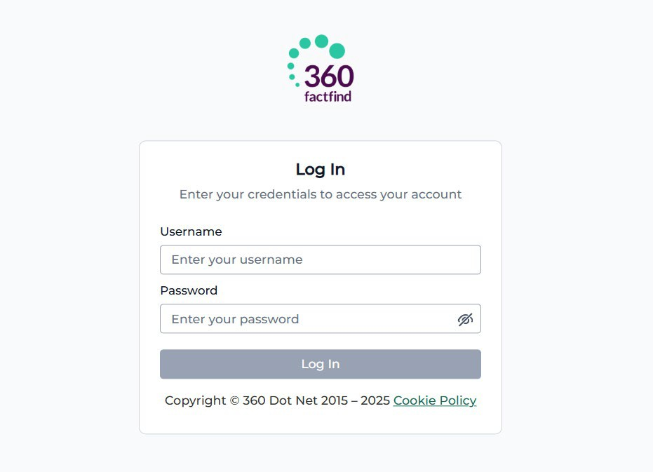

  - By entering the FactFind URL directly into your browser e.g. https://factfind.360lifecycle.co.uk/ and entering your 360 username and password.

To Begin

FactFind Navigation
If you launch the FactFind from the 360 Lifecycle sales opportunity, then this will automatically take you into the FactFind in relation to that 360 case record. If you access FactFind from your Internet Browser then after successfully logging on you will navigate to a screen like the below, showing you your ‘In Progress’ FactFinds. From here you have several options, either in relation to a FactFind which you have already launched or by using the menu options at the top of the screen.
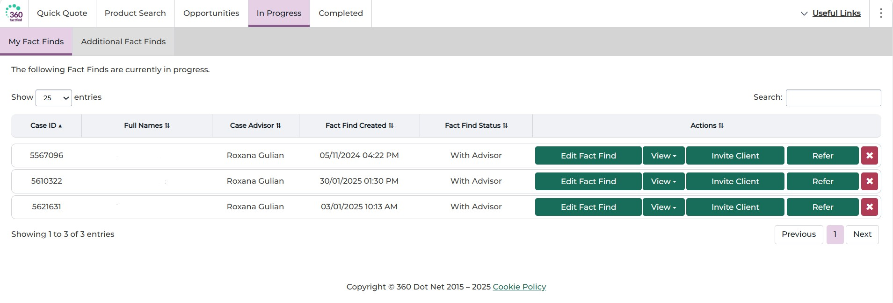

FactFind Menu Options
These menu options are always available throughout the FactFind and can be accessed at any point.
- Quick quote: This will allow you carry out integrated sourcing by entering some basic requirements. Please note a KFI/illustration cannot be produced through quick quote.
- Product search: This allows you to search all available products across specified types & requirements.
- Opportunities: Display is active 360 Lifecycle sale opportunities for which a FactFind has yet to be launched. You can also create a New opportunity or case if one is not already present in 360 Lifecycle.
- In Progress: Lists ‘In Progress’ FactFinds from which you can edit, invite client, refer or delete/cancel. You will also see ‘Additional FactFinds’ under this tab, which will allow you to view PDF copies of existing FactFinds that you are in some way associated to – other than being the adviser.

- Completed: Groups ‘Completed’ FactFinds of which have outstanding and completed recommendation reports.
- Quick quote & product search: Enter sourcing requirements with sourcing results then listed underneath.
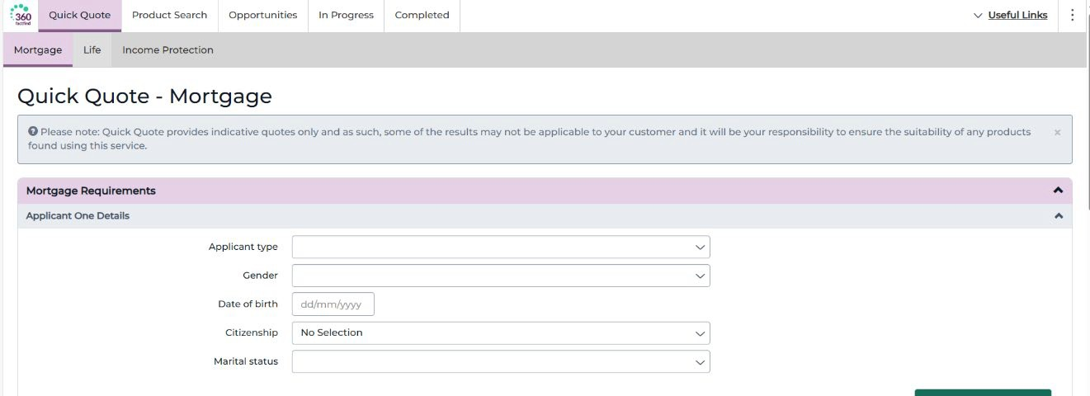

Opportunities
The opportunities landing screen will display active sale opportunities for which a FactFind has yet to be launched from. As 360’s FactFind can only be launched against a current sale opportunity and case record, from here you can also create a ‘New Opportunity’ for an existing client/case or you can create a whole ‘New
Case’/client record if one is not already present in 360 Lifecycle to then ‘Create
FactFind’ against.
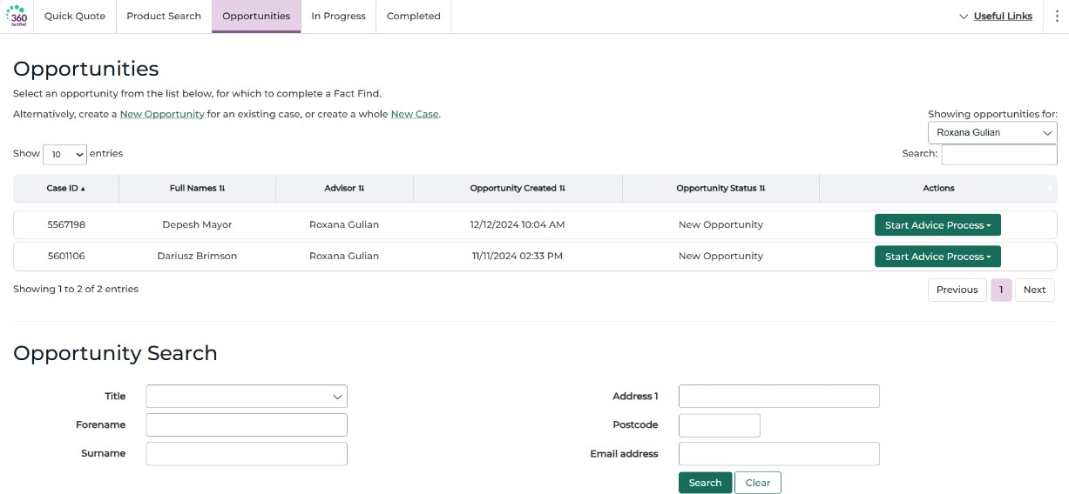

In progress
This is the landing screen if you log into FactFind directly from your Internet browser. ‘In Progress’ lists all FactFinds which have been created and have yet to be completed or cancelled. From here you can either ‘Edit FactFind’ to enter the sales process for that case, ‘Invite Client’ for the client to complete or part
complete FactFind, refer to a colleague or delete/cancel the FactFind. Please note
deleting the FactFind will remove this from the ‘In Progress’ list and will not result in any updates being made against the 360 Lifecycle case record.
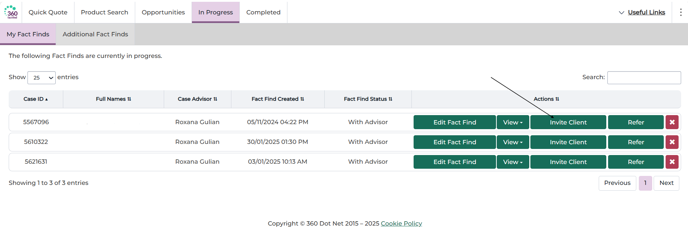

Edit FactFind, view, invite client, refer or delete
Completed
This screen groups completed FactFinds which have yet to have a suitability report produced or by where the suitability report has also been completed.
There are several actions available:

- View: Views a PDF version of Completed FactFind
- Reopen: Creates a new FactFind as a clone of the original
- Split: Creates a new Opportunity against the same case which you can then refer
- Produce report: Opens Recommendation Report Builder
- Mark complete: To be selected if Recommendation Builder Report is not required or completed ‘Offline’

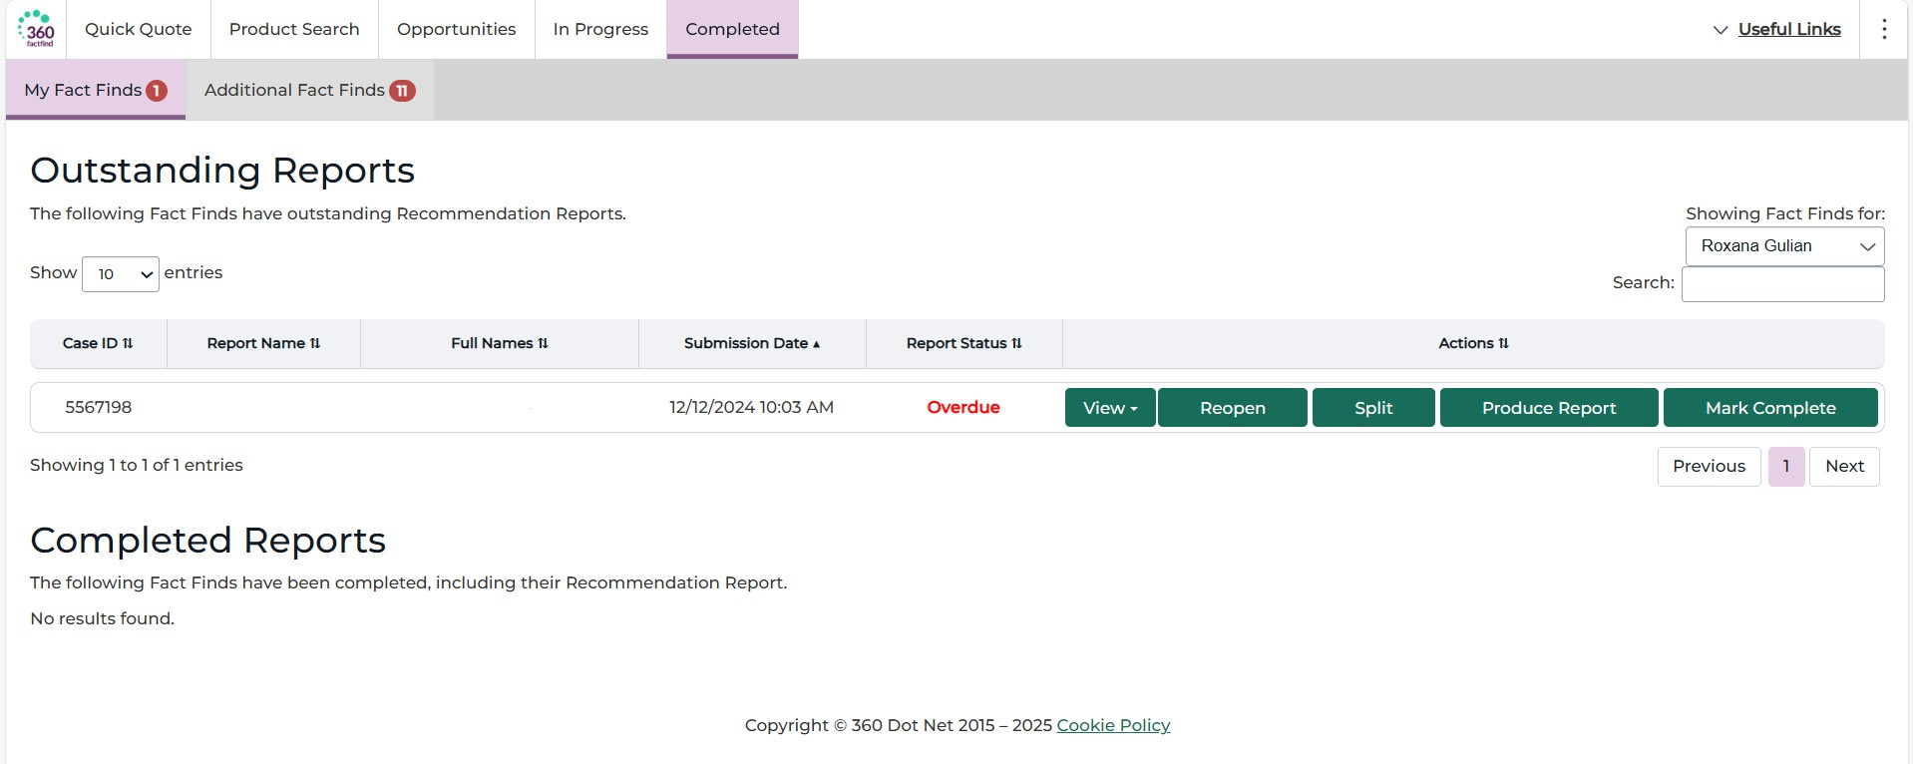

Editing the FactFind
When launching the FactFind from within 360 Lifecycle you will automatically be taken into the FactFind for the case and clients in question. Alternatively, you can enter the FactFind through the ‘Edit FactFind’ option when displaying those in progress.
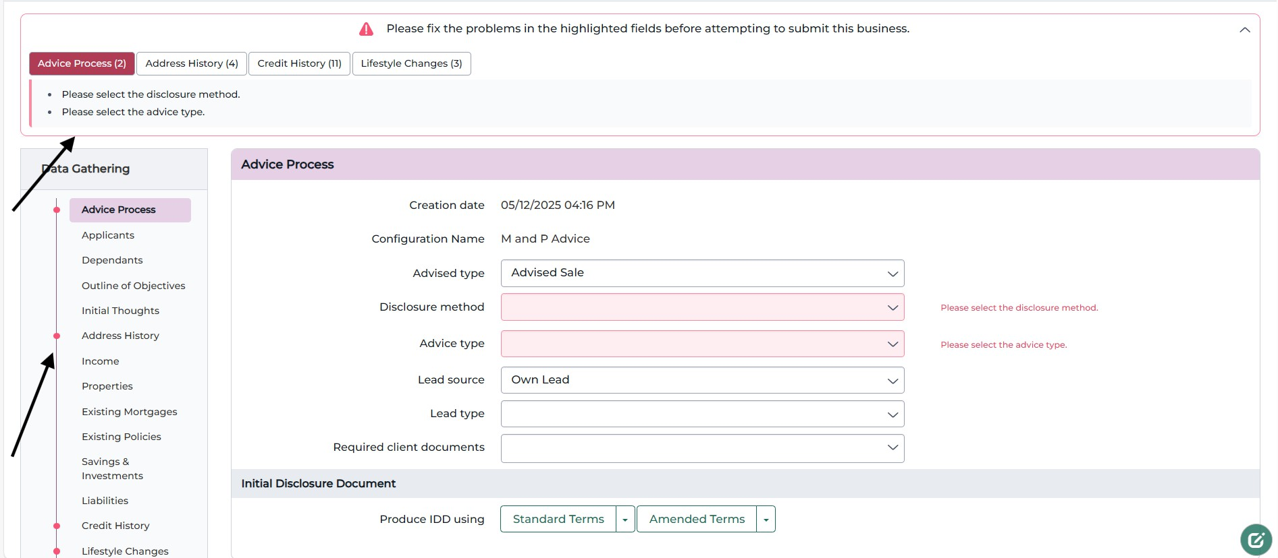
Throughout the sales process a completeness check will be performed to ensure that all mandatory data is filled in before you can ‘Submit Business’. Each time you add and enter information through the FactFind, the completeness check will inform you of any missing mandatory data at the top of the page and via the left-hand menu.
Missing mandatory items are shown at the
top
Missing mandatory items are highlighted in the left-hand menu

The ‘Advisor View’ of the FactFind is presented in the process menu on the left-hand side of the work screen and you will know where you are by colour coding of

the process menu. Please note that you can access different sections of the FactFind via the left-hand menu or via the ‘Next’ and ‘Previous’ options without completing the mandatory information on that page.

Convert FactFind
If you need to change your FactFind version mid sales process, then you can do so by selecting ‘Convert FactFind’ on the advice process tab of the FactFind. This will remove or add pages depending on the new version selected.

NOTE: If you convert to a FactFind version that removes pages, this information will not be retained.

Sales Process Screen
The opening sales process screen of the FactFind provides you with an ability to set the agenda of topics for discussion, create a printable PDF, Produce and Email to the client your IDD, and send invite for the client to complete or part complete FactFind.

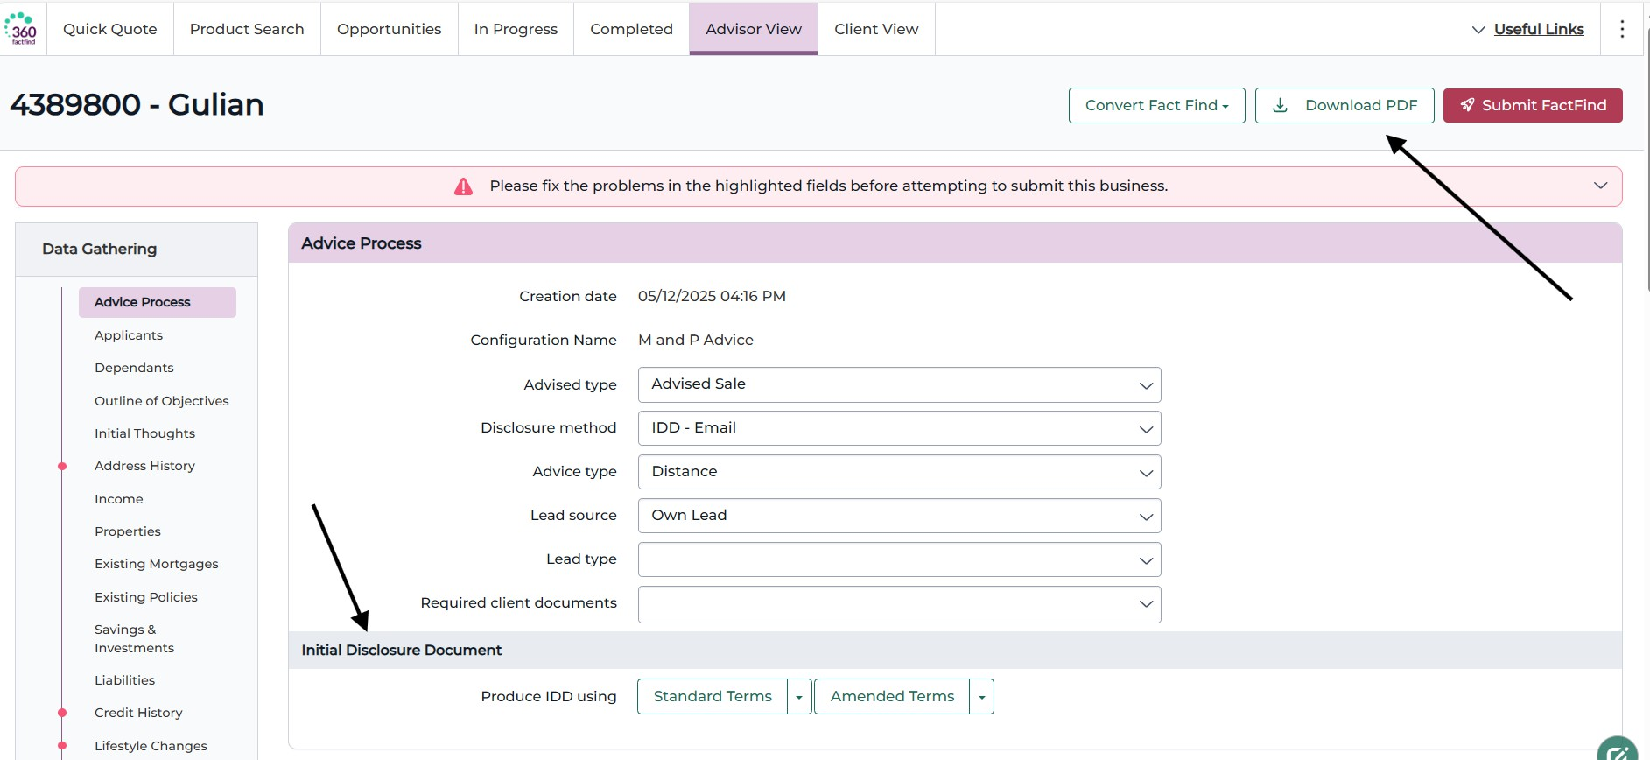
Produce IDD in standard or amended terms and for regulated or unregulated business. Once produced you can then, view or email directly to your client. Please note your default IDD settings need to be entered should you wish to produce IDD
View FactFind as a Printable PDF

Send Invite
360 FactFind provides you with an opportunity to send the FactFind to your client for full or part completion. Clients can also upload documentation as part of this process. You can send invite from either the FactFind ‘Sales Process’ or ‘In Progress’ screens and can do this directly or via the Client Portal.

The client may be invited to complete the FactFind at any stage of the process.
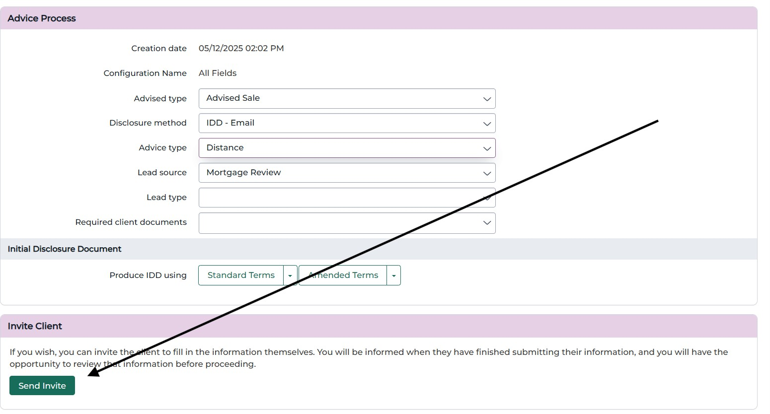

Send invite can be used at any point within the sales process

When choosing ‘Direct Invite’ you will have the opportunity to check and edit any details before sending them to the client.
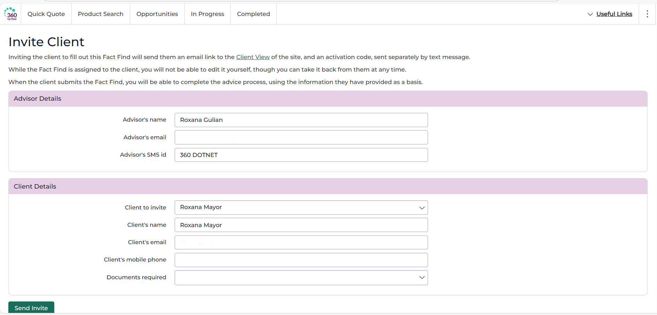

Once you have ensured that the details are correct choosing ‘Send Invite’ will then email your client with a unique link and an activation code by text message so that they can access the FactFind in client view through their own browser and device.
Example of the email and text message which your client will receive:

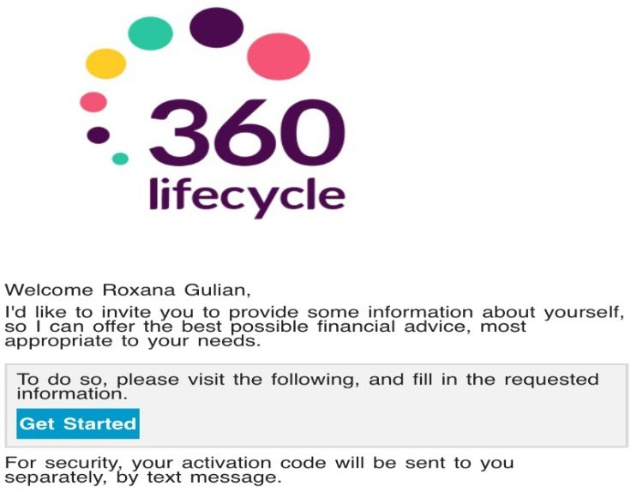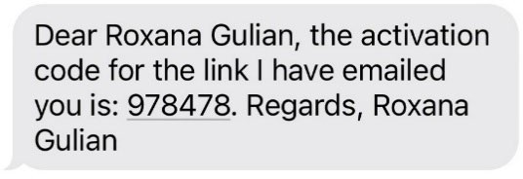

Once the client invite has been sent you will notice the ability to ‘Edit FactFind’, ‘Invite Client’, Refer’ or delete/cancel the sales process has been removed. These options would have been replaced with ‘Edit (take back from client)’. The FactFind Status will also show as ‘With Client’.
You can take back control of the FactFind at any stage and any additions or amendments the client has made will not be lost. Once the client has provided as much information as possible and submits the FactFind back, you will then receive an email alert confirming this is the case.
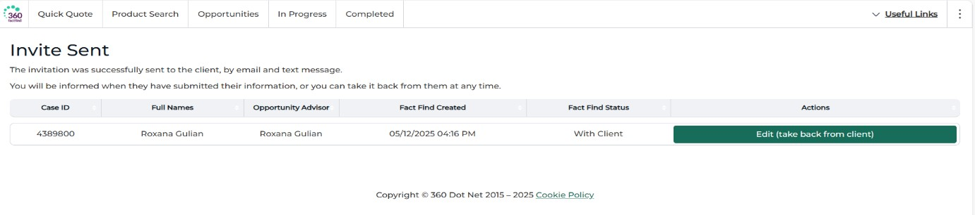
You can regain ownership of the FactFind at any time by choosing ‘Edit (take back from client)’. This action will also be displayed against ‘In Progress’ FactFinds.
You will receive email confirmation once the FactFind has been submitted back from the client.

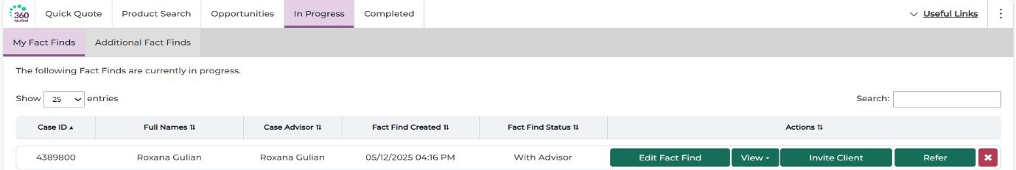

Once the client has submitted, you will again have the ‘Edit FactFind’, ‘Invite Client’, ‘Refer’ and delete/cancel FactFind options available. Re-entering the FactFind will show any updated information and documentation where this has
been provided.

FactFind Completion
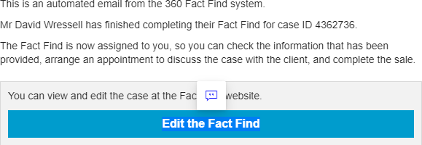
To be able to ‘Submit Business’ and update the 360 Lifecycle case record all mandatory FactFind data will need to be entered. When submitting business, the 360 Lifecycle ‘master’ case record will be
updated with any additions or amendments made in the FactFind e.g. to the client’s personal details, existing policies and recommendations made.
Advisor View
In ‘Advisor View’ each module of the sales process is presented in the process menu on the left-hand side of the work screen and you will know where you are by colour coding of the process menu. The sales process is progressed in a logical order although you can access any of the left-hand menu options at any point.
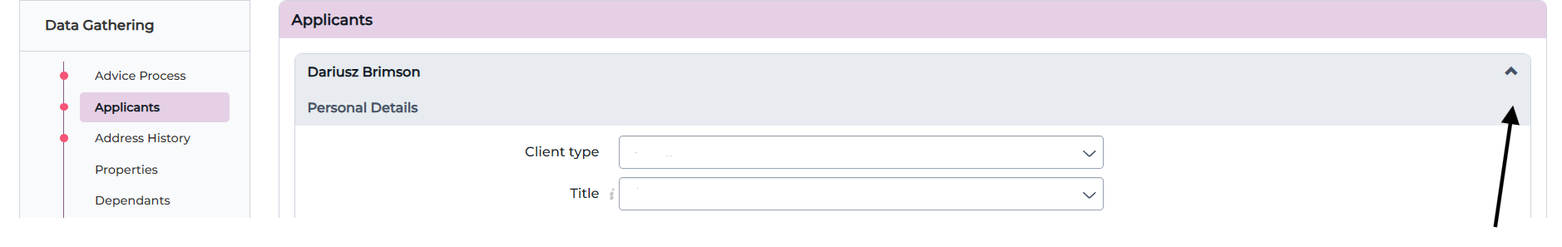
Open or collapse a row from here

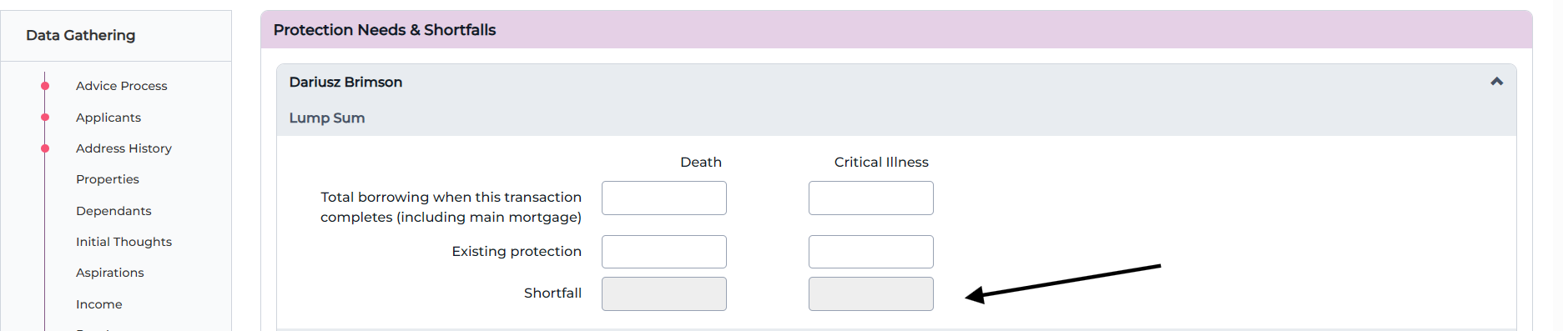
Greyed out fields are ‘Read only’ and are populated from other fields

Client View
You can switch to client view at any time during the sales process by selecting the ‘Client View’ option. Switching to client view will invoke the same user interface as your clients will experience if you invited a client.
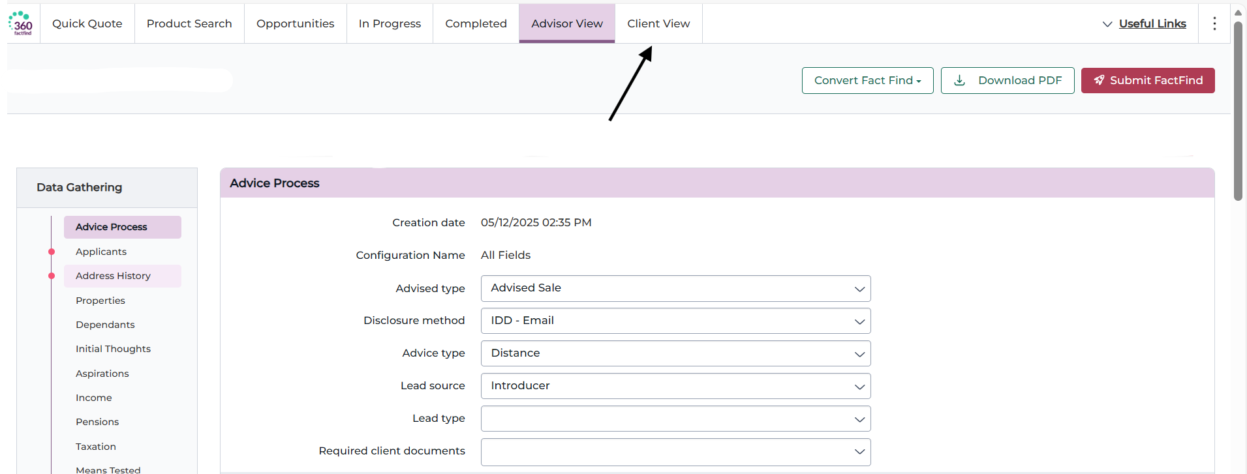

You can switch to client view at any stage within the FactFind

Client view will offer the same FactFind data capture requirements as advisor view although rather than having a left-hand process menu you can navigate through the FactFind stages via the ribbon at the top of the screen. You can switch back to advisor view at any time by choosing ‘Advisor View’.
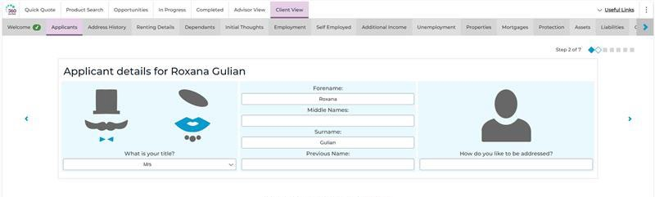

Please note that you cannot carry out sourcing or submit business in client view

FactFind Requirements & Sourcing
360 Lifecycle’s FactFind provides the ability to capture mortgage, life, income protection and B&C requirements with fully integrated sourcing. Please note that the items which have been selected as topics for discussion (see sales process section) will determine what requirements can be captured and sourcing to be carried out against.
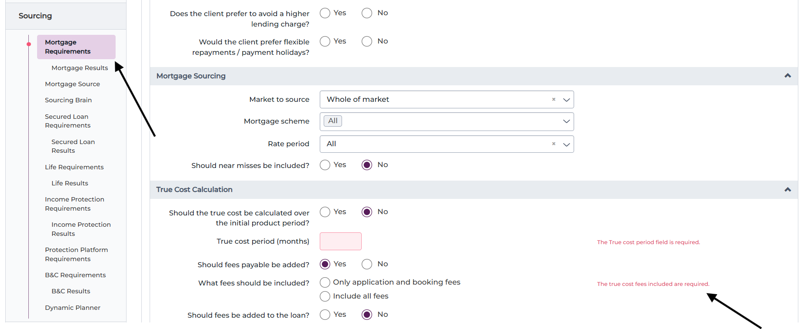

Any mandatory information which is missing will be displayed in red and highlighted on the left-hand menu

You can capture multiple requirements per need area to then carry out sourcing from and select recommendations for. The following screenshots will go through the steps of capturing requirements and displaying results for mortgages and life although it is the same process across all need areas.

Capturing Requirements
To capture requirements within any need area you first need to select ‘Add Requirement’. This will then create a set of data capture fields for which you will need to enter information. There are various menu selection items that will then
drive an additional subset of data capture fields (this is the same throughout the full sales process).
Please use your browser scroll bar to ensure all information within the Requirements screen has been captured before choosing ‘Get Quotes’.
If any mandatory information is missing the mandatory data field(s) will be displayed in red and you will be notified of missing data from the left-hand process menu.

Please note 360 FactFind also features integration with iPipeline’s SolutionBuilder to source multi-benefit products from the life requirements screen. Products that are ‘Flagged’/‘Saved for Later’ or applied for within SolutionBuilder can be retrieved back into FactFind submission sheet and will include all appropriate data and documents.

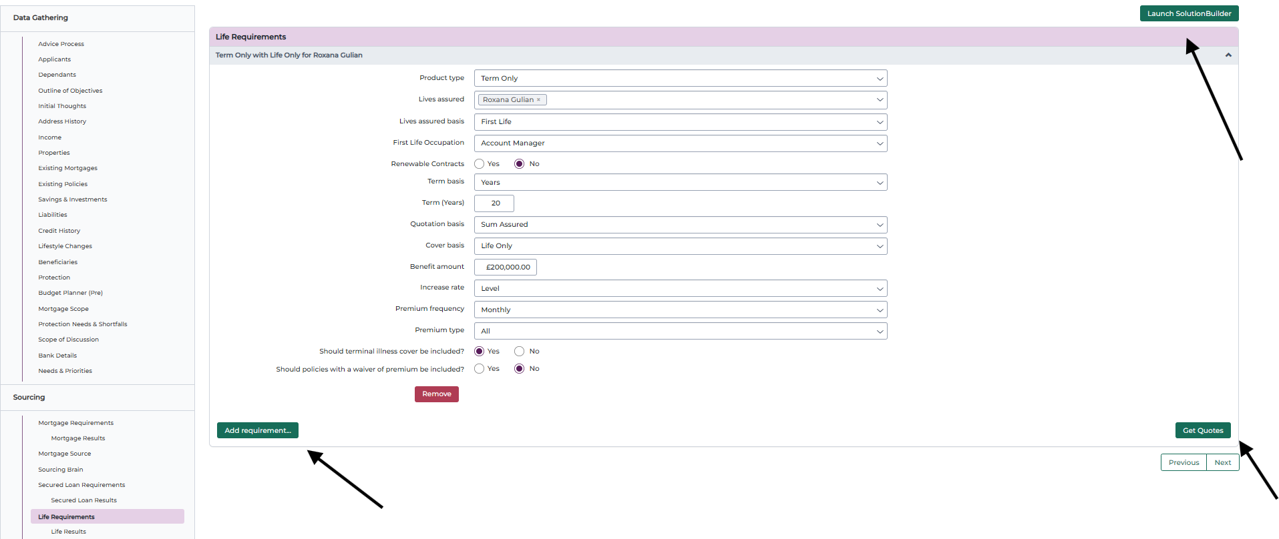
Ability to launch into SolutionBuilder from the life requirements screen. Products that are ‘Flagged’/‘Saved for Later’ or applied for within SolutionBuilder can be retrieved back into the submission sheet

You can add multiple requirements per need area to source against
Choose get quotes to carry out fully integrated Assureweb sourcing from the life requirements screen

Sourcing & Results
Upon choosing ‘Get Quotes’ you will then move forward to the Results. Where multiple requirements are present for a need area then quotations will be displayed for each requirement.
With the integrated sourcing results displayed you will have several options, including, ‘Show Details’, ‘Request Illustration’ and ‘Shortlist’.
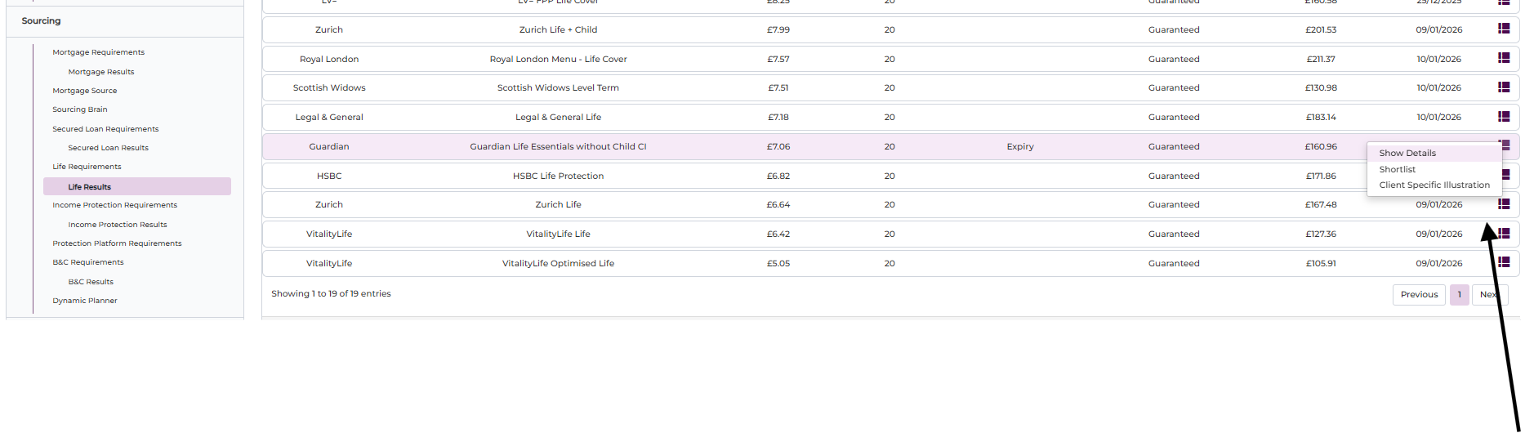

'Left click' against quotation to show details, request illustration, and shortlist
From within each of the results pages you can sort the quotations by any of the column headers, ‘Search’ for a particular product or provider and where applicable display why certain ‘Providers are not Quoting’.

Display reason why certain ‘Providers are not Quoting’
Search for a particular product or provider

Sort quotations by any of the column headers

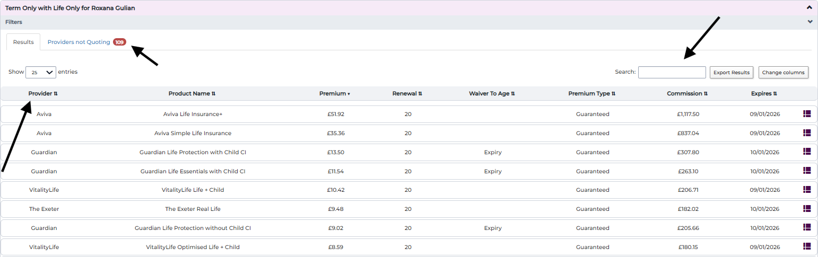
Show Details, Request Illustration and Shortlist
Left clicking against any of the quotations displayed on the Results screen will provide you with the following three options:
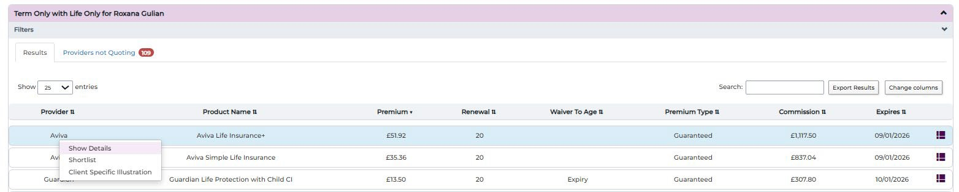

- Show details: This will provide you with some core information regarding the quotation e.g. the provider, product, suitability and commission information.
- Request Illustration: This will allow you to produce an immediate illustration for usage. Any Illustrations produced directly from the Results will automatically be uploaded to the 360 Lifecycle case record document repository.
- Choosing Shortlist copies the quotation details into the Submission Sheet, where you can later mark them as Chosen. You may shortlist multiple quotations for each requirement.

Submission Sheet
Any quotations for which you have shortlisted from within the sourcing results will be displayed on the Submission Sheet Quotations page. The submission sheet will allow you to select any quotations as ‘Chosen’ and again with the ability to either ‘Show Details’, ‘Request Illustration’ or ‘Remove’. Where present you can also
directly ‘Apply’ for a product and ‘Retrieve Quotes’ carried out via the integration
with SolutionBuilder.

Selecting ‘Chosen’ will copy the quotation details as a recommendation into the relevant product area. Submission Sheet however will also provide you with the option to add manual recommendations.

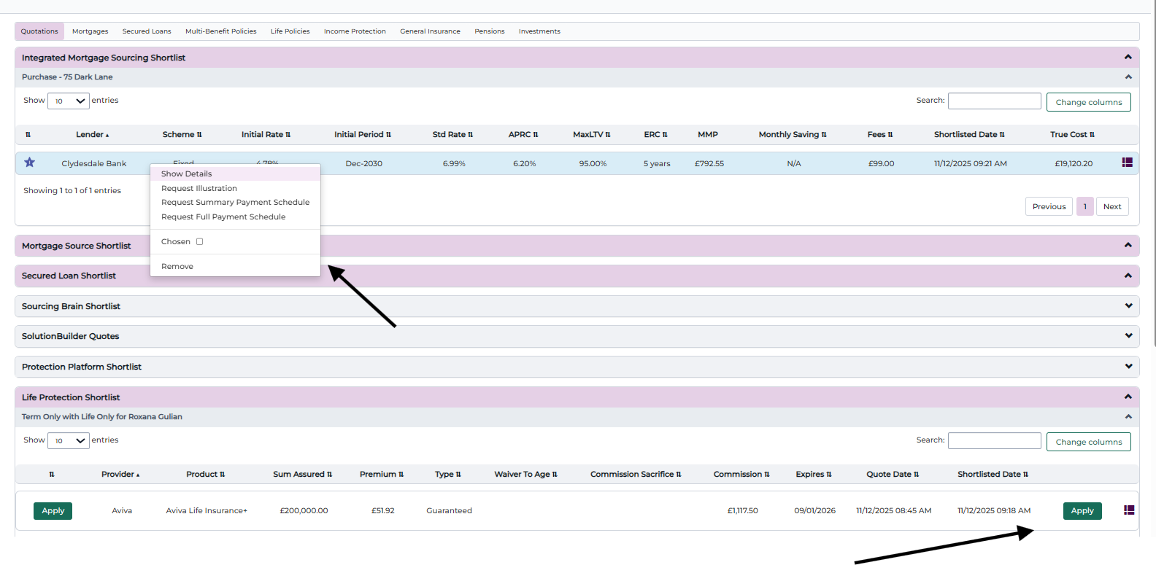
Left 'click' against a quotation to show details, request illustration, request summary payment Schedule, request full payment schedule, select as chosen or remove

Ability to apply directly with the provider for a shortlisted product

Show Details, Request Illustration, Chosen and Remove
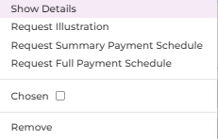
Left clicking against any of the shortlisted quotations will provide you with the following:
- Show details: This will provide you with some core information regarding the quotation e.g. the provider, product, suitability and commission information.
- Request illustration: This will allow you to produce an immediate Illustration for usage. Any illustrations produced will automatically be uploaded to the 360 Lifecycle case record document repository.

- Chosen: Selecting ‘Chosen’ will copy the quotation details into the relevant product area of submission sheet. For example, selecting ‘Chosen’ against a shortlisted mortgage quotation will copy the details into the mortgages section of submission sheet (see screenshots below). Any quotations for which you select as ‘Chosen’ can visible through colour coding. Selecting chosen will also copy the quotation details as a recommendation into the relevant need/product area.
- Request summary payment schedule: This will generate a condensed schedule showing the key payment milestones for the quotation. The file produced will be automatically downloaded on your computer and uploaded to the 360 Lifecycle case record document repository.
- Request full payment schedule: This will generate a detailed schedule outlining all individual payments associated with the quotation. The full schedule includes every instalment, amount, and date, providing a complete breakdown of the repayment plan. The file produced will be automatically downloaded on your computer and uploaded to the 360 Lifecycle case record document repository.
- Remove: Remove from the shortlisted quotations.
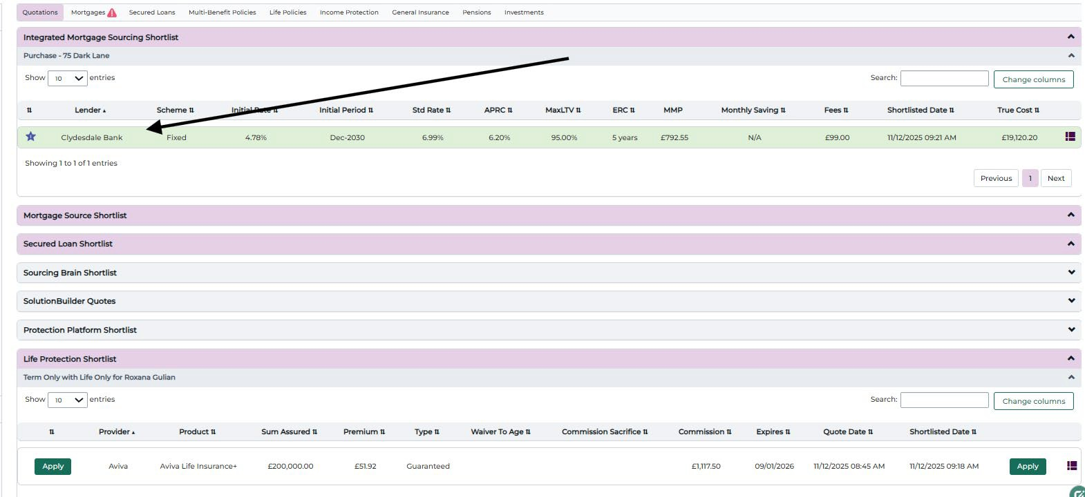
Chosen quotations will be visible through colour coding

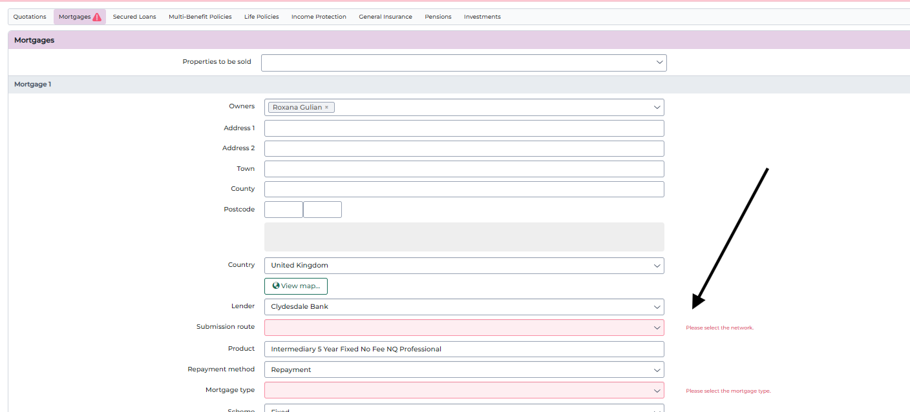

Any missing mandatory policy information will be shown in red

Retrieving SolutionBuilder Quotes
Any products that were ‘Flagged’/‘Saved for Later’ or applied for via the SolutionBuilder integration can be retrieved back into submission sheet by selecting ‘Retrieve Quotes’.

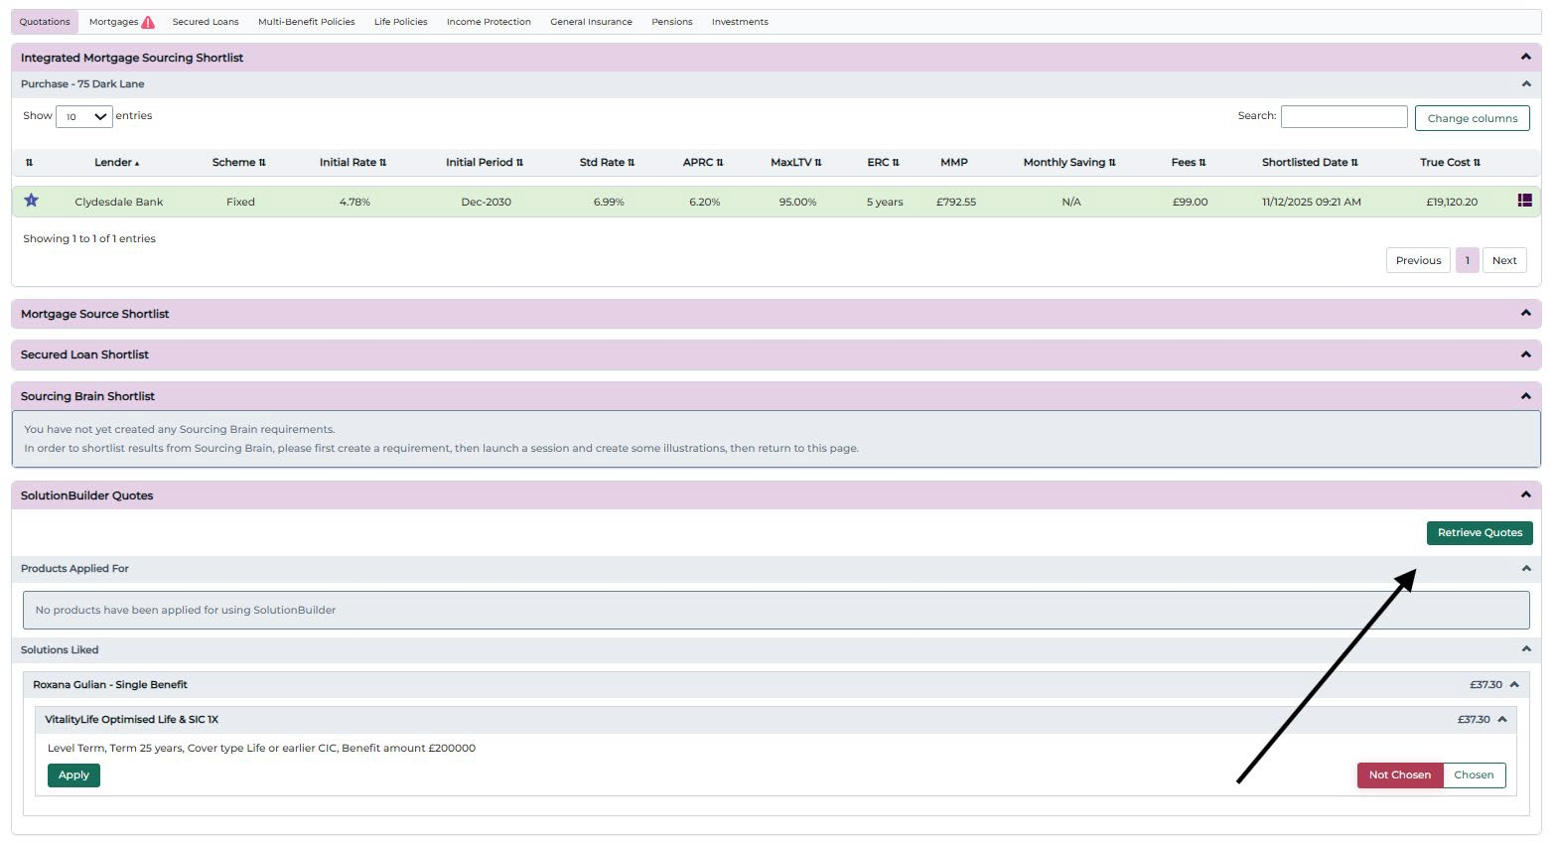
In the submission sheet you can retrieve quotes for products that were 'Flagged' and 'Saved for Later' or applied for via the SolutionBuilder integration

Once any previous SolutionBuilder quotes have been retrieved selecting ‘Chosen’ will copy the quotation details as a recommendation into the relevant product area.

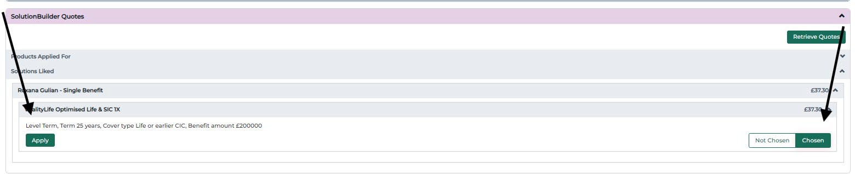
Ability to apply for a retrieved Selecting chosen will copy the
SolutionBuilder product
quotation as a recommendation into
the relevant need/product area

Manually Adding a Recommendation
If you have not completed any integrated sourcing within the FactFind or are applying for a product which you did not ‘Shortlist’ then you can manually add a recommendation within submission sheet.
To do so first navigate to the need/product area that you wish to add the record against, upon where you will find the ability to ‘Add’. You will then need to complete the policy information for the product you are recommending. If any mandatory data is missing, you will be notified of this from the process menu, and the data items will be shown in red.
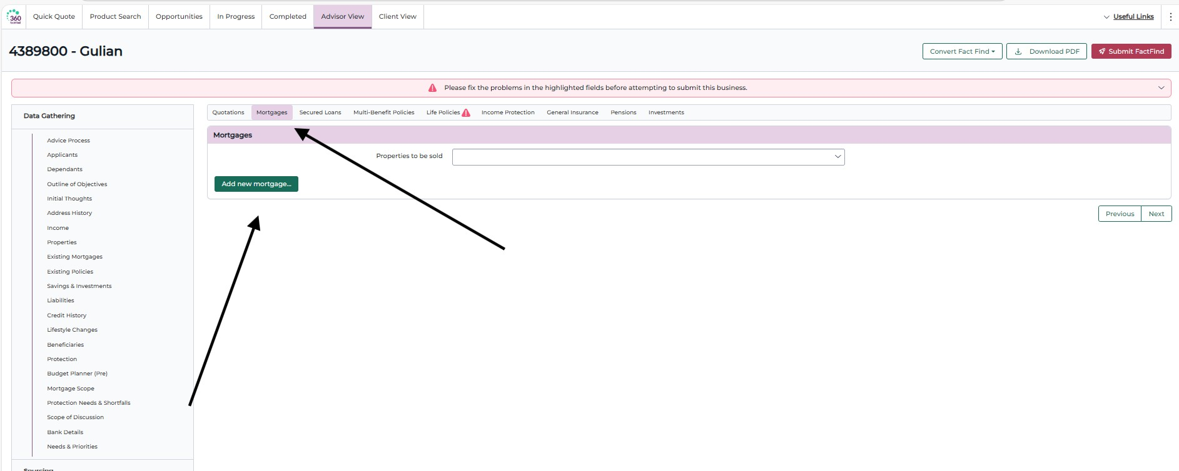

Navigate to the required need/product area and then choose 'Add New Mortgage'

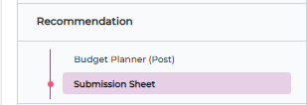
Complete the required data items of the product you are recommending. When mandatory information is incomplete, the system will add a red dot next to the relevant section in the submission sheet. A notification
box will also appear at the top of the page, prompting you to provide the missing details for the recommended product and breaking down each section that requires your attention.

Any field needing completion will first flash briefly to draw your attention and then remain highlighted in red until corrected.
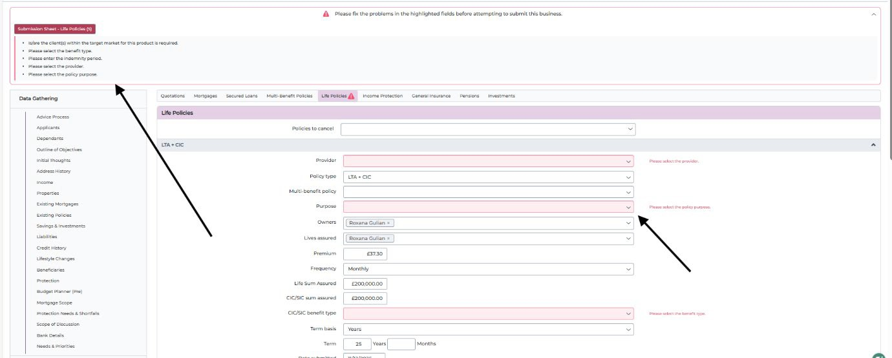
Complete the required data items of the product
you are recommending
Missing mandatory
data will be displayed

Documents
A copy of all sales process documentation which has been generated via the FactFind will be automatically saved against the 360 Lifecycle case record. This includes the produced IDD, Illustration(s), sourcing and shortlisted results.
Accessing documents from the left-hand process menu will allow you to check or reopen any of the existing case documentation which has been previously produced and uploaded or ‘Rename’, ‘Delete’ and ‘Download’. You will also be provided with the ability to add/‘Upload’ any new documents to the case record.

Ability to rename, delete or download any of the existing documents
Ability to manually search for docs

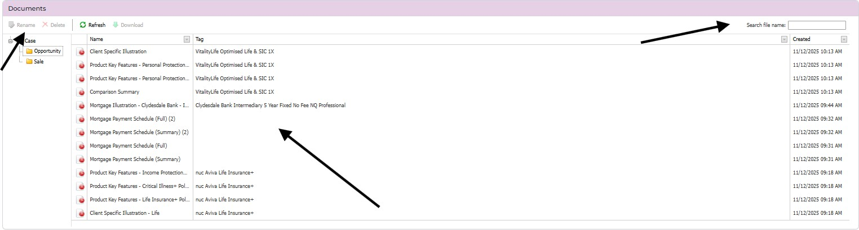
All existing case, opportunity and sale documentation, either produced through FactFind or manually uploaded will be visible

Upload Documents
As well as being able to make changes to existing documentation you can also
‘Upload’ new case documents from within the FactFind.

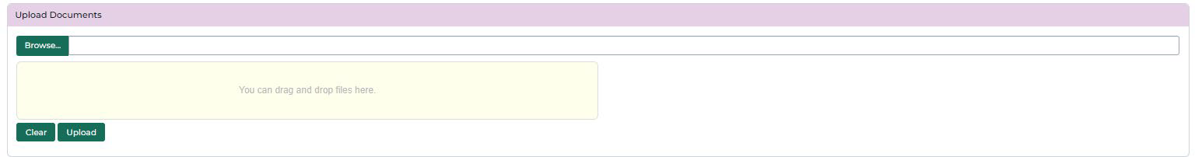

Choose to upload to either the case, opportunity or sale folder. Either browse to open a separate window or ‘drag and drop’. Select upload to import the document(s) into the case record.

Notes
You can add multiple notes against any page of the FactFind. Notes can be added or edited at any time until you have chosen to ‘Submit Business’ or cancel/delete the FactFind.

Add Note
To add a note at any stage of the FactFind process first navigate to the page for which you would like to record your notes. From the right-hand corner select the ‘Add Note’ icon. These can be added to the side of every page, or against an individual section, such as ‘Employment Income’. Notes will sit on the PDF at the end of the relevant section they are added to.
Enter or edit your free text notes within the pop-up window. If required, the note can be removed by clicking on X.

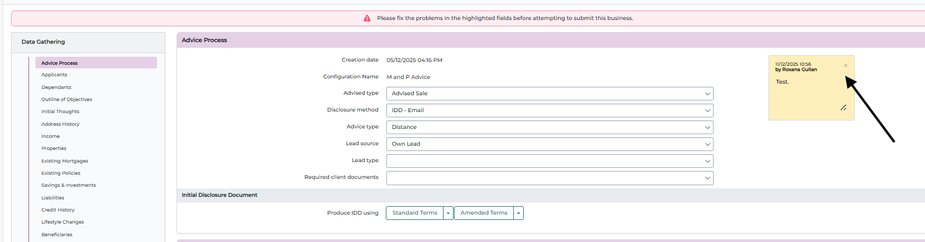
Multiple notes can be added against any section/page of the FactFind. Where notes are present, they will show on the right-hand side of the page.

All Notes
Selecting ‘All Notes’ from the left-hand menu displays all notes which have been recorded within the sales process and shows which page of the FactFind they are

recorded on. From here you can edit or delete a note which is already present.
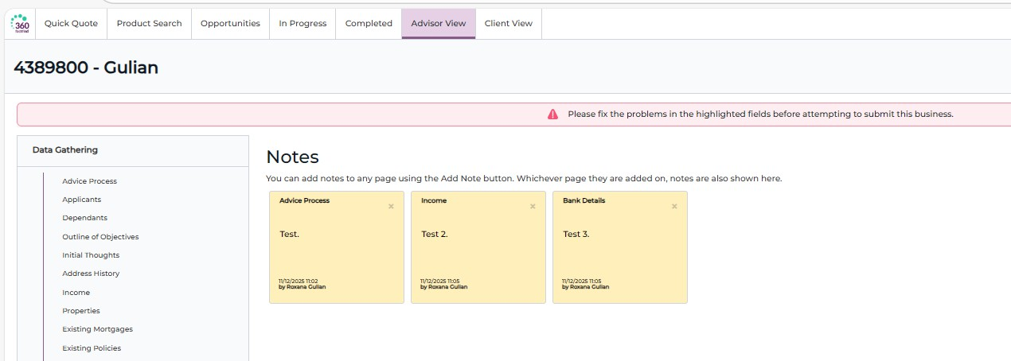

Submit Business
Once all mandatory FactFind data has been entered and you can complete the sales process you can then ‘Submit Business’. This will close off the FactFind so that no further changes can be made and update the ‘master’ 360 Lifecycle case record with the information entered and changes which have been submitted. You can clearly see once all mandatory data has been entered and when you can successfully submit business from the colour coding on right hand process menu at the top of the page.
Once all mandatory data is entered the submit business label will change from red to green.
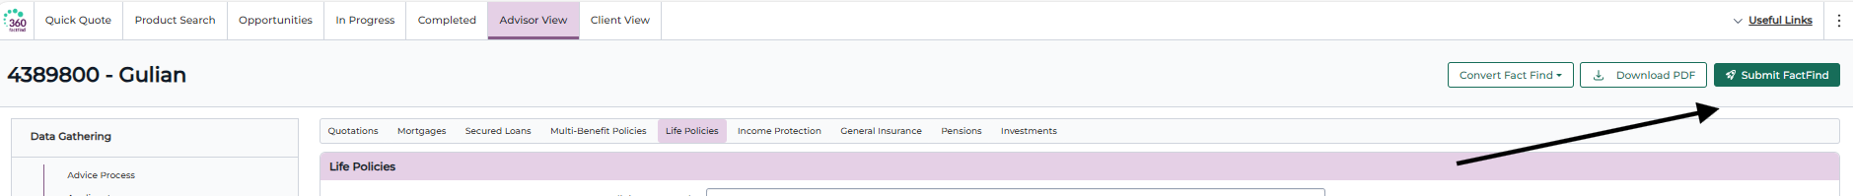
On choosing ‘Submit Business’ you will be asked to confirm whether you wish to continue with the FactFind completion
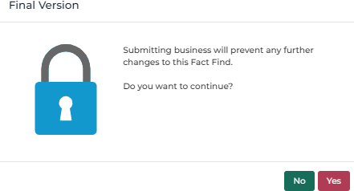

On selecting ‘Yes’ to confirm the submission of business you will be provided with confirmation that the FactFind has been completed and can no longer be edited. At this point the ‘master’ 360 Lifecycle case record would have been updated with the applicable information and the FactFind will be moved from ‘In Progress’ to ‘Completed’ and Outstanding Reports. From here you are presented with several options.
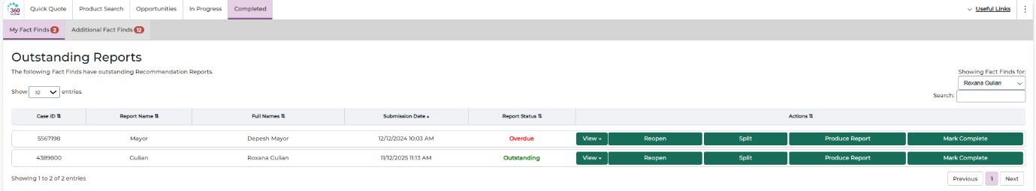
- View: This will open a PDF copy of the completed FactFind.
- Reopen: Choosing Reopen will create a new and fully editable ‘cloned’ copy of the original FactFind. The newly cloned FactFind will be attached to a new opportunity against the 360 Lifecycle case record named ‘Reopened Sales Process’.
- Split: Creates a new Opportunity against the same case which you can then refer.
- Produce report: This will launch the Recommendation Report builder for generation of the Suitability Letter.
- Mark complete: This will allow Outstanding Recommendation Reports to manually be marked as complete e.g. if the recommendation report has been completed outside of the FactFind.

Updates To The 360 Lifecycle Case Record
Once you have successfully submitted business the FactFind will no longer appear as ‘In Progress’ and will show within ‘Completed Outstanding Reports’ until a Recommendation Report has been completed. On confirming Yes to the submission of business the ‘master’ 360 Lifecycle case record is also updated. Some of the updates and changes made to the 360 Lifecycle case record are shown below:
  - The case record will include updates to the client Personal Details and a new sale event created with the ‘Chosen’ policy records.

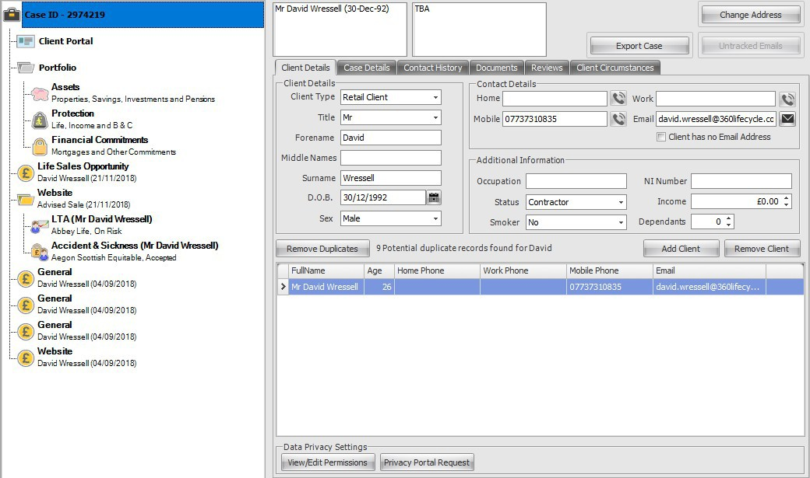

  - Any existing arrangements will be added to the ‘Portfolio’ section of the case record.
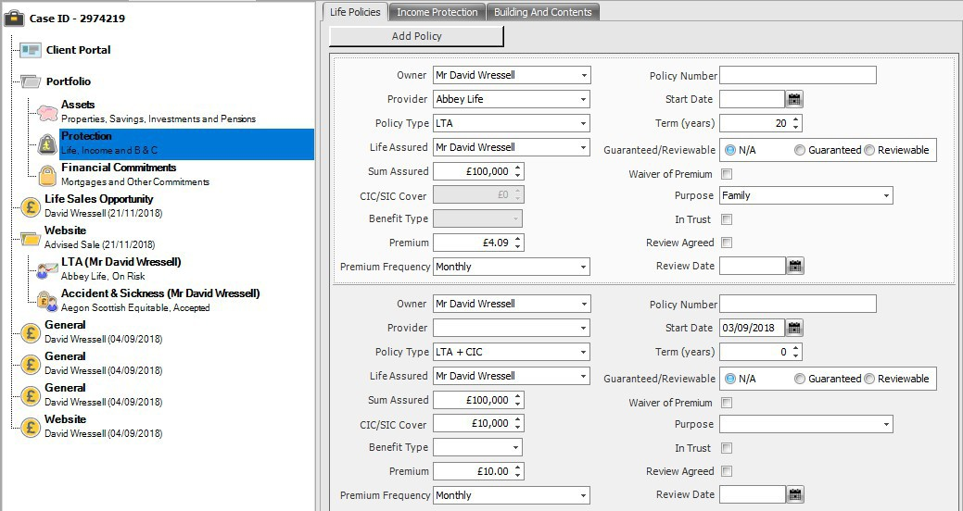

  - All sales process documents produced through the FactFind will be automatically uploaded to the 360 Lifecycle case record e.g. electronic IDD, Illustration(s) and shortlisted sourcing results etc.

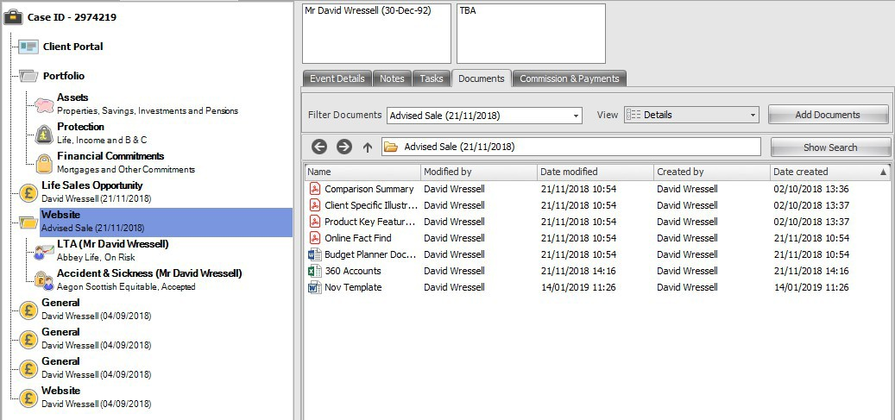

For further information on the 360 Lifecycle case record please refer to the other 360 Lifecycle navigation guides.

Recommendation Report
On successfully submitting business and completing the FactFind you will then be able to produce a Recommendation Report by choosing ‘Produce Report’. You can only produce a recommendation report against a FactFind which shows within ‘Completed Outstanding Reports’.
You can only produce the recommendation report once the FactFind has been completed. You must choose ‘Produce Report’ to launch report builder.
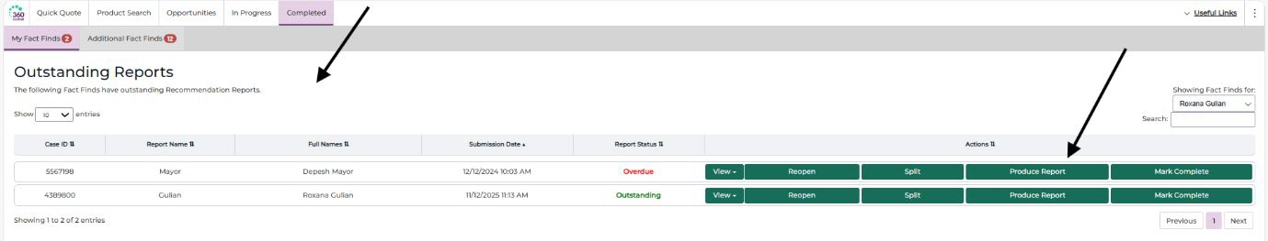
Choose produce report to

You can only produce the recommendation report once completed
launch the report builder

Selecting ‘Produce Report’ will first direct you to the report builder upon where you can select which paragraphs you wish to include in the report.

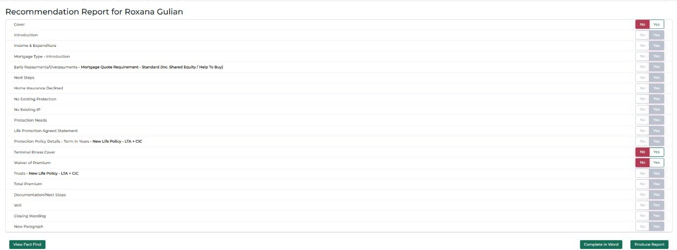
Select No or Yes to determine if the paragraph is in the scope to be included. Once you have selected the relevant paragraphs to be included you can then

‘Produce Report’.
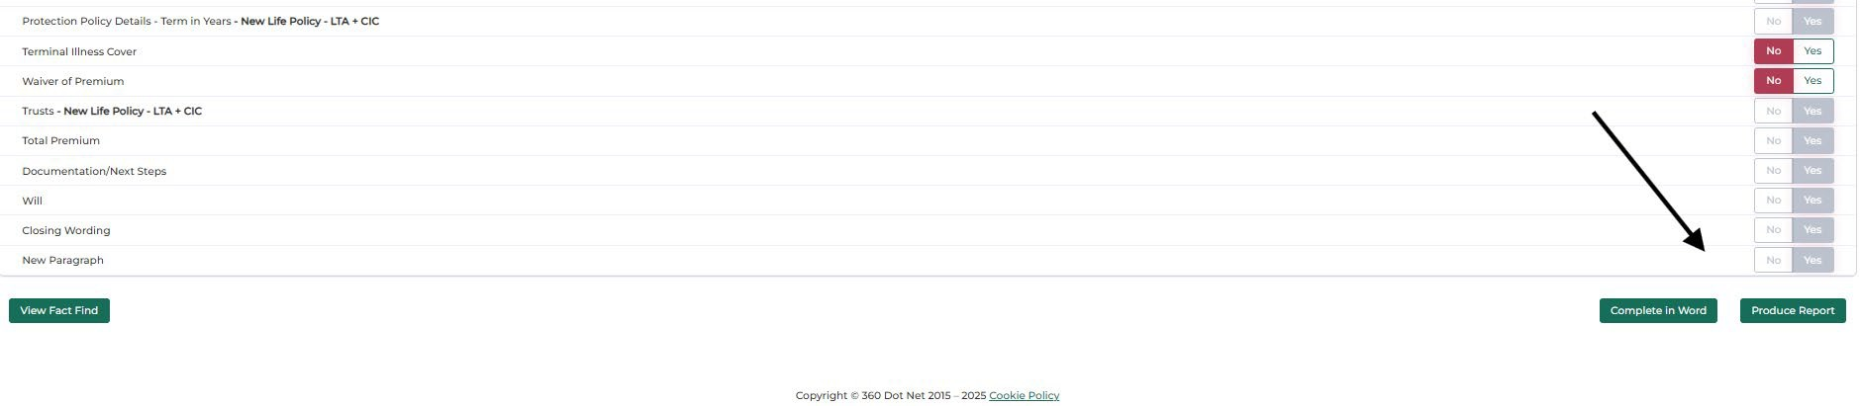

Produce report once all necessary paragraphs are in scope

The fully editable recommendation report will be launched.
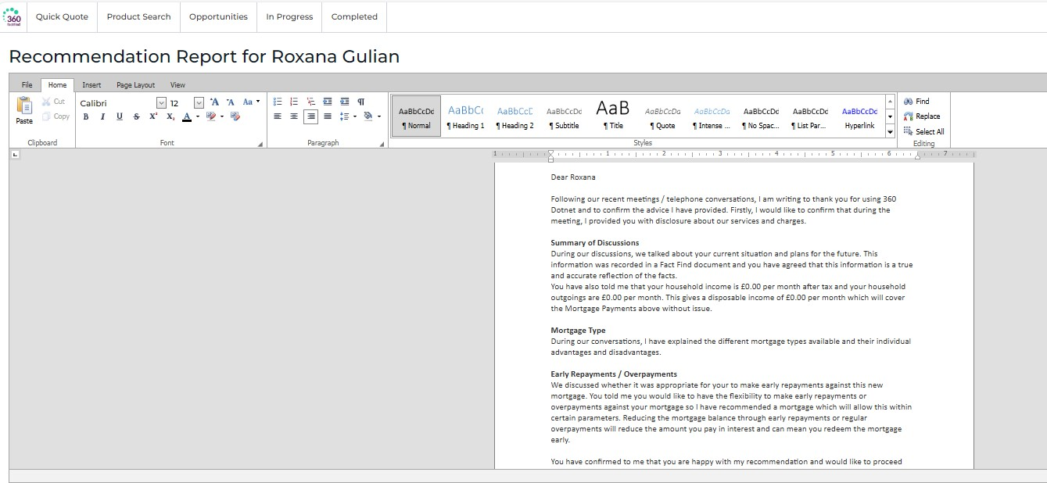

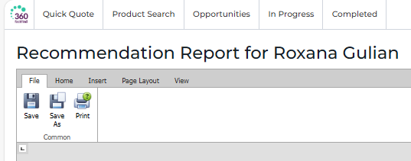
You can change save or save as to export to another format e.g. Word or print.

Any text requiring completion can be highlighted. You can use the scroll bar to navigate and make changes where necessary.
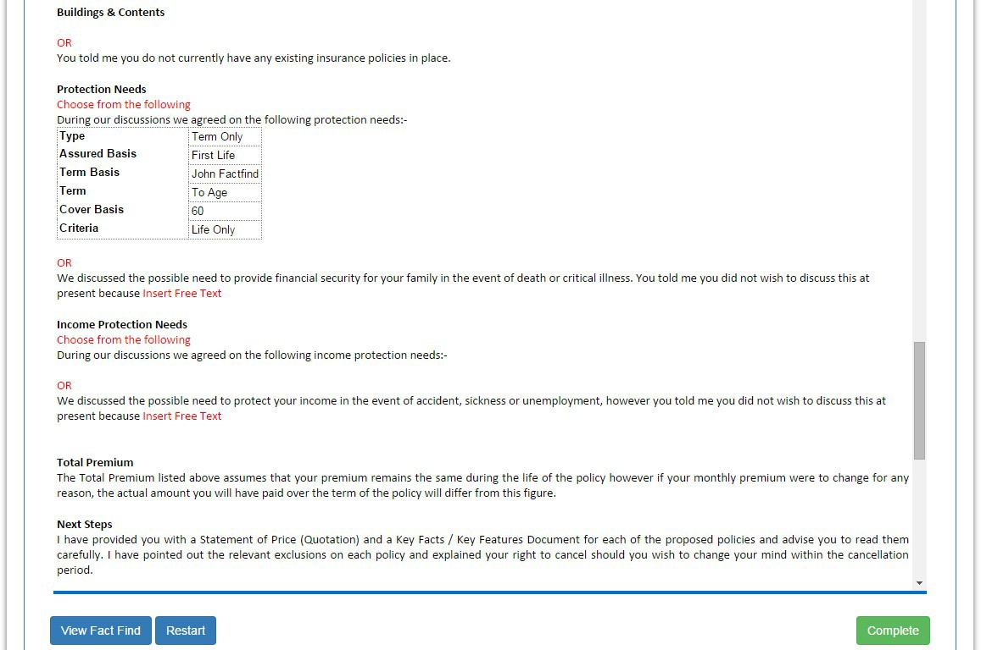
Text requiring completion
will be highlighted in red
Use the scroll bar to navigate the report
Complete to generate the finalised report

View FactFind will launch the FactFind as a PDF document. Restart will remove any changes.

Once you have made the necessary amendments to the Recommendation Report choose complete where you will be asked to confirm if you would like to continue.
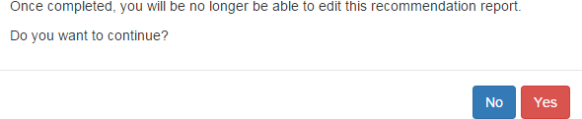

Selecting ‘Yes’ to the completion will upload a copy of the recommendation report to the documents section of the ‘master’ 360 Lifecycle record and move the case into ‘Completed/Completed Reports’.
- View: Will open a PDF copy of the FactFind
- Reopen: Will launch a newly cloned FactFind
- Split: Creates a new Opportunity against the same case which you can then refer
- Download report: To open a PDF copy of the Report
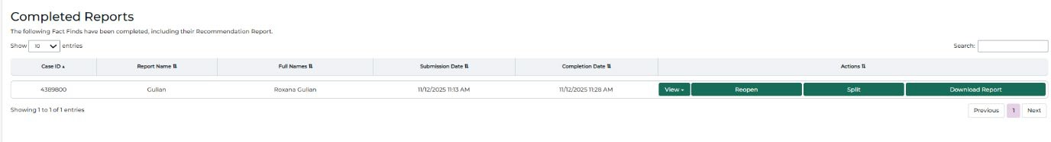

Creating or Amending Recommendation Report Templates
The recommendation report paragraph selection items and associated wording are pulled through from the information which is captured in the recommendation report template. The recommendation report template can be accessed by logging into 360 Office, however, please note that anyone accessing the recommendation report template will themselves need the role of either ‘System Administrator’ or ‘Compliance Managers’.

Getting Started
Login to 360 Office from the shortcut on your desktop. Once 360 Lifecycle has opened click onto the ‘Maintenance’ tab to access ‘Compliance’. From here choose ‘Setup Recommendation Report’ and select ‘Online FactFind’.
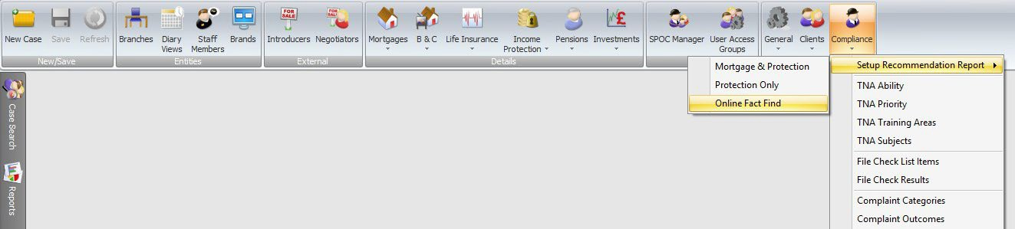

In 360 Office select maintenance > compliance > setup recommendation report and ‘Online FactFind’. You will then be taken to the recommendation report template and where any existing templates will be displayed within the content tab.
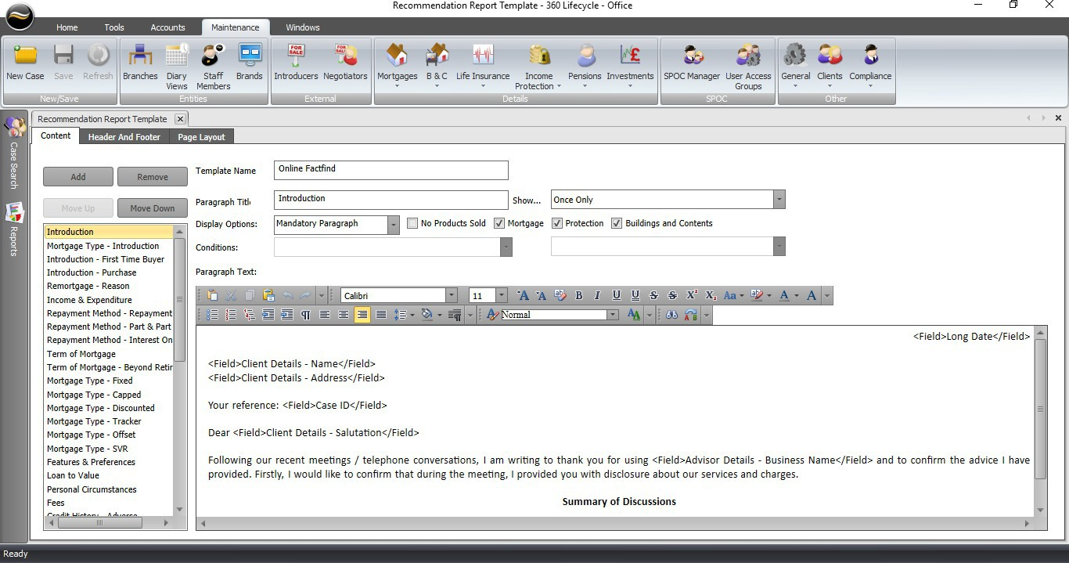

Amending Recommendation Report Content
The content tab will provide you with access to create, remove and re-order any recommendation paragraphs. Each paragraph will have its own ‘Title’ and associated wording which is then displayed when producing the report within FactFind. Paragraphs can be set to show as ‘Once Only’ or multiple times for each submission item e.g. ‘For Each Mortgage’. You can choose which submission product(s) a paragraph relates to by ticking either ‘Mortgage’, ‘Protection’, ‘Buildings & Contents’ or ‘No Products Sold’. Finally, you can choose whether the paragraph should be set as ‘Mandatory’, ‘Optional’ or ‘Conditional’ from selecting the relevant ‘Display Options’. Please note that where a paragraph is set as ‘Conditional’ the applicable ‘Conditions’ will then need to be set.

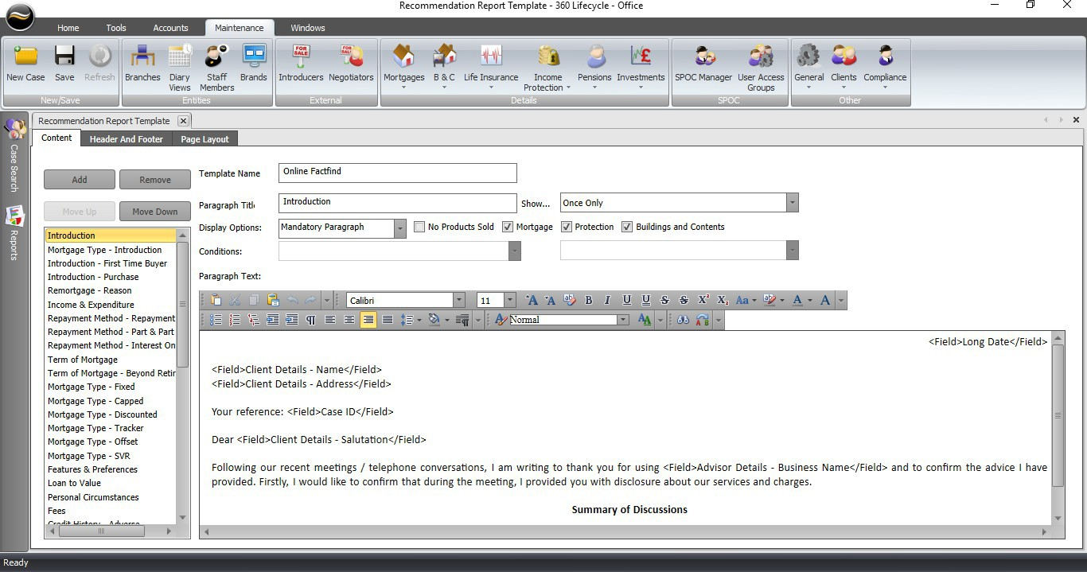
Click ‘Save’ after making any changes
You can Add or Remove paragraphs and reorder by choosing Move Up or Move Down. This is the order the paragraphs will be displayed on the FactFind.
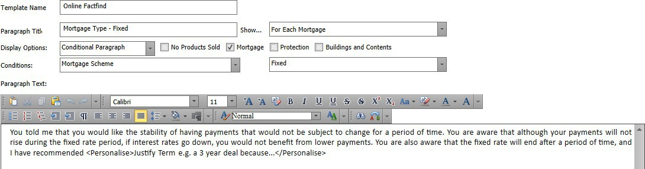
- Paragraph title: Paragraph name which will show in FactFind.
- Show: Either ‘Once Only’ e.g. Introduction paragraph or for each product entered in submission sheet e.g. ‘For Each Mortgage’.
- Display options: Tick Product(s) the paragraph relates to. Select if the paragraph is ‘Mandatory’, ‘Optional’ or ‘Conditional’. Where ‘Conditional’ then what ‘Conditions’ need to be met. Please note that mandatory or conditional paragraphs cannot be deselected when choosing produce report in FactFind.
- Paragraph text: Wording which is associated to the paragraph and that will be pulled through to the FactFind recommendation report.

When amending the ‘Paragraph Text’ you can include merge fields and have access to various editing tools e.g. ability to choose font name, size and colour etc.
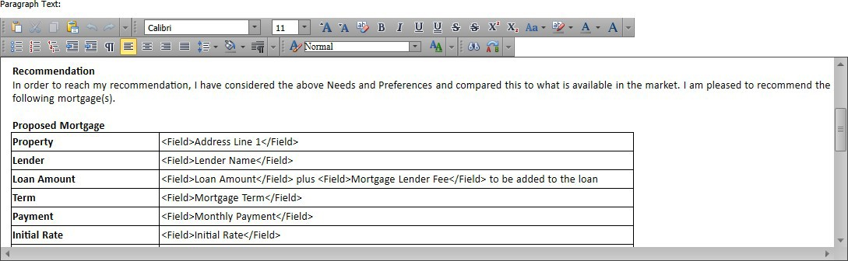

Choose font name, size and colour etc. via the ribbon with various editing tools
Merge fields can be included by ‘right clicking’ within the paragraph text. ‘Insert Field’ provides individual merge items e.g. mortgage initial rate. ‘Insert List’ will group multiple merge items and list together within the recommendation report (see below chart).

Header and Footer
You can include a header and footer within the recommendation report template. Please note that you can paste images into the template or choose the ‘Branding Image’ merge field. This will then display the uploaded image (found in Staff members) of the individual who produces report.
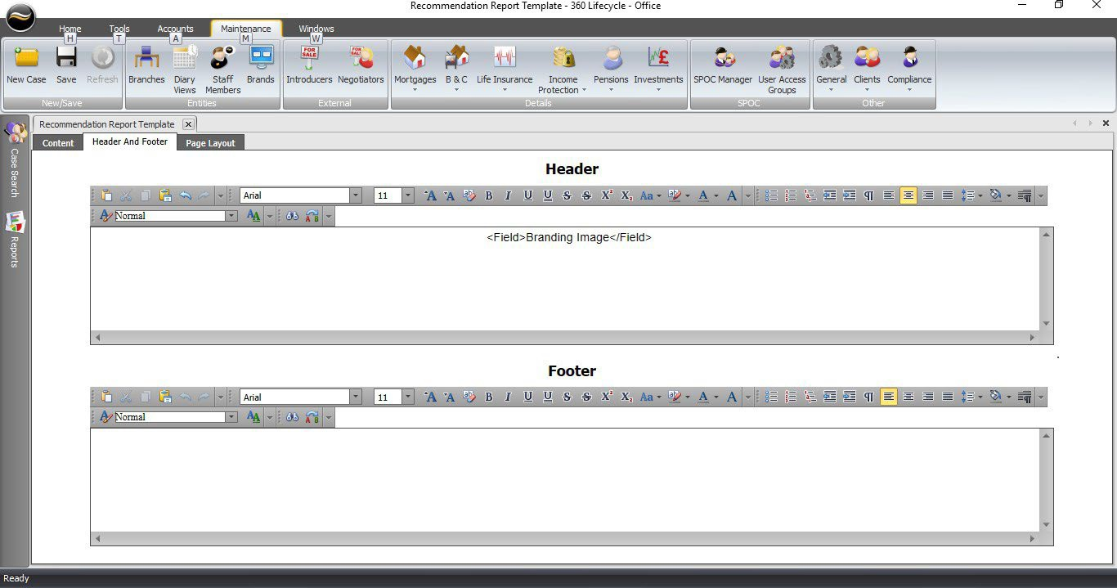

Page Layout
If desired the recommendation report margins can be altered within page layout.
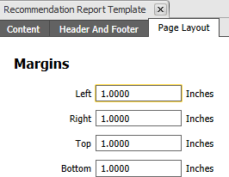

Amending Recommendation Report Content with the ‘Report per FactFind Template’ Editor

NOTE: if one of these templates is not populated, you will automatically get the report produced from the template edited above.
The Content tab will provide you with access to create, remove and re-order any recommendation paragraphs. Each paragraph will have its own ‘Title’ and associated wording which is then displayed when producing the report within FactFind. Paragraphs can be set to show as ‘Once Only’ or multiple times for each submission item e.g. ‘For Each Mortgage’. You can choose which page in the FactFind configuration you are working with by selecting an entry from the ‘Page’ dropdown. All paragraphs will be assumed to be ‘Mandatory’, unless you tick the ‘Optional’ checkbox, or add in a ‘Condition’ based on the page you are working against, e.g. submission sheet.

N.B. some pages do have additional ‘Sections’ included (see FactFind Configuration for more detail) – meaning you can filter these further if required,

e.g. Income ‘Page’, Self Employed ‘Section’

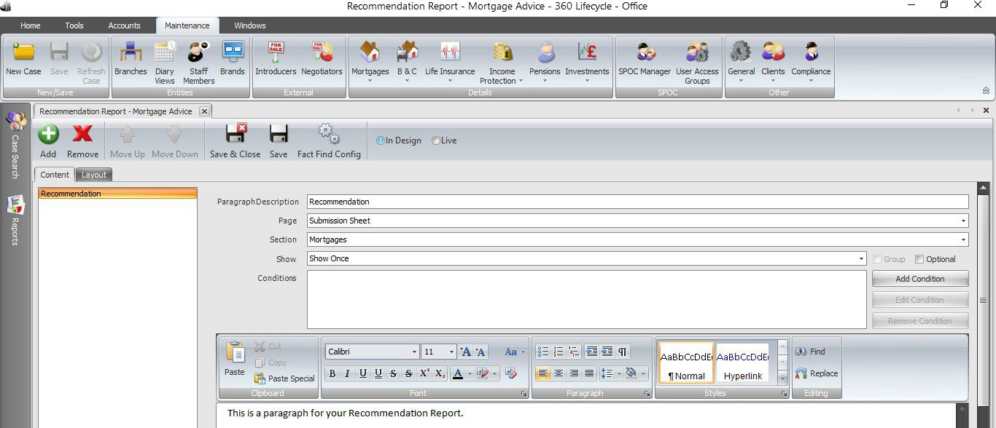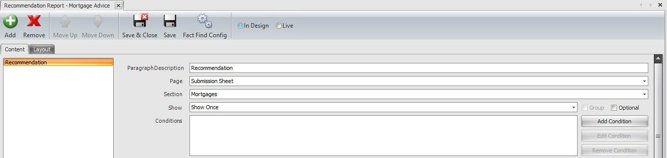
Choose ‘Save’ after making any changes
You can add or remove paragraphs and reorder by choosing move up or move down. This is the order the paragraphs will be displayed within
the FactFind.

- Paragraph description: Paragraph name which will show in FactFind.
- Show: Either ‘Once Only’ e.g. Introduction paragraph or for each product entered in submission sheet e.g. ‘For Each Mortgage’.
- Page: Select the page of the FactFind you want this paragraph to link to.
- Section: This would appear if the page selected has multiple sections.
- Add condition: Here you can add conditions based on the page you are linked to, e.g. page = submission sheet, section = mortgages, conditions will look at the fields on the mortgages tab of the submission sheet of the FactFind.
When amending the ‘Paragraph Text’ you can include merge fields and have access to various editing tools e.g. ability to choose font name, size and colour etc.

Choose font name, size and colour etc. via the ribbon with various editing tools
Merge fields can be included by ‘right clicking’ within the paragraph text. ‘Insert Field’ provides individual merge items e.g. mortgage initial rate. ‘Insert List’ will group multiple merge items and list together within the recommendation report (see below chart).

Layout
You can include a header and footer for all your trading styles (if applicable) within the recommendation report template. Please note that you can paste images into the template or choose the ‘Branding Image’ merge field. This will then display the uploaded image (found in staff members) of the individual who produces report. From here you can also edit the margins on your report template.
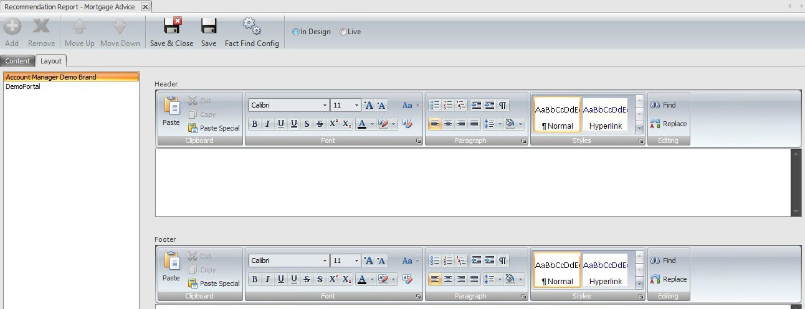

N.B. these templates are configured PER FactFind you have created within 360. This means if you want a template for each of these, they will need to be added in. If you require these to be copied from one template to another, please contact our Support team.

FactFind Configuration
Within 360 Lifecycle, you can configure your own versions of the FactFind. Within these versions, you can remove tabs and sections from within these, as well as re-order these where necessary.
You can create as many versions of the FactFind as you need and convert these throughout the Sales Process if circumstances do change.

Adding, Amending and Removing FactFinds
Within 360 Office, you can add new, amend or remove existing FactFinds. This section can be in the maintenance tab, under the compliance dropdown shown below.
Once you click on this, you will be greeted with the following screen, which will house all the current versions of the FactFind you have created.
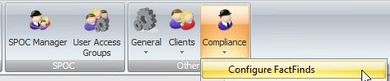
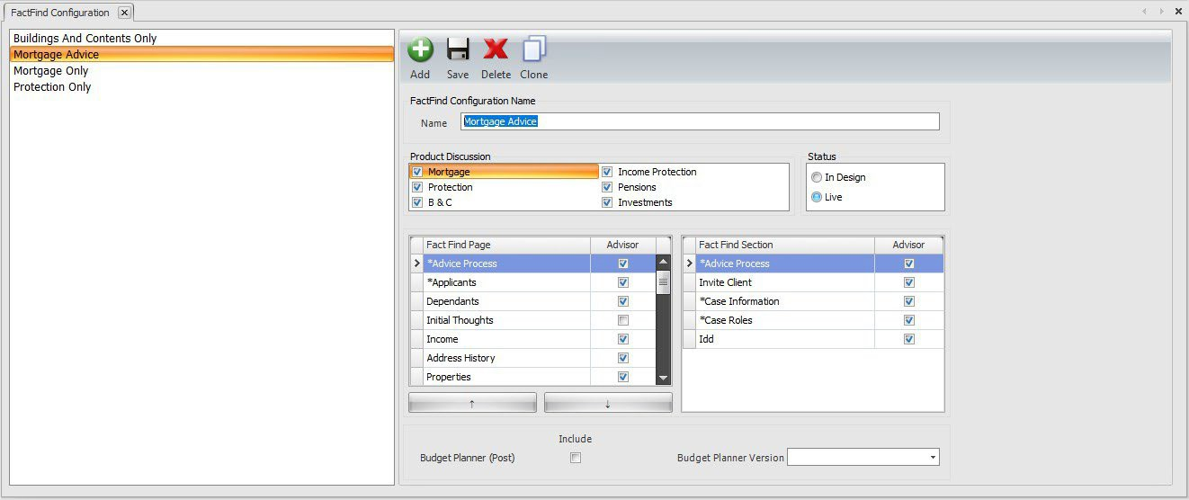

The options above the configuration screen itself allow you to do the following actions:

- Add: This will create a blank configuration screen for you to create a brand new version of the FactFind.
- Save: This will save any amendments made to the version you have selected.
- Delete: This will remove the selected FactFind version. Please contact the Support team if you wish to do this.
- Clone: This will create a carbon copy of the selected FactFind version and create a new one under the same name, with a suffix on Clone. For example, if you were to clone the ‘Mortgage Advice’ FactFind, a new version would be created called ‘Mortgage Advice Clone’.
Each FactFind will have its own ‘Name’, which will be visible to those creating FactFinds via the Hotbox, the FactFind, or converting to a different version mid sales process.
You then can tailor the ‘Product Discussion’ within that FactFind. This will allow you to pick a combination of ‘Mortgage’, ‘Protection’, ‘B&C’, ‘Income Protection’, ‘Pensions’ and ‘Investments’. This also dictates the sections shown in the ‘Submission Sheet’ tab of the FactFind. You can have as many or as few selected as you want. Below is a run through as to what these pages will show:
- ‘Mortgage’: Having this section ticked will make the mortgage requirements/results, secured loan requirements/results pages available, along with the tabs to add mortgage & secured loan policies on the submission sheet. This is also the only product discussion that will require a minimum of 3 years address history.
- ‘Protection’: Having this section ticked will make the life requirements/results pages available, along with the tab to add life policies on the submission sheet.
- ‘Income Protection’: Having this section ticked will make the Income protection requirements/results pages available, along with the tab to add income protection policies on the submission sheet.
- ‘B&C’: Having this section ticked will make the B&C requirements/results pages available, along with the tab to add general insurance policies on the submission sheet.
- ‘Pensions’: Having this section ticked will show the tab to add pension policies on the submission sheet.
- ‘Investments’: Having this section ticked will show the tab to add Investment policies on the submission sheet.

N.B. if you have ‘Protection’ and ‘Income Protection’ in the same FactFind, this will also open the Multi Benefit Policies tab on the submission sheet.
The ‘Status’ option allows you to make amendments to FactFind versions without these being made available immediately in the FactFind. The option for ‘In Design’ will allow you to make these changes, then once you are happy with these you can change the status to ‘Live’ so this is then available to all users.
The screen will then allow you to tailor the sections and sub-sections you can see in the FactFind. This is split between ‘FactFind Pages’ and ‘FactFind Sections’.
The ‘FactFind Pages’ section outlines all the options which will be displayed down the left-hand tab of the FactFind, and the ‘FactFind Sections’ are the subheadings within that particular tab. For example, income will be an option in ‘FactFind Pages’, and an option within ‘FactFind Sections’ would be employed details or self-employed details. The pages in the FactFind Configuration screen will show exactly what the name suggests, i.e. ‘Income’ will allow for client income to be
keyed, and ‘Existing Protection’ will allow for any existing client protection policies to be added in.
Some pages and sections within this screen are mandatory for the FactFind and cannot be removed. These are notated by a * next to the name itself, such as sales process and applicants. These can, however, be re-ordered where necessary.
The upward and downward facing arrows give you the ability to re-order your FactFind. For example, putting address history and income pages above the dependents page. This can only be done for tabs down the left-hand side of the page and not the subheadings within these pages.

The final piece of the FactFind you can configure is the type of budget planner available and whether you would like a post-sale budget planner with this.
You can select from one of the two options below:

- Comprehensive Mortgage Budget Planner
- Wealth Budget Planner

All the above can have a post-sale budget planner applied, which will allow you to advise on the incomings and outgoings once a policy has been recommended to the client.

Information Classification Procedure

Document Classification | Public
Document Ref | ISMS-SD27-A05-12-01
Version | 1
Dated | 07 January 2026

