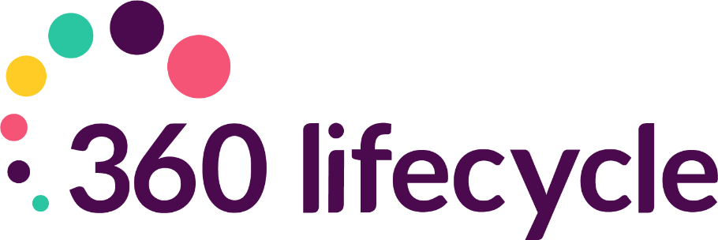
Compliance Manager Training Manual

Contents
1. INTRODUCTION 3
2. GETTING STARTED 3
3. COMPLIANCE MANAGER ROLE WITHIN STAFF MEMBERS 4
4. COMPLIANCE MANAGER 5
5. MANAGER CONFIGURATION 7
6. ACTIONS 8
7. TRACKS 14
8. SPOC MANAGER (SPAN OF CONTROL) 15
9. COMPLIANCE SEARCH 16

- INTRODUCTION
360 Lifecycle Office includes a Compliance management component which is seamlessly integrated into the rest of the system. This module allows you to centralise compliance and provides a configuration layer for businesses own compliance recording and reporting requirements. Depending on level of access you can create ‘Actions’ or ‘Tracks’ for an individual, team, group or region. Actions are potential tasks that need to be performed and are pre-set in the system (including PD Log, Test, Completion, File Check Lists and One To One Forms). Tracks can be a single action or a group of automated actions to complete. For example, you may wish to setup a ‘New Starter’ Track that groups several actions for the individual to complete at different stages.
- GETTING STARTED
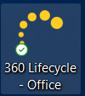
Begin by double clicking on the Office Icon which should be located on your Desktop.

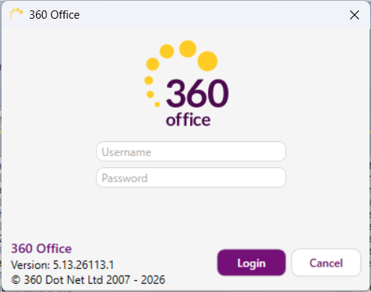
Your login page should now open, like this one.
You will now be able to enter the username and password supplied to you.
The Office landing page will open as per the below and you will be able to select ‘Tools’ within the heading and click on ‘Compliance Manager’. This will then present a list of Actions against the relevant individual, team, group or region (depending on level of access).
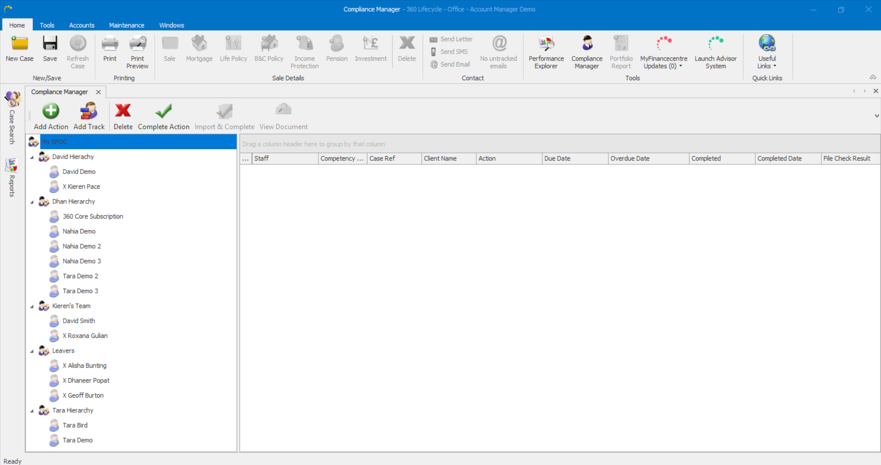

So that the Compliance Hierarchy, Actions & Tracks etc.. can be initially configured and maintained the allocation of the Compliance Manager role will need to be provided to individual(s) within the business (typically the Compliance Officer).
- COMPLIANCE MANAGER ROLE WITHIN STAFF MEMBERS
All users with the ‘Advisor’ role and who can login into 360 Office will have access to the Compliance Manager module. This will allow individuals to view themselves within the hierarchy and all compliance Actions recorded against them. If an individual oversees a SPAN (please see SPOC Manager section) they will be able to see the team/group, they are supervising.
By allocating a Staff Member the Compliance Manager role this will provide the individual with additional functionality such as:
- 360 Office>Maintenance>Compliance Options – ability to configure and maintain compliance Actions, Tracks & Tests etc…
- 360 Office>Maintenance>SPOC Manager – ability to configure compliance reporting hierarchy e.g. create teams/groups and supervisors.
- 360 Office>Tools>Compliance Search – ability to search specific actions against individuals based on search parameters.
- Compliance Manager Full Hierarchy View – users with the Compliance Manager role will have access to view the full Compliance Manager hierarchy.

- COMPLIANCE MANAGER
To access Compliance Manager, login to 360 Office click on the ‘Tools’ tab and click ‘Compliance Manager’.
A Team Manager can access the hierarchy or group they oversee, however an individual who has not been set up as a Manager, or been provided with the Compliance Manager role will only be able to access their own Actions.
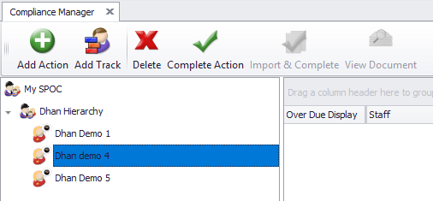

As shown above you can add an Action or Track to an individual user, or where access is provided a Manager can implement this onto the hierarchy so each user within the ‘SPAN’ will then have the same Action or Track created.
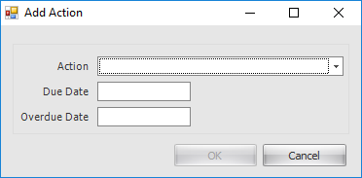
When adding an Action, you will be required to fill in the information below;

Once you click ‘OK’ this will then show as an Action to be completed within Compliance Manager.
Without an individual being set as a Manager within the ‘SPAN’ or being provided with the Compliance Manager role they will only see their own name and own compliance Actions (as per below screenshot).
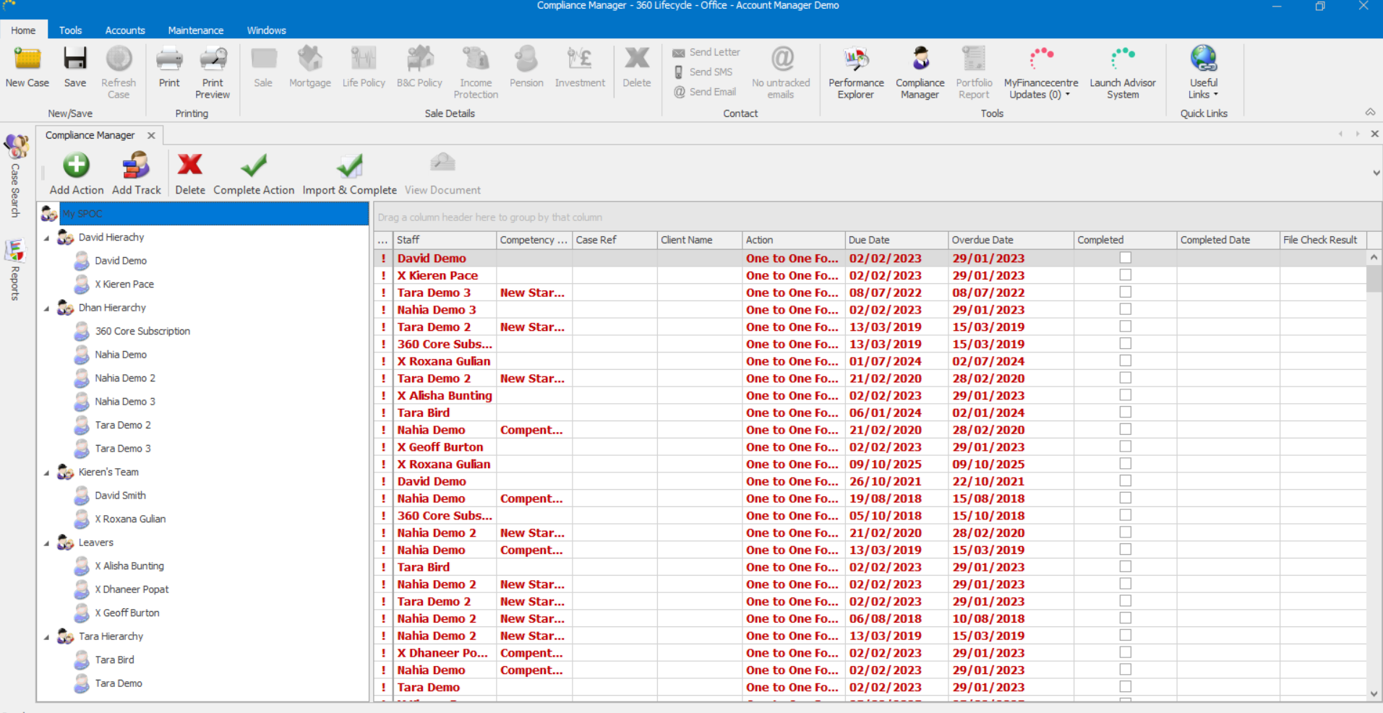

As a manager within the ‘SPAN’, you will be able to see a full hierarchy of non-completed, completed and overdue actions across a number of individuals within the group.
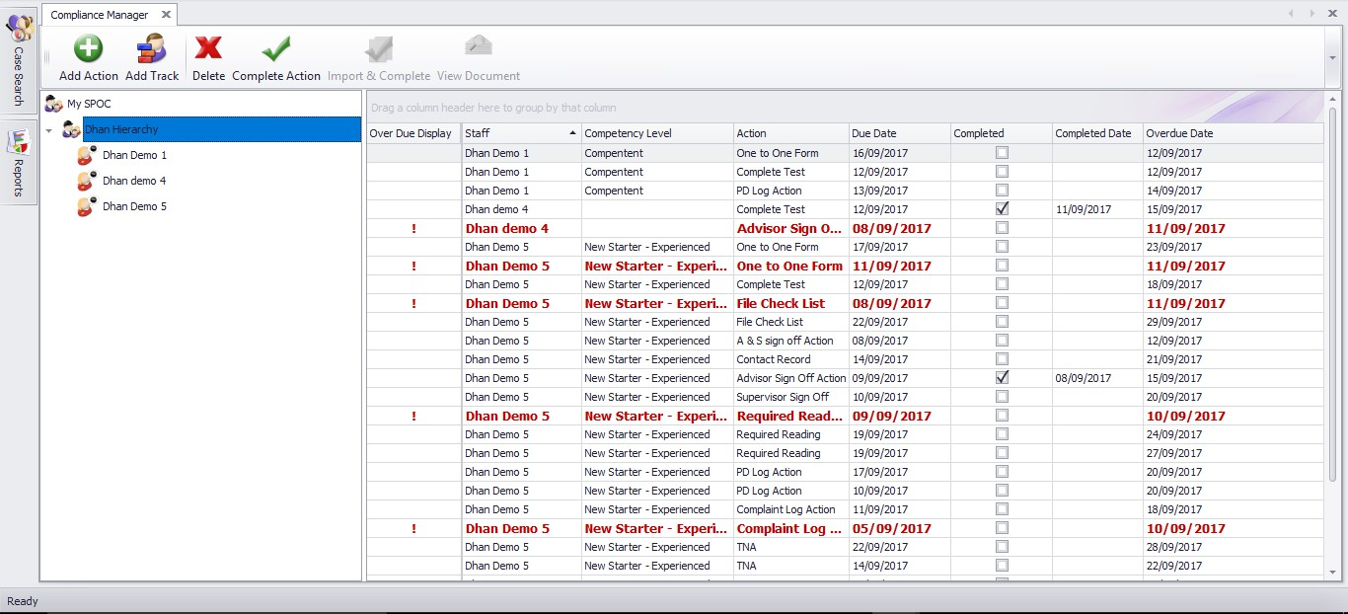

- MANAGER CONFIGURATION
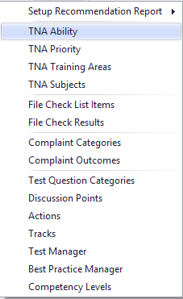
Those with either ‘System Administrators’ or ‘Compliance Manager’ roles have access to the configurable setup options which are found within 360 Office >Maintenance>Compliance. These are:
(TNA – Training Needs Analysis)
TNA Ability – Allows you record the ability of an adviser. Examples; No Development Required, Some Development Required & Significant Development Required
TNA Priority – Record the priority of the TNA action. Examples; Low, Medium, High
TNA Training Areas – Record the topic of training action Examples; Mortgages, Insurance Products
TNA Subjects – Items with which training area it links to. Examples; Repayment Methods would link to TNA Area of Mortgages
File Check List Items – Record items needed for file checks. Examples; Completed Factfind, IDD sent, FKI’s on file
File Check Results – Record the outcome of a file check. Examples; Pass – No Issues, Pass – Minor Issues, Fail Minor Actions
Complaint Categories – Record complaint categories. Examples; GI, Life, Mortgage
Complaint Outcome – Record the outcome. Examples; Compensation paid, Compensation not paid.
Test Question Categories – The categories in which tests fall into. Examples; Mortgage, Protection, Data Protection.
Discussion Points – Record discussion points to be reviewed. Examples; File Checks, DPA, TCF, Training Needs
Actions – Individually set-up Actions which need to be performed and which can be added in Compliance Manager. Each Action needs to relate to a relevant Form (see Actions)
Tracks – Actions can be grouped together to create tracks, building several actions which need to be actioned

Test Manager – Create tests which can then be added to a user’s action list or added to a track.
Best Practice Manager – This will allow you to amend Target Compliance KPI’s which are shown in the ‘Show Data’ report within Performance Explorer
Competency Levels – Record the level of knowledge of each user. Examples; Pre-CAS, CAS – Advisor Competency Level can be set against the individual within Staff Member Roles.
- ACTIONS
Businesses have the opportunity to record their own ‘Actions’ which are available for selection within Compliance Manager. Newly created Actions need to link to a pre-set form within the system that the individual is Required To Complete. Listed below are screenshots of the forms that an action can be linked to. Selecting ‘Allow Paper Copy Upload’ will allow the action to be completed via the ‘Import & Complete’ option shown within Compliance Manager.
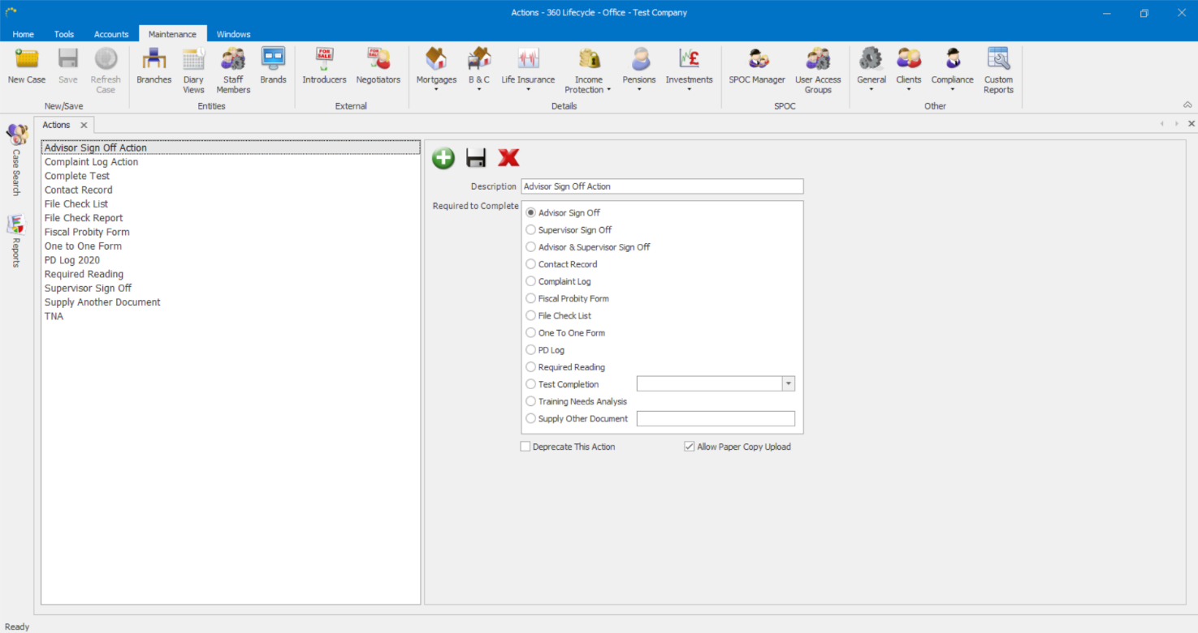

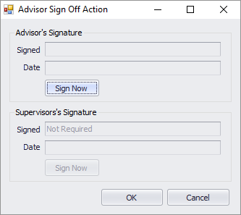
- Advisor Sign Off Form - Advisor will enter in their username and password to complete the action.

- Supervisor Sign Off Form – Supervisor will enter their username and password to complete the action.

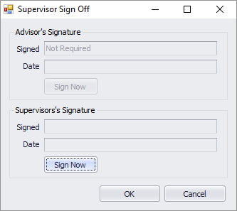
- Advisor & Supervisor Sign Off Form – Both Advisor and Supervisor will enter their username and password to complete the action.

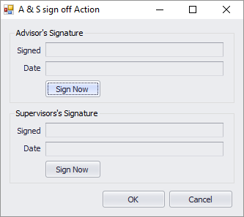
- Contact Record - Both the Advisor and Supervisor will need to enter their username and password to complete the action.

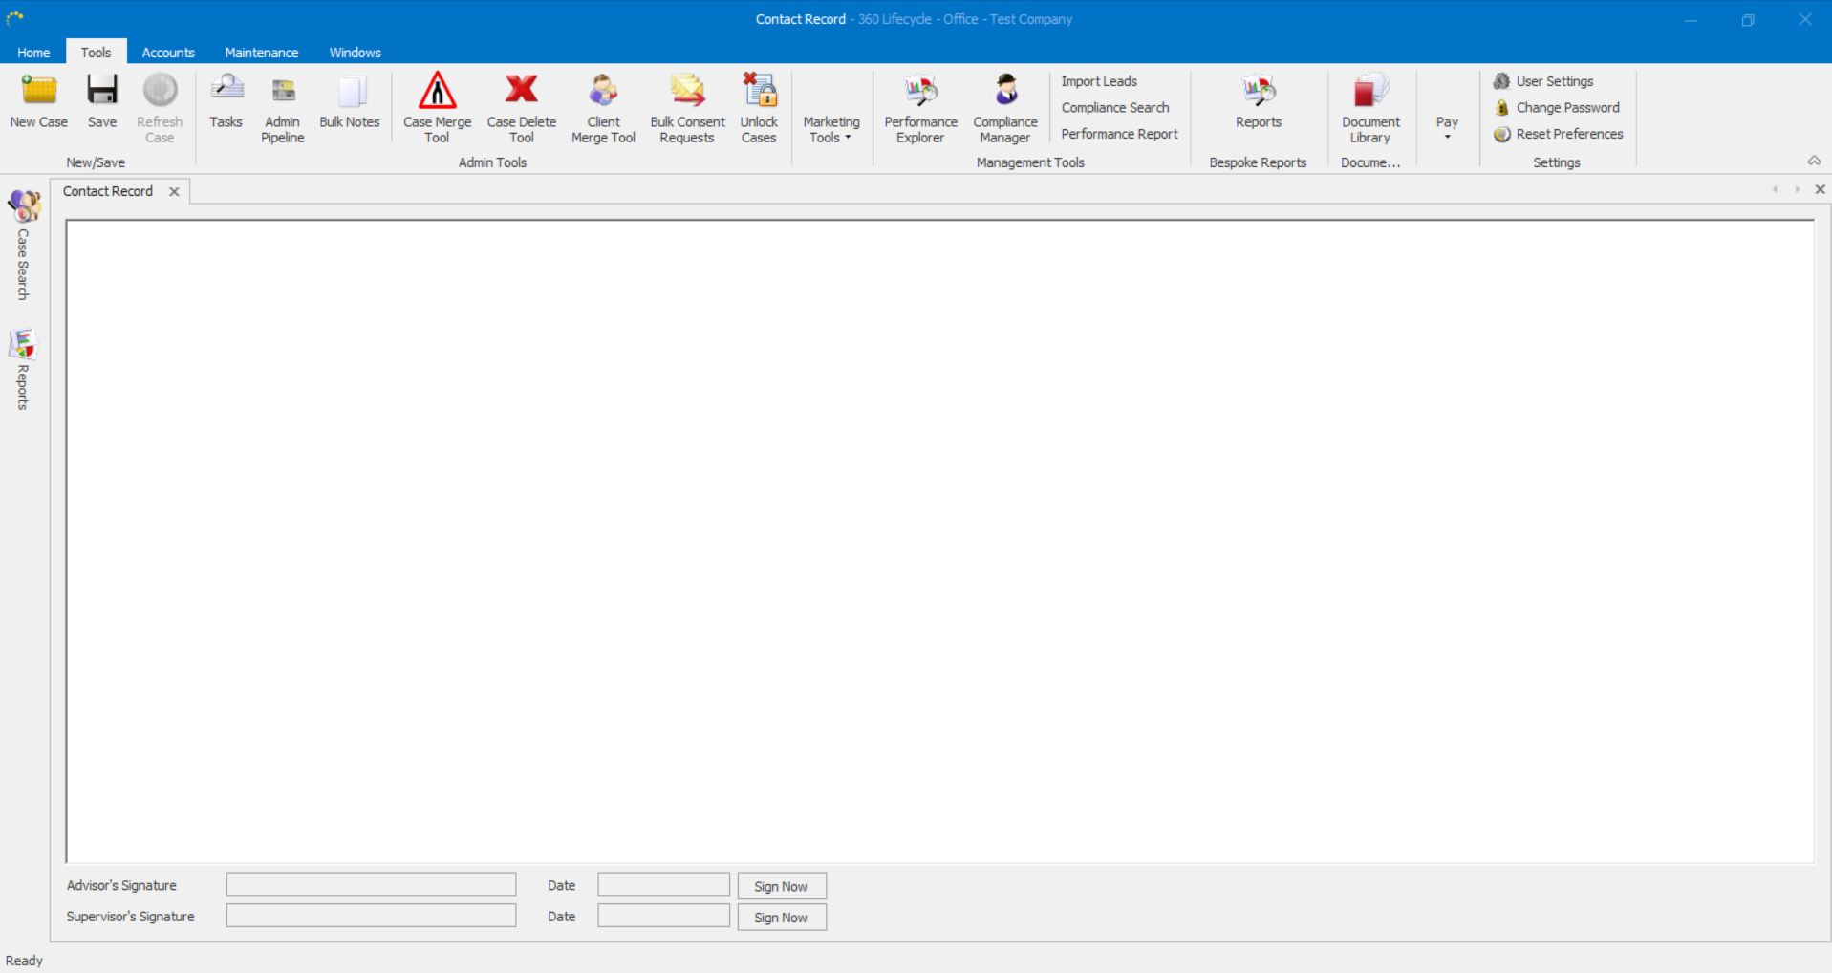

- Complaint Log - showing the Complaint Categories and Compliant Outcomes as set in Compliance Maintenance.

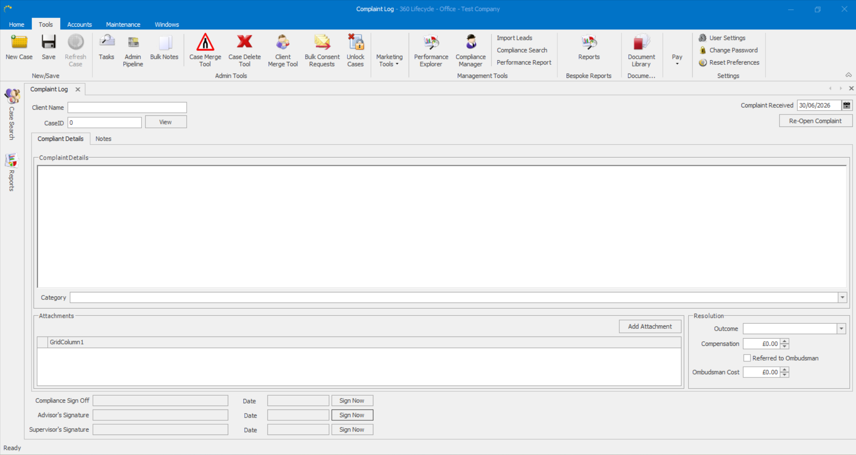

- Fiscal Probity Form - Both the Advisor & Supervisor will enter their username and password to complete the action.

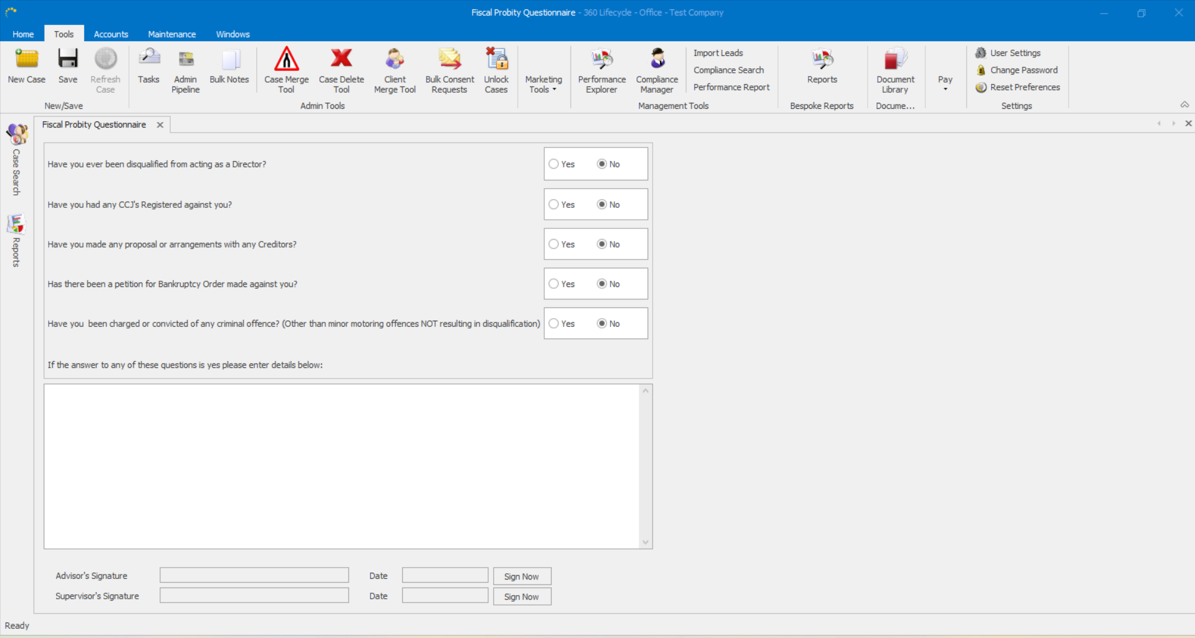

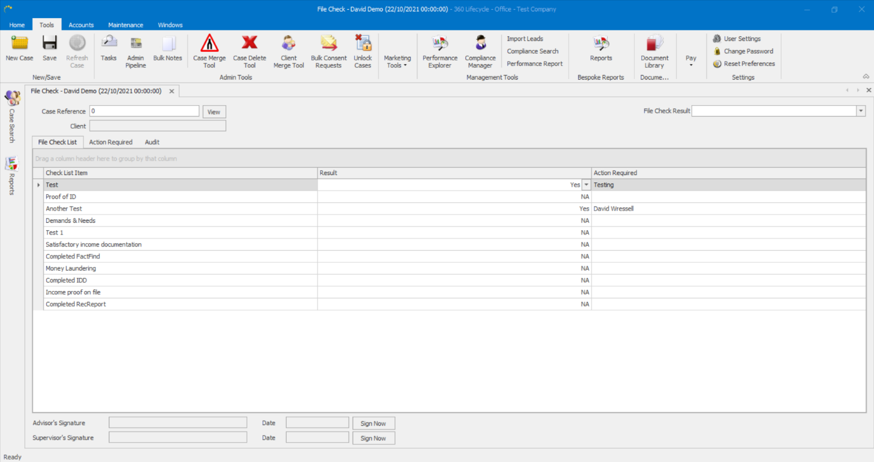
- File Check List Form - showing the File Check List Items and File Check List Results as set in Compliance Maintenance.

- One To One Form - showing the Discussion Points Reviewed as set in Compliance Maintenance.

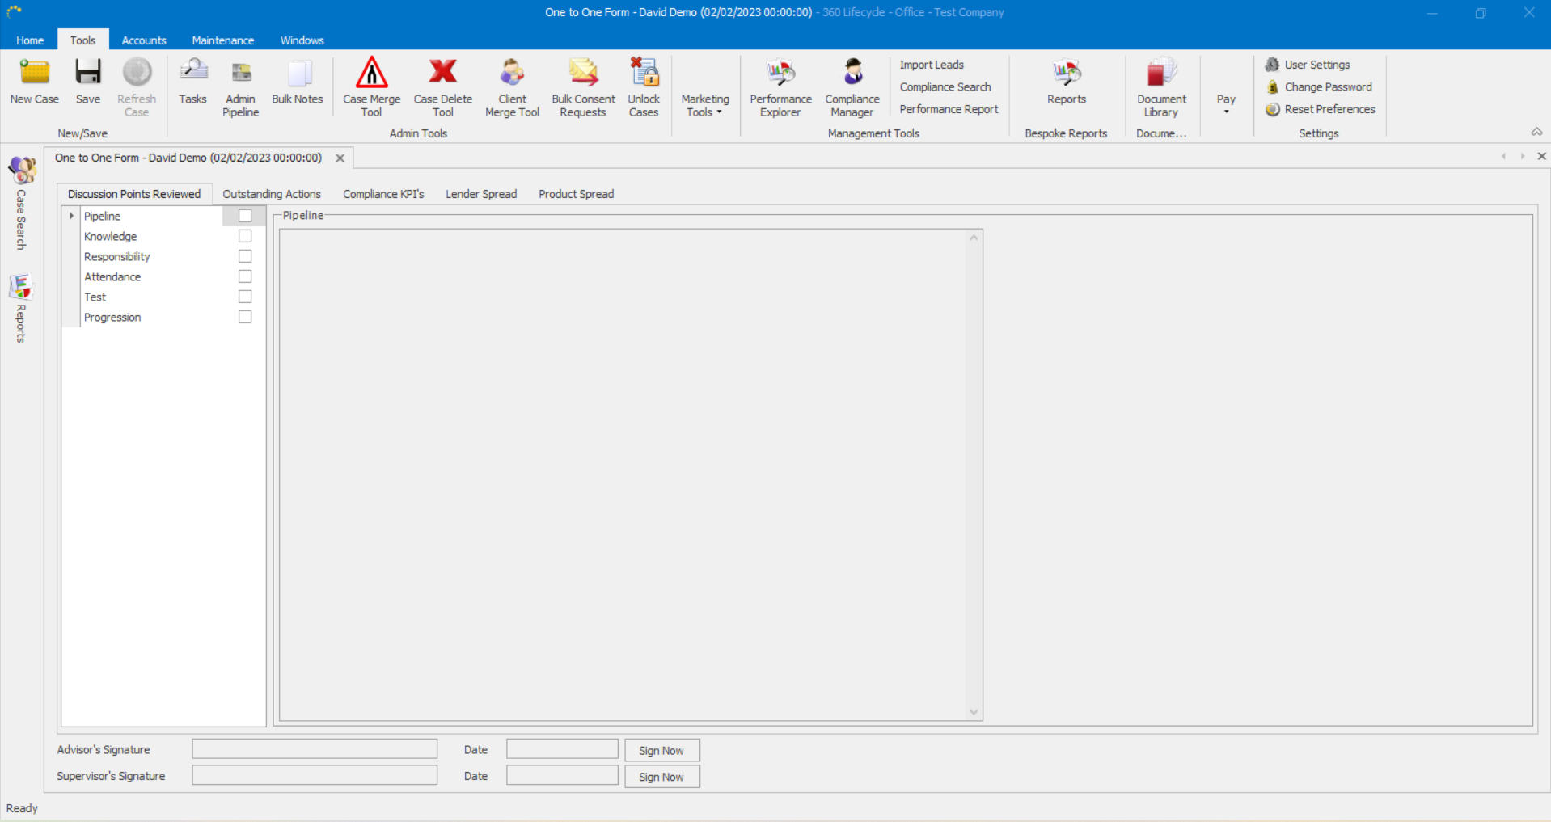

- PD Log Form – Record the development of an individual. Both the Advisor & Supervisor will enter their username and password to complete the action.
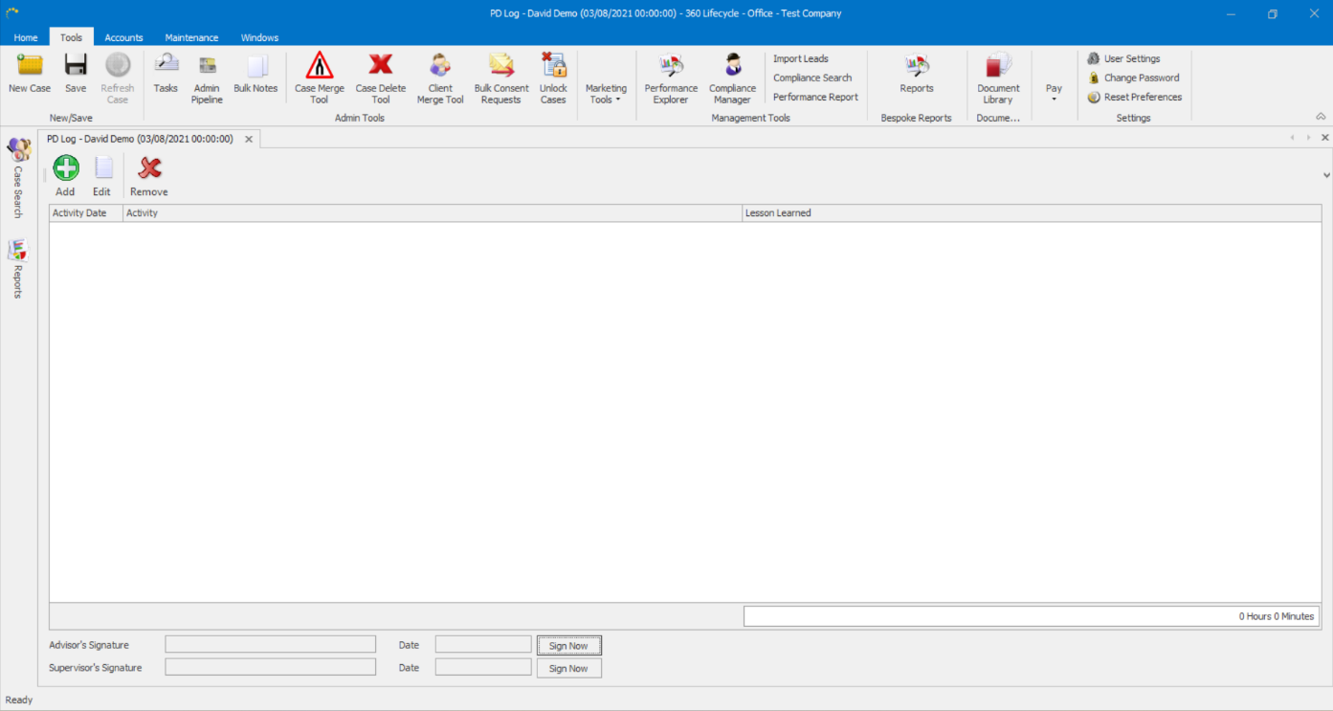

- Reading Required - Advisor will enter in their username and password to complete the action.
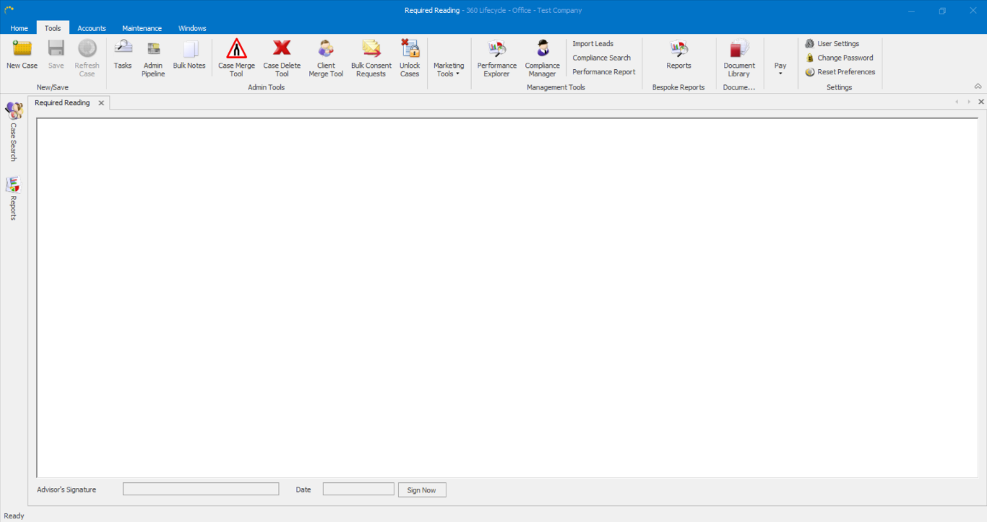

- Test Completion Form - showing Test Question Categories and Test Manager questions as set in Compliance Manager.
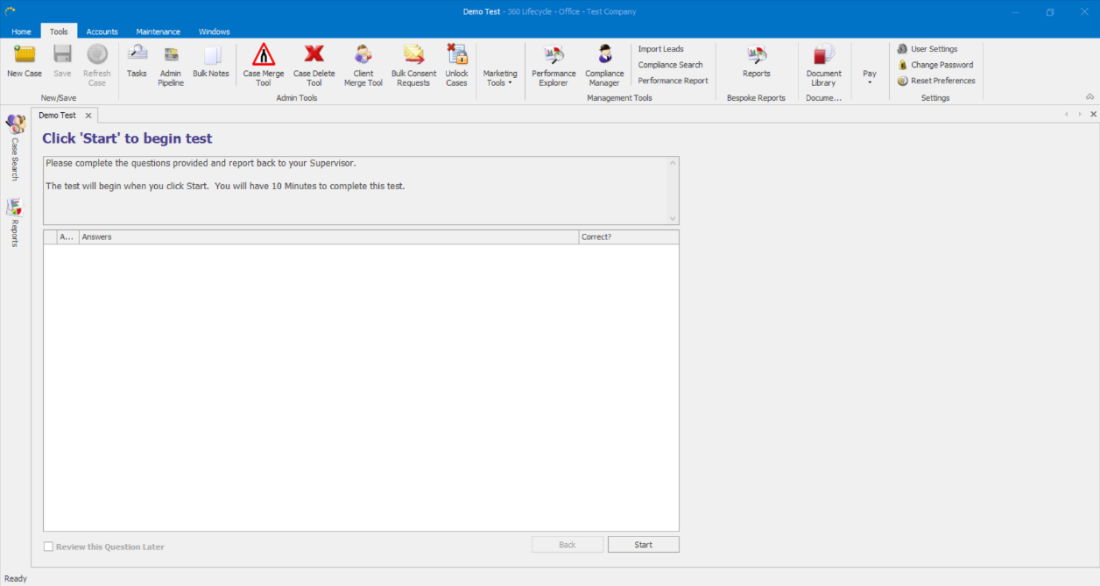

- Training Needs Analysis Form - showing the TNA Ability, TNA Priority, TNA Training Areas & TNA Subjects as set in Compliance Maintenance.

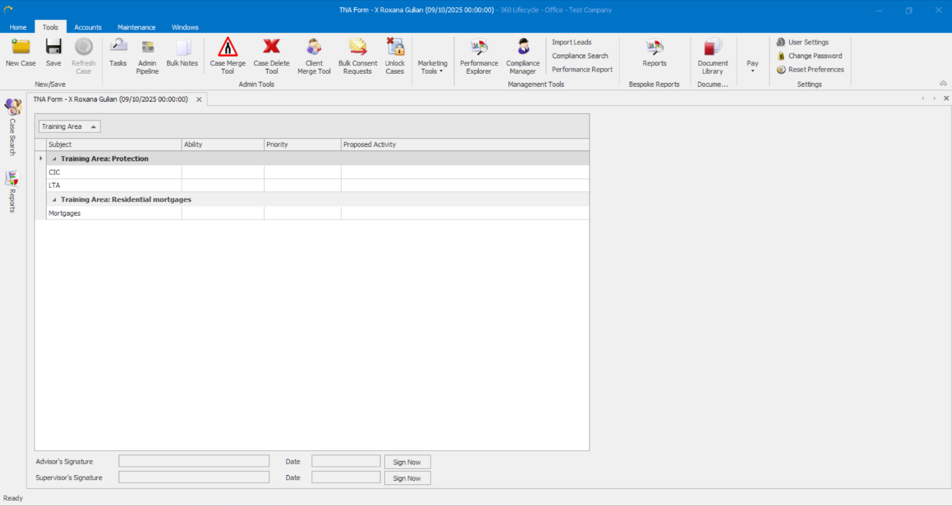

- Supply Other Document Form – upload a document to the Action which can then be viewed. Both the Advisor & Supervisor will enter their username and password to complete the action.

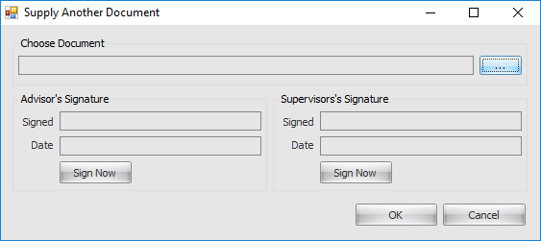

- TRACKS
Tracks are designed and created to allow a series of Actions that will need to be completed in an automated fashion. For example, you may have an ‘Induction’ or ‘New Starter Track’ that requires a number of Actions to be completed at different stages. Tracks can be set to automatically repeat on an ongoing daily, weekly or monthly basis by choosing ‘Allow Repeating Schedule’.
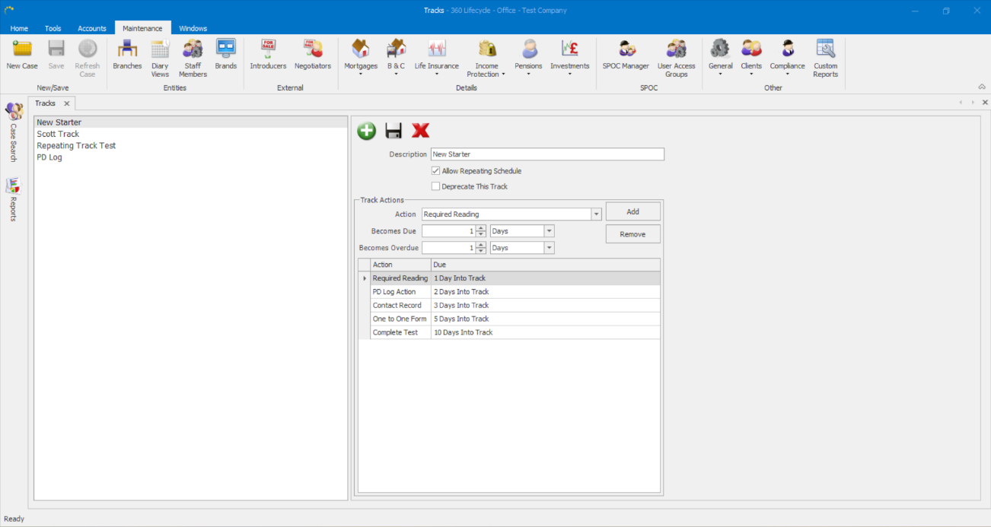
Below is an example ‘New Starter’ Track which has been created and which can be distributed via ‘Add Track’ in Compliance Manager.
- SPOC MANAGER (SPAN OF CONTROL)
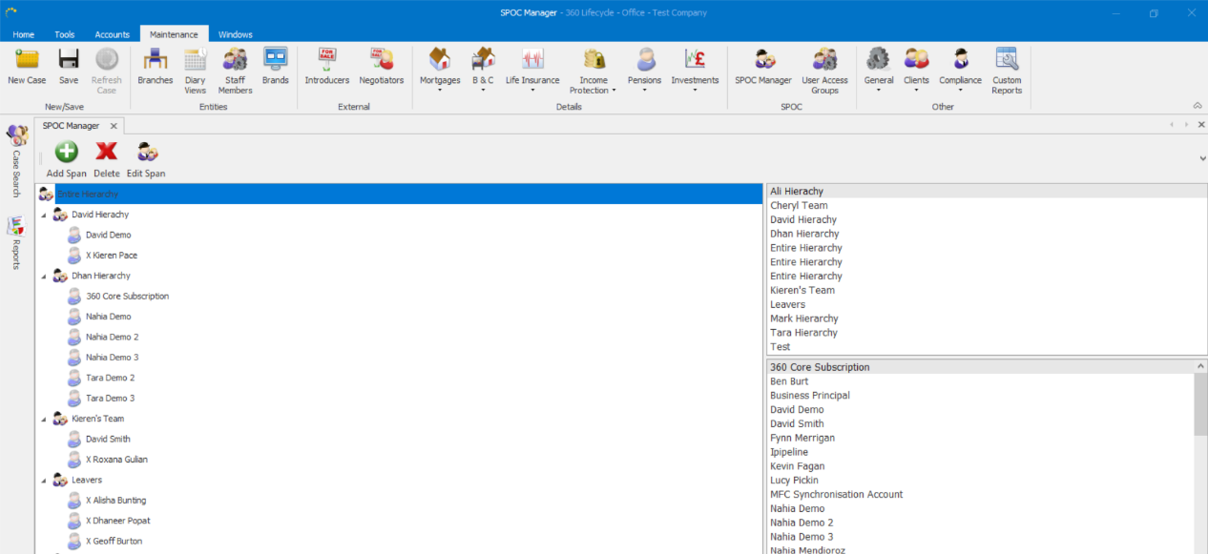
Those with either ‘System Administrators’ or ‘Compliance Manager’ roles have access to SPOC Manager, found within 360 Office >Maintenance>SPOC Manager. Within SPOC Manager you can create Compliance Manager hierarchy’s or groups which can have different managers assigned. This means when a manager logs in they will only be able to see the hierarchy or group they oversee. Each hierarchy or group is called a ‘Span’. Editing or creating a new ‘Span’ works in a very similar way to User Access Groups in Performance Explorer.
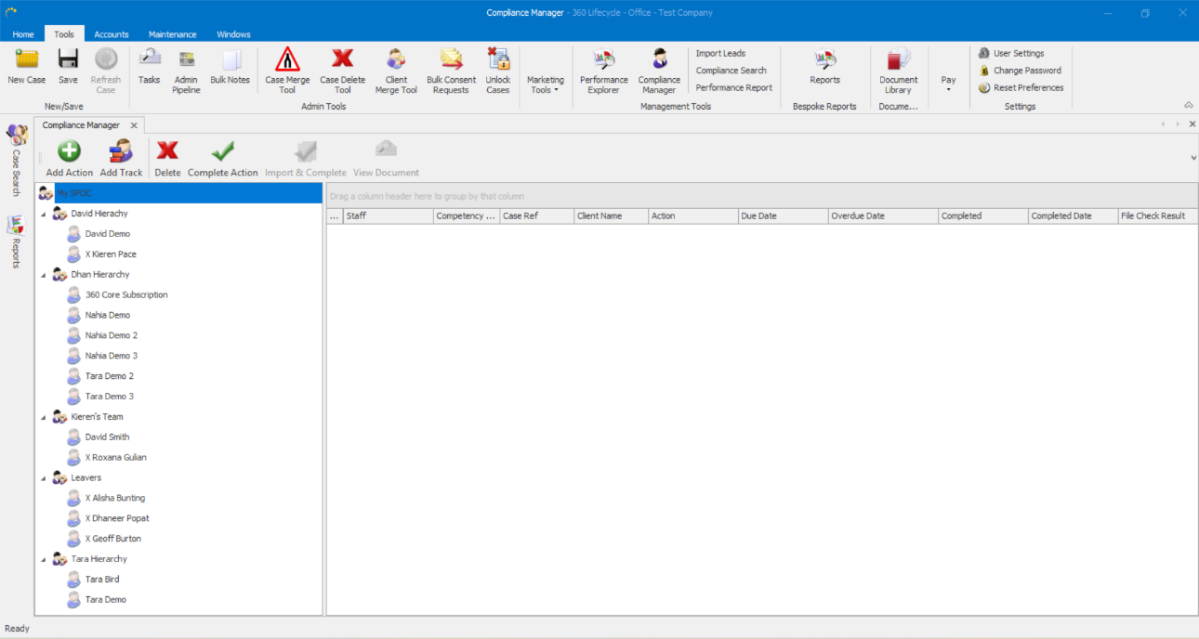
The above screenshot shows two separate Span’s (Dhan Hierarchy & Tara Hierarchy). However, as the managers are different this means when logging into Compliance Manager each manager will only see their own team.
- COMPLIANCE SEARCH
Those with either ‘Managers’, ‘System Administrators’ or ‘Compliance Manager’ roles have access to Compliance Search, found within 360 Office
>Tools>Compliance Search. Those with a Manager role will only see themselves within the Compliance Search hierarchy, unless they are a manager within the ‘SPAN’.
Within Compliance Search you can search across ‘Action Type’, ‘Due Date and ‘Completed Date’. If dates are specified an Action Type then must be chosen.
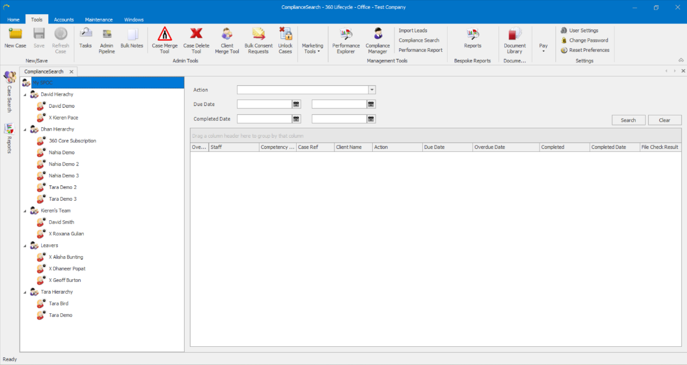
Information Classification Procedure
Document Classification | Public
Document Ref | ISMS-SD27-A05-12-01
Version | 1
Dated | 09 September 2025

