
Client Segmentation Training Manual
Contents
1. INTRODUCTION 3
2. GETTING STARTED 3
2.1 Landing Screen (Office) 3
2.2 Landing Screen (Client Segmentation) 4
2.3 Using Query Builder 5
2.4 Running A Query 6

- INTRODUCTION
The object of this manual is to give you the ability to apply/update; Servicing Arrangements, Marketing Segments, Case Statuses & Servicing Advisor, in bulk and to tens, hundreds or thousands of clients quickly and easily by whichever criteria you wish.
Using this facility to apply a Servicing Arrangement will then create automatic client servicing reviews in the adviser’s Hotbox to action and ensure you have a complete audit trail against your client file. This is a huge benefit for ensuring RDR rules are maintained and useful for potential forthcoming MMR impacts.
You can use this facility to apply a ‘marketing segmentation group’ to any number of records at one time to clearly identify groups of specific clients for marketing through Campaign Manager. Should you have Orphan clients, you are able to allocate a new servicing adviser to these clients by your selected criteria.
- GETTING STARTED
  - Landing Screen (Office)
Once you have logged in and loaded 360 Office, you will arrive at the Landing Screen.
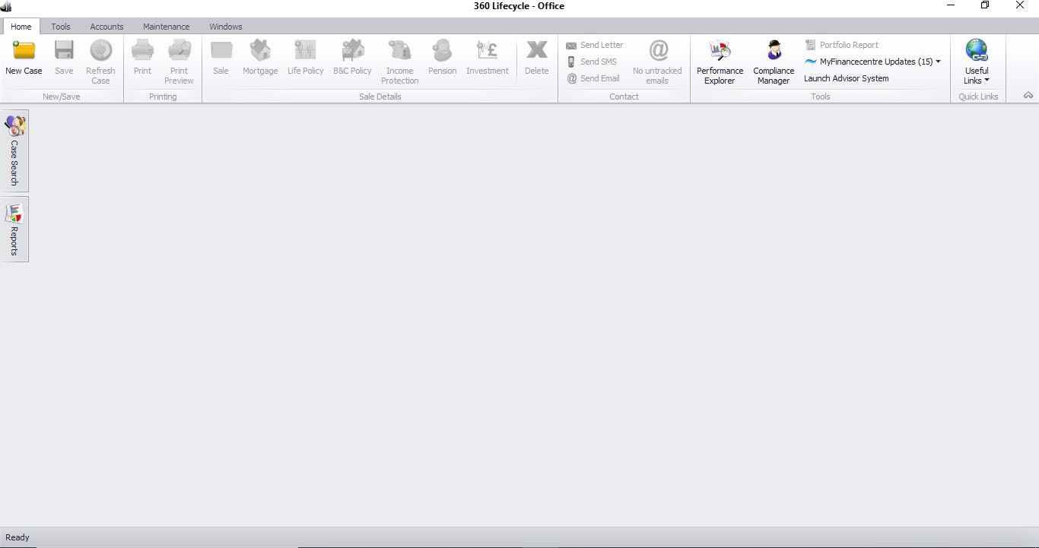

From here you need to select Tools which will show multiple icons to choose from.
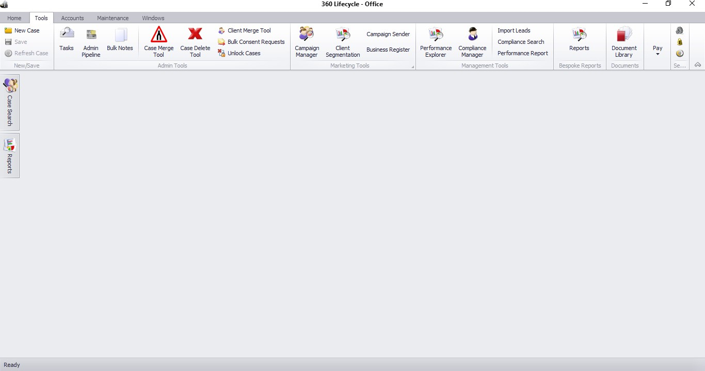
  - Landing Screen (Client Segmentation)
Now, simply select Client Segmentation. Once loaded, you will see a layout similar to that of Campaign Manager. The only notable difference at this stage is that instead of there being an option to Create Campaign, you have Update Details instead.
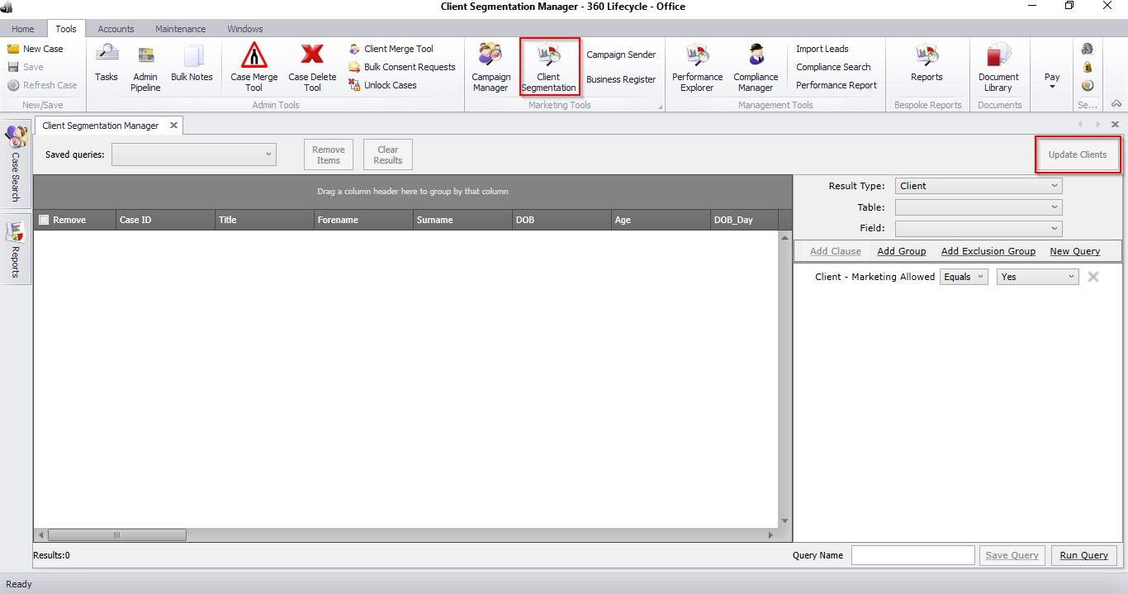

  - Using Query Builder
To begin your query, first you will need to work out what your target data is. Once you have decided this, you can then search for that data by specifying an exact criteria.
To the right of the screen, you will see a number of options that work together.
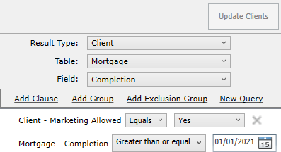

- It is recommended that most Client Segmentation queries will be ran with Result Type as Client.
Select Table = This is the ‘Table’ or section of the database you would like to query
i.e. WHETHER YOU WANT TO RUN QUERIES ON CLIENT, CASE OR A SPECIFIC POLICY TYPE INFORMATION.
Select Field = SELECT THE SPECIFIC DATA ITEM YOU WANT TO QUERY BASED ON
THE TABLE SELECTED. The Field pick list items you can choose from vary, depending on the Table selected.
Add Clause = This is an AND statement e.g. “Case has a Servicing Advisor of X”
Add Group = This is an OR statement e.g. “Case has a Servicing Advisor as X OR Y”
Add Exclusion Group = THEY DO NOT HAVE e.g. “Find all cases that DO NOT have a Servicing Arrangement of Gold”
Each layer you want to add onto your query you need to amend the Select Table and Select Field and click on ADD Clause, Group or Exclusion Group.

  - Running A Query
We have listed some example scenarios to show how the logic is applied, enabling you to build your own queries and update clients/cases. Please note that you can Run Query at any point within the campaign building process to see the number of clients/cases who are returned and how this changes as more criteria is added.
    - Example Query 1 – List all clients with a particular Servicing Advisor and then move these clients to another Advisor.
First, select Client under the Table column and then Servicing Advisor in the Field column.
Once you have done that you now need to select Add Clause ensuring that Equals appears from the drop-down menu and finally select the Advisor name from the Advisor List. Please note that Client – Marketing Allowed will always appear by default, this you can ignore.
From here, you can run the query by simply selecting Run Query. Once the system has finished loading, the results to show you the clients/case records allocated to that Advisor will be displayed.
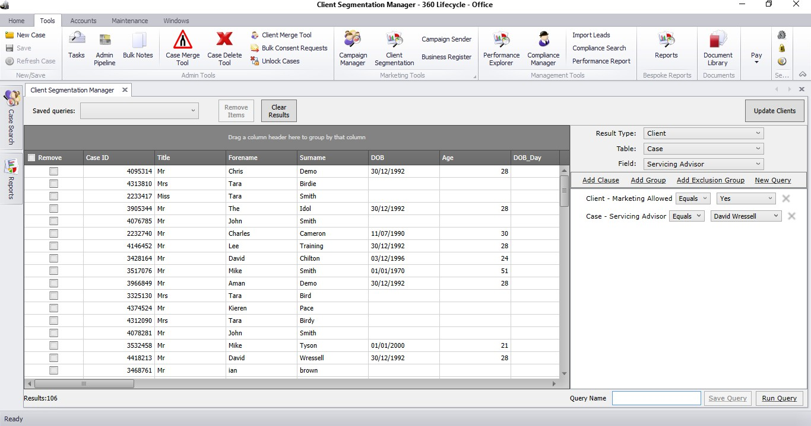

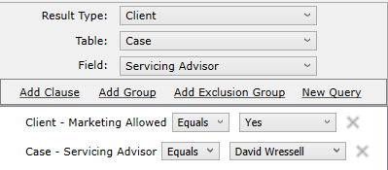
Once the results are displayed, to transfer all of these clients/case records to another advisor, simply choose the option Update Clients and select Servicing Advisor from the drop-down menu.
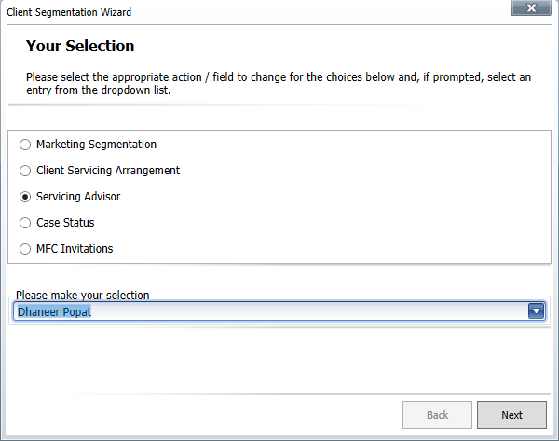

From here you can choose your selection from the drop-down menu as regards to which advisor you would like to make the transfer to. Once done, select Next.

Now you will be given the option to Commit the proposed changes.
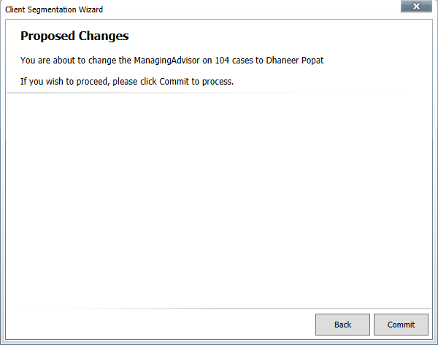

Once loaded your changes will have taken effect. All you now need to do is select Finish.
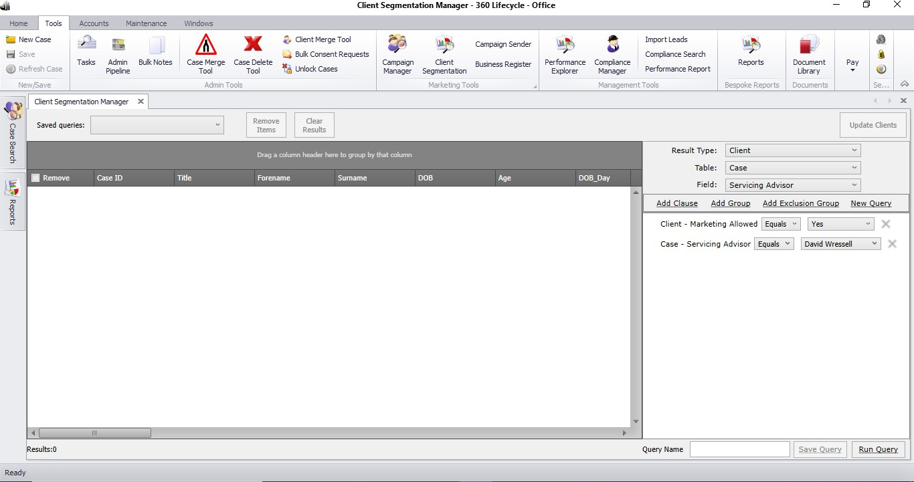
From here, you will be able to confirm that those clients have transferred across by simply re-running the same query list to display how many clients/cases are

allocated to the original Servicing Advisor. You should see that the results displayed equal 0.
    - Example Query 2 – List all clients who have an income over £50,000 and then allocate a Marketing Segment of ‘High Earner Clients’
Please note that before allocating your relevant Marketing Segment in bulk you need to add your Market Segment in Office, Maintenance, General & Market Segments
First, select Client under the Table column and then Income in the Field column.
Once you have done that you now need to select Add Clause ensuring that Greater Than or Equal appears from the drop-down menu and finally enter 50000 in the income field. If you choose ‘Run Query’ this will show you all clients with an income of £50,000 or over.
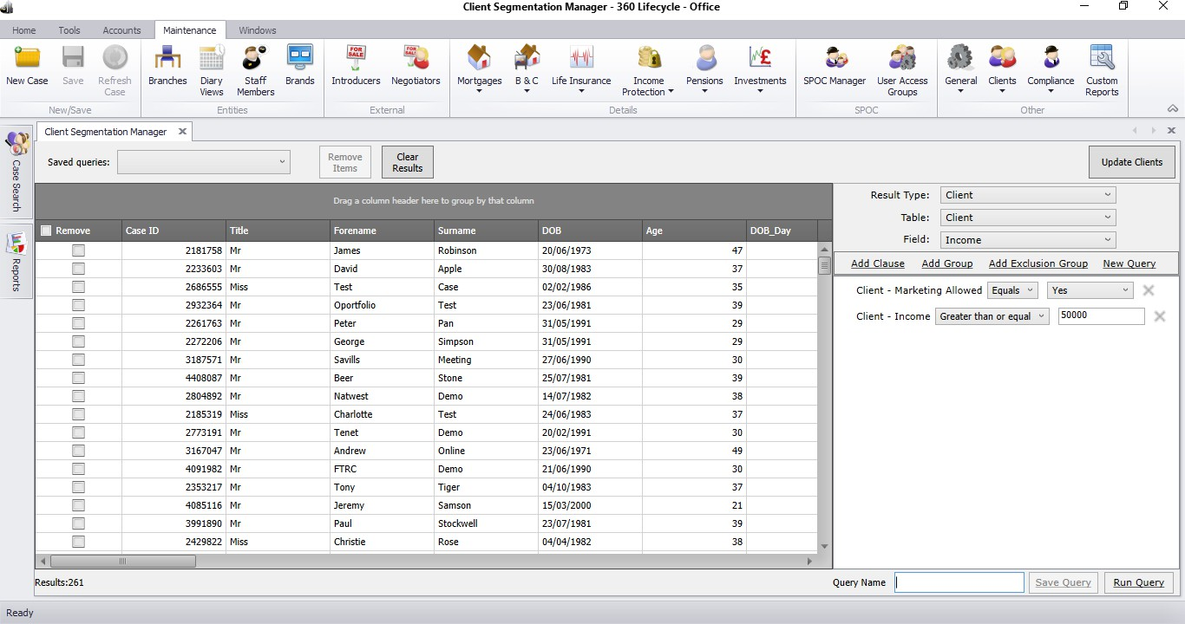

Once the results are displayed, to allocate a Marketing Segment of ‘High Earner Clients’ to all of these clients/case records simply choose the option Update Clients, select Marketing Segmentation, and the relevant selection from the drop-down menu and choose Next.

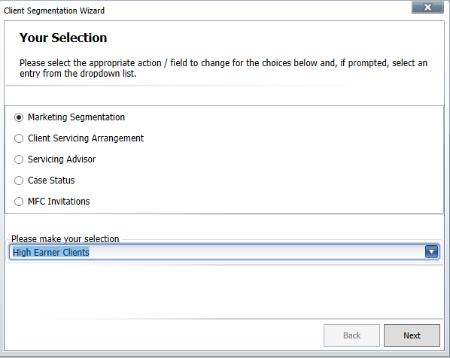
You will be given the option to Commit the proposed changes.
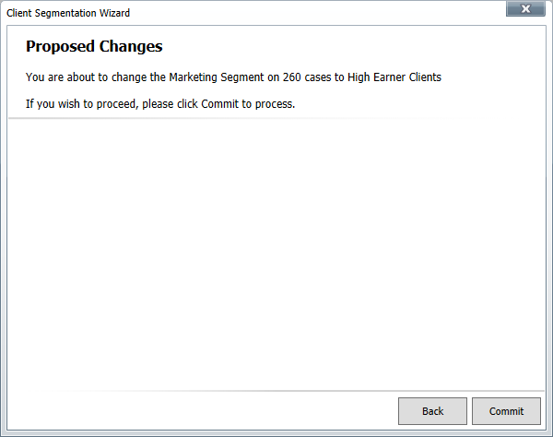

Information Classification Procedure
Document Classification | Public
Document Ref | ISMS-SD27-A05-12-01
Version | 1
Dated | 29 June 2026

