

Client Portal User Guide

Contents
Introduction 3
Registering for the Client Portal 3
Portal View (Actions) 6
Messages 8
Budget Planner 9
Documents 9
Upgrading Your Client Portal 9
My Wealth Page 11
Portfolio 11
Concierge 11

Introduction
The object of this manual is to provide you with the necessary navigational support to utilise the Client Portal to assist your financial adviser with your application process.
This manual will show you how to register to the portal, complete ‘Actions’ and identify how further information can be carried across to your adviser via your full financial portfolio. Once you have registered to the portal, this guide will show you how you can communicate with your adviser quickly and securely through messages, sharing documentation and portfolio updates.

Registering for the Client Portal
You will initially receive an email with a hyperlink included and be sent an activation code by SMS to your mobile. The invite will last 7 days but can be re-sent by your adviser at any time.
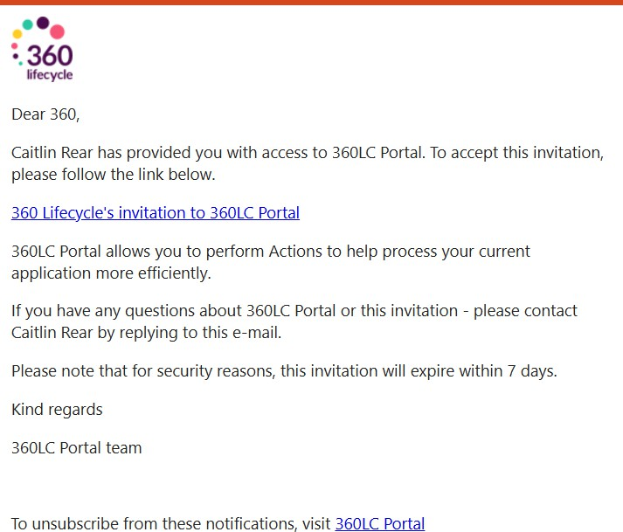

The hyperlink within the email will direct you to the registration site where the activation code sent by SMS can be entered to register.
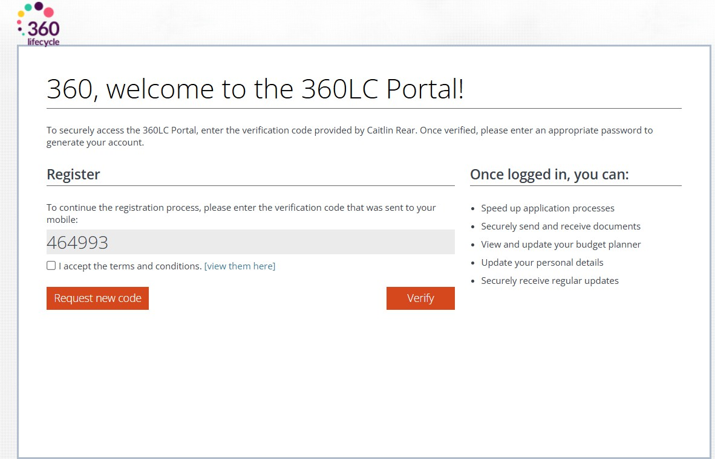
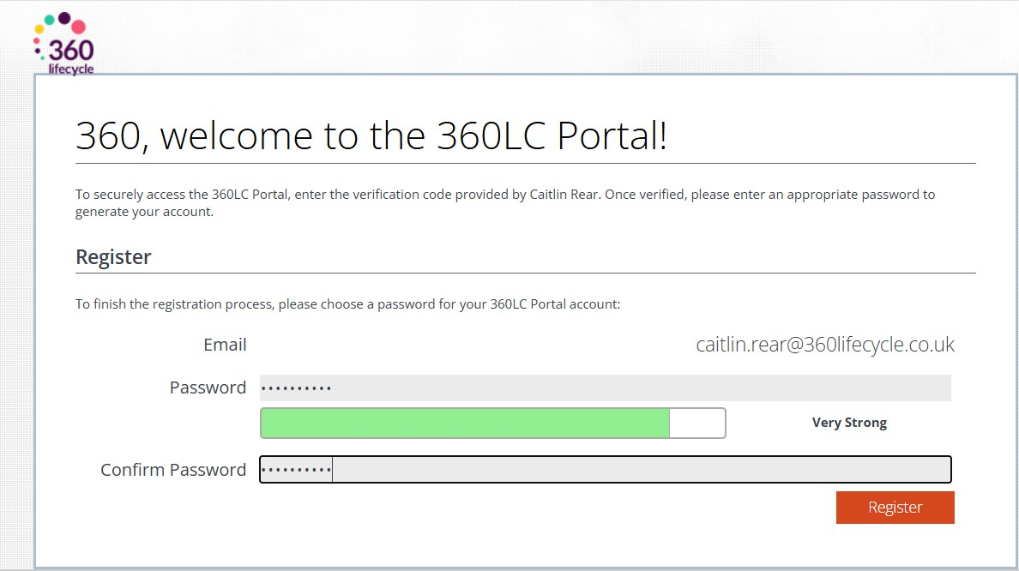
You will be asked to enter your email address and choose a password to create your account. These details will be used to login in future if your adviser requires further details from you.

Once logged in, you will then be able to access the main portal features. You can view your Actions, Messages, Budget Planner and Documents, as well having access to contact your adviser, amend your account and notification settings and choose to Upgrade your portal experience.
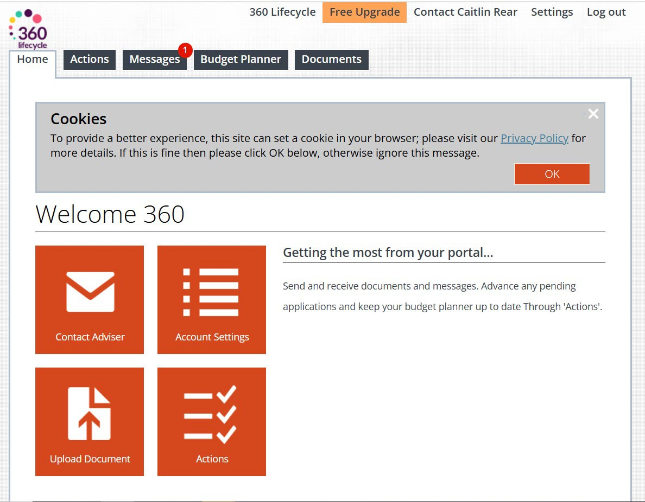
When selecting the ‘Message’ tab, you can view any messages and choose to delete or reply to these. You will automatically receive a message like the below when you register for the portal, which outlines the key features of your portal account.
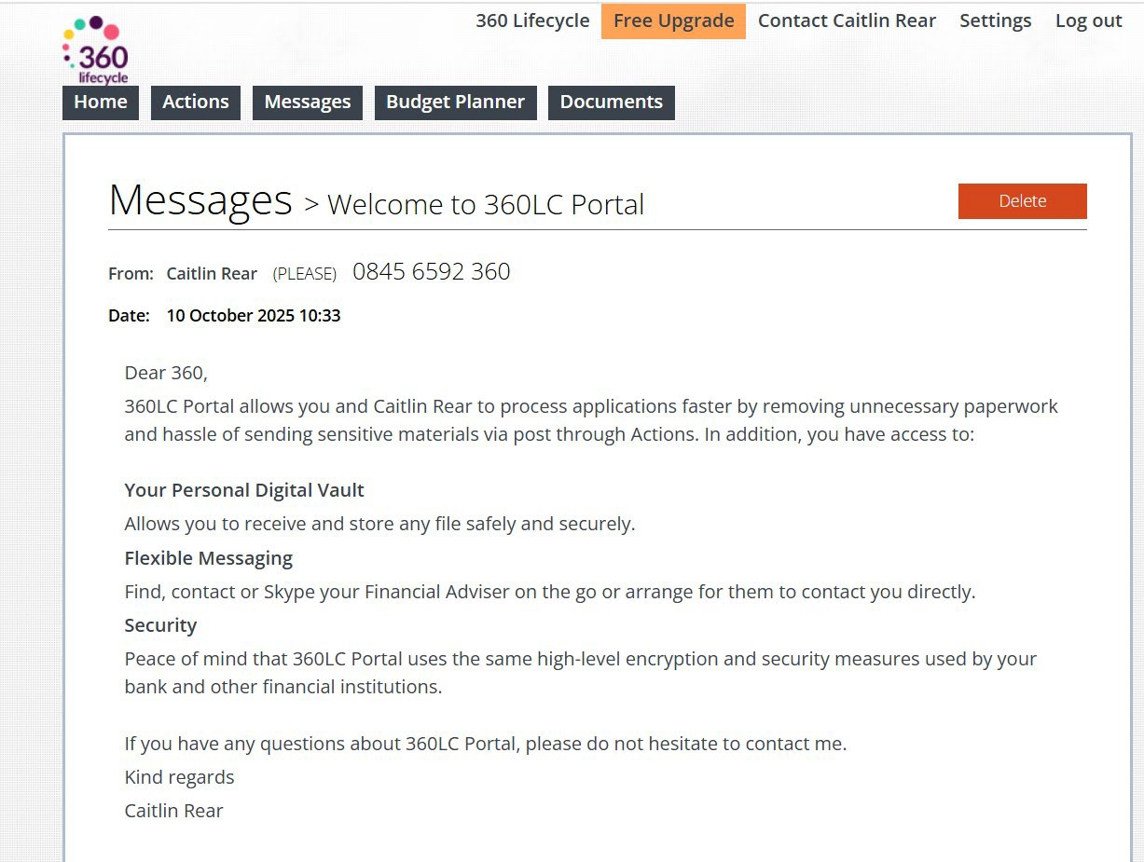

Portal View (Actions)
As part of your portal experience, you will be sent ‘Actions’ by your adviser. When these are sent, you will receive an automatic email and SMS message notification alerting you that an Action requiring attention has been sent.
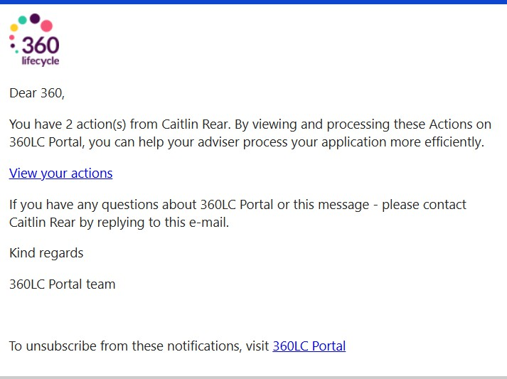
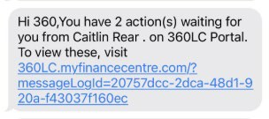

When you next log in, you will be greeted by any outstanding actions. If needed, you can close this screen and at a later point simply click on the ‘Actions’ tab to again see any outstanding actions.

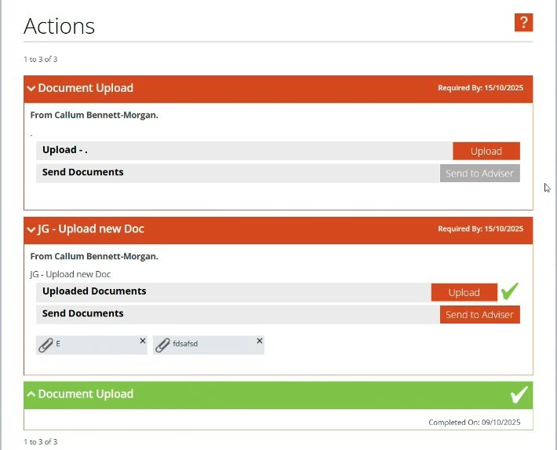
Depending on the type of action that has been sent to you, you will need to either confirm receipt of documents or send required documents back to your adviser.
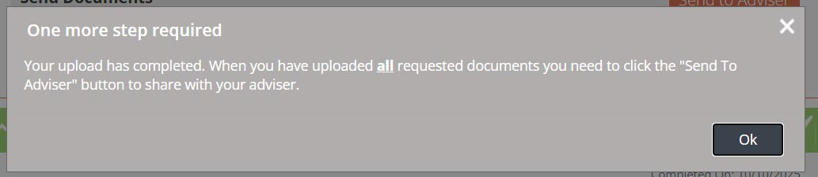
Please Note: if the action type requires you to upload documents, then the above pop-up message will appear to prompt you to press ‘Send to Adviser’ after uploading.
This will then complete the outstanding action and notify your adviser of this.

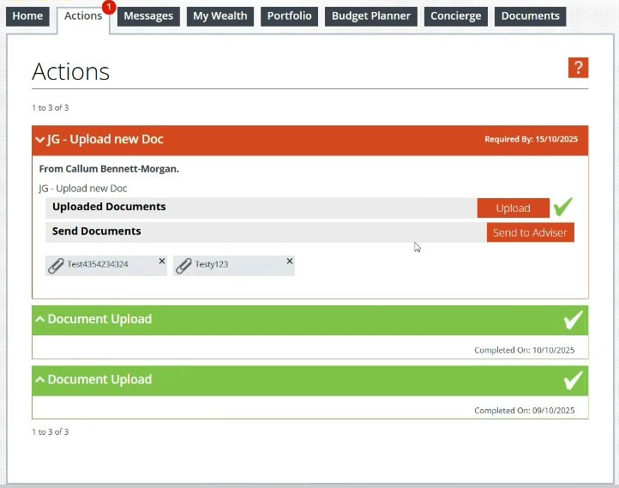
Within your portal, completed Actions are displayed GREEN.

Messages
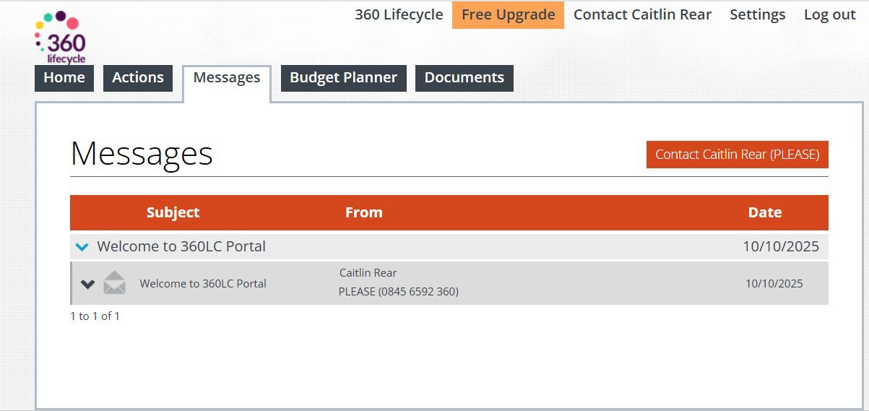
You can view the message from the ‘Messages’ tab your portal.

You will have the option to reply and see that the message has been successfully sent.
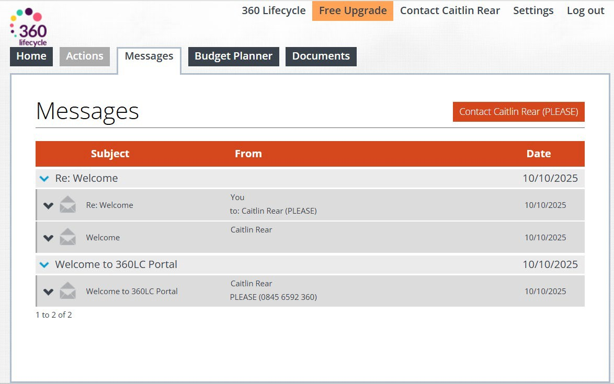

Budget Planner
This screen will allow you to create your own Budget Planner, by inputting your relevant income and expenditure figures. This will only be visible to yourself, unless you wish to share this with your adviser, which will send either a PDF or a Spreadsheet file to them.

Documents
This screen will outline the documents you have currently either have received, or sent to your adviser. If you wish to upload any documents at any point, you can do this from this screen, however if you need to notify your adviser of these, you will need to click ‘Send’ on these for your adviser to view these. The storage in your portal account is unlimited.

Upgrading Your Client Portal
If you wish to expand on your portal experience and utilise some of the enhanced features, select the ‘Free Upgrade’ button in orange below.

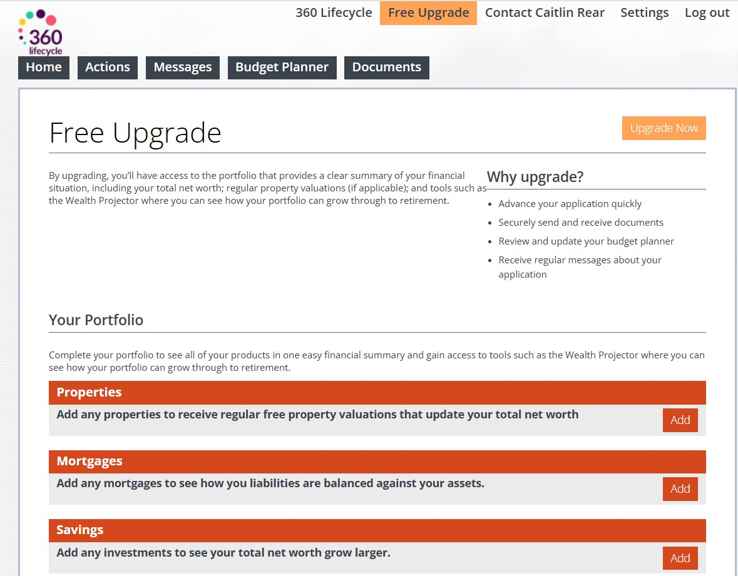
This means you will have further tabs to select from such as My Wealth, Portfolio & Concierge and with a range of additional tools available, which are explained further below. On upgrading, this will display any Portfolio items your adviser currently has a record of and allow future Portfolio changes to be shared between you and your adviser in the future.
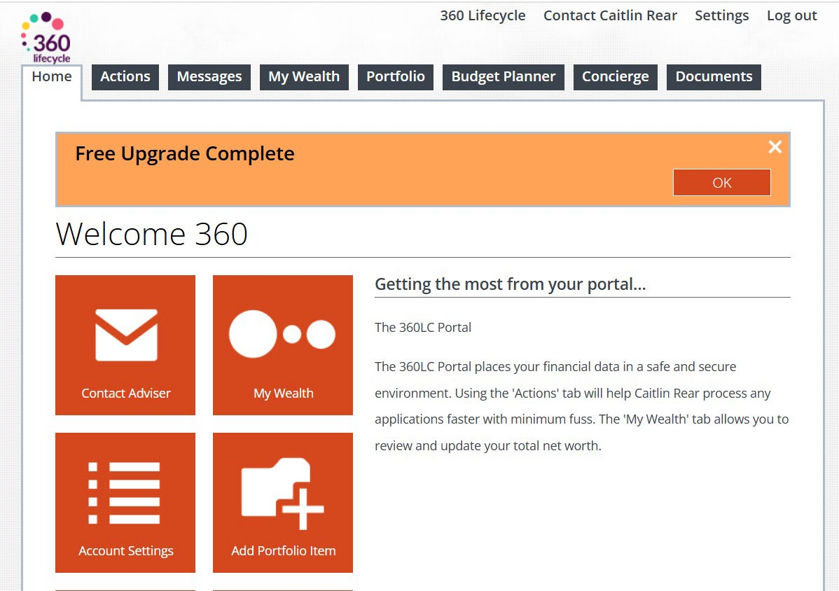

My Wealth Page
This page will allow you to monitor your existing assets and financial commitments and includes a ‘Wealth Projector’ which will automatically allow you to view how your portfolio value may increase over time.

Portfolio
This section will allow you to add any assets and financial commitments, such as properties, protection policies, mortgages, and other assets your financial adviser may not currently be aware of.
When you add these into your portfolio, you will be prompted to share these with your adviser so then can assure your portfolio is always up to date and provide you the most accurate financial advice.

Concierge
This section allows you to make amendments to your ‘profile’, which can be shared with your adviser.
This will allow you to prompt your adviser to contact you should you require advice on:
- Building & Contents Insurance
- Protection for you and your assets
- Travel or Pet Insurance
- Currency Exchange
All the above can be applied for from this screen.
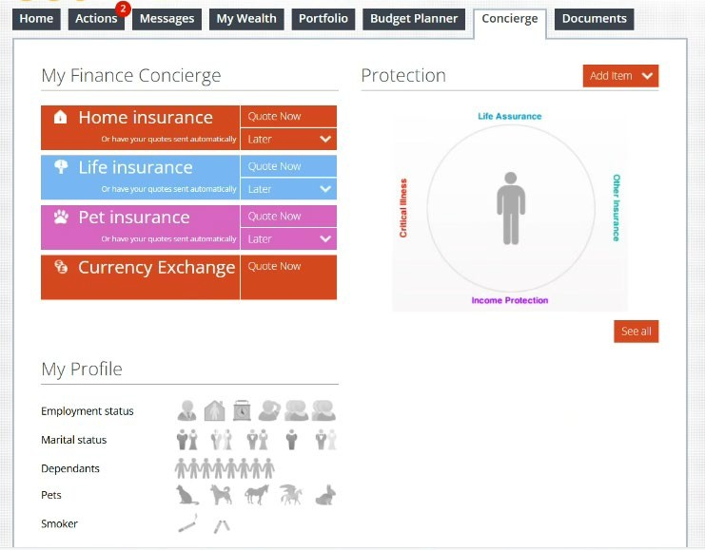
Finally, this page will give you an overview of your current protection policies and how these are split – between Life Cover, Protection for your Mortgage, Critical Illness Cover and Income Protection policies.

Information Classification Procedure
Document Classification | Public
Document Ref | ISMS-SD27-A05-12-01
Version | 1
Dated | 29 June 2026

