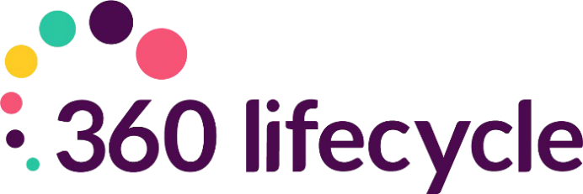

Client Portal Training Manual

Contents
Introduction 3
Getting Started 3
Accessing the Portal 3
Inviting Clients to the Portal 4
Sending an Action 8
Portal View (Actions) 10
Key Colours for Actions 12
Different Views 13
Sending a Message 13
Portal View (Messages) 14
Portal Upgrade 15
Update Client 16
Processing Portfolio Updates from the Portal 17
Reset Password 17
System Maintenance: Create a New Action 18
System Maintenance: Creating an Action Group 19
Default Message Templates Appendix 19
New User Registered 19
Consumer Action Notification 20
Document Notification 20
Message Notification 21
Invitation Reminder 21
Reset Password (Portal) 22
Portfolio Change Notification 23
Client Portal Reports 24

Introduction
The object of this manual is to provide you with navigational support, to invite your clients to the portal and communicate with them directly from the client record within 360 Lifecycle.
This manual will show you how to invite your clients to the portal, send specific ‘Actions’ and identify how further information can be carried across to their portal account allowing clients to view their full financial portfolio. Once your client has registered to the portal, this guide will show you how you can communicate with your client quickly and securely through sending specific Actions, messages, sharing documentation and portfolio updates.

Getting Started
Please note that to access the ‘Client Portal’ section of a case record within 360 Lifecycle you will need to speak to your Account Manager to obtain and fill out a ‘Client portal request’ form. This form gets passed over to the 2nd Line Technical Support to action the set up. Once the setup is completed, you will then require the ‘MFC User’ role which can be added against your staff member record.

Accessing the Portal
Begin by double clicking on the Office or Advisor icon which should be located on your desktop.
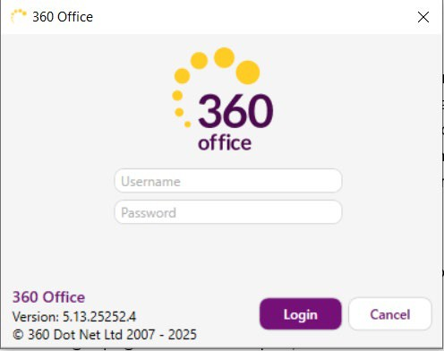
Your login page should now open, like this one:
(Please note: this manual is based around logging into and using 360 Lifecycle ‘Office’).
You will now be able to enter the username and password supplied to you.

Inviting Clients to the Portal
Click on ‘Case Search’ within 360 Office or click on ‘View Case’ on 360 Advisor, it will open the case for client with all sale details as shown below:
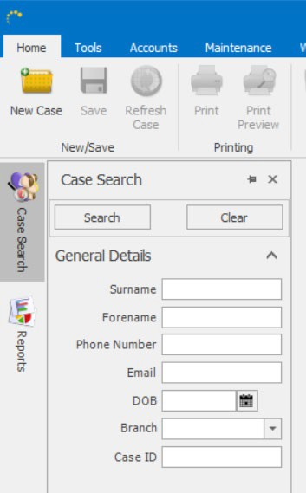
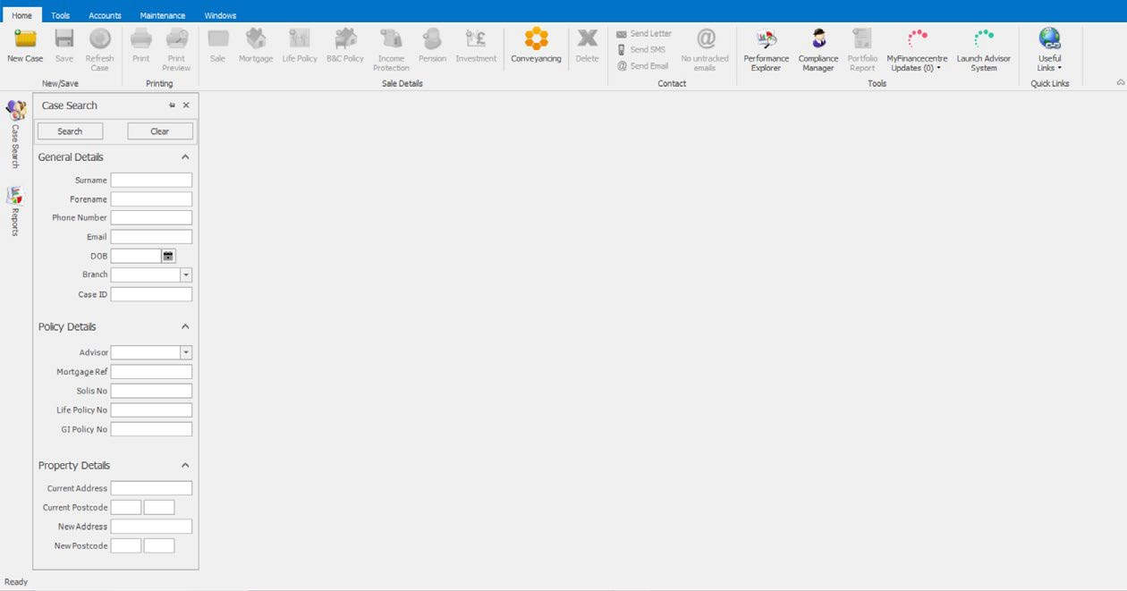
Please confirm with the client that the mobile number & email address is correct to utilise full functions of Client Portal. You must enter the client email & mobile number for the invite to be successful.
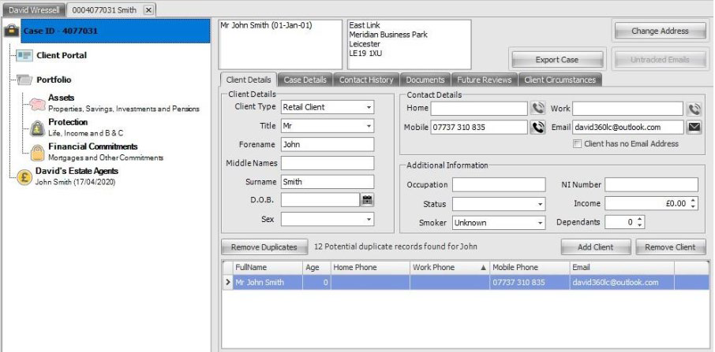
Clicking on ‘Client Portal’ will bring up a screen like the below, and from there you can invite the client(s) to the portal:

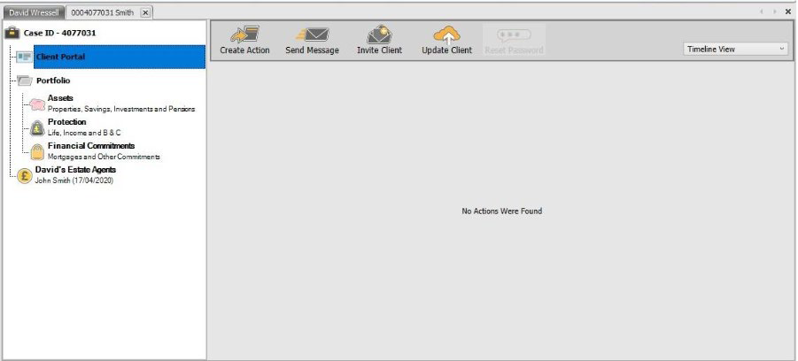
To first send a portal invitation click on ‘Invite Client’. You will have the option to include documents as part of the invite (assuming documents are already uploaded against the case).
Where documents are already attached against the case record you can select which document(s) to include with the invitation.
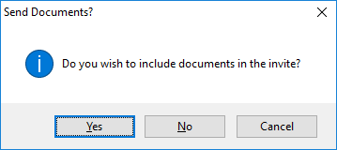
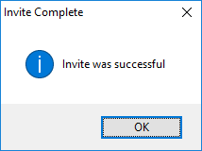

You will receive a message showing the invitation has been successful. If for any reason the invite is unsuccessful, please check that the clients email & mobile are correctly recorded.
The portal invite will be date & time stamped against the case record as an action.

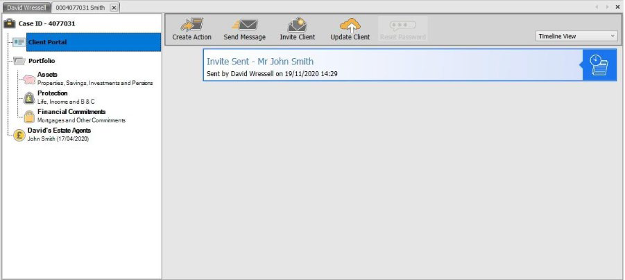

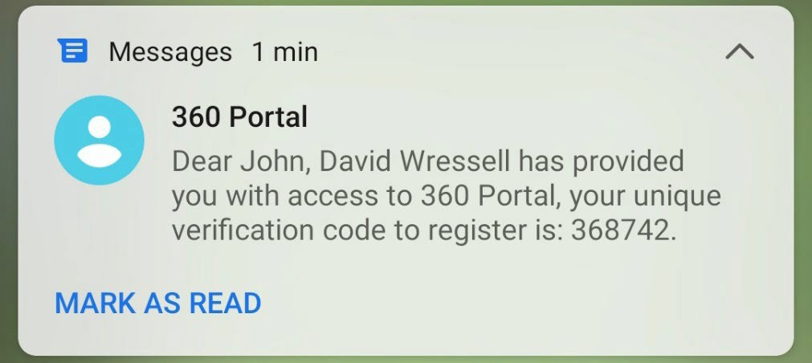
The client will receive an email with the portal hyperlink included, and an activation code by SMS to their mobile number.
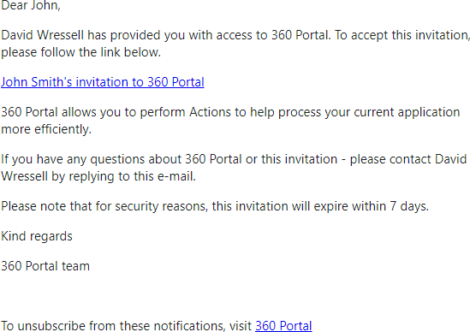
The invite will last 7 days but can be resent from the 360 case record at any time.
The hyperlink within the email will direct the client to your portal registration site where the activation code sent by SMS can be entered to register.

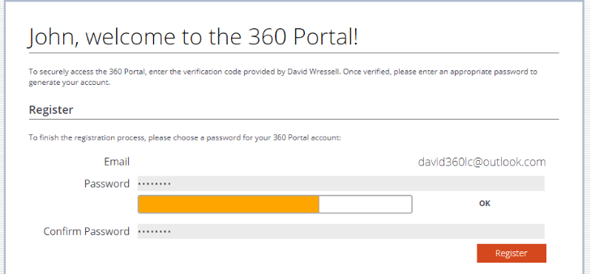
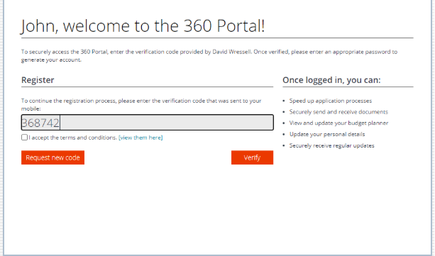
The client is asked to enter their email address and choose a password to create a portal account.
Once logged in the client will then be able to access some of portal features. They can view their Actions, Messages, Budget Planner and Documents, as well having access to contact their adviser, amend their portal account settings and choose to Upgrade (see Portal Upgrade section).
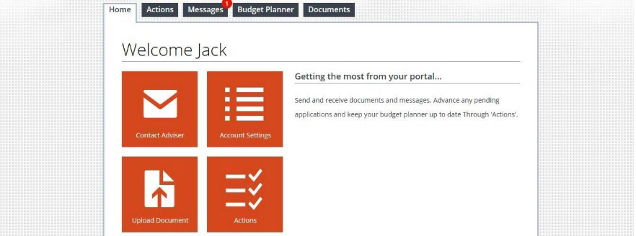
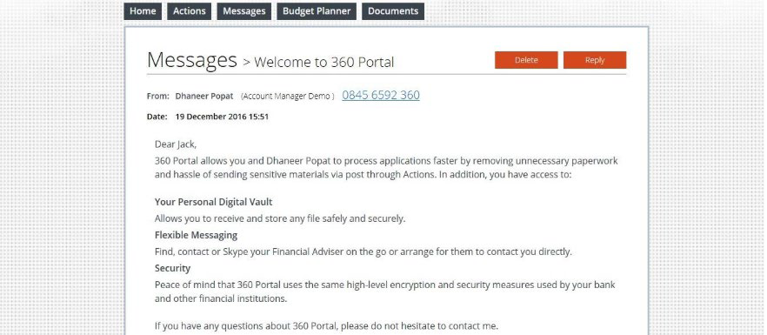
When selecting the ‘Message’ tab, they can view any messages and choose to delete or reply. As below, a message is automatically included as part of the portal invitation:

Sending an Action
Clicking on ‘Create Action’ will give you the ability to send specific actions into the Portal for the client to complete - all of which is fully audited against the 360 case record.
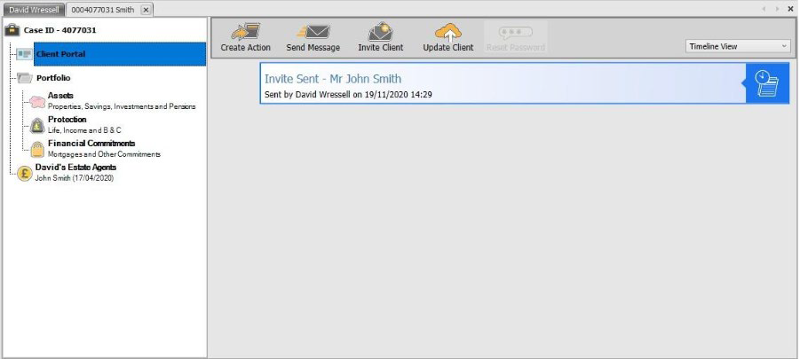
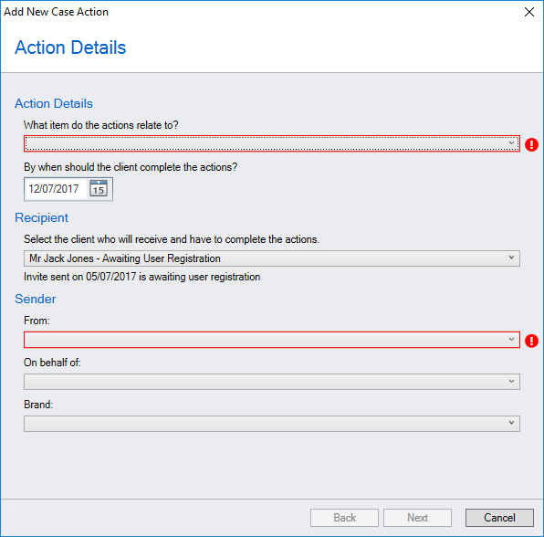
Within Action Details you can first state which section of the case record the action relates to, when the action should be completed by, which client it needs to be sent to (if multiple clients exist), who the action is from, if it is on behalf of someone else and select the applicable branding (if multiple brands are present on your 360 database).

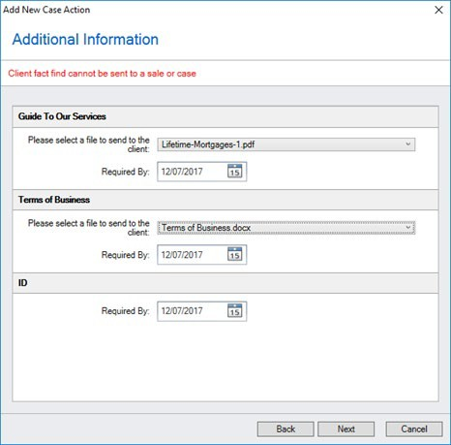
Selecting ‘Next’ will then allow you to pick a group or individual actions you would like to send to the client into their portal. Grouped actions are shown in bold (e.g. as per the Pre-appointment Pack.)
When selecting ‘Next’ the Additional Information page may allow you to select the appropriate document relevant to the action (as there may be multiple document versions related to one action) and amend the ‘Required by’ date of individual action.

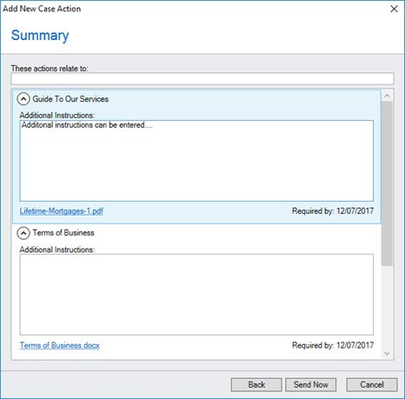
Within the Summary page you can insert an action heading and additional instructions can be added through free text, if required.
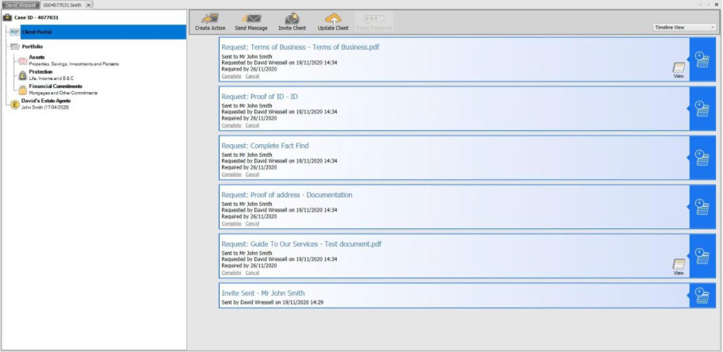
When choosing ‘Send Now’ you will then see each Action that has been sent into the Client Portal.

Portal View (Actions)
Posting Actions into the Client Portal will send an automatic email and SMS message to the client alerting them that an action requiring attention has been sent.
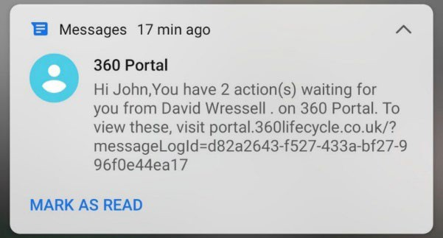
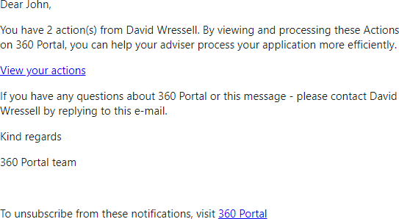
When the client next logs into the portal, they will immediately be directed to any outstanding actions. If needed, they can close this screen and click on the ‘Actions’ tab at a later point, to again see any outstanding actions.
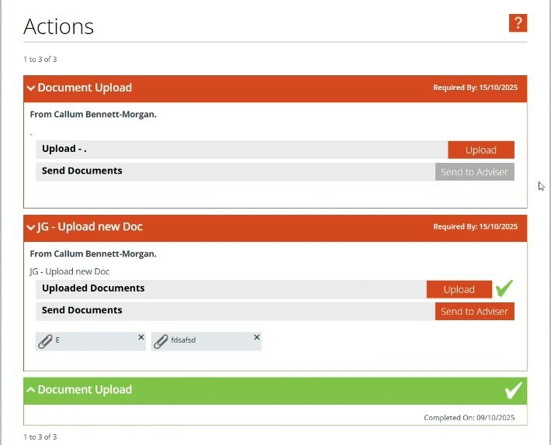
Depending on the action type, the client will either ‘Download’ or ‘Upload’ the required documents. If the adviser has requested it, the client can choose ‘Send Acknowledgement’ to confirm they've received the document.
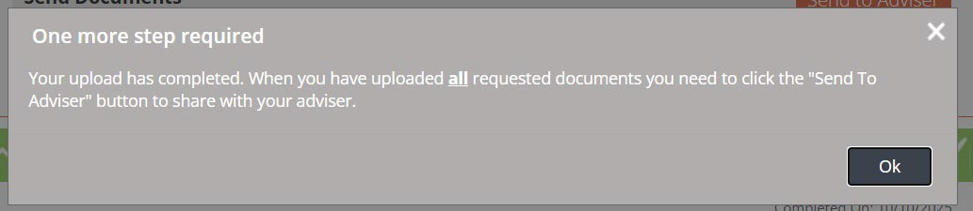
If the action type is to upload a document, a pop-up message will appear from the client’s view, prompting them to press ‘Send to Adviser’:

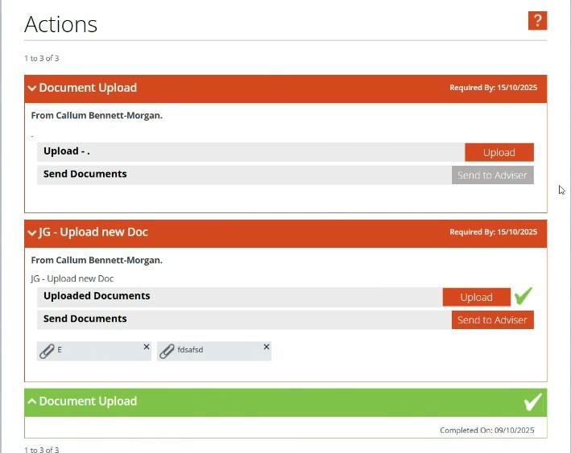
Within the portal completed Actions are displayed GREEN.
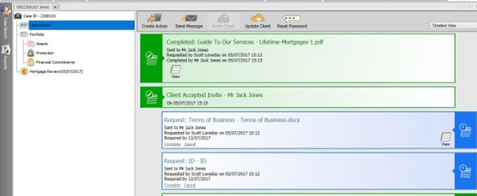

The completed action will also be displayed as GREEN within the 360 case record.
If you choose to ‘Cancel’ the Action from within the 360 case record then this will turn grey and be removed from the portal. You also can manually ‘Complete’ any outstanding Actions, for example if the client sent a requested document via an alternative method. Again, completing any outstanding Actions will remove this from the Portal.
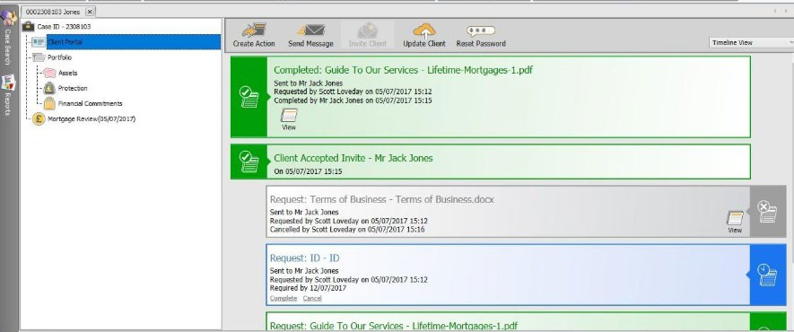
Actions displayed as RED, mean they are overdue.
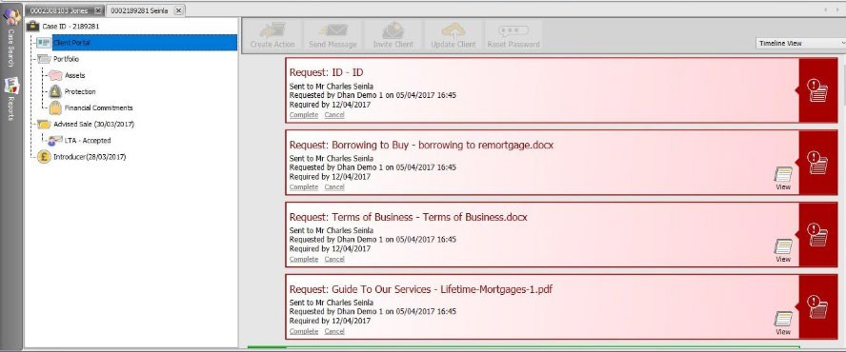

Key Colours for Actions
- Blue: the action is still outstanding but has not reached overdue stage.
- Grey: the action has been manually cancelled and therefore the client does not need to complete the action.
- Green: the action has been completed either by the client or the adviser has manually chosen to ‘complete’ the action.
- Red: the action is outstanding and overdue.

Different Views
- Timeline view: This will show all contact in terms of invites, actions and messages. (All dated and time stamped, with most recent displayed at the top.)
- Outstanding Actions: This will show all blue actions.
- Overdue Actions: This will show all red actions.
- Completed Actions: This will show all green actions.
- Messages: This will show all messages sent and received via the Portal.
- Invites: This will show all client invites (usually only one invite will be sent at the beginning of the process).
- Portfolio Shares: This will show any portfolio updates into the Portal or 360 case record (the Portal will need to be upgraded for this to be applicable – see ‘Portal Upgrade’ section).
- Document Shares: This will show all documents shared via the Portal.

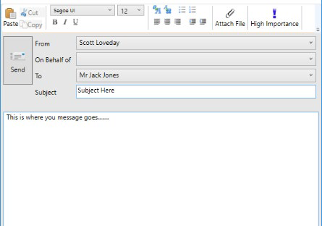
Sending a Message
Sending a message into the portal can simply be done by choosing ‘Send Message’ and will bring up the box like this.
You can attach documents if you wish.
You do not have the ability to cancel a message once it has been sent, as you can with an action.

Portal View (Messages)
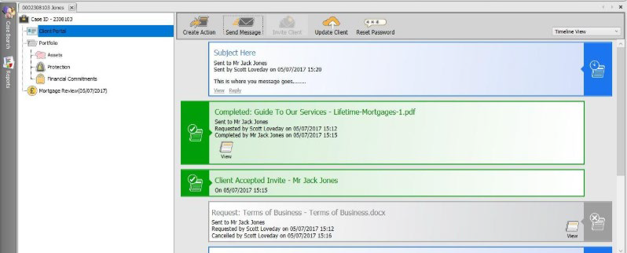
The client can view the message from the ‘Messages’ tab in the portal.
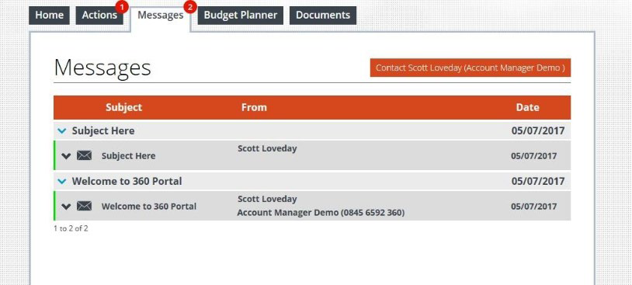
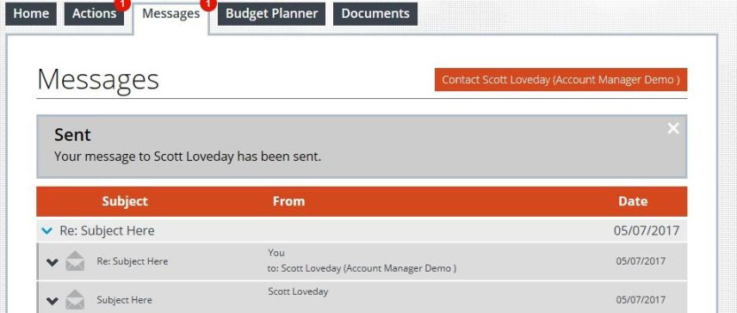
The client will have the option to reply and see that the message has been successfully sent.

Any messages sent from the portal are shown in 360 Lifecycle and where you will be able to ‘View’ or ‘Reply’ to the latest message.

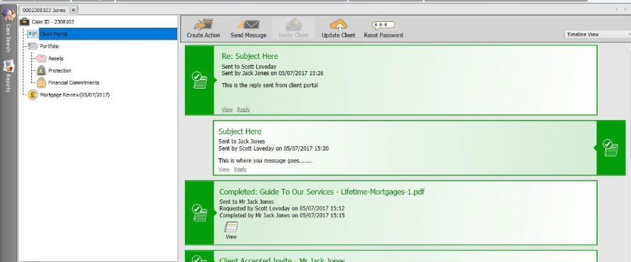
Portal Upgrade
The client can upgrade their portal by selecting the ‘Free Upgrade’.
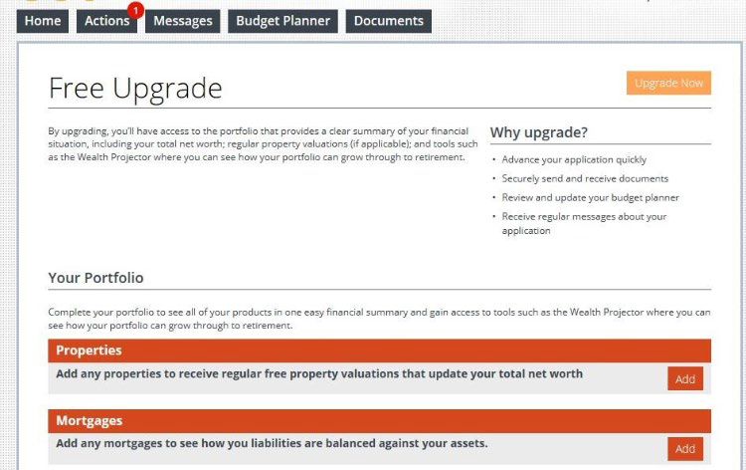
This means they will have further tabs to select from such as My Wealth, Portfolio & Concierge and with a range of additional portal tools available. On upgrading, this will display any portfolio items from within the 360 case record and allow future portfolio changes to be shared between the Client Portal and 360 case record (or
vice versa).

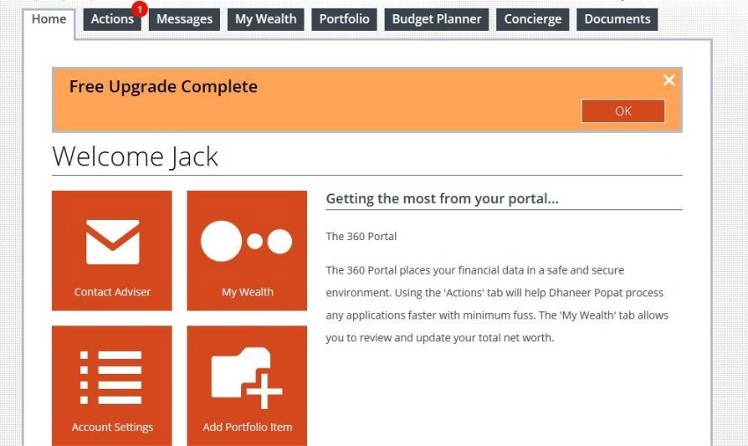

Update Client
**This is applicable where the client has upgraded their portal account via the ‘Free Upgrade’.
The Update Client option allows changes to the Portfolio items in a 360 case record to be shared directly into the Client Portal. The portfolio section of a 360 case record will hold existing Assets, Protection & Liabilities for a client, through either business you have completed or other existing arrangements. Recording the information within the 360 FactFind will automatically update the portfolio section. However, you can also manually add and amend portfolio items from the case record. For further information on how to amend or add items in the Portfolio
Manager section of a case record, please refer to the 360 Advisor manual or contact the 360 Support Team.
When choosing to ‘Update Client’ please note that any changes within the portfolio section of the case record will automatically be taken through to the portal for the client to then be able to accept or reject. This information will also impact the portal balance sheet & net worth. It is strongly recommended you check the information on the case record is correct, including the items showing in the Portfolio Manager section before choosing ‘Update Client’.
Once you are happy with the portfolio information showing and any changes made, select the ‘Update Client’ option. This will automatically send an email and text notification to the client regarding changes made to the Portal portfolio, prompting them to access the Portal to view the amendments and where they can then choose to accept or reject any changes.
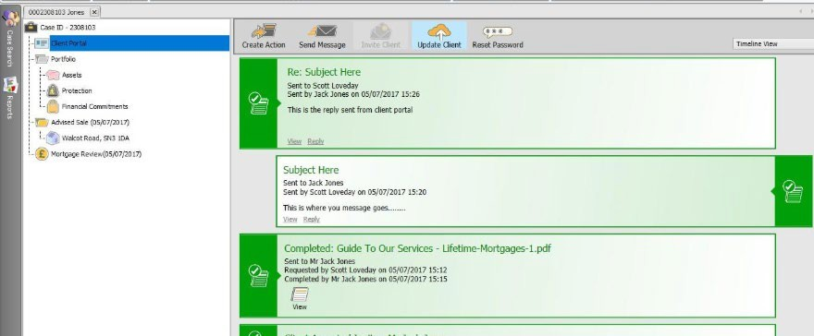

Processing Portfolio Updates from the Portal
When your client sends you a message from within the Portal; has made relevant portfolio changes post upgrade; uploaded documents directly into the ‘Documents’ section or chose to ‘Update Advisor’, you will receive a notification within 360 Lifecycle as shown below:
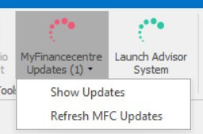
This notification can be seen within 360 Lifecycle’s Office and Advisor. An adviser can have a default administrator set within 360, so that a notification can be picked up and processed by either, ensuring a quick response to your client if necessary.

Once you have clicked onto the notification, this will take you directly into the client record and into the Client Portal screen to view the updates received.

Reset Password
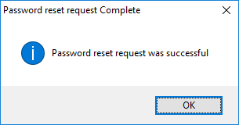
If required, you have the ability for a portal account password to be reset. When choosing ‘Reset Password’ an email will be sent to the client with a hyperlink to reset their portal password. A text message will also be sent with a verification code so the password can be changed.

System Maintenance: Create a New Action
*Please note – you may may require the ‘System Admin’ role to access Case actions/Case Action Groups*
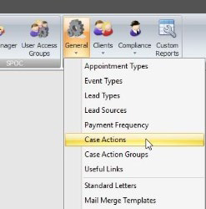
To create new Case Actions that can be sent into the portal, you simply need to go to 360 Office and click Maintenance, General and ‘Case Actions’ (please note that this is permission based and generally your system administrator will perform).
Creating a new action will allow you to pick an ‘Action Type’ (whether you would like a client to Read and Acknowledge, Upload Document of Type or Download, Sign and Return). Relevant brand logos can then be selected along with a title and description which will be displayed in the Portal.
Depending on which ‘Action Type’ selected when creating a new action, you will get the option for ‘Case Document’ or ‘Standard Document’.
Case Document: This option will provide a drop-down when sending the action, to select the document from the Case Record.
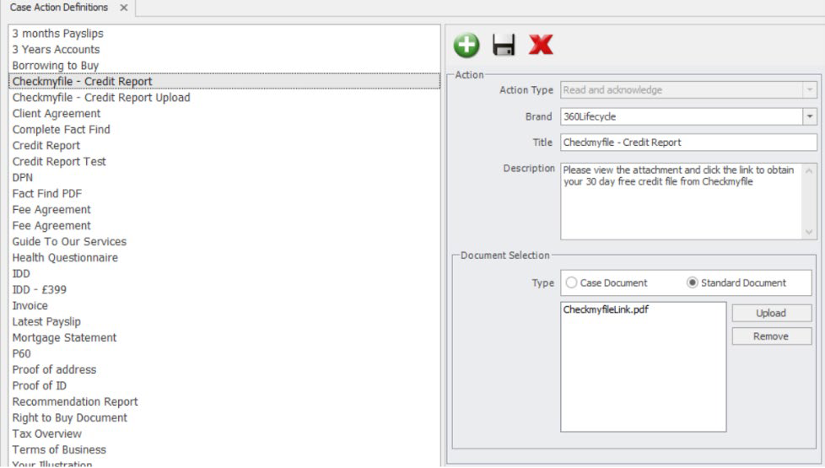
Standard Document: This is a document you upload to the action.

System Maintenance: Creating an Action Group
You can create a group of actions which will collate and create several Actions at the same time. For example, a Pre-Appointment Pack could hold multiple documents you would like the client to upload or download and acknowledge.
In order to create new Case Action Groups that can be sent into the portal, you simply need to go to 360 Office and click Maintenance, General and ‘Case Action Groups’ (please note that this is permission based and generally your system administrator will perform).
You will have the ability to put various existing Actions under one Action Group and Relevant Brand logos can then be selected along with a Description which will be displayed in the portal.
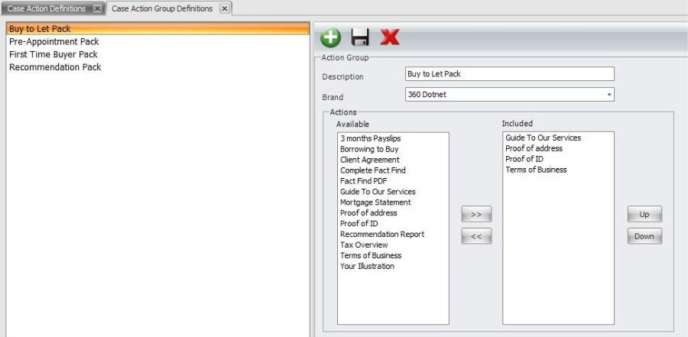

Default Message Templates Appendix
The following provides a listing of automatic messages generated by the Client Portal platform for standard communications.

New User Registered
Used when a new invitation is generated by the portal, exposing Actions, Messages, Documents, and the budget planner.

Example email
Dear Jack,
360 Demo has provided you with access to 360 Portal. To accept this invitation, please follow the link below.
Jack Jones invitation to 360 Portal
360 Portal allows you to perform Actions to help process your current application more efficiently.
If you have any questions about 360 Portal or this invitation - please contact 360 Demo by replying to this e-mail.
Please note that for security reasons, this invitation will expire within 7 days.
Kind regards, 360 Portal Team

Example SMS
Dear Jack, 360 Demo has provided you with access to 360 Portal, your unique verification code to register is: 1234567

Consumer Action Notification
Generated when actions have been created in 360 and pushed to the portal.

Example Email
Dear Jack,
You have 3 action(s) from 360 Demo. By viewing and processing these Actions on 360 Portal, you can help your adviser process your application more efficiently.
View your actions
If you have any questions about 360 Portal or this message - please contact 360 Demo by replying to this e-mail.
Kind regards, 360 Portal

Example SMS
Dear Jack, you have 3 action(s) waiting for you from 360 Demo on 360 Portal. To view these, visit portal.360lifecycle.co.uk

Document Notification
Generated when document(s) have been sent to the client from 360.

Example Email
Dear Jack,
You have received 2 document(s) from 360 Portal. You can securely view these on 360 Portal by following the link below.
View your documents
If you have any questions about 360 Portal or this message - please contact 360 Demo by replying to this e-mail.
Kind regards, 360 Portal

Example SMS
Dear Jack, 360 Demo has sent you 1 document(s) on 360 Portal. To view these, visit portal.360lifecyle.co.uk

Message Notification
Used for messages that have been generated by the adviser into the Portal.

Example Email
Dear Jack,
You have received a message from 360 Demo. You can securely view this on 360 Portal by following the link below.
360Portal
If you have any questions about 360 Portal or this message - please contact 360 Demo by replying to this e-mail.
Kind regards, 360 Portal

Example SMS
Dear Jack, 360 Demo has you a message on 360 Portal. To view this, visit portal.360lifecycle.co.uk

Invitation Reminder
Sent one day before the 7-day (notional) expiry period elapses.

Example Email
Dear Jack,
Your access to 360 Portal is due to expire within the next 24 hours. 360 Portal allows you to perform Actions to enable 360 Demo to continue with your application.
Jack Jones invitation to 360 Portal
If you have any questions about 360 Portal or this message - please contact 360 Demo by replying to this e-mail.
Kind regards, 360 Portal

Example SMS
Dear Jack, you only have 24hrs left to access 360 Portal! Visit portal.360lifecycle.co.uk to continue.

Outstanding Actions Reminder
Sent one day before any outstanding actions are required by the adviser.

Example Email
Dear Jack,
You have 1 action(s) outstanding from 360 Demo. Processing these action(s) will enable 360 Demo to continue with your application.
360 Portal
If you have any questions about 360 Portal or this message – you can contact 360 Demo by replying to this e-mail.
Kind regards, 360 Portal

Example SMS
Dear Jack, you have 1 action(s) outstanding on the 360 Portal from 360 Demo. To complete these, visit portal.360lifecycle.co.uk

Reset Password (Portal)
Password reset request generated by the consumer where they’ve used the Portal Account authentication method.

Example Email
Dear Jack,
You are receiving this message because a password reset was requested on 360 Portal.
If you requested this then please reset your password by clicking the link below. Reset your password
Kind regards, 360 Portal

Example SMS
Dear Jack, your unique verification code to reset your password is: 1234567.

Portfolio Change Notification
Generated if an applicable change has been made to the consumers’ 360 portfolio record and shared via ‘Update Client’. Note portfolio changes will only be visible if the client has chosen to ‘Upgrade’.

Example Email
Dear Jack,
360 Demo has made changes to your portfolio. You can view and accept or reject these changes on 360 Portal to keep your financial summary up to date by following the link below.
360 Portal
If you have any questions about 360 Portal or this message - please contact 360 Demo by replying to this e-mail.
Kind regards, 360 Portal

SMS Content
Dear Jack, 360 Demo has made changes to your 360 Portal portfolio. To view these, visit portal.360lifecycle.co.uk
Message Type | Email | SMS
New User Registered |  | *
Consumer Action Notification
Document Notification
Message Notification
Invitation Reminder (6 days after initial invite)
Outstanding Action Reminder (1 day before any outstanding actions are required)
Portfolio Change Notification
Reset Password |  | *
* Used to send validation codes as part of the two-method authentication

Client Portal Reports
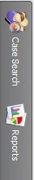
Client Portal reports can be found in 360 Lifecycle Office and are located within the 'Reports' on the left-hand side of your screen.
These can be accessed by clicking on the 'Reports' tab and scrolling down to 'Client Contact Reports'

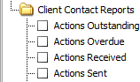
The following reports are available:

- Actions Outstanding: This provides you with a list of actions within the Client Portal which have been sent but not yet completed. Includes overdue and non-overdue actions.
- Actions Overdue: This provides you with a list of actions within the Client Portal which have been sent but not yet been completed and the ‘required by’ date has passed.
- Actions Received: This provides you with a list of actions within the Client Portal which have been sent and completed either by the Client, or the Adviser has clicked the ‘Complete’ option within a 360 Lifecycle case record.
- Actions Sent: This provides you with a list of actions within the Client Portal which have been sent regardless if they are overdue, completed or cancelled.

Information Classification Procedure
Document Classification | Public
Document Ref | ISMS-SD27-A05-12-01
Version | 1
Dated | 29 June 2026

