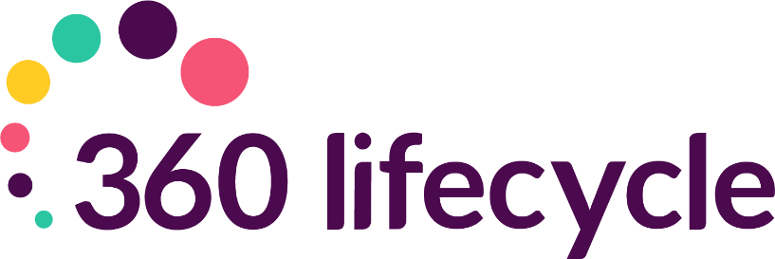
Automatic Reviews Training Manual

Contents
1. Mortgages 3
2. Life Policies 3
3. Buildings and Contents 4
4. All Other Policies – (Income, Pension, Investment, Reviews) 4
4.1 Income Protection 4
4.2 Pension 5
4.3 Investment Policies 5
5. Annual Reviews 5
6. Servicing Arrangements 5
6.1 How to Setup Servicing Arrangements 6
6.2 How your reviews generate 7
6.3 Review Generation Settings 8

360 Lifecycle automatically generates your future sales opportunities based on key dates entered against each policy record. These opportunities are generated overnight and will appear in the servicing adviser’s Hotbox for them to action accordingly. The triggers for each policy are as follows;
- Mortgages
Mortgage Reviews can be driven by a ‘Fixed End Date’ or ‘Initial Rate Period’. Note, if you select Initial Rate Period, this review will only be generated once a Completed Date has been inputted.
If you select ‘No End Date’, this will generate a review based on the ‘Penalties End’ field. If neither are populated, a review will generate 2 years after the ‘Completed’ date on the policy.
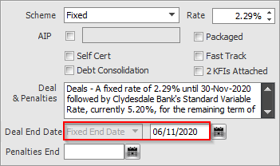

- Life Policies
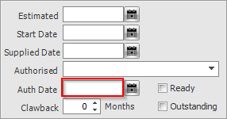
Life reviews are generated from the ‘Authorised Date’, plus the Clawback period minus the ‘Advanced Notification Period’.

For example, if the Authorised date is the 25.09.13 and the claw back period is 48 months, then the review will be generated 30 days before 25.09.17, therefore will appear in the adviser’s Hotbox on the 25.08.17.

- Buildings and Contents
Building and Contents reviews are triggered from the ‘End Date’, by default the system generates a review based on the ‘End Date’, less the ‘Advanced Notification Period’. If the ‘End Date’ is not populated, then this will work from the ‘Start Date’.
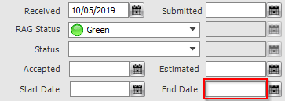

- All Other Policies – (Income, Pension, Investment, Reviews)
Triggers for Income Protection, Pension and Investment policies work from the ‘Start Date’, plus the ‘Clawback Period’, less the ‘Advanced Notification Period’.
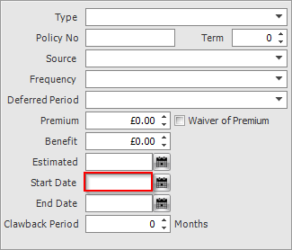
  - Income Protection

  - Pension
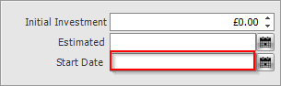

  - Investment Policies
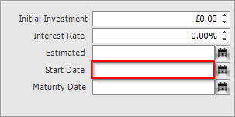

- Annual Reviews
An Annual Review will be generated 11 months after the last completed bit of business. Therefore, if a life policy is the last completed bit of business on a client case then the annual review will be generated 11 months from the ‘Authorised Date’ entered on that policy.
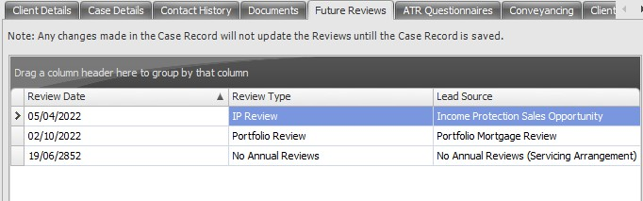
There is also a ‘Reviews’ tab on the ‘Case ID’ level on a case, if you choose to click on this there is also an option to view all the reviews at once.

- Servicing Arrangements
If a servicing arrangement is set for a policy, then this will override any review that the system will generate. This is so you can manipulate the reviews in which will be sent to your Hotbox and the level of service that you provide to a client.

The setting and dates for a servicing arrangement can be amended in Maintenance> General > select Servicing Arrangement settings in the drop-down menu.
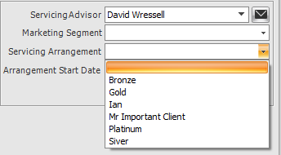

  - How to Setup Servicing Arrangements
To setup a Servicing Arrangement, you need to login to 360 Office, and select
Maintenance> General > Common Settings > Servicing Arrangement Settings.
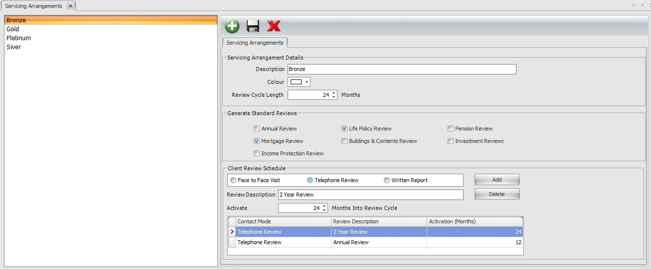
To add a new Servicing Arrangement, click the Green ‘+’ button.
You will need to give the Arrangement a Description, which is the text that will show when selecting this on a case record.
The Review Cycle Length is how long the Servicing Arrangement will last. This will restart after this initial period elapses.
You can dictate whether the specific case generates the standard policy specific reviews by ticking or unticking the relevant options, e.g., “Mortgage Review”, “Life Policy Review”, etc.

Under the Client Review Schedule, you can setup when in the cycle the Arrangement will generate opportunities. To do this, click ‘Add’, and specify from the radio buttons if this is a ‘Face to Face Visit’, ‘Telephone Review’ or ‘Written Report’. This will show in the Hotbox when the opportunity generates. You give this a description which will support this and input how many months into the Arrangement cycle you want this to generate. You can generate as many opportunities as you need to within a Servicing Arrangement, and handle these as you would any other Opportunity in the Hotbox.
  - How your reviews generate
Here is a reminder of the dates in which will prompt your system to generate a review:
Income | Mortgage Review | Life Policy Review | B&C Review | Protection Review | Investments Review | Pension Review
Start Date |  |  |  | XX | XX | XX
Penalty End Date | X
End Date | XXX |  | X
Authorised Date |  | XX
Annual Reviews worked based on the last completed bit of business, here is a reminder of how these will be generated:

Last completed bit of business | Annual Reviews
Mortgage | If a mortgage is the last competed bit of business then, the annual review will be generated based on the completed date of the mortgage.
Life Policy | If a Life Policy is the last completed bit  of business then the annual review will be based on the authorised date.
Buildings and contents | Where a buildings and contents policy is the last completed bit of business the annual review will be generated from the End Date.
Income Protection | Where an Income Protection policy is the last completed bit of business the annual review will be generated from the Start Date.
Investments | Where an Investments policy is the last completed bit of business the annual review will be generated from the Start Date.
Pension | Where a Pension is the last completed bit of business the annual review will be generated from the Start Date.
  - Review Generation Settings
You can now manage your own review generation settings within 360 Office. Login, and locate Maintenance > General > Common Settings > Review Generation Settings. This will open a window like the below:

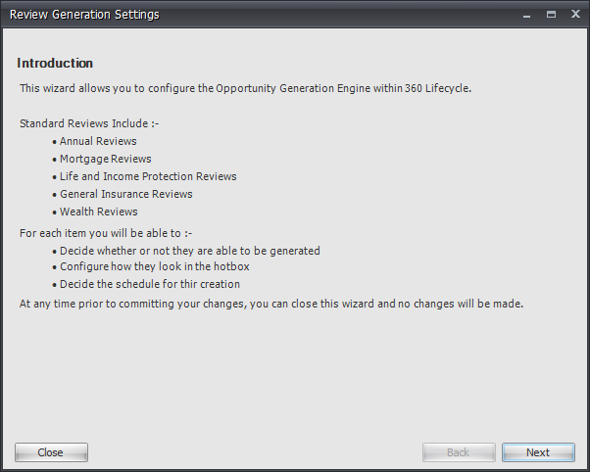
From here, you can quickly and easily maintain your reviews, determining the Advance Notification Period, and the Lead Source linked to these. This can be done for Annual Reviews, Mortgage Reviews, B&C Reviews, Life & Income Protection Reviews and Wealth Reviews.

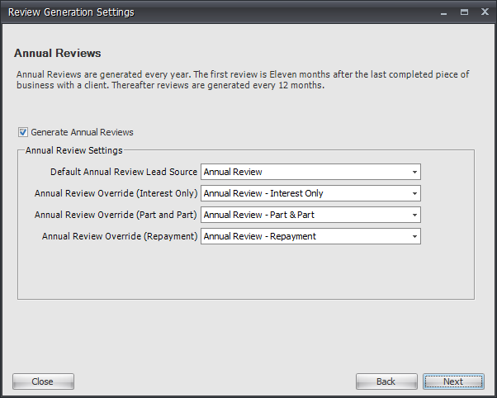
If you make any changes, these will take immediate effect, meaning if you were to change your Mortgage Review period from 3 to 6 months, leads will immediately show in the relevant adviser’s Hotbox as per the clients they manage. If you were to reverse this, however – i.e., change from 6 back to 3 months – then any leads that have already generated will be removed from the Case Record.

Information Classification Procedure
Document Classification | Public
Document Ref | ISMS-SD27-A05-12-01
Version | 1
Dated | 09 September 2025

