
Advisor Training Manual

Contents

1. Introduction 4
2. Diary 4
2.1 Diary Views 4
2.2 Shared Diary Views 5
2.3 Calendar Views 5
2.4 Adding Appointments 5
2.5 Blocking Time & Daily Notes 11
2.6 Diary Integration 12
2.7 Phone Integration 16
3. Hotbox 17
3.1 Column Chooser 18
3.2 Your Hotbox 19
3.3 Adding a Manual Opportunity to Your Hotbox 19
3.4 System Generated Opportunities 21
3.5 Managing Your Hotbox 21
3.6 Postponed Hotbox 22
3.7 Your Referrals 24
4. Managing your clients’ case record 24
4.1 Client Search 24
4.2 Document Management 26
4.3 Creating Your Clients Portfolio 27
4.4 Assets 28
4.5 Protection 34
4.6 Financial Commitments 37
4.7 Portfolio Report 39
5. Client Communication 43
5.1 Sending a Letter 43
5.2 Sending an SMS 44
5.3 Sending an Email 44
6. Letter Templates 47
6.1 Adding a new letter template 48
6.2 Amending an existing letter template 49
7. Creating default portfolio report headers 50

- Introduction

360 Lifecycle allows advisers to efficiently drive increased sales and manage activity resulting in new business.
Comprised of tools and features that allow you to fully utilise your existing and prospect client bank, 360 Lifecycle enhances your ability to run a successful business and deliver great customer services.
360 Lifecycle comes in 2 separate links/applications, ‘360 Advisor’ and ‘360 Office’. This guide will cover the core functionality available in both applications and show you how to make best use of the tools including:
- Calendar navigation with integrated external diary system (360 Advisor)
- Hotbox for lead and referral management (360 Advisor)
- Basic case handling and building (360 Advisor & 360 Office)

- Diary
To access your diary, you need to log into your ‘360 Advisor’ application. Your diary is split into 2 types of views; diary views and calendar views.
  - Diary Views
You can view your diary as one day, five working days, or even seven consecutive days, one-week view to a month view by simply clicking on the appropriate tabs.
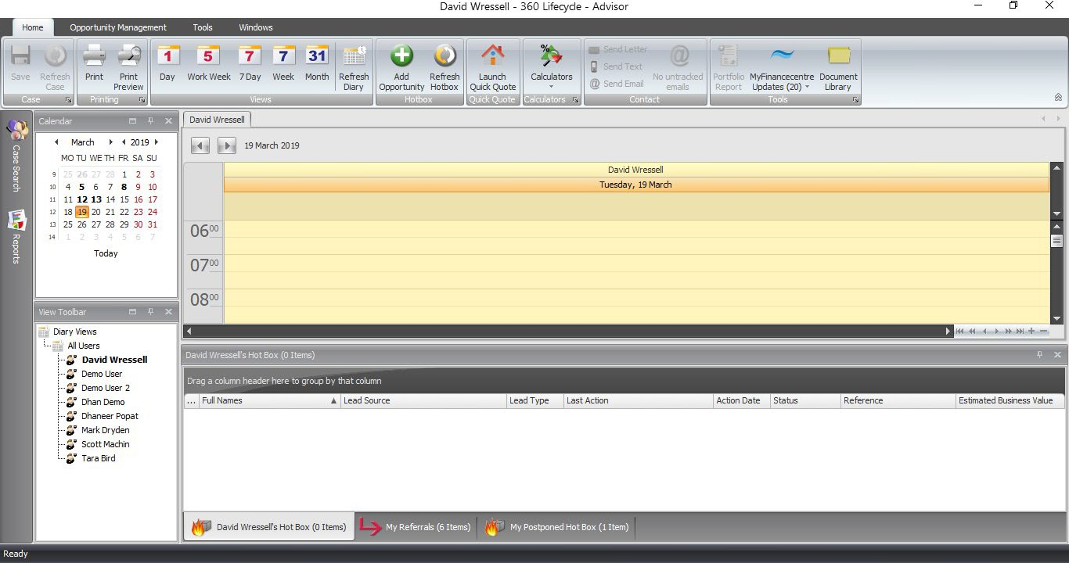
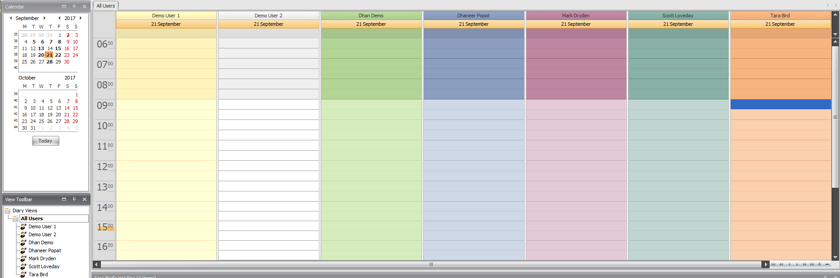

  - Shared Diary Views
You can also see shared diary views. This access is set in Diary Views, held within 360 Lifecycle System Office.

Select the diary view name you wish to see at once. This is a great feature that will work as a huge advantage for administrators, personal assistants, etc. who can add appointments directly into advisors’ diaries. You can access another individual’s diary or a whole diary team which will show all diaries within the group.
  - Calendar Views
You can navigate forwards and backwards through your diary by using the arrow signs to the left and right of the month or year. Any historical data entered on the
calendar will remain on the calendar.

Days and weeks can also be highlighted so that you can view all on one page.

If anything has been saved into your diary, the day it has been saved on will be emboldened on your calendar views so you can easily navigate through days where you are free and days where you have time blocked.
  - Adding Appointments
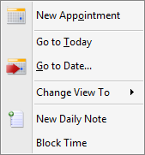
It is very easy to add an appointment into your Advisor Diary. First, find the time and date that your appointment will be booked in for and select it by clicking in the relevant place and making sure it is highlighted.

Right click and a menu will appear with a list of options.

Select ‘New Appointment’ and a screen will open for you to enter the details of the appointment.

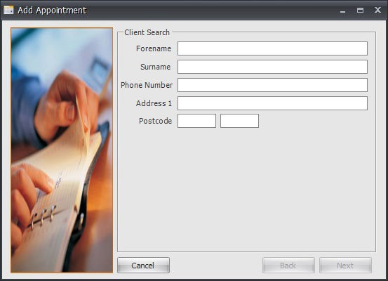
In the first screen you will enter as much detail about the client as possible. A name is mandatory.
Click ‘Next’ once you have done this.

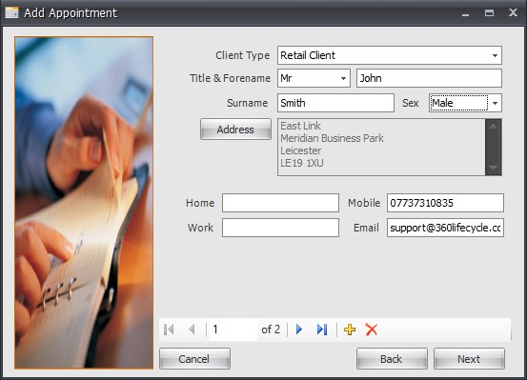
The system will then trawl your client base looking for a matching client. If a match is found, you can select it from the list options and then click ‘Next’. If there is no match you will tick the ‘No Match Found Create New Client’ and then click ‘Next’.

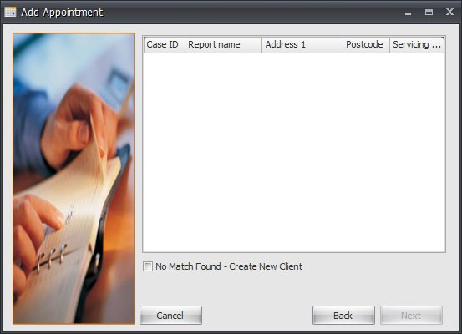
In this screen you can enter more details about the client. A contact number and email address is highly recommended as being saved. You can add an address by clicking on the ‘Address’ button.

If there is more than one client, you can add another attendee by clicking on the yellow ‘+’ sign
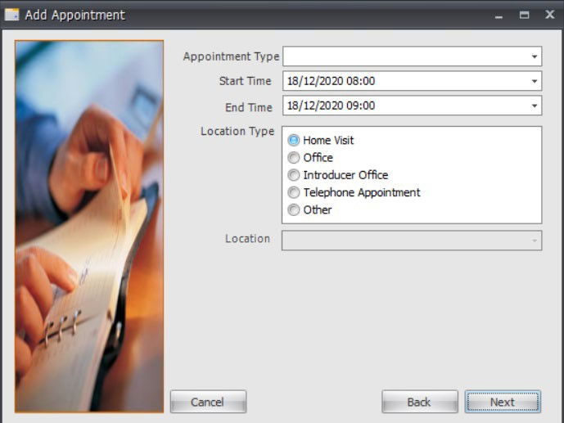
Here you add the details of the appointment; specifying whether it is a first or second appointment, what time it is due to start and finish, the date and where the appointment is to take place. Click ‘Next’

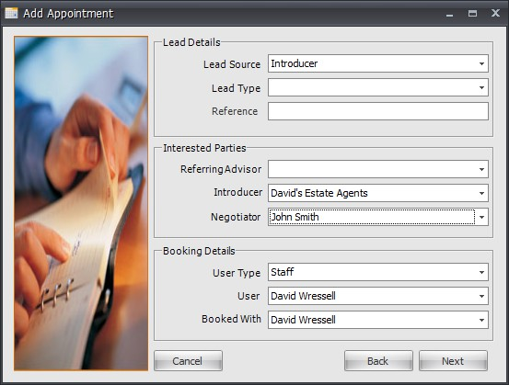
Next you select the Opportunity details. All appointments with clients that you add are saved with sales opportunities. If you do not want them saving in this way, please see Adding Blocked Time. Tick the ‘Create New Sales Opportunity’ box, filling in the ‘Lead Source’ (where the opportunity has come from,
‘Referring Advisor’ (if there is one) and ‘Introducer’ details.

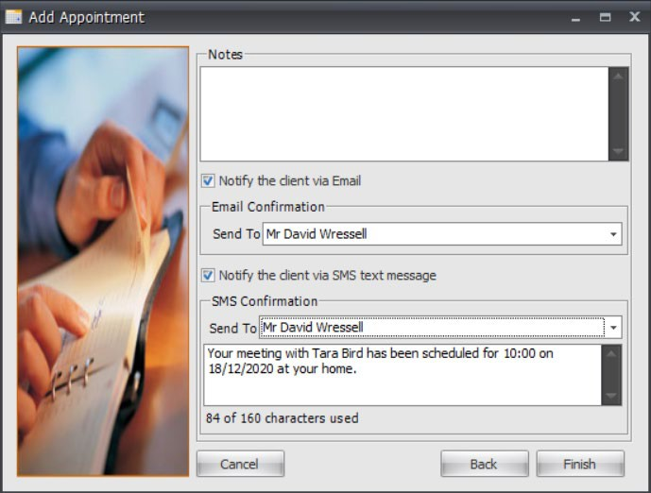
Add any notes in the ‘Notes’ section. If you would like to send your client a text message confirming the appointment details tick the ‘Notify the client via SMS text message’ box. This SMS message can be sent to multiple clients, is editable and can be amended before sending.

To send a pre-templated email to your clients, tick the ‘Notify the client via Email’ box. If you wish to amend the template, please contact the Support team.
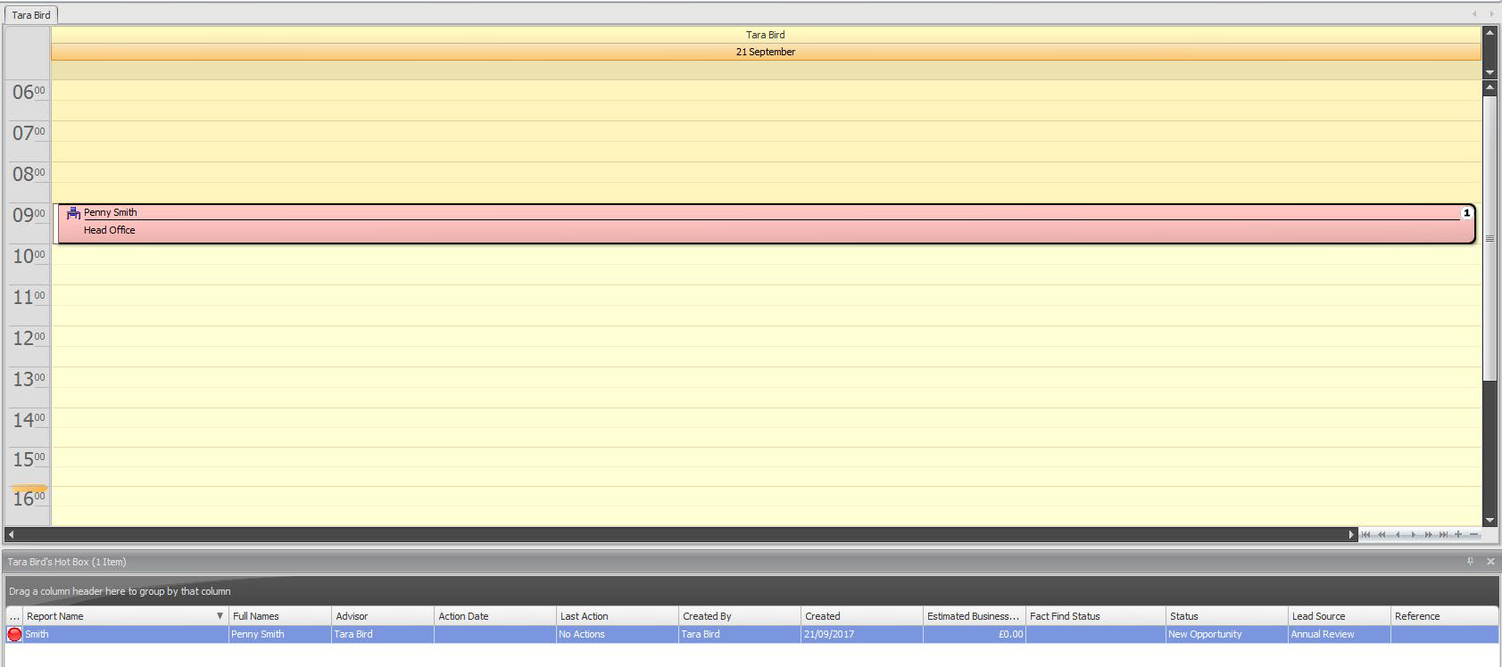
Once you have selected ‘Finish’, this would have carried out a number of things;

- A new client record would have been created if this was a new client.
- You will notice the client appointment has now been added and saved into your diary.
- If applicable the client(s) would have been notified of the booked appointment by an automatic SMS message and/or Email.
- If diary integration is enabled, this would have sent a meeting request to your external calendar. For a guide on diary integration please refer to Diary Integration.
- An opportunity dropped into your Hotbox. For a guide on the Hotbox please refer to Your Hotbox.

    - Editing/Moving/Cancelling Appointments
To edit the appointment details simply double click on the appointment in your diary. This will bring up a screen where you can edit the clients details, the appointment details as well as the lead source details.
You can also change an appointment time by dragging it to another place in your diary. Simply click on the appointment, dragging it up or down depending on the time needed. If the appointment is to take place on another day you can drag the appointment over to your calendar, hovering over the day needed and then dropping the appointment here.
If there is a client in your Hotbox you wish to create an appointment for you can drag the opportunity from the Hotbox over into your diary, dropping onto the specified date and time. This will not remove it from your Hotbox, it will just create the appointment in your diary.

You can also record ‘Outcomes’ of appointments below, including cancellations, successful appointments and DTU (Didn’t Turn Up) appointments
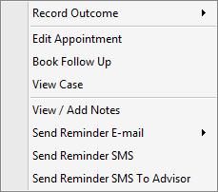

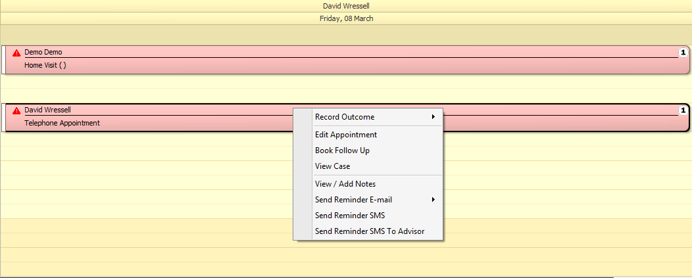
Another way you can edit the appointment is by right clicking on the appointment in your diary and selecting the ‘Edit Appointment’ option.

Within ‘Edit Appointment’ there is an option to book the appointment into another person’s diary should you wish to. You can do this by clicking the ‘Unlock’ option next to the ‘Booked With’ field and amending the name accordingly. This will then transfer the appointment into the advisers diary and any associated sales opportunities into their Hotbox.
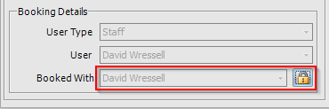

Once an appointment has been edited, you can ‘Notify’ your clients via SMS and/or email of the appointment details.
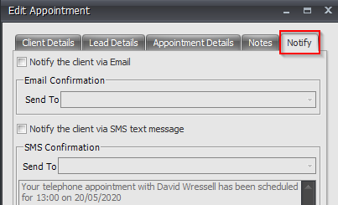

Using the right click menu option you can also cancel the appointment. Selecting this will turn the appointment in your diary lilac but for audit reasons the appointment will remain in your diary. If you prefer to, within 360 Office, you can update this so that Cancelled appointments are removed from the diary display. Note, these will still be audited in the file.

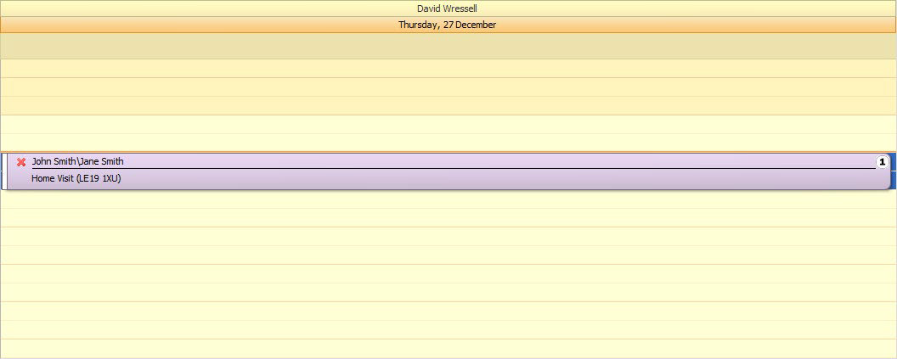

If you have cancelled the appointment by accident or have been able to rebook it for the same date and time you can click the ‘Reinstate Appointment’ option from the right click menu. The appointment will turn back from lilac to blue in your diary.

If your client did not turn up to the appointment, using the right click menu options you can select the ‘DTU Appointment’ option. This will turn the appointment in your diary an olive green colour.
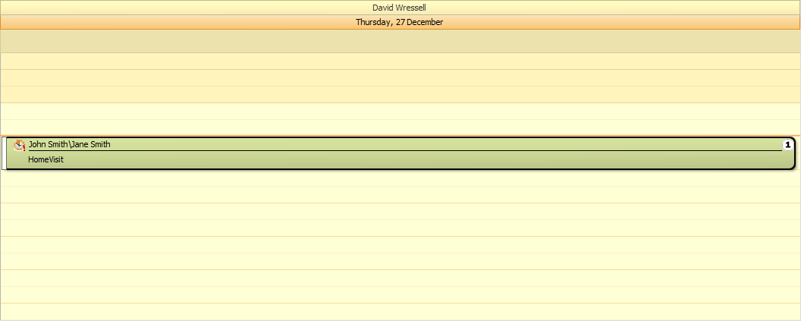

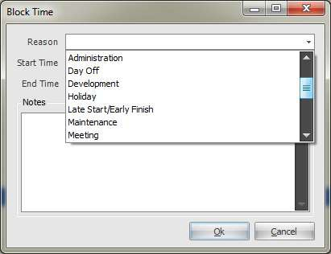
  - Blocking Time & Daily Notes
Blocking Time
To block time out of your diary, eg, for a meeting or to schedule time in for administration, etc, simply right click in your diary on the day and time you wish to block the time out and choose ‘Block Time’.

Select the reason for the blocked time from the drop down menu, along with the start time and date and any notes you may wish to add.

Click on ‘OK’ and the blocked time will be saved into your diary.
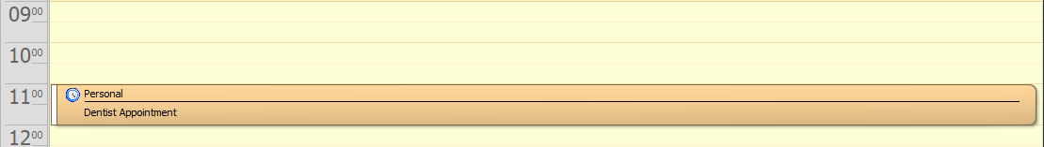

In the same way as an appointment, you can drag and drop this blocked time to other times and dates in your diary. You can also right click on the blocked to edit it further or add notes, etc. or you can remove it completely.

Adding a Daily Note
To add a daily note right click in your diary and choose ‘New Daily Note’. A menu will appear where you will have many options included to add a ‘New Daily Note’. Click on this. A screen will appear where you are able to enter and save the details of the note.

Click ‘OK’. The daily note will appear at the top of your diary on the day you have saved it. Please note that a maximum of 10 daily notes can be added against any day.
  - Diary Integration
The 360 System enables you to integrate your Advisor diary with your personal diary. Compatible diaries are:

- Outlook
- Outlook Web Access
- Gmail
- iPhone & iPad
- Windows Phone
- Yahoo Mail

NB: Diary integration may work with other alternative email diaries, but we are not able to guarantee this. Also, when integrating your diaries to your phone you may need to undertake a few more steps that listed here in this guide. If you are unable

to integrate your smartphone or email in general, please call the Support Team on
08456 592360.

Log in to Advisor or Office. Click on the ‘User Settings’ tab under the Tools menu.
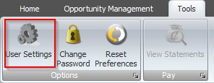

Once you have clicked on the ‘User Settings’ icon a screen will appear.
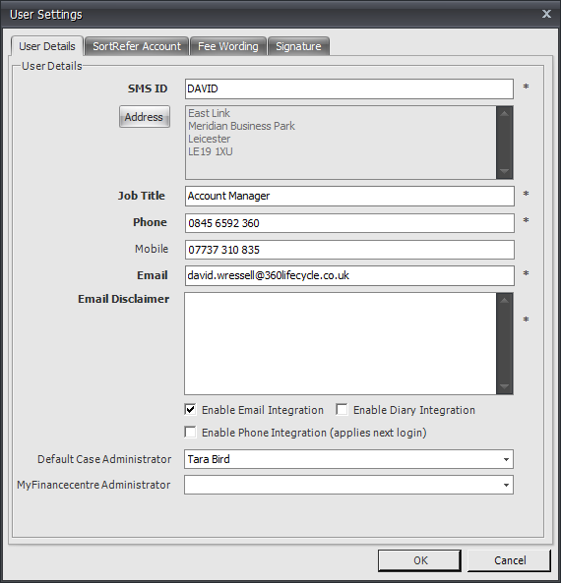

You will see a tick box at the bottom of the screen ‘Enable Diary Integration’. Tick this, double checking that you have entered your email address in the relevant field and checking that all fields with a * next to them have also been filled in before clicking ‘Ok’.

Your Advisor Diary is now integrated with your personal diary.

How do I make a new appointment/block out time in 360 Advisor appear in my existing diary?
Create an appointment/block out time in your diary as shown in Appointments and Blocking Time & Adding Daily Notes.

With diary integration enabled you will receive an invitation email from pa@360lifecycle.co.uk to your personal (external) email account (the account you have integrated with) notifying you of the new appointment/blocked time in your diary.

When you have received this, you will have the options to ‘Accept’, ‘Maybe’ or
‘Decline’ the appointment.
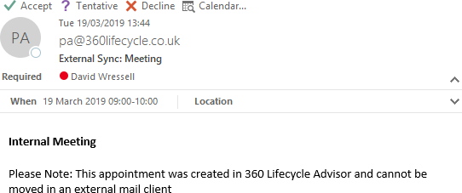

Accepting the invitation will put the time into your external email calendar, while declining will mean it will not enter your external calendar.
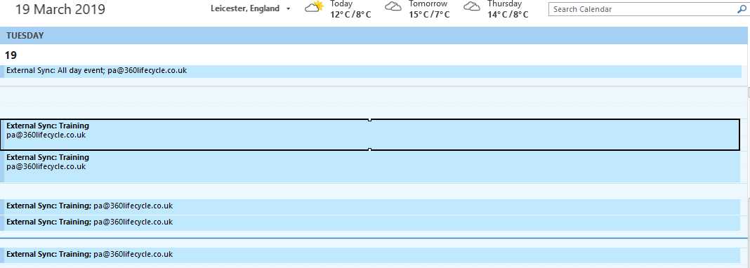

NB: You cannot edit an appointment/blocked time/daily note through your external email calendar if it has been sent through from 360 Advisor. Amendments

must be done through the 360 Advisor diary.

Note: For the purposes of this user guide the above screen shots comes from Microsoft Outlook 2010.

Double clicking on the appointment within your diary you can access any notes or information about the appointment. If it is a client appointment and the client is already saved onto the system, the clients contact details will also be displayed in the appointment message.

How do I make an appointment/blocked time in my existing diary appear in my
360 Advisor diary?

Within your existing external email calendar right click on the day and time that you would like to set up an appointment, as you would usually. Select ‘New Appointment’, or your external calendar equivalent.

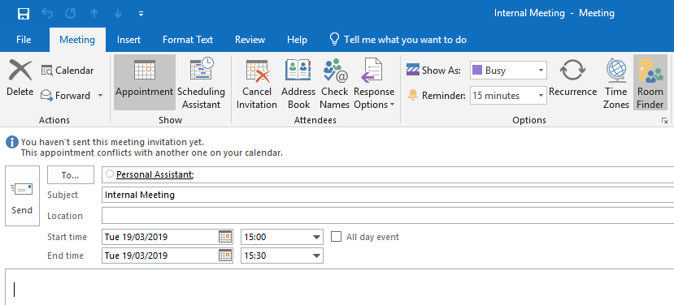
Enter, as asked for, the details of the appointment. Before clicking on ‘Save and Close’, or ‘Send’, you need to invite pa@360lifecycle.co.uk as an attendee. For the purpose of this guide the following instructions on how to do this are done through Microsoft Outlook 2010 but if you are unsure how to go about this with another email calendar (one that is compatible with calendar and diary integration) please ring our support desk on 0845 659 2360.In Microsoft Office, add your appointment as usual, but please ensure you select ‘Invite Attendees’ and invite pa@360lifecycle.co.uk for this to sync with your 360 Calendar and click ‘Send’.


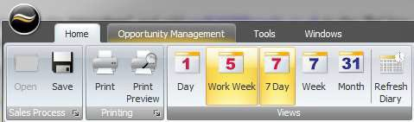
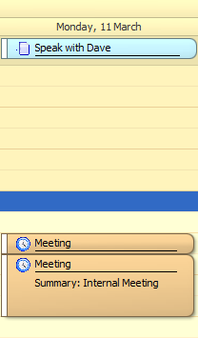
If you are already logged into 360 Advisor, click on ‘Refresh Diary’ to update your diary with the incoming appointments you have just created. Your appointment will appear in your diary as shown above. You cannot edit this appointment in 360 Advisor as it was created through an external email calendar. To edit you will need to do so through the calendar you created the appointment in.

Microsoft Exchange Integration

If you have an email account managed by ‘Microsoft Exchange’ this can also integrate with your 360 Diary. The processes covered above will remain the same, and you can input your Exchange credentials within 360 Office.
  - Phone Integration
Within 360 Lifecycle you can integrate a VOIP based phone system. To configure this, follow the below steps.

- Log in to Advisor or Office. Click on the ‘User Settings’ tab under the Tools menu.

Once you have clicked on the ‘User Settings’ icon a screen will appear.

You will see a tick box at the bottom of the screen ‘Enable Phone Integration (applies next login)’. Tick this, checking that all fields with a * next to them have also been filled in before clicking ‘Ok’.

You will now be able to pull contact numbers into your external phone system from the available phone icons within 360 Lifecycle.

- Hotbox
Your Hotbox is a unique feature that offers you a focused window into your client bank. Sales Opportunities can be entered manually and automated system generated leads/opportunities will appear here. It acts as a time management system enabling advisors to concentrate on timely productive opportunities.
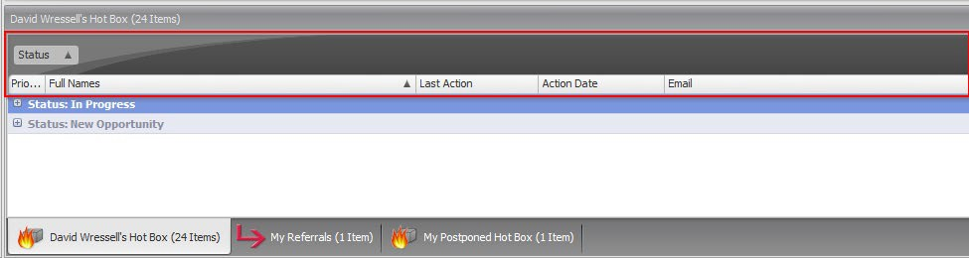

Drag and drop column headings to the grey bar to organise the screen as you wish. The Hotbox above is grouped by opportunity status.

To ungroup simply drag and drop the header back into the header bar.

If you right click on the column headings a menu will appear with a choice of different actions.

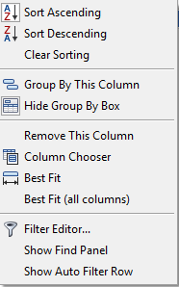
  - ‘Sort Ascending’ will sort all opportunities in your Hotbox alphabetically from A-Z.
  - ‘Sort Descending’ will sort all opportunities in your Hotbox alphabetically from A-Z
  - ‘Clear Sorting’ will clear any search/grouping parameters you have added to your Hotbox.
  - ‘Group By This Column’ will group all opportunities in your Hotbox by the column you have right clicked on.
  - ‘Hide Group By Box’ will hide the grey bar where you can drag column headers to group by.
  - ‘Remove This Column’ will remove the column you have just right clicked on.
  - ‘Column Chooser’ will bring up a customization box where you can drag and drop headings in which you wish/do not wish your Hotbox to be filtered by.
  - Column Chooser
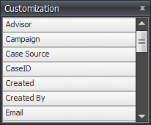
Column chooser is a feature that allows you to tailor your Hotbox in a way that suits you. Right click on your Hotbox column headings and select ‘Column Chooser’ from the menu options.
A Customization box will appear. From here you can drag and drop over to your Hotbox headings.

  - Your Hotbox
Below will show you how to create and manage your Hotbox. There are primarily 3 ways that an opportunity will arrive in your Hotbox. These are; when making a diary appointment in Advisor, manually adding an opportunity and the system automatically creating opportunities for you
  - Adding a Manual Opportunity to Your Hotbox
To add a manual opportunity to your Hotbox click on the ‘Add Opportunity’ icon under the Home tab.
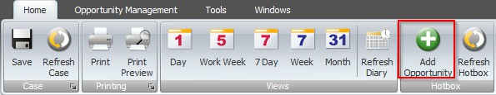
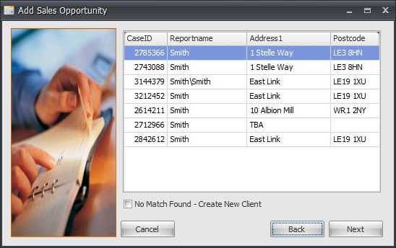
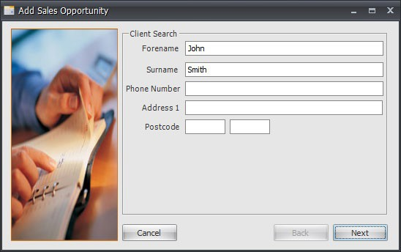

The system will trawl your client base looking for existing client records. If an existing and matching record is pulled up select it and then click ‘Next’.

If no matches are found click on ‘No Match Found – Create New Client’ and then click ‘Next’.

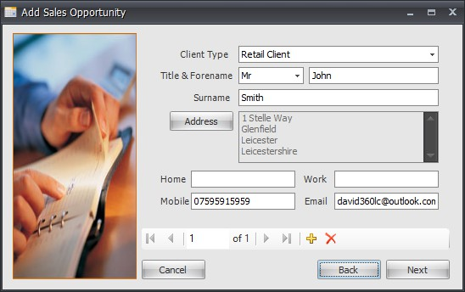
In this screen you can enter more specific details for your client. It is recommended that you enter a telephone number, address and email address. These details will allow you to contact the client through the system.
If there is more than one client you would like to add, click on the yellow ‘+’ sign and repeat the process. Click ‘Next’

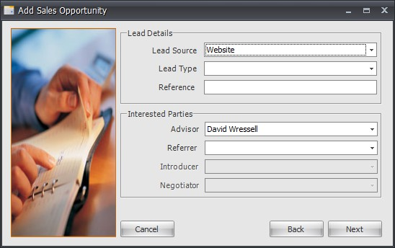
In this part of the screen, you will enter the lead details of the opportunity.

The ‘Lead Source’ refers to how the opportunity came about.

referred the opportunity to you. Click ‘Next’
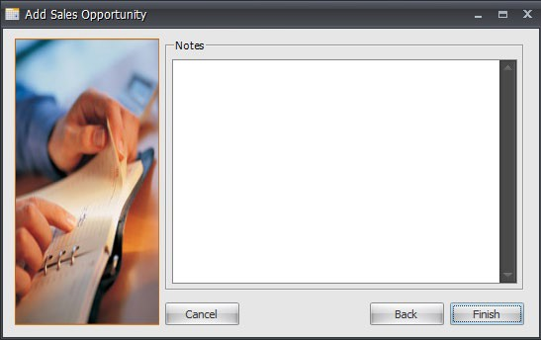
‘Referring Advisor’ would be selected if another advisor had

Here you can enter any other notes you may need. These will be saved into the Notes section of the case record.

Your new sales opportunity is now in your Hotbox.

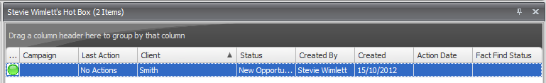

  - System Generated Opportunities
360 Lifecycle automatically generates opportunities based on the data you add into the system. Simply, the reviews are generated from the following criteria:

- Annual Reviews are created 11 months after the last completed bit of business on a case record. They are then generated every 12 months thereafter.
- Mortgage Reviews – by default – are created 3 months before the End Date of the mortgage. This can be updated to a different time period if required. If no End Date is entered, then the review is created 2 years after the completed date.
- Life Reviews are created 30 days before the end of the clawback period. This is calculated from the authorised date plus the length of the clawback period in months.
- Buildings and Contents Reviews are created 10 months after the start date of the policy.
- Pension Reviews/Income Protection/Investment Reviews are all created 11 months after the start date and then every 12 months thereafter.

Please refer the separate Automatic Review Generation document for more details on system generated opportunities and how you can set your own review criteria.
  - Managing Your Hotbox
You can right click on the opportunity in your Hotbox, which will bring up a menu of options.

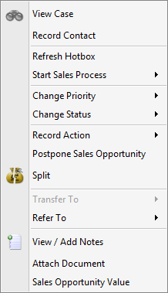
    - View Case’ will take you into the client’s case record.
    - ‘Change Status’ will give you options that you can apply to the opportunity such as Signed up’, ‘In Progress’, ‘Action Complete’, ‘NPW’ (Not Proceeding With).
    - ‘Record Action’ allows you to select the method of communication used. This is displayed in last action and automatically updates the notes section with any action recorded.
    - Postpone Sales Opportunity – will postpone the opportunity for the desired time as set by you. You will be able to see this in your Postponed Hotbox.
    - ‘Split’ will allow you to create a brand new lead with the same information as the lead selected.
    - ‘Transfer To’ updates the Servicing Advisor and transfers ownership of the client.
- ‘Refer To’ refers the opportunity directly to another advisors Hotbox but retains the original servicing advisor.
- ‘Attach Document’ will allow you to add a document to the sales opportunity. These will be saved into the Documents section of the sales opportunity in the case record.
- ‘Sale Opportunity Value’ is where you enter the cost of the lead for you along with the potential business value they may bring to you.
NB: Some change statuses will remove an opportunity from your Hotbox. These are ‘Action Complete’, all the ‘NPW’ statuses and the ‘Signed Up’ status.
  - Postponed Hotbox
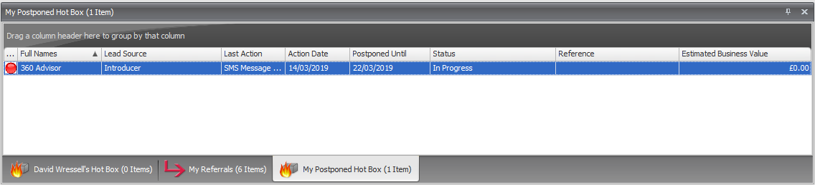
Your postponed Hotbox works similar to your Hotbox but is populated by postponed opportunities that are due to be reinstated in the next 30 days. This makes it much easier for you to see which opportunities are coming back into your Hotbox.

You can arrange your postponed Hotbox in the same way as you can your opportunity Hotbox.


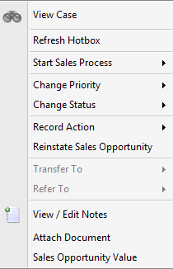
Right click on a postponed opportunity. You still have the same options as you do when you right click on an opportunity in your Hotbox. This makes it easier for you to reinstate the opportunity at an earlier period or to locate it to add notes or documents to.

Here you can reinstate the sales opportunity. This will move it back into your opportunity Hotbox.

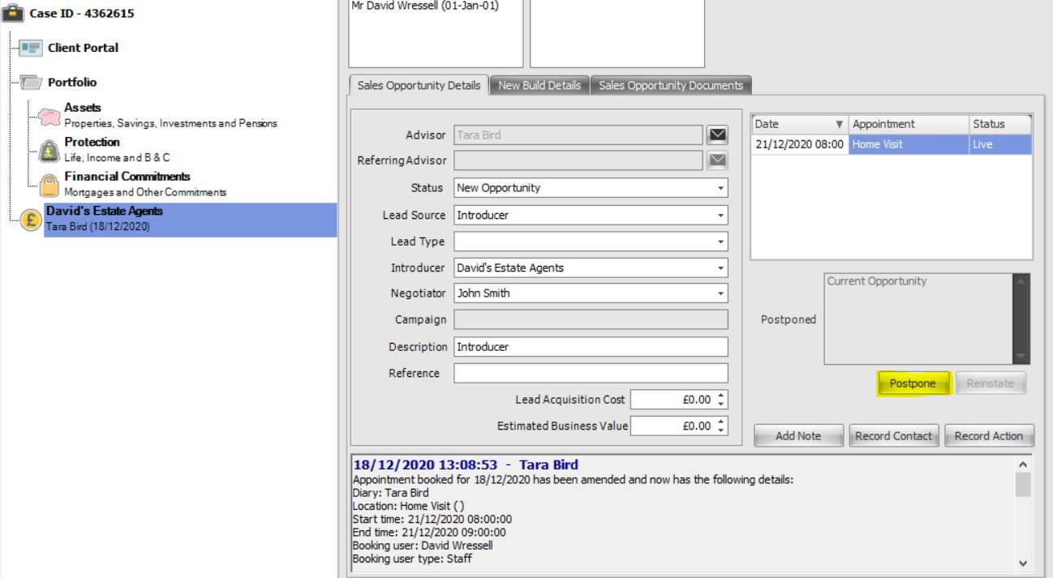

You can also postpone and reinstate your sales opportunities from within the case record on 360. Click on the sales opportunity you are working on and ‘click’ the postpone or reinstate button accordingly.

  - Your Referrals
Click on ‘My Referrals’ located at the bottom of the screen.

This will list the clients that you have passed into another advisers Hotbox, providing full transparency. The drag and drop screens enable you to sort the column headings in the order that you want to prioritise.
For example, it may be useful to see the information displayed by client and filtered by status and last action allowing the referring Advisor to view and keep track of the referred lead.
Example: A mortgage Advisor refers a Wealth lead to a qualified Financial Advisor. Referring the opportunity allows both the referring and the referred Advisor to earn commission whilst allowing the original Advisor to keep the client and offer a full financial service.

- Managing your clients’ case record

You can maintain your clients’ information and details through 360 Advisor keeping their portfolio constantly up to date. You can access a clients’ record from 360 Advisor through either the Client Search option, see below, or by right clicking against a sales opportunity in your Hotbox and choosing ‘View Case’. Please note that you can also maintain your clients information and carry out the below functions when accessing the client record in 360 Office.
  - Client Search
    - Client Search – 360 Advisor
Client search tab is located to the left-hand side of your diary.
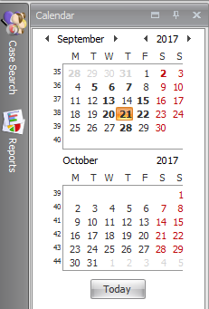
Simply click on the button and enter in the name or part of the address and click ‘Search’. The system will look for the search parameters selected and will identify the client or appointment. You may need to identify which address is relevant for popular names such as Smith or Jones where the search may show more than one result.

Double clicking on one of the returned results will bring up the case record.

    - Case Search – 360 Office

Case search is found in 360 Office along the left-hand side toolbar.

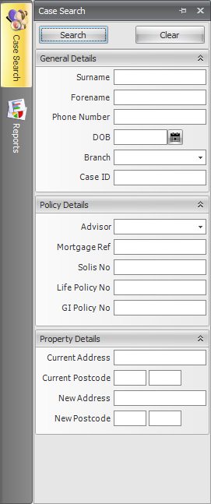
You can search by surname, forename, DOB, or CaseID to bring up a specific case.

If you wish to search for all cases belonging to a certain advisor, select the advisors name from the ‘Advisor’ drop down menu.

You can also search by mortgage ref, solis no, life policy no or GI policy no.

Clicking on the ‘Search’ button will open up the case search results screen where you can double click and open the relevant case record.
Clicking on the ‘Clear’ button will clear all information contained in any of the search fields.

  - Document Management
Documents can be managed throughout the case record within 360 Lifecycle. The top-level part of the case record is at the top of the case tree and will say Case ID – (followed by ID). Documents added here are usually in regards to a client’s proof of address or income, etc.
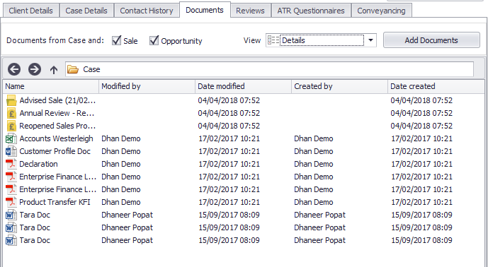

From this view, you can see all documents uploaded to the case level, and documents added to Opportunities and/or Sale Events will be grouped into specific folders. To add a document, you can follow the below steps.

- Browse for the document file from your documents.
- Click on ‘Open’ once you have selected the correct file.
- The system will now upload this to the case record.
- Click on the ‘Save’ icon to save your changes

    - Removing/Renaming/Moving Documents

You can update and move documents easily and quickly. Right click the document(s) in question.

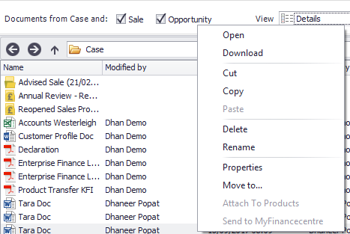
A menu will appear where you can ‘Open, ‘Download’, ‘Copy’, ‘Paste’, ‘Move To’ or ‘Rename’. Remember to save your changes before coming out of the case record.

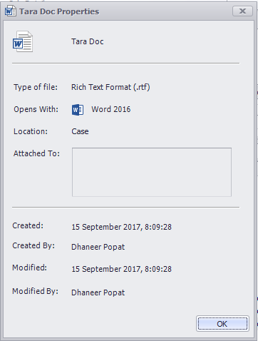
The ‘Properties’ option will allow you to see an overview of the document, including file type, location, creation date, etc. as per the below.

  - Creating Your Clients Portfolio
On accessing a case record you can manually enter the client’s other existing arrangements/full portfolio outside of any sale(s) & recommendation(s) which would have been captured. Entering any further Assets, Protection or Financial Commitments within the Portfolio section will then appear on the client Portfolio Report and you can also set review dates against these Portfolio items to then appear in your Hotbox at the required time.

This is an example of how your Portfolio screen will look after a sale event and

mortgage policy has been created. You can see that the system is already compiling the data and allowing you to have a holistic view of your client. The Portfolio screen will automatically update throughout when new Portfolio items are manually added. Please refer below on how to manually add Assets, Protection & Commitments.

This screen will automatically update throughout the whole case progression, keeping it up to date and easily viewable.
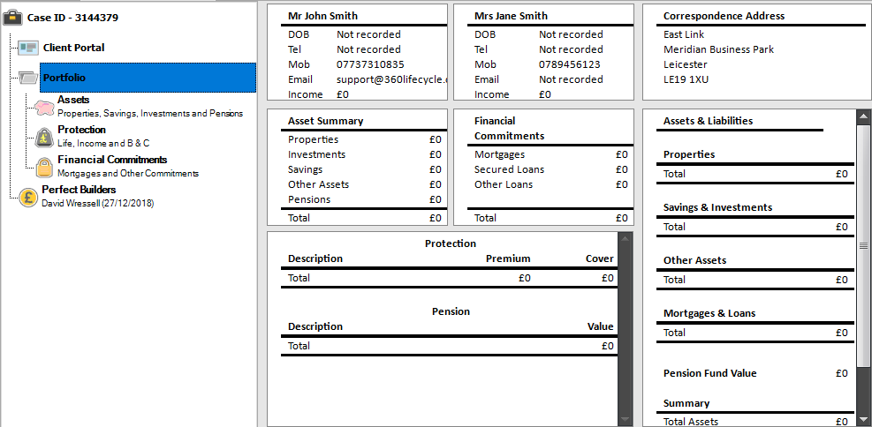
  - Assets
This is where you will compile a detailed portfolio of your client’s assets, from properties to a family heirloom. They do not have to be assets sold to them by you; this is about getting the best picture you can to understand your client, making sure that they are getting information and products that are as tailored as possible to their needs.
    - Adding a property as an asset
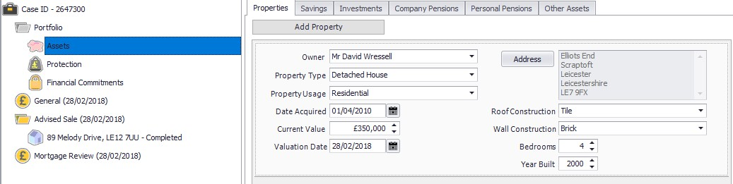

To add a property as an asset you need to click on ‘Asset’ underneath ‘Portfolio’
and click on ‘Add Property’ underneath the Properties tab.

      - Begin by selecting the ‘Owner’ from the drop-down menu. The clients you have added at the top level of the Case Record populate this field.
      - Select ‘Property Type’ from the drop-down menu.
      - Select ‘Property Usage’ from the drop menu.
      - Input the ‘Date Acquired’. This is referring to the date that the owner established ownership of the property in question.
      - The ‘Current Value’ is the current value of the property. You can add the date that this valuation was passed in the ‘Valuation Date’ field below.
      - To add the address of the property you need to click on the ‘Address’ button, input the address, clicking ok once complete.
      - From the drop-down menus select the ‘Roof Construction’ and the ‘Wall Construction’.
      - Finally finish by selecting the amount of bedrooms in the property and the year that it was built remembering to click on the ‘Save’ icon
NB: If you have a client with a mortgage, you will need to fill in this part of the Portfolio to be able to add a mortgage. Please refer to adding a mortgage for a guide on how to add amortgage.
    - Adding savings as an asset
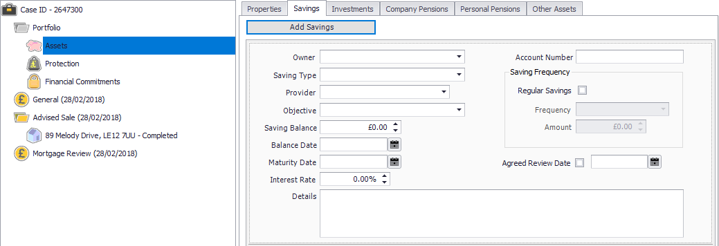

To add a savings click on the ‘Add Savings’ button underneath the ‘Savings’ tab.

      - Begin by selecting the ‘Owner’ of the savings. The clients you have added at the top level of the Case Record populate this field.
      - Select the ‘Savings Type’, e.g shares, from the drop-down menu. Choose the savings ‘Provider’
      - From the drop-down menu select the savings ‘Objective’.
      - Input the ‘Saving Balance’ (how much the saving is worth, etc.) along with the ‘Balance Date’. This date is referring to the date that the balance was accounted for.
      - Enter a ‘Maturity Date’ (if there is one) along with the ‘Interest Rate’ of the savings.
      - Add the ‘Account Number’ for the savings.
      - If the savings are added to on a regular basis you can tick the ‘Regular Savings’ box. Input the frequency of payment along with the amount that is added at each time.
      - If, for example, you had not sold this product to your client but between you had agreed that you would review it in the future, you are able to tick the box next to ‘Agreed Review Date’, entering in the date in the field next to it. This product will then enter your Hotbox on the date specified as a new opportunity for review.
    - Adding an investment as an asset
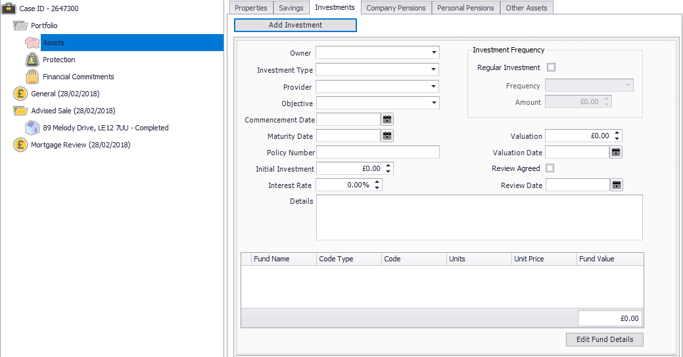
To add an investment click on the ‘Add Investment’ button underneath the
‘Investments’ tab.
      - Begin by selecting the ‘Owner’ of the investment. The clients you have added at the top level of the case record populate this field.
      - Select the ‘Investment Type’ from the drop-down menu.
      - Choose the investments ‘Provider’ from the drop-down menu. Select the
‘Objective’ of the investment.
      - Input the ‘Commencement Date’ of the investment. This is the date that the investment began.
      - Enter the ‘Maturity Date’ (if there is one) and the policy number for the Investment in question.
      - You will need to enter in the ‘Initial Investment’ (how much your client first invested) along with the ‘Interest Rate’ of the investment.
      - If your client pays regularly into their investment you are able to check the
‘Regular Investment’ box.
        - Select the ‘Frequency’ of the payment
        - Select the ‘Amount’ that is paid in at each frequent payment.
      - Enter the ‘Valuation’ of the investment (this is the present day investment valuation) along with the date that this valuation was made.
      - If you have agreed with your client that you are both going to review this investment, you can tick the box ‘Review Agreed’, entering in a ‘Review Date’. This is the date you wish for the review to enter your Hotbox.
      - Any further details can be added into the ‘Details’ box.
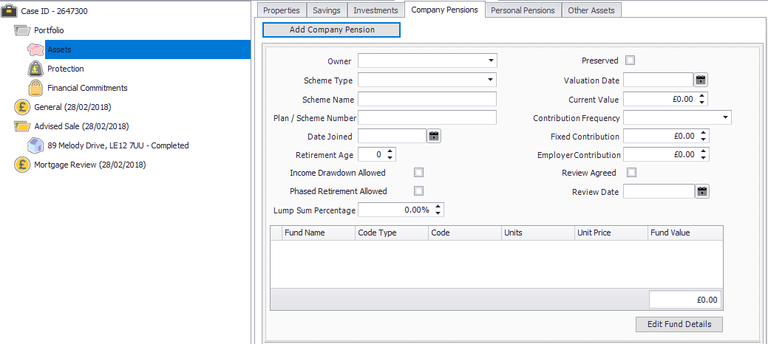
      - You can also add in ‘Fund Details’ by clicking ‘Edit Fund Details’ and populate these here.
    - Adding a company pension

To add a company pension click on the ‘Add Company Pension’ button underneath the ‘Company Pensions’ tab.

      - Begin by selecting the owner of the pension. The clients you have added at the top level of the case record populate this field.
      - Select the ‘Scheme Type’ from the drop-down menu.
      - Type in the ‘Scheme Name’ of the pension policy along with the
‘Plan/Scheme Number’.
      - Type in the ‘Date Joined’. This is referring the date that the client took out the company pension.
      - Select the clients ‘Retirement Age’
      - Tick the boxes if either ‘Income Drawdown is Allowed’ or ‘Phased Retirement is Allowed’
      - Enter the ‘Lump Sum Percentage’
      - Tick the box if the pension is ‘Preserved’
      - In the box provided enter in the ‘Valuation Date’ along with the ‘Current Value’ of the pension. This is how much the client’s pension is currently worth.
      - From the drop-down menu select the ‘Contribution Frequency’.
      - Enter the ‘Fixed Contribution’ (the premium the client pays into their pension each time)
      - If a review on this policy has been agreed between you and your client you can tick the ‘Review Agreed’ box, entering in a date you wish for this to drop into your Hotbox as a review.
      - You can also add in ‘Fund Details’ by clicking ‘Edit Fund Details’ and populate these here.
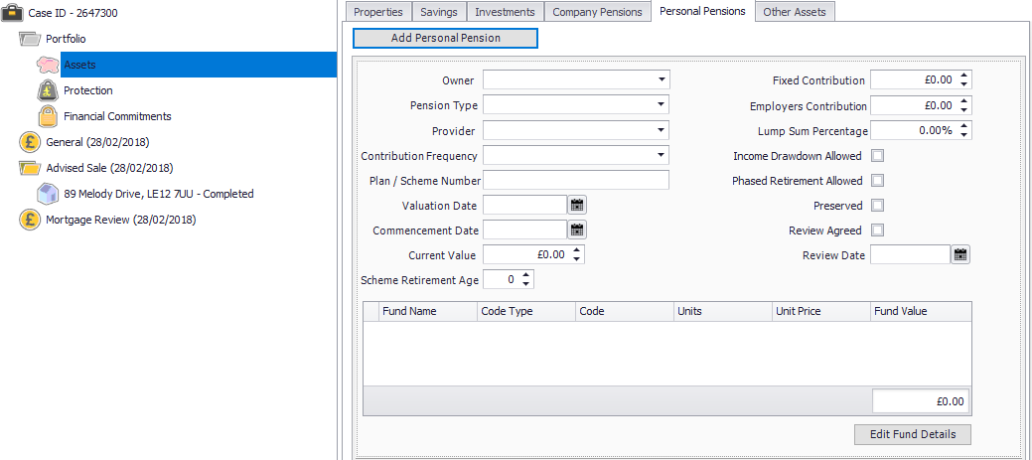
    - Adding a personal pension

To add a personal pension click on the ‘Add Personal Pension’ underneath the
‘Personal Pensions’ tab.

      - Begin by selecting the ‘Owner’ of the pension from the drop-down menu.
      - Select the ‘Pension Type’ from the drop-down menu.
      - Select the ‘Provider’ from the drop-down menu.
      - Select the ‘Contribution Frequency’ from the options available.
      - Type in the ‘Plan/Scheme Number’.
      - Enter the ‘Valuation Date’. This is the date in which the pension was last valued.
      - Enter the ‘Commencement Date’. This is the date the client started their pension scheme.
      - The ‘Current Value’ is the total amount that the client has in their pension fund.
      - Select the ‘Retirement Age’.
      - Enter the ‘Fixed Contribution’ amount (the amount the client pays regularly into their pension, along with their ‘Employers Contribution’ (if any).
      - Select the ‘Lump Sum Percentage’.
      - Tick the relevant boxes if the pension meets any of the following:
        - Income Drawdown Allowed
        - Phased Retirement
        - Allowed
        - Preserved
      - If a review has been agreed between you and your client for this product tick the ‘Review Agreed’ box, entering in a ‘Review Date’ (the date you wish for this to pop into your Hotbox as a review.
      - You can also add in ‘Fund Details’ by clicking ‘Edit Fund Details’ and populate these here.
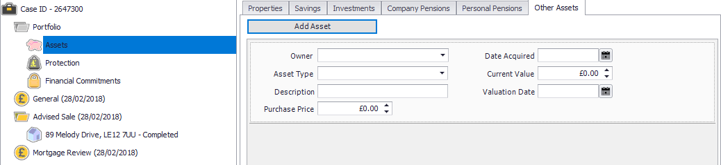
    - Adding any other assets

To add any further assets your client may have, e.g Antiques, Works of Art, etc click the ‘Add Asset’ button underneath the ‘Other Assets’ tab.

      - Select the ‘Owner’ from the drop-down menu. The clients you have saved at the top level of the case record populate these options.
      - Select the ‘Asset Type’ from the drop-down menu.
      - Type in a ‘Description’ (if needed) for the asset.
      - Select the ‘Purchase Price’ of the asset (how much the client first paid for the asset)
      - Enter in the ‘Date Asset Required’ along with the ‘Current Value’ and
‘Valuation Date’
  - Protection
This is where you will collect information from your clients of any protection policies they may have, whether these have been taken out with you or not. Protection here ranges from protection of their health to protection to the salary, house, belongings, etc.
    - Adding a life policy
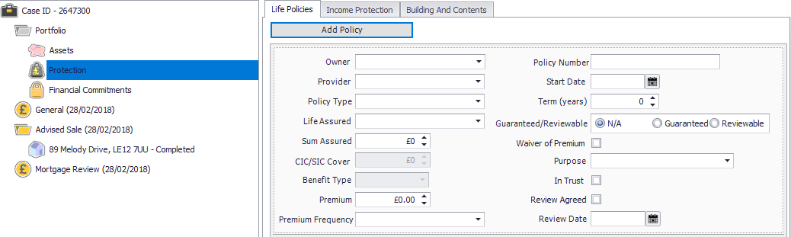

To add a life policy for your client (one that has not necessarily been taken out by you – if you are looking at adding a life policy which you yourself have sold a client please refer to Adding a Life Policy) click on the ‘Add Policy’ button underneath the ‘Life Policies’ tab.

      - Select the ‘Owner’ of the life policy from the drop-down menu. (Whose name the policy has been taken out in) The clients you have saved at the top level of the case record populate this menu.
      - Select the ‘Provider’ from the drop-down menu.
      - Choose from the drop-down menus the ‘Policy Type’.
      - Select the ‘Life Assured’ (who the policy covers).
      - Enter the ‘Policy Number’.
      - Select the ‘Sum Assured’ (the total amount of cover that will provided) along with the
      - ‘Premium’ that is to be paid accordingly with the payment frequency.
      - Select the ‘Premium Frequency’.
      - Enter the ‘Start Date’. This is the date the life policy went live.
      - Select the ‘Term’ of the policy.
      - Tick (if applicable), whether the policy is ‘Guaranteed’ or ‘Reviewable’.
      - If ‘Waiver of Premium’ is included, please tick this box.
      - Select the ‘Purpose’ of the life insurance from the drop-down menu.
      - Tick the box if the policy is written ‘In Trust’.
      - If a review date has been agreed tick the ‘Review Agreed’ box and enter in the date you wish for this to drop into your Hotbox as a review in the ‘Review Date’
    - Adding an income protection policy
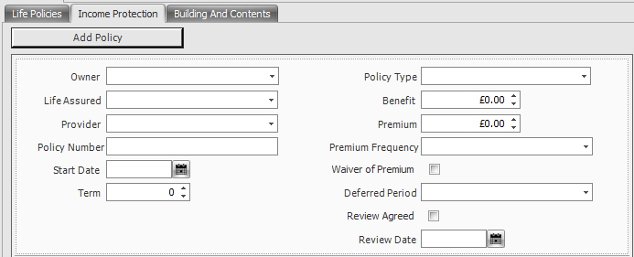

To add an income protection policy (one which has not been sold by you) click on the ‘Add Policy’ button underneath the ‘Income Protection’ tab.

      - Select the ‘Owner’ from the drop-down menu. (Whose name the policy has been taken out in) The clients you have saved at the top level of the case record populate this menu.
      - Select from the drop-down menu which client(s) this policy ‘Assures’. It can be one client or more than one, just click the relevant check boxes
      - From the drop-down menu select the ‘Provider’.
      - Enter the ‘Policy Number’ (if known at the time) along with the ‘Start Date’
of the protection.
      - Select the ‘Term’ of the policy.
      - From the drop-down menu select the ‘Policy Type’.
      - Enter the ‘Benefit’ of the income protection policy (how much the provider is prepared to pay the client a month).
      - Enter the ‘Premium’ of the policy, selecting the ‘Premium Frequency’ from the drop-down menu.
      - If ‘Waiver of Premium’ is included, please tick this box.
      - From the drop-down menu select the ‘Deferred Period’ of the policy.
      - If a review has been agreed between you and your client tick the ‘Review

Agreed’ check box, entering in the date you wish for this review to drop into your Hotbox in the ‘Review Date’ field.
    - Adding a buildings and contents policy
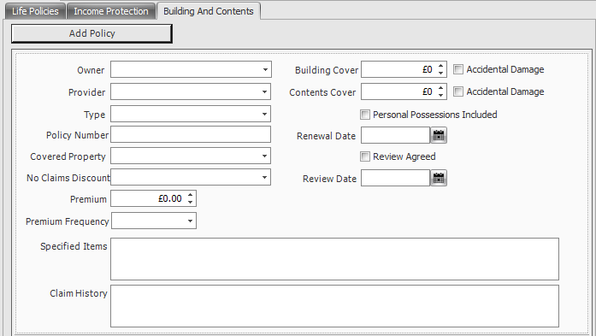

To add a buildings and contents policy (one which has not been sold by you) click on the ‘Add Policy’ button underneath the ‘Building and Contents’ tab.

      - Select the ‘Owner’ from the drop-down menu. (Whose name the policy has been taken out in) The clients you have saved at the top level of the case record populate this menu.
      - Select the provider of the policy from the drop-down menu.
      - From the drop-down menu select the ‘Type’ of insurance given, e.g, contents only.
      - Select from the drop-down menu the property covered (if applicable). If the property here is not available, you will need to refer back to adding a property. Remember to save your changes.
      - Select the ‘No Claims Discount’ from the drop-down menu.
      - Enter the ‘Premium’ of the policy.
      - You are able to enter in the boxes any ‘Specified Items’ to be covered and details of the clients ‘Claim History’.
      - Enter the amount of ‘Building Cover’ and/or ‘Contents Cover’, ticking whether ‘Accidental Damage’ is included.

      - Tick the box if ‘Personal Possessions’ are included in the policy terms.
      - Enter the ‘Renewal Date’ of the policy in the field provided.
      - If a review has been agreed between you and your client you can tick the
‘Review Agreed’ box, entering the ‘Review Date’ in the field provided.

  - Financial Commitments
This is where you will collect information from your clients of any financial commitments they are tied to. The purpose here is to establish a fuller picture of your clients’ needs and demands by taking into account any commitments they have that have not been sold by you. Financial Commitments here range from your client having a mortgage, a credit card, a personal loan, even a store card in credit.
    - Adding a mortgage

To add a mortgage (one which has not been sold by you) click on the ‘Add Mortgage’ button underneath the ‘Mortgages’ tab.
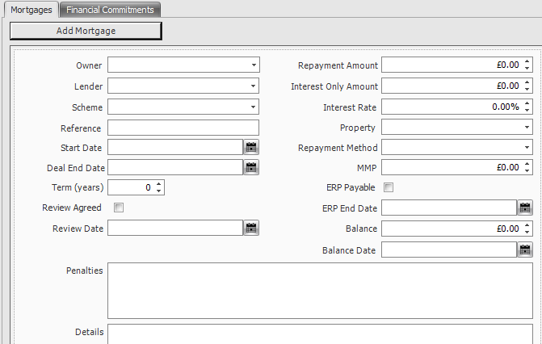

      - Select the ‘Owner’ of the policy from the drop-down menu. The owner here refers to whose name(s) is on the policy terms. The clients you have saved at the top level of the case record populate this menu.
      - Choose from the options available in the drop-down menu the ‘Lender’ of the mortgage.
      - Select the ‘Scheme’ of the mortgage from the drop-down menu.

      - Enter the ‘Reference’ of the mortgage (if known).
      - Enter the ‘Start Date’. This is the date that it was agreed the mortgage would begin.
      - Input the ‘End Date’ of the mortgage. This is the date that the mortgage will expire.
      - Enter the ‘Term’ of the mortgage in years.
      - If a review has been agreed by you and your client, you can tick the ‘Review Agreed’ box and enter the date that you wish for this review to enter your Hotbox in the ‘Review Date’ field
      - You are able to enter any details about the mortgage in the ‘Penalties’ and
‘Details’ boxes.
      - Input the ‘Repayment Amount’. This is how much in total the client will need to repay.
      - Enter the ‘Interest Only Amount’ of the mortgage along with the ‘Interest Rate’.
      - Select the ‘Property’ that the mortgage relates to from the drop-down menu. If the property in question does not appear here, you will need to add it as a property in assets. Please refer to adding a property
      - Select the ‘Repayment Method’ from the drop-down menu.
      - Enter the ‘MMP’ (Monthly Mortgage Payment).
      - If the mortgage is part of an ‘ERP’ (Emergency Repair Program), tick the
‘ERP Payable’ box, entering in the ‘ERP End Date’.
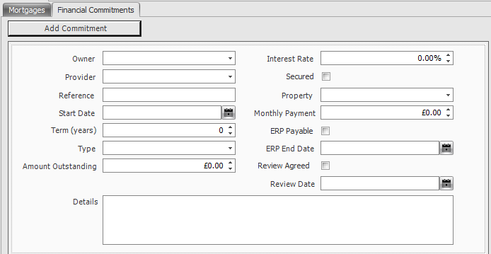
      - To add any other financial commitments your client may have click on the
‘Add Commitment’ button underneath the ‘Financial Commitments’ tab.
      - Select the ‘Owner’ from the drop-down menu. The owner here refers to

whose name(s) is on the policy terms. The clients you have saved at the top level of the case record populate this menu.
      - Select the ‘Provider’ from the drop-down menu.
      - Enter the ‘Reference’ number of the commitment along with the ‘Start Date’ of the commitment in question.
      - Type the ‘Term’ of the commitment; how long the client is to be held to this commitment.
      - Select the ‘Type’ of the commitment from the drop-down menu.
      - Input the amount that the client still has outstanding to pay on the commitment.
      - There is a box where you can enter any further necessary ‘Details’ of the commitment.
      - Select the ‘Interest Rate’ and tick the check box if the commitment is
‘Secured’
      - If the client has a property tied into their loan you can select this from the
‘Property’ drop down menu.

  - Portfolio Report
The Portfolio Report is located under the home tab and provides a complete summary of everything entered in the Portfolio section of a case record. As you are adding and updating the portfolio file, the portfolio report will also update keeping it up to date. It provides a form of documentation to give to clients or to keep for your own records.

When you are inside any case record the Portfolio Report Button shown below will be enabled.

Clicking this button will show you the Portfolio Report Headers Screen. You can edit these headers and their corresponding paragraphs to personalise the report to suit your client.
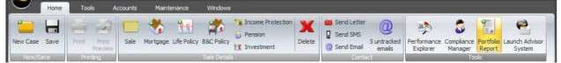

Clicking this button will show you the Portfolio Report Headers Screen. You can edit these headers and their corresponding paragraphs to personalise the report to suit your client.

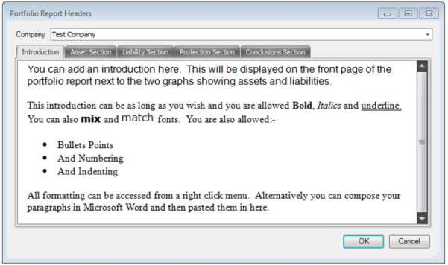

The remainder of the header pages work in the same way except they also allow you to enter a title for the section.
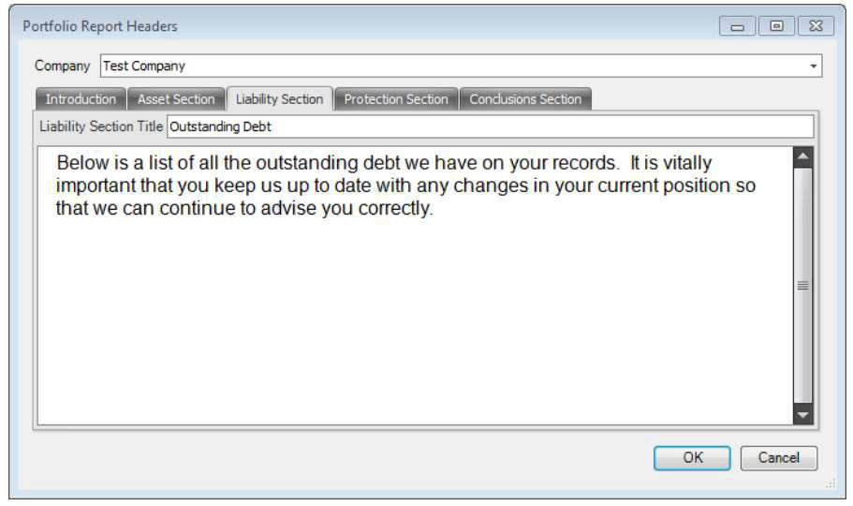

Each section can be customised in this way. Although you can use each section as you see fit, one use for the conclusion may be for you to remind your client of all your products and services.

Once you are happy with your Portfolio Report headers select ‘Ok’. This will open your portfolio report.
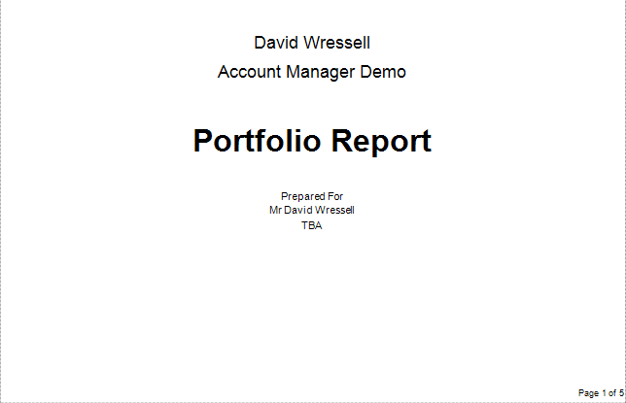

The report contains a headed title page with your company logo, your name and the clients name and address. The report is automatically time date and stamped. The below section of the portfolio gives a breakdown of the clients assets and liabilities in a graph.

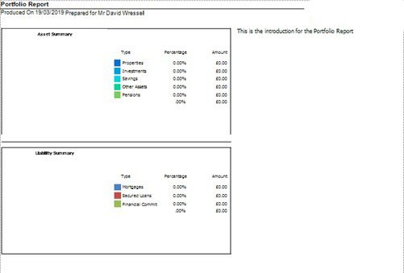
The assets and liabilities are then further broken down to include policy specific information.

You can customize your report by adding a watermark (by clicking on the ‘Watermark’ icon on the tools bar), adjust the background colour as well as the scale of the report.

The Portfolio Report can be printed, saved or exported in various file formats including PDF, HTML and CSV. Once printed/saved or exported, when you come to close the report the system will prompt you as to whether you would like to automatically save a copy of the report into the case document library where it will be saved as a PDF document.
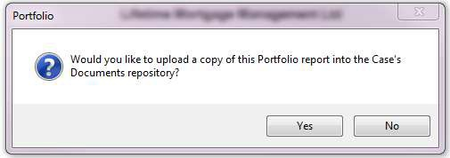

- Client Communication

There are three methods by which you are able to communicate with your client through the system: sending a letter, sending an SMS and sending an email. All communication is added to the documents/contact history of the case record.
  - Sending a Letter
To send a letter to your client, open their case record and click on the ‘Send Letter’
icon under the home tab.
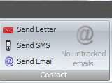

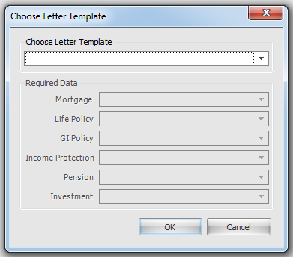
letters will require you to do this),
A screen will appear for you to select the letter you wish to send from the ‘Letter Template’ drop down menu. To create your own letter template please refer to Creating A Letter Template.
Simply select the letter to send. If the letter corresponds to a product, eg a mortgage, you will use the ‘Mortgage’ drop down menu to select the correct sale. (NB: Not all

Click ‘OK’. A screen will appear with your letter. Here you can make amendments before clicking on the ‘Print’ button to print out your letter.

Remember to click ‘Save’ or ‘Save & Close’ for the letter to be saved into the
‘Documents’ of the case record.

  - Sending an SMS
To send an SMS to your client click on the ‘Send SMS’ icon under the home tab. You will need to have the case record open.
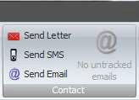

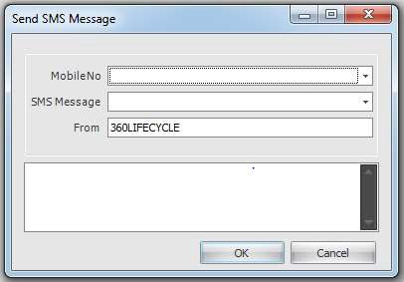
A screen will appear for you to select the correct clients phone number along with the ‘SMS Message’ you wish to send.

The ‘SMS Message’ is populated from the SMS templates.

into the box or write your own message.
You can edit the message when it falls

NB: There is a character limit of 160 characters allowed per text message.

  - Sending an Email
To send an email to your client click on the ‘Send Email’ icon under the home tab. You will need to have the case record open.
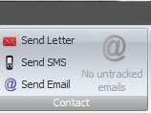

The system will open a blank email through your default email client e.g., Outlook where you are able to add to the message body. Click on ‘Send’ once you have composed the email. This will be sent to your client and a copy of the email will be audited in the documents section of the case record (provided Email integration is enabled).

From within the Case Record, you can also email clients and other users within the database by selecting the email icon next to the relevant party.
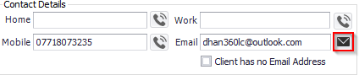
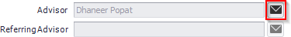
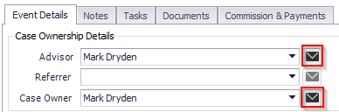

This will open a new email in your default mail client and pre-populate the email next to the icon selected.
    - Email Integration

Email integration allows you to send emails from the system to your clients and that email to then be saved as a document to your clients case record.

To enable Email Integration, you will need to log into 360 Advisor or Office, click on the Tools menu and then on User Settings.

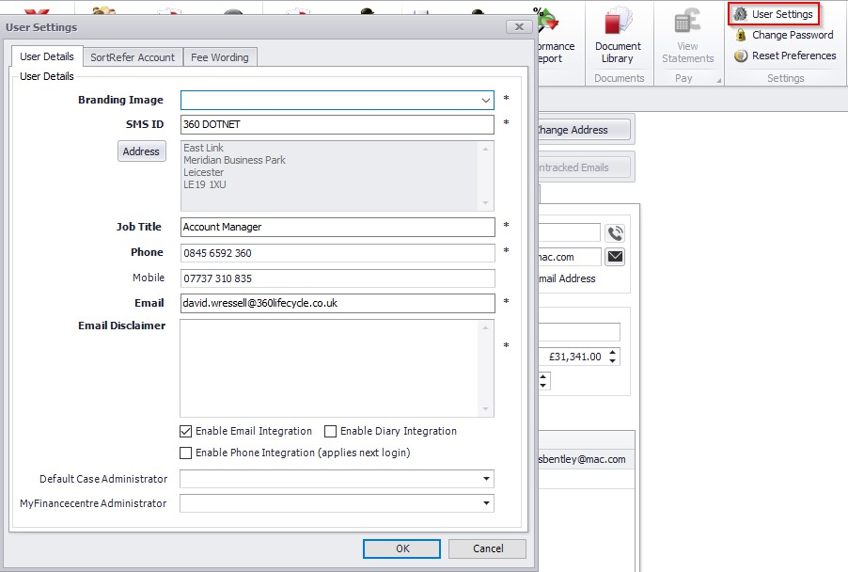

When you send an email (see Sending an Email for instructions on how to do this) a copy of this email is saved into the documents section as an audit trail. The Email Tracking part of the system means that when your client replies to the email sent a copy of that email will also save into the documents section of the case record providing further audit.

When you click on ‘Send Email’ the system will open a new email through your default email client, e.g MS Outlook.
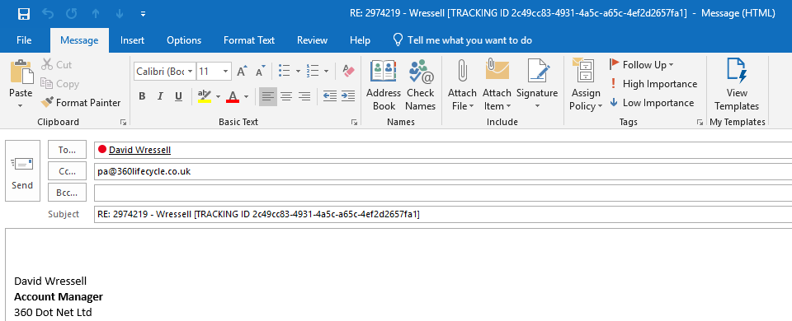

You will notice that the email address ‘pa@360lifecycle.co.uk’ has automatically populated the ‘CC’ field. For a copy of your clients reply to be added to the case

record this address needs to be kept here and the client will need to ‘Reply To All’ when replying to your email.

In the ‘Subject’ field of the email you will see ‘TRACKING ID’ followed by a long ID number. Again, this tracking ID needs to remain in the subject field for the system to be able to attach it back to the relevant case.

Once your message is composed simply click on the ‘Send’ button. A link will be created in the system between you and the case record and your client.

When your client replies to the email they will need to click on the ‘Reply All’ button. This will ‘CC’ pa@360lifecycle.co.uk which will then allow for the reply to be saved back into the case record.

- What happens if the client does not click on ‘Reply all’?

As long as your client sends the email to your correct email address you can then forward it on to pa@360lifecycle.co.uk to attach it to the case record. (Provided that the TRACKING ID is still in the subject field).

- What happens if the client does not reply with the TRACKING ID number or the correct message subject?

If the client changes the email subject or removes the TRACKING ID the email will then be put into ‘Untracked Emails’.

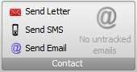
‘Untracked Emails’ is a feature which will show you any emails which the system is unable to save to a case record. Once an email is in here you will then be able to match it up to the relevant case.

- Letter Templates
Letter templates are found in 360 Office under the ‘Maintenance’ ‘General’ tab in ‘Standard Letters’. Letter templates are used when sending a letter from a case record. Please refer to Sending a Letter to see how this is done. Please note you may not have the ‘Maintenance’ option as this is permission based. If not

please speak to your system administrator.

  - Adding a new letter template
To add a new letter template, click on ‘Standard Letters’ under the general tab in 360 Office.
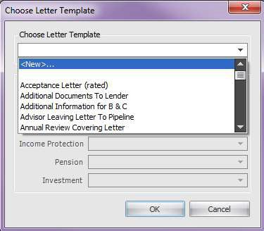
Select <New>… from the drop-down menu and then click on Ok. This will open up the letter template editor screen.

Simply type out and format your letter into the template. By navigating through the Home, Page Layout, Insert, Design and Format tabs, you can tailor the letter template specifically to your needs.

You can add a variety of mail merge fields into your template by right clicking on the document and selecting ‘Insert Merge Field’ from the menu.
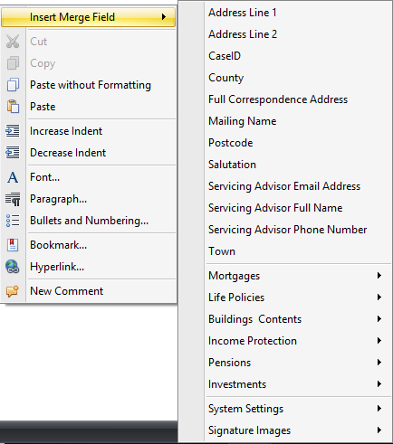

Once you are happy with your template click on the ‘Save and Close’ icon under the File menu.

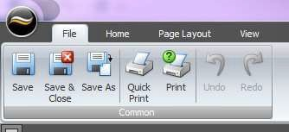

You will be prompted to add a template name. Enter a title and click on ‘Ok’. The template has now been added to your database letter templates.
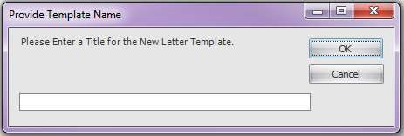

If you wish to save the template to your local documents on your computer select
‘Save As’ under the file menu.

Select where on your computer you wish to save the document and click ‘Ok’.
  - Amending an existing letter template
To amend an existing letter template navigate to ‘Standard Letters’ under the ‘Maintenance’ ‘General tab’ in 360 Office.

Select the letter you wish to amend from the drop-down menu and click ‘Ok’.

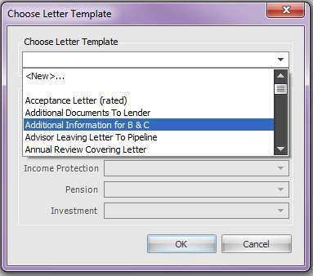

This will open the letter template editor. Simply add your amendments to the letter and select the ‘Save’ from the file menu.
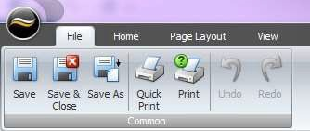
Exit the template editor
- Creating default portfolio report headers
To create your default portfolio report headers you need to log into 360 Office. Under the Maintenance tab select ‘Portfolio Report Headers’ from the General icon. Please note you may not have the ‘Maintenance’ option as this is permission based. If not please speak to your system administrator.

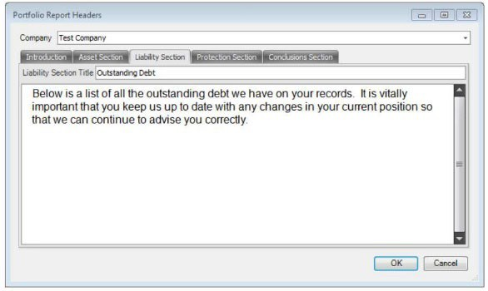
Clicking this button will show you the Portfolio Report Headers Screen. Select your company from the drop-down menu. If you have more than one company set up on your 360 database you can create differing default portfolio headers to tailor the portfolio report to your own company needs.
As shown above you can tailor and format your portfolio report headers with different fonts, bullet points or even copy and paste from a word document.

The remainder of the header pages work in the same way except they also allow you to enter a title for the section.
Each section can be customised in this way. Although you can use each section as you see fit, one use for the conclusion may be for you to remind your client of all your products and services.

Once you are happy with your Portfolio Report headers select ‘Ok’. This will save the headers and default them to all future portfolio reports that you create.

